**RTFB ACM**

**Libraries Report | Ballyroan Library | November 2022**

Ballyroan Library had 16,144 visitors in October. A total of 62 events were hosted by the library throughout the month, with 1,094 people attending.

**Ballyroan Library October Highlights**

**Digital Folklore Project**

South Dublin Libraries was proud to launch the 2022 Digital Folklore and Storytelling Project, funded by Creative Ireland. In the summer of 2022, artist, folklorist and digital educator Michael Fortune taught local enthusiasts how to use digital media to capture and record stories of social, historical and folkloric importance. The majority of the participants were involved in local history activities or research and all had stories they wanted to record and share but needed to develop their technical skills using modern technology for storytelling purposes.

The objective of the course was to inspire not only the participants but the wider community of South Dublin County to get involved in preserving stories of local and national significance for future generations. Ideally, we strive to sponsor heritage projects that not only give a sense of our rich tapestry of local history and folklore in our local county and across the country but which also give people the confidence to tell these stories for themselves and to become part of our wider research and storytelling traditions.

Upon the conclusion of the course, the group spent some time putting the digital skills learned from the course into practice and produced several videos on social history, personal / family history, local heritage sites and folklore. A live virtual launch was hosted by Ballyroan Library in October and the final film produced by the group was shared on our Vimeo and Facebook platforms. The finished film can be viewed at <https://vimeo.com/757896460>

**Red Line Festival**

The Red Line Festival was a great success this year and ran from October 13-16th in over 40 events in fascinating performance venues including Rathfarnham Castle, Pearse Museum and Baldonnel Aerodrome as well as the Civic and branch libraries across South Dublin.  From ‘True Crime’ with Paul Williams, Ex-State Pathologist Dr Marie Cassidy and Private Investigator Patrick Marry to rapping with writer in residence Selló at The Civic or readings of Ulysses at Rathfarnham Castle to Shadow puppet making at Pearce Museum and a whole series of sports events at Tallaght Stadium, poetry awards and Puca puppets, the Red Line Festival was a celebration of all things literary be it spoken, written, sung, played, illustrated, or even just thought!

The Red Line Festival was produced by South Dublin Libraries and Arts at South Dublin County Council offering a programme of events and workshops that appeals to people of all ages and interests, from children to adults, casual readers to bookworms with events in six different strands As Gaeilge, Literary, Sport & Wellbeing, Music & Performance, Crime & Horror and Family.  The festival featured wonderful authors such as Michael Harding, Donal Ryan and Emilie Pine, Conor Creighton, Louise Phillips and many more.

History, heritage and the Irish language featured throughout the festival. Dean Ruxton discussed his book Death on Ireland’s Eye and Rebecca Brownlie brought her Abandoned Ireland exhibition to the Tallaght Library, highlighting the social importance of our forgotten buildings.   Colmán Ó Raghallaigh, Micheál Ó Conghaile and Réaltán Ní Leannáin took part in the As Gaeilge strand.

Red Line Festival was also delighted to work with NOISE Music DJ Programme and ‘Give Us The Night’ providing opportunities for young people to learn how to DJ and develop their musical knowledge. The poetry programme took the limelight when award winning poet Jessica Traynor announced the winners of the Red Line Poetry Competition. First place went to Nuala Roche for 'Spirit of American Youth Rising from the Waves. Second place went to Winifred McNulty for 'When Lough na Suil Drains' and third place went to  Ruth Quinlan for her poem 'Lamping'  This was an incredible achievement as almost 300 poems were entered this year of an exceptionally high standard.

On Sunday at Tallaght Stadium Jonathan Wilson discussed his biography of Bobby and Jack Charlton with local journalist Ronan O’Flaherty. Siobhán Doyle gave a brilliant talk on The History of GAA in 100 objects and George Hamilton had a rousing discussion with Gareth Maher about his book: Away Days - 30 years of Irish footballers in the Premier League.

**Ballyroan Library November Highlights**

**Christmas Craft Fair**

Saturday 26th November 10:00am – 4:00pm

Our annual Christmas Craft Fair returns with handmade gifts from local crafters, cakes and bakes, and live music from Rathfarnham Ukelele Group.

**Season of Science**

Our month-long programme of science events for schools. Workshops at Ballyroan include Make Mini Rockets with MakerMeet, The Eccentric Energy Show with Dr. How’s Science Wows and Colourful Science with Anyone4Science.

**Decade of Centenaries Programme**

Saturday 19th November at 1:00pm**|Wading Through Blood: de Valera and the Civil War**

This lecture, from historian and journalist David McCullagh charts the bloody happenings of 1922 from the perspective of the “long fellow.” This lecture is based on volume one of David McCullagh's biography of Eamon de Valera. *Online event.*

**Adult/Lifelong Learning Events**

Monday 7th November at 2:00pm |**Ballyroan Film Club**

A matinée screening of classics and musicals, this is a new monthly event aimed at adults with additional needs. Takes place on the first Monday of the month.

Every Monday 11:00am – 12:30pm

Every Thursday 6:30pm – 8:00pm| **Stitched Together Craft Group**

Twice-weekly craft skills share sessions.

Tuesday 15th November at 11:00am| **Adult Craft Class**

Craft class with artist Kim Jenkinson

Wednesday 30th November at 11:00am| **Golden Moments Social Club: Bingo Ballyroan**

Eyes down and join us for this fun bingo morning! There’ll be prizes galore and refreshments and chat afterwards. All welcome.

Thursday mornings at 10:30am|**Age Action computer/smart phone classes continue.**

**Tuesdays at** 2:30 and 3:30pm| **Irish Language Classes ongoing**

Six week Irish course for adults catering for beginners and improvers.

Monday 21st November at 6:30pm | **Live Music Night with No Direction**

Led by Ballyroan Men’s Shed’s resident band, No Direction, this is a new monthly event where all are welcome to come along to kick back, relax and enjoy the music, or take to the floor with a tune or a song. All welcome!

Tuesdays 1st, 15th and 29th November | **Creative Writing Class**

Ongoing creative writing group, facilitated by Tanya Farrelly.

Tuesday 1st November at 6:45pm|**Spooky South Dublin and other Irish Ghost Stories**

The legends surrounding the Hell Fire Club are probably South Dublin’s most famous chilling tales, but there are plenty of other local ghoulish stories. Come along to hear all about it, with local historian Tony Duffy.

Tuesday 1st November at 7pm| **Talk: Sensory Processing Disorder – Overloaded, Overwhelmed and Misunderstood! (online event)**

Do you or your child have ‘supersonic’ senses? Noises seem louder than they do to others; clothes that other people have no problem wearing feel scratchy or sore; smells that others don’t even notice make you sick or uncomfortable? Many neurodiverse people experience sensory overload, it’s an invisible phenomenon that others can find difficult to understand but it’s very real! If you are interested in learning more about sensory processing disorder join us for this informative, helpful seminar and Q&A. *Supported by the Dormant Accounts Fund.*

Wednesday 2nd November at 7pm| **Talk: Autism and Toilet Training – a gentle developmental approach**

Join ASIAM Training Officer Amanda McGuinness in this live talk. Toileting independence is a huge developmental milestone for children. If your children have additional needs, you may find you are meeting additional barriers to success in toileting. There can be regressions, withholding, sensory differences, intellectual and communicative misunderstandings. Toilet Training: A Gentle Developmental Approach will seek to support families in helping their children on their toileting independence. *Supported by the Dormant Accounts Fund.*

Monday 14th November at 10:30am | **Using Toys to Develop Your Child’s Language Skills**

Play is an integral part of your child’s development. This short talk will show you how to use your child’s toys to help develop and encourage their language skills. Online event. *Supported by the Dormant Accounts Fund.*

Wednesday 16th November at 11am | **Courageous Conversations**

Thinking about death is not easy, and talking about it is even harder, but planning for your funeral can ease the stress surrounding end-of-life wishes. This is the first in a series of related talks presented by the Irish Hospice Foundation Think Ahead programme.

**Children’s Events**

Wednesday 2nd November at 10:00am | **Circus 250: Juanita’s Talk**

Juanita’s Talk is an hour-long interactive environmental show for the whole family by Ireland’s leading female clown Angelica Santander. Juanita wants to lift the lid on your recycling bin. What should we do with all this plastic? Where does all that plastic we recycle actually go? What can we do to stop it? Juanita can’t answer these questions on her own – she needs you to help her. So she invites the audience to assist in fulfilling her quest for a plastic-free world. Using projections, music, dance and clowning, plastic pollution is tackled in a provocative, entertaining and ridiculous way. An important, urgent and utterly hilarious show full of hope for our future. Juanita’s Talk is followed by a led discussion on positive solutions to plastic pollution.

Wednesday 2nd November at 2:00pm | **National Reptile Zoo**

Create your own creature and learn about the superpowers of reptiles as well as meeting

some super cool animals from The National Reptile Zoo.

Thursday 3rd November at 10:30am|**Baby Boo Music Workshops**

A fun music class for 0-4 year olds with some spooky little songs! Facilitated by Music Generation South Dublin, these workshops are designed to nurture musical creativity and expression through singing, musical games, listening and performing.

Thursday 17th November at 3:30pm | **World Cup Panini Sticker Swap Event**

Bring your sticker book and cards and get swapping – for kids of all ages. No booking required.

Thursday 10th November at 3:30pm | **Makerspace Workshop: Design and Print a Water Bottle**

Try out our brand new makerspace equipment where you’ll create your very own custom designed water bottle! Suitable for 8-12 year olds.

**Regular Children’s Events**

Thursday 24th November at 4:00pm|**Junior Book Club**

Monthly meeting of our children’s book club.

Wednesday 8th and 23rd November 6:00 -8:00pm|**Coderdojo Rathfarnham**

We're back live and in person with CoderDojo Rathfarnham at Ballyroan Library! Coders of all abilities are welcome! Whether an absolute beginner or a more experienced coder, we'll cover something to interest everyone. Suitable for 7-17 year olds.

Fridays at 10:00am|**Toddler Time**

Songs, stories and play time for wobblers and toddlers.

Saturday 12th, 19th and 26th November at 10:00am|**Chess Club**

Suitable for children aged 7-12, come along and try your chess skills against other enthusiasts! Our Chess Master Fred is on hand with tips and tricks.

Monday 28th November at 3:30pm|**Philosophy Club**

Philosophy Club is a fun, activity based club for children in 4th - 6th class. Anyone can come along and no experience in philosophy is needed. All we need are curious minds!

Tuesday 15th November at 10:00am|**Baby Book Club**

Instil a love of reading and books in your little ones!

Thursday 17th November at 3:30pm | STEM Studio

Join Patrick for another fun science workshop! Suitable for 7-12 year olds.

**Castletymon Library October Highlights**

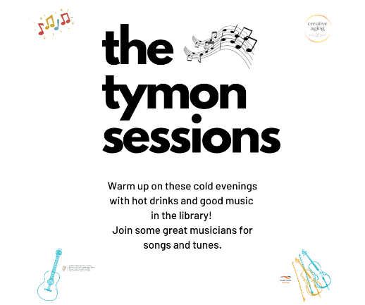**Creative Aging at Castletymon**

There has been great success with the Tymon music sessions over October, funded by Local Live programme. Part of Castletymon Library’s Creative Aging programme, specifically aimed at older adults, the sessions will continue on a regular basis due to popular demand.

Another strand of the Creative Aging programme, ukulele lessons and STEAM workshops will begin in November.

Our accessibility events continue to be well attended, with monthly STEAM events specifically catered for children with additional needs and their carers, bi-monthly sensory times and dedicated visits for local schools and centres.

**Halloween Events**

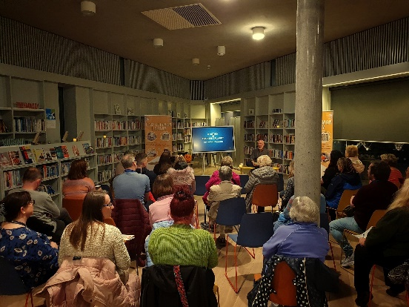**Monday 24th October 7pm History of Haunted Tallaght**

To celebrate Halloween, historian Albert Perris guided us through the terrifying, haunted history of Tallaght. This spooky talk was well attended.

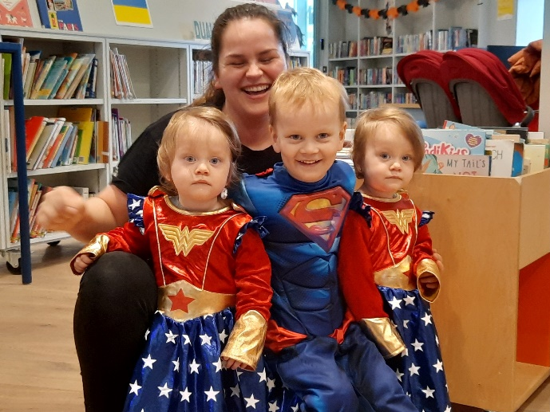

**Wed 26th Oct 3.30pm Fairly Scary Halloween Storytime and Crafts**

Halloween Stories and Crafts with Dress up. Ages 3+

**Thursday 27th Oct 2.30pm Halloween Dress Up!**

Dress up the little ones in their favourite costumes and come to the library for some Halloween fun. All welcome.

**Coming up in November at Castletymon Library**

**Early Music Classes with Music Generation**

Starting Monday 7th November.

0 - 18 mths: 10.30am - 11am

18th mths - 4 yrs: 11.15am - 11.45am

A fun-filled 6 week course for children that will get them singing, moving and having fun!

Booking is for one adult and one child.

**First Aid For Parents**

Monday 7th November @ 7pm

An introduction to first aid for parents. Learn life-saving basics with a fully trained first-aider.

Supported by the Dormant Accounts Fund as part of the ***Sorry I’m Late, I have kids*** programme.

*Booking now open:castletymonlibrary.eventbrite.ie*

**Little Lámh Storytelling**

Saturday 12th November @ 10am

Supported by the Dormant Accounts Fund as part of the ***South Dublin Celebrates Neuro Diversity*** Programme

**Story telling with Lámh, visuals and sensory props.** Suitable for young children with developmental disabilities, autism or a language delay who use Lámh, pictures or other communication systems

*Booking essential, from Tuesday, 2nd Nov @10am: castletymonlibrary.eventbrite.ie*

**Mobile Library Highlights**

On 20th October we paid our first visit to Youthreach Priory in Tallaght where the young people visited the library truck, took out membership and engaged in a drumming workshop.

