Cover Page

Our Journey Towards Vision Zero
South Dublin County Council
Road Safety Action Plan 2022 – 2024

Contents
- Forewords 3 – 5
- Our journey towards Vision Zero 6
- Introduction 7 - 11
3.1 Profile of the County
3.2 Collision Statistics
3.3 Evaluation of RSP 2016 – 2020
3.4 Targets National and Local

- Delivering our Plan 12 – 15
4.1 Strategic Approach
4.2 Safety Performance Indicators
4.3 Critical Success Factors
4.4 Role of Stakeholders
4.5 Governance
- Action Plan 16 - 22
- Monitoring and Evaluation 23
- Road Safety Working Together Group 23

- Foreword I, II, and III.
(PHOTO)
Mr Daniel McLoughlin, CEO, South Dublin County Council
South Dublin County Council is acutely aware of the importance of road safety and of concerns about safety around active travel.
Traffic flow within and through South Dublin County is extremely busy due in part to the M50 motorway, N4 and N7 within our boundary. However, due to a renewed modal shift aimed primarily at achieving sustainability and mitigation against climate change factors and healthy living, active travel including cycling, walking, scooting, and use of public transport is on the increase and we have our own active travel ambitions and targets set out in our Cycle South Dublin programme of work.
South Dublin County Council is also acutely aware of our obligations for all road users. That said, in line with our climate action obligations, there is a need to reduce the number of trips by motorised transport which will require increased focus regarding road safety for those that cycle, scoot, walk and use public transport.
In partnership with the members of the Land Use Planning & Transportation SPC, Road Safety Working Together Group (see 7, p23), established in each Local Authority, we are now positioned to take a joint approach to the safety of all road users. Applying the Safe Systems Approach (Education, Engineering, Enforcement, and Evaluation) we will strive to reduce the number of fatalities and injuries on our roads.
I am very pleased to present the South Dublin County Council Road Safety Plan 2022 – 2024 which has been prepared in collaboration with other relevant agencies including An Garda Síochána, Dublin Fire Service, Transport Infrastructure Ireland, National Transport Authority, and the Road Safety Authority, and outlines a series of national and local objectives, targets and actions
(PHOTO)
Mayor Emma Murphy
There is an increase in appetite for cycling and walking to work, college, and school. Whilst the change is slow, it is changing and very much welcomed. However, due to the suburban and rural nature of the County the mode of choice is still the car. This inevitably creates challenges for road safety within the county and for those that wish to use active travel modes as a means of transportation. Those that cycle and walk are less protected than those that drive; therefore, they require increased attention to improve the perception of safety associated with these modes.
The safety on our roads is not the responsibility of one organisation, but that of all stakeholders and road users. The Road Safety Working Together Group in South Dublin will have responsibility in overseeing the implementation of this plan and I am delighted to see commitment from various stakeholders to protecting our road users.
As Mayor of South Dublin County Council, I am proud to be involved with efforts to improve road safety within our county. I believe there is need for an increased focus in the promotion of active travel and public transportation to meet our climate and sustainability goals. I call on everyone to play their part in making this plan work and create a sustainable journey towards vision zero for South Dublin.

(PHOTO)
Sam Waide, CEO, Road Safety Authority
Ireland has made significant progress over the lifetime of previous road safety strategies. Since the launch of the first ever Road Safety Strategy in 1998, road deaths have declined by almost 70%. None of that progress could have been possible without our key stakeholders working together in a coordinated, strategic way.

This, Ireland’s fifth Road Safety Strategy, will adopt a transformational and partnership-based approach to road safety in Ireland to achieve a 50% reduction in deaths and serious injuries by 2030. Road safety is a whole-of-government issue and needs a whole-of-government response. We have seen how governments over the years have enacted measures that have made our roads safer, from the mandatory wearing of seat belts, the lowering of drink-driving limits, the introduction of penalties for dangerous behaviours, safer infrastructure and targeted enforcement. These measures have saved lives.

The 2020 Programme for Government commits to achieving ‘Vision Zero’ – i.e. no deaths or serious injuries on the roads – which we will achieve by 2050. This commitment must be matched by action, enabling funding, accountability and good governance. Critically, we need even greater partnership and collaboration to achieve the ambitious target of Vision Zero. Vision Zero in road safety is not just a catchphrase. It is a serious commitment to end all deaths and serious injuries on our roads. Vision Zero will be delivered through embedding the Safe System approach into our national road safety policy and practice.

The Safe System approach recognises that while road safety education and training can reduce the number of road collisions, human error cannot be eliminated. It aims to reduce the likelihood of a collision occurring and, if one does occur, to ensure that the road users involved will not be killed or seriously injured. The seven areas of intervention of our Safe System approach are:

1. Safe roads and roadsides
2. Safe speeds
3. Safe vehicles
4. Safe road use
5. Post-crash response
6. Safe and healthy modes
of travel
7. Safe work-related road use
These intervention areas will drive the scope of our work, and all action plans will include actions under each of these headings. By implementing these seven priority intervention areas of the Safe System approach, we are delivering international best practice. The public has a central role to play in achieving our goals.

To prevent fatalities or serious injuries on our roads, we must continue to tackle road safety strategically and collectively. It will be challenging, but it is achievable with investment and support from the highest levels of leadership to local community level.

Reducing road deaths and serious injuries by 50% over the next decade is achievable. Vision Zero by 2050 is achievable. We can do it. Given our road safety journey to date, no target is too ambitious for us. The starting point is recognising that road deaths or serious injuries should not be the price to pay for our mobility.

- Vision: the journey towards vision zero
Ireland’s road safety performance has improved significantly since the first adopted Road Safety Strategy in 1998. The last Government Road Safety Strategy (GRSS) (2013 – 2020) saw Ireland achieve its lowest number of annual road deaths since records began (137 in 2018), and the second lowest rate of road deaths in the European Union (EU) in 2019. Despite this good progress however, several challenges remain. The number of serious injuries increased during the 2013 – 2020 strategy and the target to reduce road fatalities to 124 per year by 2020 was not met, and there has been a lack of progress in reducing cyclist and pedestrian deaths. The need to protect cyclists and pedestrians is more vital as we strive to meet vital national climate action objectives in promoting a modal shift towards active travel and public transportation. Underpinning the 2021 – 2030 GRSS is Ireland’s long-term goal of achieving Vision Zero (i.e. zero road deaths or serious injuries) by 2050. Vision Zero was formally adopted in Ireland’s Programme for Government in 2020 and underpins the EU Road Safety Policy Framework (2021 – 2030).
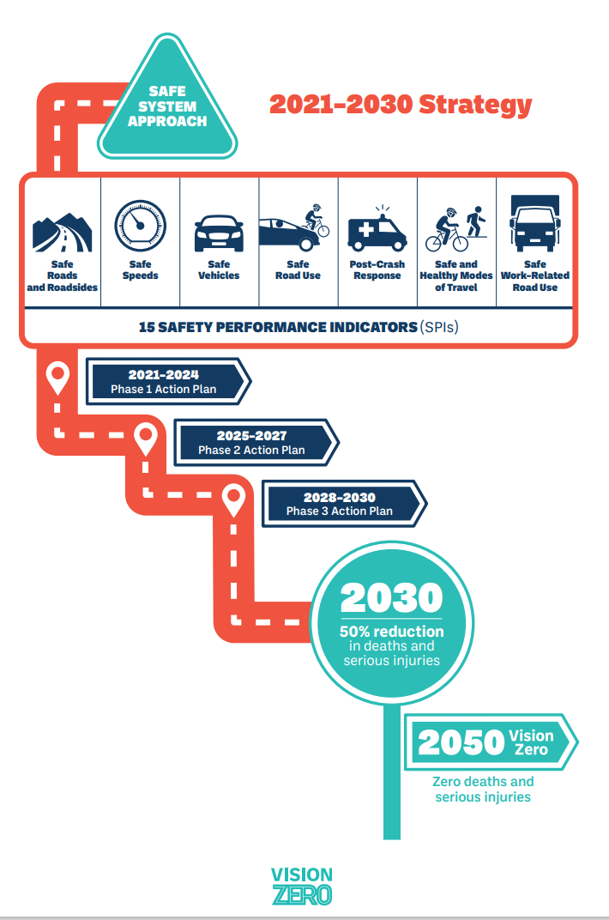

- Introduction (insert consultation)
In December 2021 the Road Safety Authority (RSA) launched Ireland’s Government Road Safety Strategy (GRSS) 2021 -2030. This fifth Road Safety Strategy is titled “Our Journey Towards Vision Zero” and it outlines the national plan for making the Irish roads network one of the safest in Europe. It sets out clear targets of reducing the number of lives lost on our roads annually to 124 and the number of people seriously injured to 330 by 2030. The GRSS is divided into three distinct phases:
- 2021 – 2024
- 2025 – 2027
- 2028 – 2030

South Dublin County Council (SDCC) support the work of the RSA and to fulfil our obligations under the GRSS we have produced this action plan 2022 -2024. It is a complementary document to the national strategy and outlines the actions that South Dublin County Council will undertake to improve the safety of our roads. This action plan aims to identify areas where we can promote and improve road safety within our County. In addition, we will create and publish annual action plans to help support our 2022 – 2024 plan. The actions presented within this plan are adapted from those actions assigned to Local Authorities within the GRSS which underwent public consultation in

SDCC recognises that while a combined national approach is required to make a noticeable and long-lasting change to our roads, Local Authorities have a responsibility to work at the local level to bring about this change. We have statutory obligations under the Roads Act 1993, but we also have a social obligation to the people of South Dublin County and all those who traverse our roads network. Creating the safest roads possible and raising awareness among road users of the risks associated with roads and promoting responsible behavior when using them, is an extremely high priority for SDCC

3.1 Profile of the County
SDCC is the administrating authority over the South West section of County Dublin. It was established in 1994 and it covers an area of 222.7 sq.km (55,030 acres). It has both urban and rural landscapes and it the Local Authority with responsibility for the suburban towns of Rathfarnham, Tallaght, Clondalkin and Lucan.
In 2016 the population of South Dublin County was 278,767 (Census, 2016) and according to the SDCC Development Plan 2022 – 2028 is expected to grow by a further 50,000 people up to 329,000 by 2030.
Recent preliminary Census 2022 data indicates that the population of South Dublin County is now at 299,793.
This growth will bring increased pressure for new homes, and employment space. The provision of sustainable transport that offers people a safe, desirable, and connected walking and cycling network is essential for the growth of South Dublin County.
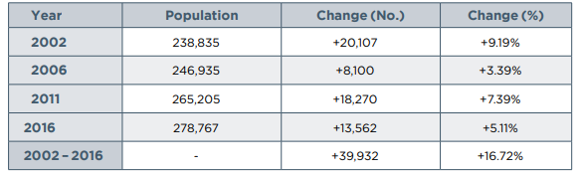
South Dublin County Population (persons) Trend 2002 - 2016, CSO

There is 15km of M50 motorway within the South Dublin area which carries the highest volumes of traffic in Ireland. The two main commuter routes into Dublin City (N4 and N7) also run through the county as well as the N81, and in addition, a characteristic of the main routes in South Dublin is that they transition from high-speed commuter roads to medium speed urban roads with the county. In South Dublin County vehicle traffic on our roads increased by approximately 11% since 2016. When current levels of traffic are coupled with increases in our future population growth, the coming years will see further increases in traffic congestion and road safety challenges.

Motorway | 15km
National Primary | 36km
National Secondary | 13km
Regional | 114km
Local | 792km
Cycle Tracks | 215km (150km segregated and 65km road markings)
Footpaths | 1,500km

The transition towards more active travel modes and public transport usage is important if we are to meet our climate action objectives and sustainability goals. The number of private motor vehicle trips will need to reduce if we are to reduce our dependence on carbon-based transport and to improve road safety. In addition, our Cycle South Dublin programme of works aims for South Dublin to become one of Ireland’s most cycle friendly counties by improving the perception of safety with cycling and walking to make it an appealing mode of transport. Within the county exists 215 km of cycle tracks and 1500km of footpaths. In addition, South Dublin is also well served by rail with stations at Adamstown, Clondalkin Fonthill, Kishogue which is due to open in 2023, and Luas which has two termination points, Tallaght and Saggart, and multiple Park and Ride facilities serving the local and wider community.

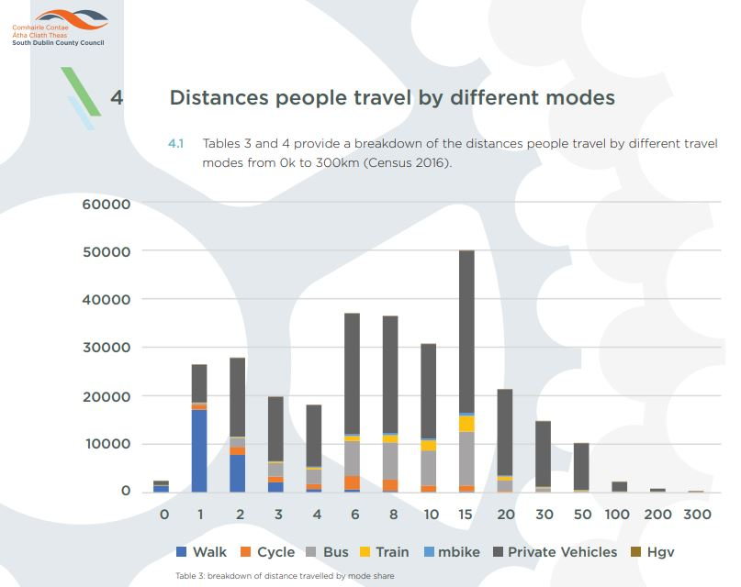

  - Collision Statistics
The collision statistics in table 1 below outline the most recent data and trends for South Dublin County Council in relation to the 4 Dublin LA’s. As can be seen from the tables there has been an upward trend on fatalities from 2016 (4) to 2021 (6). Whilst the incidence of fatalities is below the national average the trajectory is going the wrong direction if we are to realise our vision zero by 2050. In addition, table x outlines the fatalities by mode of travel. Whilst the number of fatalities is below average, within South Dublin it can be seen car users have experienced the highest number of fatalities. However, it can be said, that those that cycle, walk or use a motorcycle are disproportionally affected within the data as not as many use these modes compared to a car.
 |  | 2016 |  | 2017 |  | 2018 |  | 2019 |  | 2020 |  | 2021
 | Population 2016 | Fatalities (count) | Fatalities (per 100,000) | Fatalities (count) | Fatalities (per 100,000) | Fatalities (count) | Fatalities (per 100,000) | Fatalities (count) | Fatalities (per 100,000) | Fatalities (count) | Fatalities (per 100,000) | Fatalities (count) | Fatalities (per 100,000)
Dublin County | 1,347,359 | 21 | 1.6 | 24 | 1.8 | 14 | 1.0 | 19 | 1.4 | 20 | 1.5 | 21 | 1.6
SDCC | 278,767 | 4 | 1.4 | 7 | 2.5 | 3 | 1.1 | 4 | 1.4 | 5 | 1.8 | 6 | 2.2
Table 1: showing SDCC collision figures per 100,000 in comparison with those for the Dublin County.

2016 |  | 2017 |  | 2018 |  | 2019 |  | 2020 |  | 2021
Fatal Collisions | Fatalities | Fatal Collisions | Fatalities | Fatal Collisions | Fatalities | Fatal Collisions | Fatalities | Fatal Collisions | Fatalities | Fatal Collisions | Fatalities
21 | 21 | 24 | 24 | 14 | 14 | 17 | 19 | 20 | 20 | 19 | 21
4 | 4 | 7 | 7 | 3 | 3 | 3 | 4 | 5 | 5 | 4 | 6
Table 2: the number of fatal collisions and fatalities for the South Dublin County.

Fatalities by road user | 2016 | 2017 | 2018 | 2019 | 2020 | 2021
Pedestrian | 1 | 2 | 1 | 0 | 1 | 0
Pedal Cycle Users | 0 | 3 | 0 | 0 | 0 | 2
Motorcycle Users | 1 | 0 | 1 | 1 | 0 | 1
Car Users | 1 | 2 | 1 | 3 | 4 | 3
Goods Vehicle Users | 0 | 0 | 0 | 0 | 0 | 0
PSV Users | 0 | 0 | 0 | 0 | 0 | 0
Other | 1 | 0 | 0 | 0 | 0 | 0
Totals | 4 | 7 | 3 | 4 | 5 | 6
Table 3: the number of fatalities for South Dublin County by mode of travel.
Table 4 below outlines the number of Serious Injuries which occurred from 2016 – 2020. There has been an increase in the number of serious injuries from 2016 (38) to 2020 (47), as above the trajectory on serious injuries is going the wrong way within South Dublin. It is not known by what mode these injuries occurred and therefore an assessment or comment cannot be made.
 | 2016 |  | 2017 |  | 2018 |  | 2019 |  | 2020
 | Serious Injury Collisions | Serious Injuries | Serious Injury Collisions | Serious Injuries | Serious Injury Collisions | Serious Injuries | Serious Injury Collisions | Serious Injuries | Serious Injury Collisions | Serious Injuries
Dublin County | 240 | 247 | 306 | 326 | 367 | 379 | 424 | 435 | 328 | 352
South Dublin County Council | 37 | 38 | 45 | 47 | 50 | 52 | 49 | 50 | 44 | 47
Table 4: showing the number of serious injury collisions and serious injuries within South Dublin County compared to Dublin County.

3.3 Evaluation of Previous Road Safety Plan
South Dublin County Council’s first Road Safety Plan “A Safer Community” covered the period 2016 – 2020 and included 44 actions across Education, Engineering, Enforcement and Evaluation. A summary overview of the key actions is outlined below:
- Support and delivery of Cycle Right training at 122 primary schools for 6320 pupils,
- Delivery of a pilot adult Cycle Right initiative with Go-Ahead Ireland employees,
- 32 schools within the County received their Green Flag for Travel or Global Citizenship Travel as part of the Green-Schools Programme,
- 30 km/h as the default speed limit in all residential estates that are in charge,
- 20 X 30 km/h periodic speed limits,
- Cycle tracks is currently at 215 km
- Footpaths increased from 1264 km to 1500 km

3.4 Targets
This section looks at targets for the 2021 – 2024 Government Road Safety Strategy (GRSS) and the SDCC Road Safety Plan 2022 – 2024.
National Targets
The period 2017 – 2019 was used as the baseline for the setting of targets in the GRSS. The targets within the national strategy are:
15% reduction in fatalities by 2024 (End pf phase I)
10% reduction in serious injuries by 2024 (end of Phase I)
50% reduction in fatalities by 2030
50% reduction in serious injuries by 2030

Local Targets
The rates for local targets have been informed by the Road Safety Authority and South Dublin County Council has set the following targets for Killed or Seriously Injured (KSI) as part of this plan.
2024 the target will be to reduce KSI by 10%, and
2030 the target will be to reduce KSI by 50%.

- Delivering our plan
4.1 Strategic Approach
The Safe System approach is based on four principles:
- People make mistakes when using the roads, which can lead to collisions.
- The human body has a limited ability to tolerate collision impacts.
- There is a shared responsibility amongst those who design, build, manage and use the roads and vehicles to prevent or reduce collision impacts, and those who provide post-crash response to mitigate injury.
- All parts of the traffic system need to be strengthened to multiply their effects and to ensure that road users are protected if one part of the system fails.
The Safe System approach has been internationally recognised by key organisations as the optimal, best-practice approach to achieve ambitious reductions in road user fatalities and serious injuries. It recognises that while death and serious injury can be prevented through strengthening the traffic system, we can never eliminate road traffic collisions because there will always be a degree of human error contributing to this. International research has demonstrated that a large proportion of road traffic collisions arise due to error of perception or judgement by otherwise compliant road users.
When collisions do occur, the human body is inherently vulnerable to death or injury. Considering this we need to manage our infrastructure, vehicles, and speeds to reduce collision impacts to survivable levels. We need to provide efficient emergency medical response and trauma care to reduce injury consequences, and we need to continue to assist road users in complying with road safety legislation and sharing the roads safely. This is the essence of the proactive Safe System approach. Fully embracing and embedding a Safe System approach across all components and partners of the traffic system will allow us to transform our policy and practice beyond traditional road safety interventions and help achieve greater reductions in fatalities and serious injuries than before. This will also include aligning with key international road safety policies, such as the Stockholm Declaration (Road Safety Sweden, 2020).
By implementing the following seven priority intervention areas of the Safe System approach, we are delivering international best practice:

- Safe roads and roadsides involve the planning, design and operation of roads and roadsides and provides the framework for safe road and vehicle use.
- Safe speeds are a central element of the Safe System approach. It involves consideration of road and vehicle planning and design, the setting of injury-minimising speed limits, as well as public education and awareness, and the enforcement of these limits.
- Safe vehicles is an element of the Safe Systems approach which addresses the safety of road users both inside and outside the vehicle through legislative standards, consumer information, public procurement and industry initiatives.
- Safe road use incorporates a wide range of safety behaviours such as compliance with the posted speed limit, driving without impairment (due to alcohol, drugs, fatigue, or distraction), helmet wearing, seatbelt wearing and correct use of child restraints.
- Post-crash response concerns the rescue, treatment, and rehabilitation of survivors of road traffic collisions and aims to reduce the severity and consequence of injuries in the event of a collision.
- Safe and healthy modes of travel acknowledges that there is a substantial difference in fatal and serious injury risks across different modes of travel.
- Safe work-related road use involves the planned, systematic safety management of work journeys on the roads, aiming to reduce the risk of death and serious injury.
There are a total of 186 actions in the GRSS Phase 1 Action Plan, and the South Dublin County Council action plan will include 32 (tbc) actions which are linked to the GRSS. In addition, we will develop further yearly action plans that will help guide the implementation of our 2022 – 2024 plan.

  - Safety Performance Indicators (SPIs)
South Dublin County Council will use the following measures to monitor road safety performance.
- Delivery of Cycle Right training to primary school children within the County,
- Increase the number of cycle totems and monitoring,
- Cycling parking installations,
- KM’s of cycling and walking infrastructure installed,
- Use of Speed Display Signs to monitor speed limit compliance,
- Improved junction safety/redesign of junction,
- Speed limit review to commence in 2023,
- HGV mobility policy review,
- School Crossings Reviews and safety measures implemented outside schools,
- Continuing collaboration with SDCC RSWTG on a quarterly basis in oversight of the strategic aspects of the Council’s Road Safety Strategy and Plan.
- Continuing liaison with ASG in the analysis of collision data

4.3 Critical Success Factors
The factors outlined below have been identified from the GRSS as being critical in ensuring that this strategy meets its full potential.
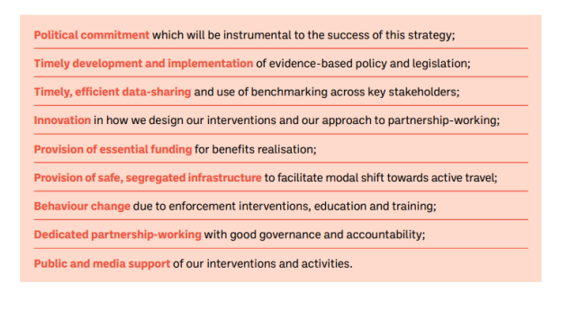

4.4 Role of Stakeholders – a shared responsibility
The following provides a description of the key stakeholders who will play a role overseeing the implementation of the Council’s Road Safety Strategy.

South Dublin County Council
South Dublin County Council (SDCC) is responsible for the construction and maintenance of public roads and the provision of a safe and efficient road network within the County. This involves ensuring safety is a key consideration in the planning; design; construction; and maintenance of roads;, and the Council also has an important role in road safety education and awareness raising across the County.

Transport Infrastructure Ireland (TII)
TII's purpose is to provide sustainable transport infrastructure and services, delivering a better quality of life, supporting economic growth, and respecting the environment.
It’s primary function under the Roads Act 1993, is ‘to secure the provision of a safe and efficient network of national roads.’ For this purpose, it has overall responsibility for planning and supervision of construction and maintenance works on these national roads within South Dublin County.
National Transport Authority (NTA)

The National Transport Authority is tasked with improving the national transport network and in creating provision for sustainable transport measures. Within the Greater Dublin Area the NTA has responsibility for the strategic planning of transport and the effective management of traffic and transport demand.

An Garda Síochána(AGS)
This mission statement of An Garda Síochána is to “Keep People Safe.” This includes several strategic goals relative to road safety aiming to significantly reduce the incidence of fatal and serious injuries and improve road safety.

Dublin Fire Service
The purpose of the Fire Service is to respond quickly and efficiently to fires and other emergencies, including road traffic incidents, throughout the County. This response consists of pre-determined turnout of appliances and equipment based on the nature, magnitude, and severity of the incident.
Road Safety Authority (RSA)
The RSA mission is to make Irish roads safer for everyone. That means working in every way possible to save lives and prevent injuries by helping to reduce the number and severity of collisions on Irish roads.

The RSA is recognised as the leading voice for road safety in Ireland and as a leading voice internationally. This recognition is built upon a strong record of driving positive change in the attitudes and behaviours of all road users, while effectively collaborating with many stakeholders, such as An Garda Síochána and the Health and Safety Authority, to save lives.

  - Governance Model
The GRSS will be subject to a cross-governmental governance structure, overseen by a ministerial committee on road safety, to review implementation of the 2021 – 2030 strategy. The County and City Management Association (CCMA) will be required to participate in the monitoring structure of the GRSS and contribute quarterly local updates for consideration at a national level. Key to this reporting is the development of the Road Safety Working Together Group (Action 94) and the development, implementation, and monitoring of the SDCC Road Safety Plan (Action 95). South Dublin County Council will support the CCMA in this regard.

- Action Plan
High Impact Actions – lead agency
Pillar | Link to GRSS | Action | Lead Department or Agency | Responsibility | Due Date | Support Department or Agency | Original Completion Date
Safe Roads and Roadsides | 4 | Implement low-cost safety schemes as identified on the regional and local road network. | SDCC | CEO/DOS | Annual | DTTAS/NTA | Annually
Safe Roads and Roadsides | 5 | Deliver segregated walking and cycling facilities as part of Cycle South Dublin to provide safe cycling and walking arrangements for users of all ages. | SDCC | CEO/DOS | Q4 2024 | DTTAS/NTA | 2021 to 2024 inclusive.

High Impact Actions – support agency

Pillar | Link to GRSS | Action | Lead Department or Agency | Responsibility | Due Date | Support Department or Agency | Original Completion Date
Safe Roads and Roadsides | 2 | Support the delivery of road safety improvement schemes and minor realignment schemes on national roads, to create forgiving roadsides, self-explaining roads, and a safe environment for vulnerable road users. | TII | CEO | Annual | SDCC | Annually
Safe Speeds | 6 | During 2022 – 2024 undertake a speed limit review for the County. As part of this review there will be a specific consideration of the introduction of a 30kph default speed limit in urban areas. | DOT | CEO | Q4 2024 | SDCC | 2024
Safe Speeds | 8 | In collaboration with An Garda Síochána, at appropriate high-risk locations, expand speed management measures to include periodic speed limits and Speed Display Signs. | TII/NTA/AGS | DoT Principal, CEO TII, CEO NTA | Q4 2024 | SDCC | 2024
Safe Road Use | 22 | Promote the Government Road Safety Strategy and the Council’s Road Safety Plan amongst stakeholders and the public. | RSA/SDCC | Director - Road Safety, Research & Driver Education | Q1 2022 | DTTAS/NTA/AGS | Annually
Safe and Healthy Modes of Travel | 39 | Support a National Cycle Network plan for interurban rural cycling and walking, providing connections to active travel networks and Greenways. | TII/NTA | CEO | Q4 2022 | SDCC | Evaluation
Safe and Healthy Modes of Travel | 40 | Continue to avail of the active travel infrastructure scheme to apply for funding to develop improved active travel infrastructure within the County. | DTTAS | Principal | Q3 2021 | SDCC | 2021
Safe and Healthy Modes of Travel | 42 | Promote and support the Cycle Right training programme which includes online theory and practical skills for children and adults. | DTTAS / Cycling Ireland | DoT Principal, CEO Cycling Ireland | Annual | SDCC, RSA, An Taisce Green-Schools | 2024

Support Actions – lead agency

Pillar | Action No. | Actions | Lead Department or Agency | Responsibility | Due Date | Support Department or Agency | Action Number
Safe Roads and Roadsides | 58 | Undertake the Heavy Good Vehicle (HGV) mobility policy review for the County. | SDCC | CEO | 2024 |  | Evaluation
Safe Roads and Roadsides | 61 | Continue to complete LA 16 Collision Reporting and Evaluation Procedure forms where a fatality, or collision that is likely to become fatal, has occurred. | AGS and SDCC | Commissioner of An Garda Síochána, CEO | Q4 2024 | TII, DoT | Evaluation
Safe Roads and Roadsides | 68 | Publish/renew the Council’s prioritised plan on road construction and maintenance (including footpaths and cycle lanes) on an annual basis. | SDCC | CEO | Annual | DoT | Infrastructure
Safe Roads and Roadsides | 69 | To continue with the upgrade of public lighting to appropriate standards using LED lighting to improve visibility and enhance safety for road users. | SDCC | CEO | Ongoing to Q4 2026 | DoT | Infrastructure
Safe Speeds | 78 | As part of the speed limit review explore, where feasible, implementation of additional 30kmh speed limit zones in high-risk locations (urban centres) to protect Vulnerable Road Users in line with best practice models. | SDCC | CEO | Annual | DoT | Infrastructure
Safe Speeds | 79 | Examine the feasibility of 30kmh speed limit or lower in school vicinities and to report on progress. | SDCC | CEO | Annual | DoT | Infrastructure
Safe Road Use | 94 | To maintain the Road Safety Working Together Group (RSWTG) to co-ordinate multi-agency road safety policy and implementation at a local level. | SDCC | CEO | Q4 2021 | RSA/TII/AGS/DFS/AGS | Strategy Governance
Safe Road Use | 95 | The Council to publish a multi-agency Road Safety Annual Action Plan and to publish an annual review on progress with implementation. | SDCC | CEO | Annual | RSA, AGS, TII, | Strategy Governance
Safe and Healthy Modes of Travel | 177 | Support the Safe Routes to Schools Programme to provide “front-of-school” treatments schools. | SDCC | CEO | Q4 2024 | NTA/An Taisce | Infrastructure

Support Actions – support agency
Pillar | Action No. | Actions | Lead Department or Agency | Responsibility | Due Date | Support Department or Agency | Action Number
Safe Roads and Roadsides | 55 | Support the implementation of the National Cycle Manual within cycle scheme design guidance aligned with the safe system approach and to include appropriate training. | DTTAS/NTA | DoT Principal, CEO NTA | Q2 2022 | SDCC | Evaluation
Safe Roads and Roadsides | 56 | Support the review and recommendations on facilitating cyclists and pedestrians at junctions, including measures that do not require powered traffic signals. | DTTAS/NTA | Principal | Q4 2022 | SDCC | Evaluation
Safe Roads and Roadsides | 64 | To avail of training for designers, project managers, engineers and local authorities on the delivery of safe designs based on the Design Manual for Urban Roads and Streets (DMURS) and the National Cycle Manual (NCM). | Department of Transport | Principal | Q4 2022 | TII, NTA, CCMA / LA's | Education
Safe Roads and Roadsides | 66 | Partake in TII training:  • to provide guidance to An Garda Síochána and Local Authority staff on collision analysis and reporting from an engineering perspective  • to provide guidance on the design of roads utilising the safe system approach | Transport Infrastructure Ireland | CEO | Q4 2024 | AGS, CCMA / LA's | Education
Safe Roads and Roadsides | 71 | As part of Bus Connnects support the improvement of bus stop locations annually on the National Road Network in line with a Safe System approach. | Transport Infrastructure Ireland | CEO | Q4 2024 | SDCC | Infrastructure
Safe Roads and Roadsides | 72 | As part of Bus Connects at appropriate locations improve visibility, lighting and age-friendly seating at regional and local bus stops to enhance safety for those waiting for a bus. | National Transport Authority, | CEO NTA, CEO Bus Éireann | Q4 2024 | SDCC | Infrastructure
Safe Speeds | 76 | Deliver and support education and awareness interventions to raise awareness of the benefits of and build community support for 30kmh zones in urban areas. | Road Safety Authority | Director - Road Safety, Research & Driver Education | Annual | CCMA / LA's | Communications
Safe Road Use | 133 | Deliver and support educational measures aimed at protecting vulnerable road users. | Road Safety Authority | Director - Road Safety, Research & Driver Education | Annual | HSA, CCMA / LA's, AGS, Bus Éireann | Education
Safe Road Use | 137 | Deliver and support road safety campaigns targeting drivers to highlight the risks faced by Vulnerable Road Workers (School Wardens, Emergency Service Personnel, Construction workers etc). | Road Safety Authority | Director - Road Safety, Research & Driver Education | Q2 2023 | AGS, Fire Service, HSA, CCMA / LA's, TII | Education

- Monitoring and Evaluation
South Dublin County Council is responsible for leading, monitoring, reporting and evaluating the implementation of our Road Safety Plan through the *Road Safety Working Together Group. This will require a collaborative approach across a range of organisations and agencies. South Dublin County Council will produce yearly action plans that reflects this three year strategy . The Road Safety Working Together Group will meet on a quarterly basis to oversee the implementation of the annual plan to ensure we remain on track to meet our actions. In addition, an evaluation report of the respective years plan will be presented at the Land Use Planning and Transportation Strategic Policy Committee and to Council. In addition, quarterly updates will be provided to the CMMA, as and when required, which will support the implementation of the GRSS.

* RSWTG Membership
South Dublin County Council operates a Road Safety Working Together Group (RSWTG) that meets on a quarterly basis. The role of the RSWTG is to oversee the strategic aspects of the Council’s Road Safety Strategy and Plan. Current members of the RSWTG include:
- An Garda Síochána
- Dublin Ambulance and Fire Service
- Transport Infrastructure Ireland (TII)
- An Taisce Green-Schools
- Road Safety Authority
- Dublin Cycling Campaign

