Update on Part 8 for St Cuthberts Park

PROPOSED UPGRADE OF ST CUTHBERT’S PARK, IN THE TOWNLANDS OF KILMAHUDDRICK AND DEANSRATH, DUBLIN 22
Persons wishing to inspect drawings and particulars of the proposed development can do so as follows between the period from 20th September 2022 to 2nd November 2022.
IN PERSON: Plans and particulars of the proposed development will be available for inspection or purchase at a fee not exceeding the reasonable cost of making a copy, at County Hall, Tallaght, Dublin 24 during office hours from 20th September 2022 to 2nd November 2022.
ONLINE: https://consult.sdublincoco.ie/browse from 20th September 2022 to 2nd November 2022 at 5.00pm.
Submissions and observations with respect to the proposed development dealing with the proper planning and sustainable development of the area in which the proposed development will be situated, may be made in writing up to 5.00pm on the 2nd November 2022 and may be submitted:
Online: https://consult.sdublincoco.ie/browse
Or
Post to: Senior Executive Officer, Environment Water and Climate Change Department, South Dublin County Council, County Hall, Tallaght, Dublin 24 YNN5.
NOTE: Please make your submission by one medium only. All submissions should include your name and a contact address. It should be noted that the Freedom of Information Act, 1997-2006 (as amended) applies to all records held by South Dublin County Council.
Director, Environment Water and Climate Change Department, South Dublin County Council, County Hall, Tallaght, Dublin 24.

Please Note: A set of the Part 8 drawings and reports have been made available for viewing, on an informal basis, at Clondalkin Civic Offices and Bawnogue Community Centre, Clondalkin.

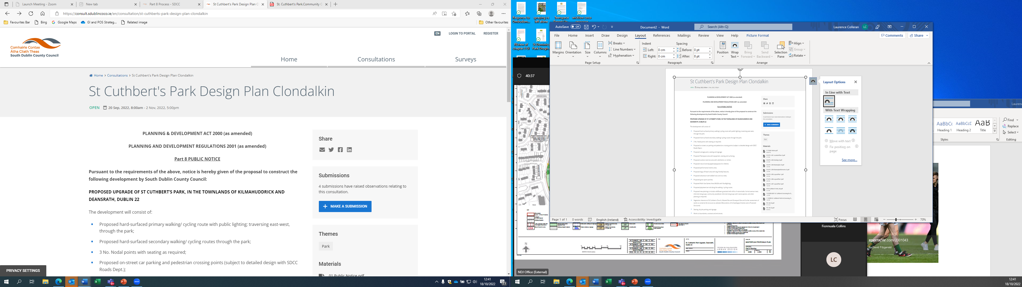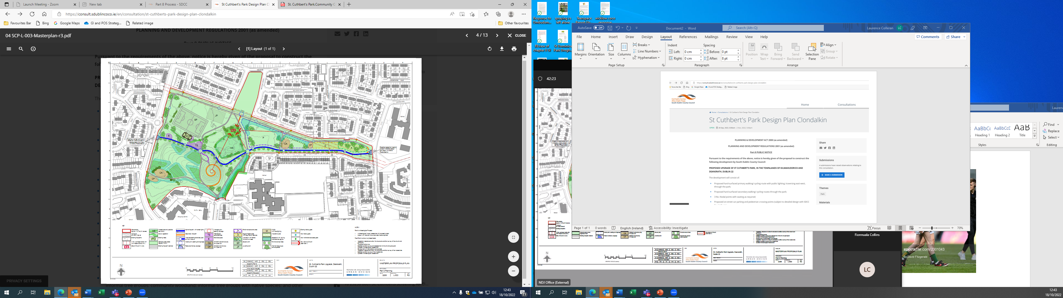
All Plans and details on display as part of formal consultation process.

