***ACM: October Highlights @ NCL:***

Overall, there were 671 events held across the library branch network in October. 656 in person and 15 online. NCL held 142 events with 2 online.

**Partnership with other organisations: Rowlagh Health Fair**

**Communiversity (SDCP and Maynooth University) Tues 11th October**

**Mondays at 10pm in the library**



15 attend regularly. Rowlagh Community Centre

**Red Line Festival in NCL**

The Red Line Festival ran from October 13-16th with over 40 events in fascinating performance venues including Rathfarnham Castle, Pearse Museum and Baldonnel Aerodrome as well as the Civic and branch libraries across South Dublin. This year’s festival expanded beyond the book to incorporate, sport, music theatre. Two events were held in NCL:

**Give Us The Night Bake Theatre**

Thurs 13th Oct Saturday 15th Oct



**ACM Highlights - Lucan Library – October 2022**

**Class Visits, throughout the month**

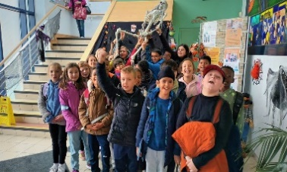 Lucan library is pleased to welcome a record number of both first-time and repeat class visits throughout the month of October. With a warm and informative welcome provided by library staff, primary and secondary school borrowers are encouraged to make use of all that library membership provides.

**RedLine Festival at Lucan Library**

Lucan Library offers a range of RedLine festival events in branch:

**Mon 10 Oct 7pm: The Ghost Stories of MR James – Lucan Library Group Read**. Join us for a group chat focussing on these classic tales of terror and mystery.

**Thurs 13 Oct 7pm: Tales from the Fraud Squad – Willie O’Dea in conversation with Seoirse Dunbar**. Former Garda, Willie O’Dea, offers insight into his years on the frontline with the Fraud Squad. Booking via RedLine Festival website.

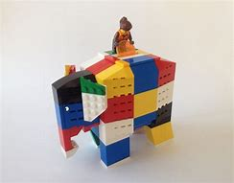**Sat 15 Oct, 10: 30 to 14:00: I Love Lego Family Workshops** – creative fun for all the family in these book-themed workshops. Booking via RedLine Festival website.

**Community Events at Lucan Library**

**Connect Cafe – Tuesday 11th October 11am**

Marking World Mental Health Month, Lucan Library is pleased to host a Connect Café, offering a chat, a coffee and a chance to connect with others from the local community.

The goal of a Connect Cafe is to open conversations and to strengthen the connection with ourselves, with others and with our communities, keeping the library at the heart of it all!

**Palmerstown Hub**

**Hallowe'en Special Storytime!**

Wednesday 26th October, 2.45pm and 6.45pm.

For 3-5 year olds. Come dressed in your costume!

All welcome.

**Hallowe'en LED cards Workshop**

Wednesday 26th October, 3.15pm OR Thursday 27th October, 3.15pm

Make a unique scary card which lights up! For 9-12 year olds

Identical workshops, book one only via Eventbrite

**Libraries Report | Mobile Libraries | October 2022**

The Mobile Library’s visitor numbers are still increasing, and September was our busiest month to date at our public stops.  We resumed our schools service and visited 12 primary school in September.  We had our second Ukrainian Outreach event at the Citywest Hotel on 22nd September.  Our Library@Home Service continues to serve isolated members of the community with 111 home deliveries made in September.  Please see below for full list of stops planned for October.

