**Clondalkin ACM**

**Libraries Report | Clondalkin Library | October 2022**

Throughout September Clondalkin Library issued 3852 items and 263 new members were registered.

A total of 58 events were hosted by the library throughout the month.

**Events for October**

For children, it was a busy time with our festivals including Children’s Book Festival visits from authors Lauren O’Hara, Flora Dealargy & Padraig Kenny.  As part of this year’s Red Line, we were delighted to welcome back Moon & Sixpence Puppet Theatre who presented their much-loved Red Riding Hood, over 40 children booked into each session.

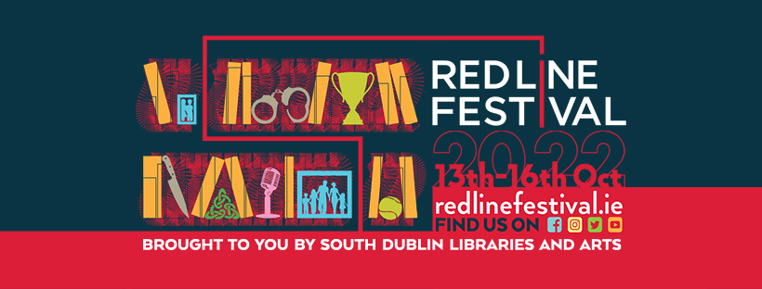

As part of our Halloween festivities, we have a host of activities starting 19th October including a Spooky Interactive Storytime with Simone Schuemmelfeder in Clondalkin Round Tower, a self-led Halloween trail around Clondalkin Village, spooky storytelling by candlelight, a guided ghouls and ghosts history walk around Clondalkin Village for families, a pumpkin carving competition, Halloween craft packs and much more.

**Events for Adults**

For adults, we ran a month-long course, Introduction to Writing Prose with acclaimed author Tanya Farrelly and as part of Red Line Festival, we had a one-off workshop Do You Have a Story In You? The second of our monthly history took place with a hybrid talk by Liz Gillis on The Red Cow Murders, this talk was extremely successful with over 150 participants online and over 30 in attendance in person.

We have also linked in with Friends of the Elderly and have started hosting coffee and line dancing mornings, the last morning was very successful with all the participants joining the Line Dancing.

**Events for November**

As part of our ongoing programmes for adults we are starting a 5-week Ukulele for beginners' course on Fri 4th November and computers classes for beginners on 7th Nov in conjunction with DDLETB. We will also host several talks including a talk by author Michael Kelly on his new book The G.I.Y diaries on 1st November and a history talk by Monica McGill on Where There's a Will about the Caldbeck family in Clondalkin on 3rd Nov. We also have our ongoing monthly clubs inc. geneaology club/book club/ G.I.Y club.

To mark **International Men's Day on Sat 19th November** we will have a full day packed with local groups demonstrating their crafts etc. This will be an open day for anyone to drop in and enjoy the demonstrations.

Our children's events include an Eccentric energy show on 3rd Nov and break the Ice challenge on 17th Nov as part of our Season of Science programme. Juliette Saumande will host two workshops to cater for 3-6yrs and 8-12 years on exploring the sense of touch and tactile books and exploring the world through sounds respectively. Finally, we will have a decade of Centenaries stamp design workshop for schools to celebrate the first Irish stamp being designed to mark the creation of the Irish Free state.

We also continue have weekly story times and host baby and toddler mornings every Tuesday and alternating weekends, as well as our monthly STEAM activities, junior book club and TTRS three days a week. As part of our ongoing weekly schools programme, we have school visits most weekdays.

**Libraries Report | Mobile Libraries | October 2022**

The Mobile Library’s visitor numbers are still increasing, and September was our busiest month to date at our public stops.  We resumed our schools service and visited 12 primary school in September.  We had our second Ukrainian Outreach event at the Citywest Hotel on 22nd September.  Our Library@Home Service continues to serve isolated members of the community with 111 home deliveries made in September.  Please see below for full list of stops planned for October.

