September ACM

**ACM Highlights: Lucan, NCL & Palmerstown Hub:**

There were 138 Mobiles outreach events in August with an attendance of 563.

Overall, there were **460** events in August with an attendance of **5941**

There were **452 in-person** events with an attendance of **5792**.

There were **8 online events** with an attendance of **149**.

There are 548 events noted for September, 540 are in-person with 8 online highlights.

**ACM Highlights - Lucan Library - September 2022**

**Summer Stars Finale Event, Saturday 3rd September 10.30am-12.30pm**

Over 1,000 children signed up to the Summer Stars Reading Programme at Lucan Library this summer, our highest number ever. To celebrate all the wonderful reading over the summer we had professional face painters Saturday morning while children came to collect their Certificate of Achievement. The prize draw for a voucher for Smyths Toy Stores, streamed live on Facebook, was won by a very happy Grace.

**Culture Night at Lucan Library, Friday 23rd September**

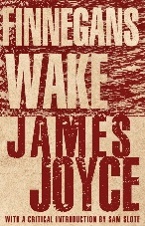Lucan Library celebrates Culture Night with online and in-person events:

**4pm – 6pm: Online Workshop: Tackling Finnegan’s Wake for the Absolute Beginner**. The facilitator, Roslyn Hickey, will share her experience of reading Finnegans Wake, make suggestions on how to approach the text and provide a list of resources and support material which she has found useful. Booking essential via Lucan Library Eventbrite

**5.30pm – 6.15pm:** **Family Music Fun at the Library** – fun for all the family in this music workshop. Book via Lucan Library Eventbrite

**Community Well Being Workshop – Monday 19th September 6pm**

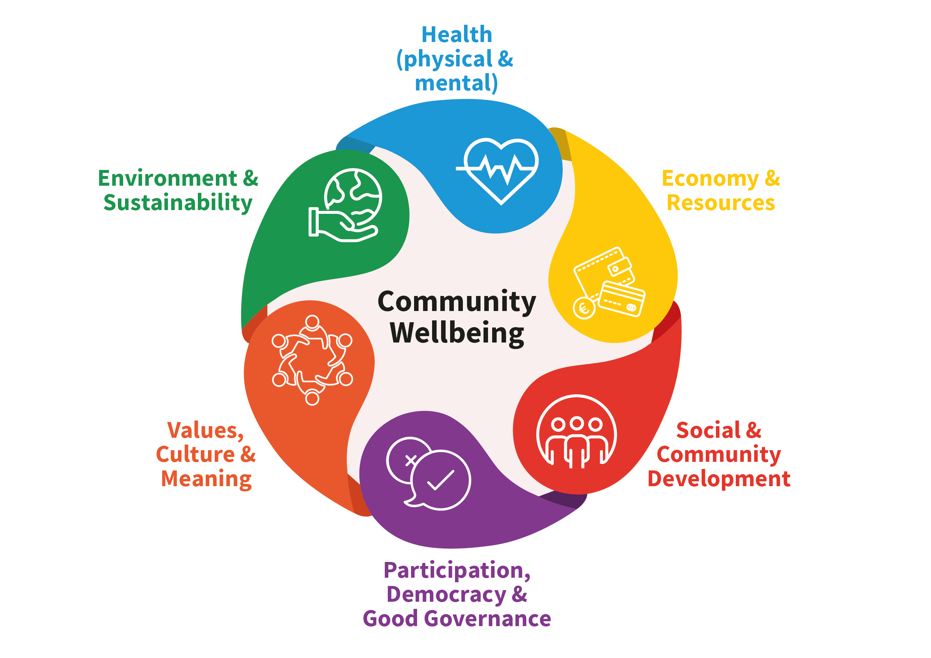South Dublin County Public Participation Network are inviting all members of the community to have their say in the Community Well-Being Statement.

Considering all the aspects of community wellbeing together will help to identify the actions that can be undertaken by communities alongside local and national government. This workshop is an excellent opportunity for everyone to contribute to improving the quality of life in the Lucan Community. All Welcome!

**North Clondalkin Library: September Highlights**

**Projects:**

**Literacy Project: Rowlagh Reads Roddy –**

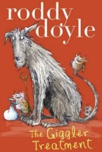 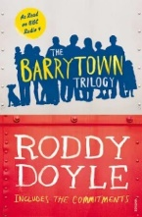 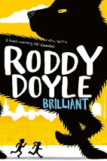

2 primary schools and one secondary school will take part in this literacy project. Participating classes will follow up with a variety of workshops and events in NCL, culminating in an “in conversation” with Roddy Doyle himself later in 2022.

**Voices from Ukraine: DAF funded Project:**

**Voices from Ukraine** is an artistic strategy to make the Ukrainian story “visible and heard”.

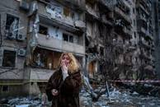Through interviews /podcasts and photographs, newly arrived refugees from Ukraine will be empowered to tell their inspirational stories of heartbreak, loss, strength and courage-providing a remarkable portrait of their journey to Ireland and how they have been received. The goal is to create an exhibition of stories and portraits which will go on display in NCL and be exhibited on Humans of Dublin website.

**Culture Night**: **Friday 23rd September**

**5pm: Street art workshop for teens**

NCL is delighted to provide the opportunity for young people to collaborate with local artist Jess Tobin (aka Novice Jess) on a wall piece through the medium of spray paint. Inspired by the work of Vincent Van Gogh. The finished art piece will be on display in NCL for all to visit.

**7pm: Live from the Library: Music and Spoken Word**

Join us in NCL for live music by local artists – a mixture of traditional folk and more modern covers there’ll be something for everyone to enjoy. The music will be accompanied by spoken word performances.

**Support for Senior Cycle Students Autumn Programme :** Secondary school programme

A programme aimed at supporting students , parents & teachers - covering exam subjects, climate change, music, comic festival and much, much more.



**New Podcast on the History of Corkagh Demense**

**Corkagh - The Life and Times of a South Dublin Demesne is a new podcast by Turtle Bunbury, commissioned by South Dublin County Libraries. This project is supported by the Heritage Council under the Heritage Stewardship Fund 2022. A teaser episode was released for Heritage Week and is available at** [**https://soundcloud.com/sdl-local-studies**](https://soundcloud.com/sdl-local-studies)

**The full podcast will be released on all the usual platforms in late September.**

**Palmerstown Hub: Highlights**

**Change in opening Hours:**

**Paper Pots, Plant Tree Seeds**

Thursday 15th September from 3.30pm & 4.15pm. Make pots with newspaper, fill them with compost and plant seeds of a small native tree to grow on at home. For children ages 8-12. Part of Dublin Climate Action Week 2022.

**Weaving Workshop**

Wednesday 21st September from 11.30am. Learn about Irish weaving traditions from Margaret Goulding & make your own piece to take home. (For adults)

**Red Line Festival 2022**

The Red Line Festival is a celebration of all things literary; be it spoken, written, sung, played, illustrated, or even just thought!

We are really looking forward to welcoming you all back to South Dublin County for another Red Line Festival. 2022 provides a programme of events and workshops aimed at attracting people of all ages and interests.

To see the full programme visit [www.redlinefestival.ie](http://www.redlinefestival.ie)

**Libraries Report | Mobile Libraries | September 2022**

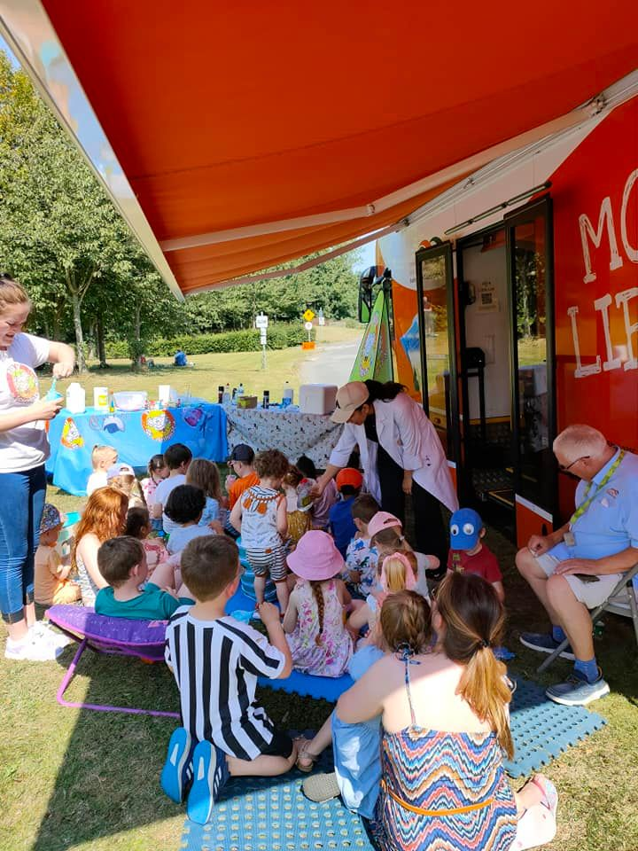

As you can see from the schedule below it was a jam-packed Summer for the mobile libraries. There were 146 Mobiles outreach events in July with an attendance of 1205. Schools were closed so events included Library@Home, hospitals, Baldonnel airport family day, Corcagh and Tymon Park family fun days and urban picnic, Deis schools summer camps, St Mark’s GAA Springfield Tallaght Youth Mental Health initiative family day, creche visits and drops.

Family Park Days

Tymon Park-   Wednesday 13th July -family fun

                           Wednesday 20th July – Waffles The  Wonderful

Corcagh Park - Thursday 14th July -family fun

                           Thursday 21st July – Trixie the Balloon modeller

Griffeen Park- Wed 10th August -family fun

                            Wed 18th August – two viking coin striking workshops

Saturday Food Market Days

2nd July Tymon Park 11am to 3pm - 2 events from Brilliant Events (Captain Ho Ho )

23rd July Corcagh Park 11am to 3pm –  2 sessions - Nutty Scientists

13th August Tymon Park 11am to 3pm – 2 Sessions – Nutty Scientists

10th September Corcagh Park 11am to 3pm -  family Yoga

Other visits

23rd July - St Marks GAA 11am to 1pm – Musical tots event

23rd July Baldonnel airport family day 2pm to 5pm Nutty Scientists events 2 sessions

9th August – City west Hotel visit to Ukrainian families. 10.30am to12 noon

11th August – Collinstown Park . Bingo event with NCL