**Libraries Report | Clondalkin Library | September 2022**

There were 460 events across our South Dublin Libraries in August with an attendance of 5941. There were 452 in-person events with an attendance of 5792. There were 8 online events with an attendance of 149.

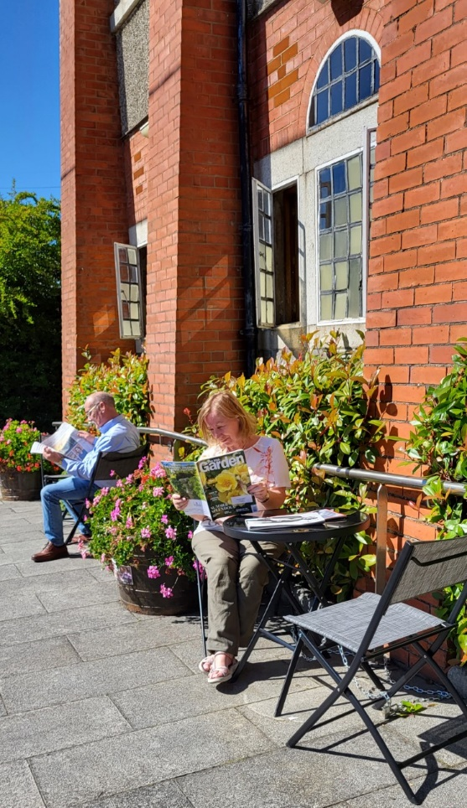 **Summer 2022**We have implemented a lot of improvements throughout the building: rearranged shelving, new furniture, new spaces in the library, tables, and chairs outside (weather permitting) – all to improve current borrowers’ usage of the library and entice new borrowers in.

We had a very successful Summer Stars campaign. As part of this, we had a busy Summer of Activities for Children in July, with 19 events across two days, with most events being sold out.   
  
Due to the huge uptake, we continued this momentum with weekly author visits throughout August, as well as starting new ongoing events such as our Quiet Thursdays and our bi-weekly self-led Baby & Toddler Group, which has been incredibly well-attended and whose attendance is growing week upon week.

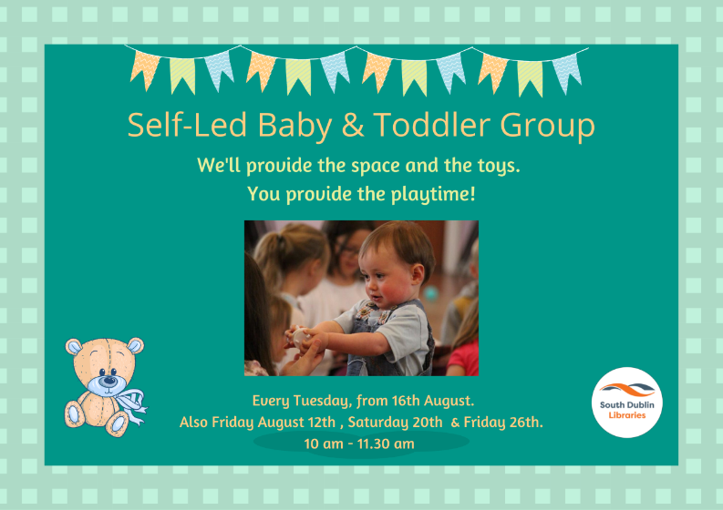

**September 2022**Starting the new school year, we have a large event to close off our Summer Stars: our Summer Stars Presentation on the 12th of September featuring Sarah Sparkles. We are also kicking off our class visits, with Nicola Pierce & Juliette Saumande, as well as welcoming schools to visit the library again on a regular basis. Finally, we are beginning to offer TTRS (Touch Type Read and Spell) spaces to local children, guided by library staff.   
  
For adults, we are starting our language courses with Irish and English for Beginners. We will have a talk on the history of The Tower Cinema in Clondalkin for Culture Night. We are starting our monthly series of History Talks, and September’s is a talk by Cathy Scuffil on The Camino & Dublin, as well as starting a monthly craft class with Joan Connolly for adults. All this alongside our regular events such as our Genealogy and GIY groups, our book club – of which a second one begins this month and more.   
  
We are also doing two full days of outreach events in The Round Tower, one celebrating Creativity in Older Age and the other a full day of interactive storytelling for children with Simone Schuemmelfeder.   
  
**Looking Ahead to October**For children, it’s a busy time with our Children’s Book Festival visits from authors Lauren O’Hara, Flora Dealargy & Padraig Kenny. We will have acclaimed psychotherapist Fiona Hall talk to secondary school classes on Social Media & Its Impact on Our Mental Health. As part of this year’s Red Line, we are delighted to welcome back Moon & Sixpence Puppet Theatre who will be presenting their much-loved Red Riding Hood. We also return to The Round Tower for a Spooky Interactive Storytime with Simone Schuemmelfeder.   
  
For adults, we are delighted to be running a month-long course,Introduction to Writing Prose with acclaimed author Tanya Farrelly. Complementing this, we have, as part of Red Line Festival, a one-off workshop Do You Have a Story In You? The second of our monthly history talks will be Liz Gillis on The Red Cow Murders, a hybrid event offered both online and in-person, and Fiona Hall returns with a talk for adults on People Pleasing.   
  
Finally, for Halloween, we have a whole host of events including spooky movies and a Halloween Trail throughout Clondalkin for the kids to follow.

**Libraries Report | Mobile Libraries | September 2022**

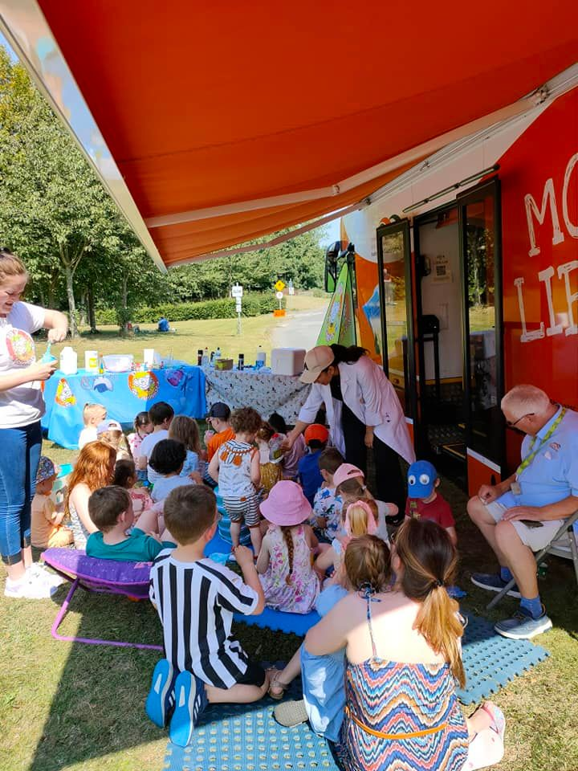

As you can see from the schedule below it was a jam-packed Summer for the mobile libraries. There were 146 Mobiles outreach events in July with an attendance of 1205. Schools were closed so events included Library@Home, hospitals, Baldonnel airport family day, Corcagh and Tymon Park family fun days and urban picnic, Deis schools summer camps, St Mark’s GAA Springfield Tallaght Youth Mental Health initiative family day, creche visits and drops.

**Family Park Days**

Tymon Park-   Wednesday 13th July -family fun

                           Wednesday 20th July – Waffles The  Wonderful

Corcagh Park - Thursday 14th July -family fun

                           Thursday 21st July – Trixie the Balloon modeller

Griffeen Park- Wed 10th August -family fun

                            Wed 18th August – two viking coin striking workshops

**Saturday Food Market Days**

2nd July Tymon Park 11am to 3pm - 2 events from Brilliant Events (Captain Ho Ho )

23rd July Corcagh Park 11am to 3pm –  2 sessions - Nutty Scientists

13th August Tymon Park 11am to 3pm – 2 Sessions – Nutty Scientists

10th September Corcagh Park 11am to 3pm -  family Yoga

**Other visits**

23rd July - St Marks GAA 11am to 1pm – Musical tots event

23rd July Baldonnel airport family day 2pm to 5pm Nutty Scientists events 2 sessions

9th August – City west Hotel visit to Ukrainian families. 10.30am to12 noon

11th August – Collinstown Park . Bingo event with NCL