**RTFB ACM**

**Libraries Report | Ballyroan Library | September 2022**

In the months of July and August, we had 31,857 visits to Ballyroan Library, and 40,347 items were issued. 1,507 new library members joined Ballyroan Library over the two-month period.

**Summer Highlights**

**Summer Stars**

Summer Stars is the public library national summer reading programme for children that ran from the 13th of June until the end of August. All children throughout the country are invited to join the adventure and to enjoy the fun and pleasure of reading and writing over the summer. Summer Stars is non-competitive and every child who reads even one book/ ebook is regarded as having completed the programme – and it’s all completely free! As part of the programme, Ballyroan Library hosted a range of events for children over the summer, including the Exploration Dome mobile planetarium, a heritage treasure hunt in Massy’s Woods, film making workshops, science workshops, magic shows, story times, a silent disco, and much more. The programme will conclude with a Summer Stars party in the library on 15th September, at which all participating children will be awarded their medals and certificates. Almost 800 children from the area took part.

**History and Heritage Programme**

This year’s programme of history and heritage events is ongoing, with over 60 events taking place across the county between August and October. Supported by the South Dublin County Heritage Plan, the programme is comprised of guided heritage walks, history talks on topics ranging from Clondalkin’s cinema to Tallaght’s aerodrome to Dublin’s Camino connections, Irish dance classes, exhibitions and much more – there really is something for all ages and interests. Highlights include the ever-popular Big Dig events, a simulated archaeological dig for children which took place during Heritage Week; and a six-week introduction to family history course with renowned genealogist Fiona Fitzsimons.

Local events included walking tours of Rathfarnham, Whitechurch and Massy’s Wood, a Decade of Centenaries talk on Michael Collins and Arthur Griffith which was a hybrid online/in person event attended by almost 150 people. Full details of all events can be found at southdublinlibraries.ie

**I South Dublin County Photography Competition**

We invited photographers to capture in a photograph what South Dublin County means to them – People, places, history, heritage, nature and everything in-between. 195 valid entries were received, with the top three receiving prizes, and all entries will be displayed in a digital exhibition in library branches, and archived on Source, the libraries’ digital archive.

**Mini Craft Fair**

A mini craft fair was held in the library on Saturday 20th August and was very successful with almost 800 people attending over the four-hour duration. The Rathfarnham Ukelele Group provided entertainment.

**September Event Highlights**

**Adult/Lifelong Learning Events**

Monday 5th September at 2:00pm

**Ballyroan Film Club**

A matinée screening of classics and musicals, this is a new monthly event aimed at adults with additional needs. Takes place on the first Monday of the month.

Every Monday 11:00am – 12:30pm

Every Thursday 6:30pm – 8:00pm

**Stitched Together Craft Group**

Twice-weekly craft skills share sessions.

Tuesday 20th September at 11:00am

**Crafts with Kim**

Learn a new craft with artist Kim Jenkinson.

Wednesday 28th September at 11:00am

**Golden Moments Social Club**

This month’s event is a talk by historian Cathy Scuffil on the *Secrets in Dublin Placenames*.

*All welcome!*

Tuesday 5th September and Tuesday 20th September at 7pm

**Decade of Centenaries Talks**

Propaganda and the Irish Civil War with Ian Kenneally

Executions and Reprisals: the atrocities of the Irish Civil War with Myles Dungan

**Thursday mornings**

Age Action computer/smart phone classes resume.

Friday 23rd September 7:00-9:00pm

**Culture Night | Céilí Mór**

Brian Boru Céilí Band will be providing the tunes and our resident dance teacher will be on hand to call the sets. No previous dance experience required! All welcome.

**Children’s Events**

Every Tuesday at 3.30pm

**Story Time**

Our weekly story time suitable for 3-6 year olds and their grown-ups.

Thursday 29th September at 4:00pm

**Junior Book Club**

Monthly meeting of our children’s book club.

Wednesday evenings fortnightly from 14th September.

**Coderdojo Rathfarnham**

We're back live and in person with CoderDojo Rathfarnham at Ballyroan Library! Coders of all abilities are welcome! Whether an absolute beginner or a more experienced coder, we'll cover something to interest everyone. Suitable for 7-17 year olds.

Fridays at 10:00am

**Toddler Time**

Songs, stories and play time for wobblers and toddlers. Resumes on 23rd September.

Every Saturday at 10:00am

**Chess Club**

Suitable for children aged 7-12, come along and try your chess skills against other enthusiasts! Our Chess Master Fred is on hand with tips and tricks. Resumes on 10th September.

Monday 26th September at 3:30pm

**Philosophy Club** Philosophy Club is a fun, activity based club for children in 4th - 6th class. Anyone can come along and no experience in philosophy is needed. All we need are curious minds!

Wednesday mornings

**Music for Little Ones with Music Generation**

6 week course for 0-18 months and 18months – 4 years resumes on 7th September.

Saturday 24th September at 2:30pm

**Family Film Screening in Ukrainian: Happy Feet Two.**

Thursday 15th September

**Youth Climate Conference**

The conference will highlight the importance of taking climate action to secondary school students. Environmental educators (Rediscovery Centre and Aoife Munn) will engage students on a range of topics from energy efficiency at home, to sustainable living and sustainable fashion, to how reusing materials helps support the circular economy while reducing greenhouse gas emissions. Students will take part in hands-on practical workshops as part of the conference. This event is being delivered as part of Dublin Climate Action Week 12th to 17th September.

**Libraries Report | Mobile Libraries | September 2022**

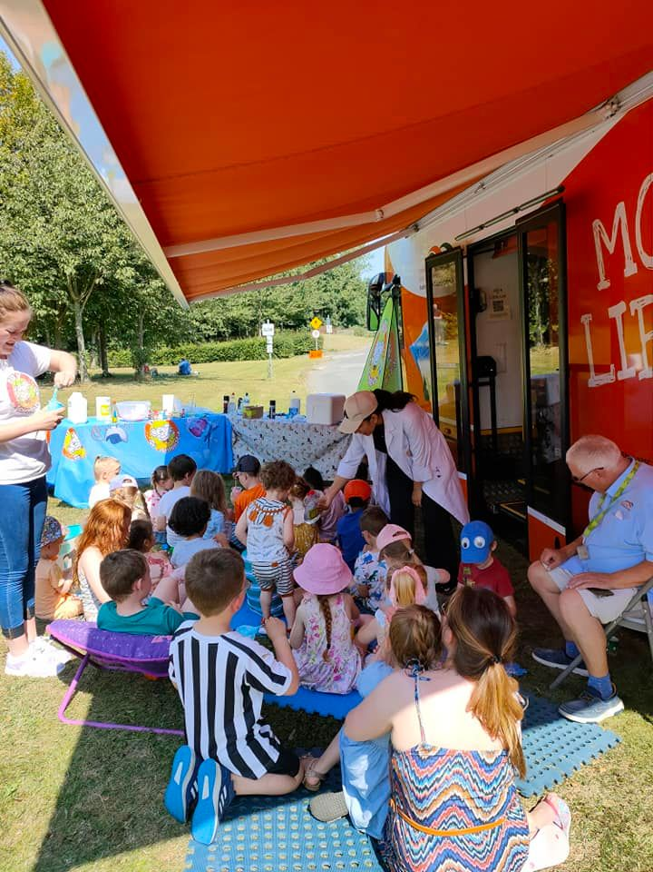

As you can see from the schedule below it was a jam-packed Summer for the mobile libraries. There were 146 Mobiles outreach events in July with an attendance of 1205. Schools were closed so events included Library@Home, hospitals, Baldonnel airport family day, Corcagh and Tymon Park family fun days and urban picnic, Deis schools summer camps, St Mark’s GAA Springfield Tallaght Youth Mental Health initiative family day, creche visits and drops.

Family Park Days

Tymon Park-   Wednesday 13th July -family fun

                           Wednesday 20th July – Waffles The  Wonderful

Corcagh Park - Thursday 14th July -family fun

                           Thursday 21st July – Trixie the Balloon modeller

Griffeen Park- Wed 10th August -family fun

                            Wed 18th August – two viking coin striking workshops

Saturday Food Market Days

2nd July Tymon Park 11am to 3pm - 2 events from Brilliant Events (Captain Ho Ho )

23rd July Corcagh Park 11am to 3pm –  2 sessions - Nutty Scientists

13th August Tymon Park 11am to 3pm – 2 Sessions – Nutty Scientists

10th September Corcagh Park 11am to 3pm -  family Yoga

Other visits

23rd July - St Marks GAA 11am to 1pm – Musical tots event

23rd July Baldonnel airport family day 2pm to 5pm Nutty Scientists events 2 sessions

9th August – City west Hotel visit to Ukrainian families. 10.30am to12 noon

11th August – Collinstown Park . Bingo event with NCL