**Report on the Feasibility of a uncontrolled left turn slip and U-turn on the R148 for east bound to turn around and go westbound.**

**West Bound Slip off Kennelsfort Road Upper:**

There is a signalised controlled left slip off Kennelsfort Road Upper onto the R148.

The left slip runs with the straight ahead and right turn out of Kennelsfort Road.

It also runs as a **bonus phase** when the straight ahead and right turn on the main R148 into Town is operating.

It cannot run as an uncontrolled left slip as the Out Of Town / Westbound traffic movements (Bus Lane) and the merge from the left slip all combine at a single point. This would constitute a safety hazard.

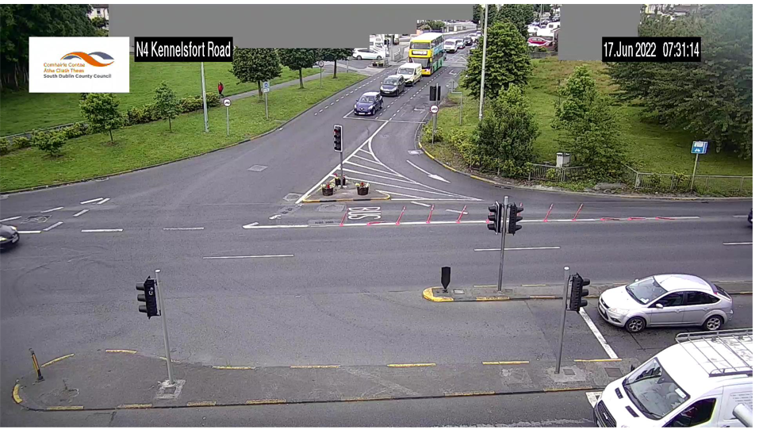

**U-turn for East Bound Traffic to go West Bound:**

As the vehicles are U turning on the Right turn phase, they are then combining with traffic coming off the left slip on the Bonus phase when the straight ahead and right turn on the main R148 into Town is operating.

It is unsafe to U-turn at this point, especially for large vehicles with the current permitted traffic movements on the junction.

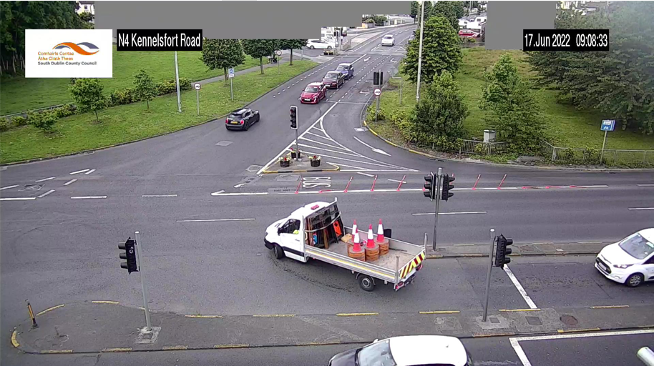

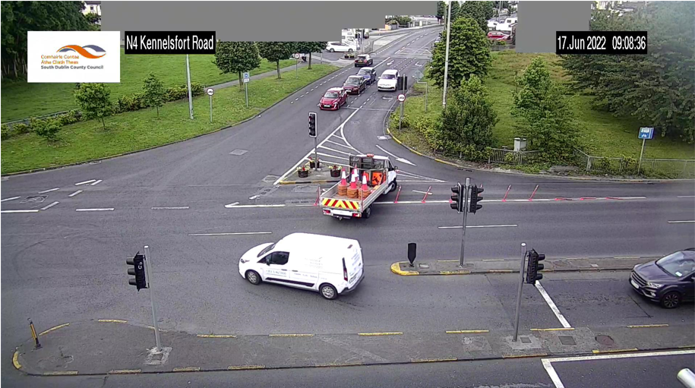

Vehicles are crossing into the path of oncoming left slip traffic.

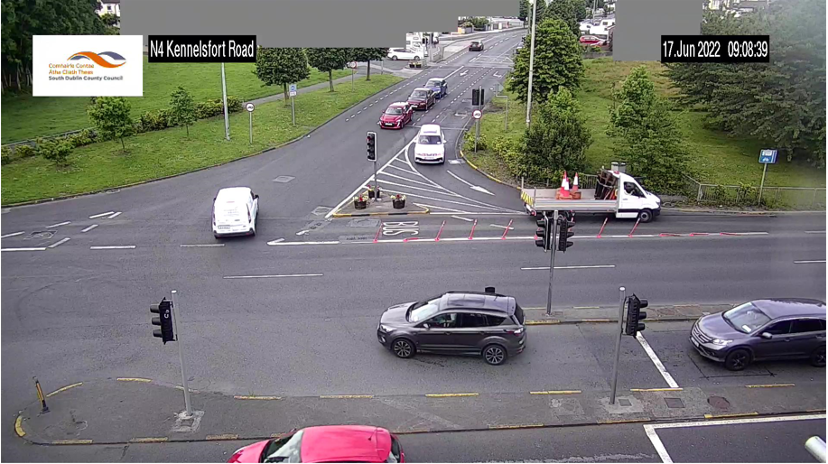

To allow a U Turn facility at this junction, the additional Bonus left turn phase running when the straight ahead and right turn on the main R148 into Town is operating would have to be removed.

This would allow vehicles to U turn safely, however this would **significantly increase** **congestion** on Kennelsfort Road Upper.

It is not recommended to take this course of action.

There is a U Turn route which takes traffic down to Chapelizod, under the R148 and back westbound Out of Town on the R148 to the M50 or N4. This adds 2.9km to the journey, but it is a safe U-turn route.

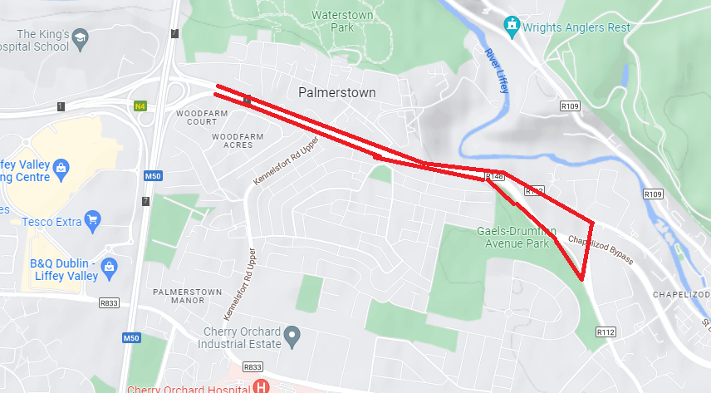

**Conclusion:**

For the moment, it is not proposed to make any changes at the R148 / Kennelsfort Road Upper Junction.