Clondalkin ACM June 2022
Libraries Report | Clondalkin Library | June 2022

In the month of May, across the county, there were 604 events with an attendance of 6943. There were 597 in-person events with an attendance of 6805. There were 7 online events with an attendance of 138. There were 157 Mobiles outreach events in May with an attendance of 2160 covering Library@Home, school visits, hospitals, nursing homes, creche visit and drops.

Event Highlights

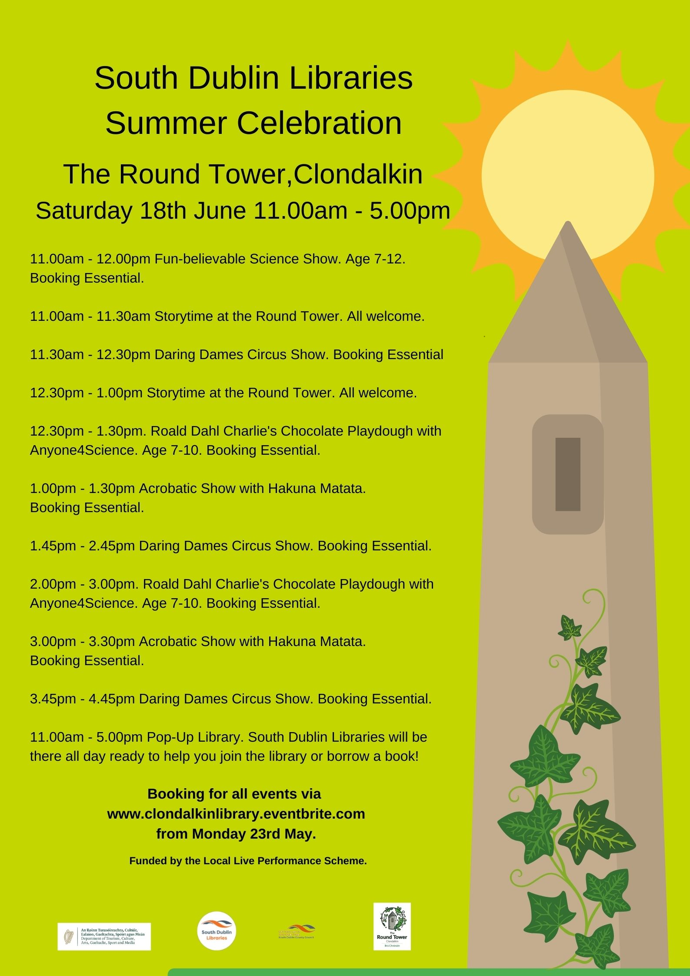

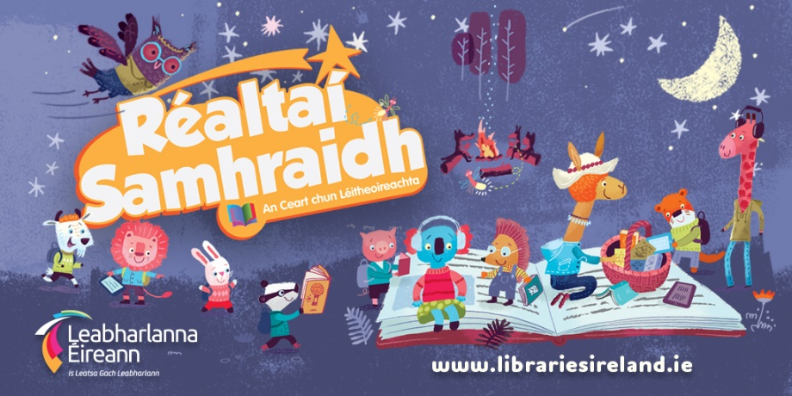
Summer Stars
For the month of June, library staff will be visiting schools and organising class visits to our libraries to promote Summer Stars. Summer Stars is the public library national summer reading programme for children that runs from the 13th of June until the end of August. All children throughout the country are invited to join the adventure and to enjoy the fun and pleasure of reading and writing over the summer. Summer Stars is non-competitive and every child who reads even one book/ ebook is regarded as having completed the programme – and it’s all completely free! Call into Clondalkin Library to sign up and start your reading adventure!

Returning Events
Clondalkin Library is excited to announce the return of our regular library events. Class visits returned since mid-May with 2 school classes visiting the library four days a week. June will see the return of Grow It Yourself workshops (2nd June, 6.30pm), Genealogy Workshops (16th June, 6.30pm) and the Adult Book Club (30th June, 6.30pm).

Adult/Lifelong Learning Events

Who Was Anne Devlin? A Talk by Micheál Ó Doibhlín
Monday 13th June, 7-8pm
This talk explores Anne Devlin and her roles in the 1798 rebellion and the 1803 Rising.
The talk is presented by The Joe Williams Archive. All welcome, no booking required.

Summer Gardening: A Talk with Aoife Munn
Monday 20th June, 7-8pm
Learn everything you need to know to create a beautiful outdoor space this summer. Booking Essential via Eventbrite.

Clutter-Free Living with Fiona Hall
Thursday 23rd June, 7-8pm
This talk looks at our motivations for buying things and how to take back control and successfully declutter our houses and lives.
Booking Essential via Eventbrite.

Pride Events
Pin Your Pride (month of June)
The Pin Your Pride campaign will run across South Dublin Libraries for the month of June. This initiative celebrates the principles of diversity, inclusion and representation which are at the heart of the public library services. We’re encouraging everyone to drop into their local branch to collect each of the four specially designed Pin Your Pride badges.

Libraries Report | Mobile Libraries | May/June 2022

During May we had 2652 visitors to our mobile stops averaging at 17.4 people per stop (36 stops).
Of the 9 new stops that were introduced in March, 8 of those are now in the top 50% for footfall in all our stops i.e. Shackleton drive, Rathfarnham Castle, Cuil Duin Avenue, Silken Park Avenue, Citywest Village, Templeroan Lawn, Greydon Terrace and The Priory Grange Road.

A new schedule for the Summer will include three new stops i.e. Parkland Green, City west, Moy Glass Wood in Lucan and Whitechurch Community Centre. After careful consideration we withdrew three stops that had very poor engagement over a long time i.e. Sruleen, Homelawn and Brittas. They consistently had zero and up to 4 visitors every week and these stops either have a library within 3kms or alternative stop with 3kms. The Britta’s stop is very close to a Wicklow library and despite heavy promotion, it often had no visitors. The new areas we are going to have expressed an interest in having a mobile library service. Again, we can review this in September.

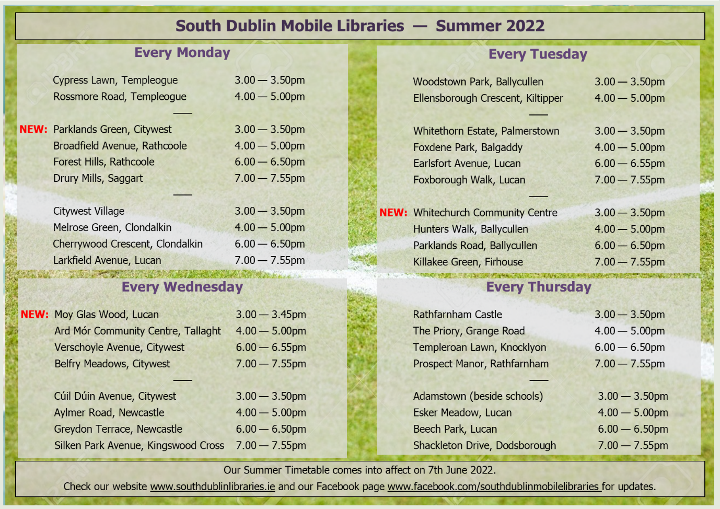

The Summer timetable takes effect on 7th June and will be reviewed in September.
The Library@Home will continue over the Summer as an essential service to people who cannot use a library, usually because of mobility issues. We visited Bloomfield Healthcare and due to its success we have now added Peamount Hospital to our visits. Creche drops continue to be popular and the demand for creche visits is high. We have some family fun days planned for July and August in Tymon, Corcagh and Griffeen parks. We will also have a presence at the Saturday Dublin Markets and Urban Picnics in Tymon and Corcagh with our library trucks and family entertainment.
The School service moves into the last month before we take break for the Summer. We have 16 Deis schools on our books that are visited every 3 weeks consistently over the school terms. There are a few Summer Camps at these schools that we have promised to visit as part of their literacy programmes. There also some bookings for creche visits and autism units over the Summer.

