RTFB ACM June 2022
Libraries Report | Ballyroan Library | June 2022

In the month of April, across the county, there were 41,880 library visits in person with 64,952 Items issued. Ballyroan Library had 14,224 visitors in April, and visitor numbers for May jumped to 21, 521.

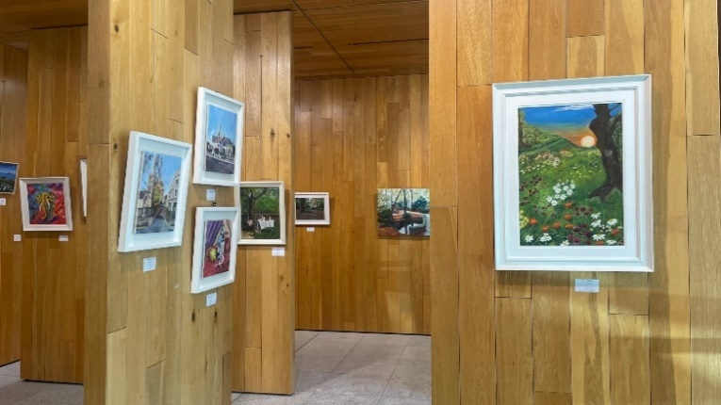
Event Highlights

Exhibition
Our current exhibition by the Castle Art Group, a collective of local artist, will run until 10th June.

Cruinniú na nÓg
Cruinniú na nÓg, the national day of creativity for young people, takes place on 11th June. There are lots of events happening locally in celebration.

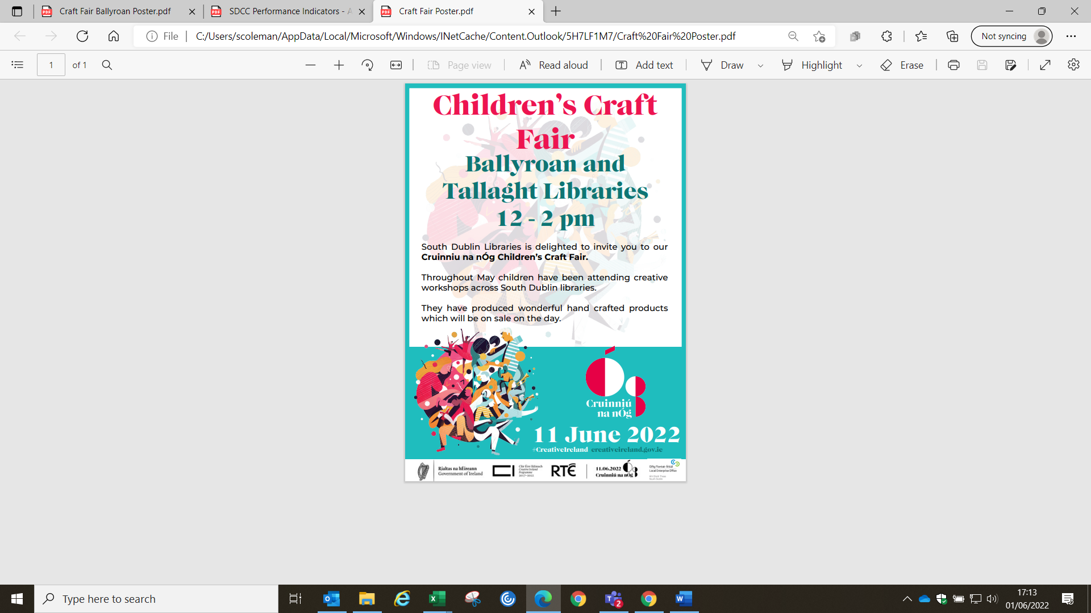
10:00am – 1:00pm Mega Doodle at Ballyroan Library
This is a hands-on Illustration workshop introducing young people to the world of image making and collage with Illustrator Eva Kelly. The young people will make drawings about their world and the finished work will take the form of a Mega Doodle giant drawing to exhibit in the library.

11:00am Early Starters Music Workshops with Music Generation, for children aged 4 and under, in Castletymon Library and Tallaght Library.

12:00 – 2:00pm Cruinniú na nÓg Craft Fair at Ballyroan Library and Tallaght Library. For the month of May, children have been attending creative workshops across South Dublin Libraries, producing hand crafted products which will be sold at the Cruinniú na nÓg Craft Fair. Supported by Creative Ireland and LEO South Dublin.

2:00pm Classical Kids Concert at Ballyroan Library
Join classicalkids.ie for a fun interactive kid's concert for the whole family. Meet the instruments, play games, sing, dance and learn about the music. Get your groove on and have fun!

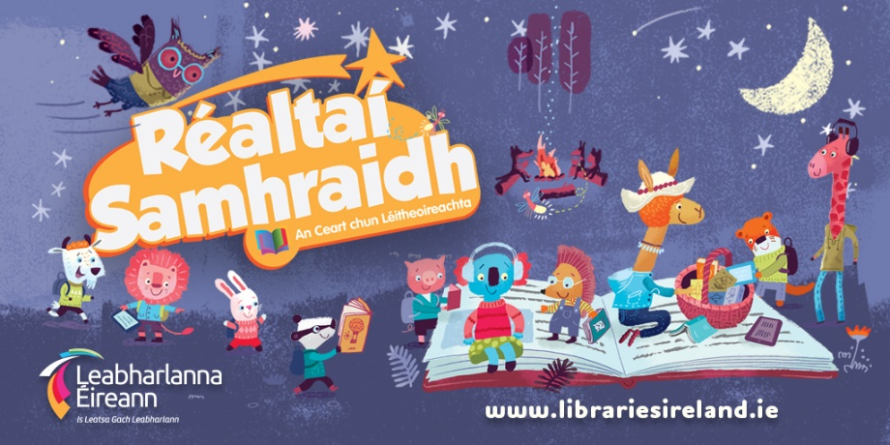
Summer Stars
For the month of June, library staff will be visiting schools and organising class visits to our libraries to promote Summer Stars. Summer Stars is the public library national summer reading programme for children that runs from the 13th of June until the end of August. All children throughout the country are invited to join the adventure and to enjoy the fun and pleasure of reading and writing over the summer. Summer Stars is non-competitive and every child who reads even one book/ ebook is regarded as having completed the programme – and it’s all completely free! As part of the programme, Ballyroan Library will host a range of events for children over the summer, including a mobile planetarium, film making workshops, treasure hunts, science workshops, story times, a silent disco, and much more.

Pride Events
Pin Your Pride (month of June)
The Pin Your Pride campaign will run across South Dublin Libraries for the month of June. This initiative celebrates the principles of diversity, inclusion and representation which are at the heart of the public library services. We’re encouraging everyone to drop into their local branch to collect each of the four specially designed Pin Your Pride badges.

Tuesday 21st June 6:00pm
Film Screening: Handsome Devil
In celebration of Pride, Ballyroan Library will be screening this Irish coming of age comedy drama. All welcome!

Decade of Centenaries
Thursday 9th June 2:00pm (Tallaght Library)
WM Letts Symposium and Exhibition
Winfred Mabel Letts was a poet, playwright and children’s author. Her children’s books including The Story-Spinner (1907) were very popular and were regularly adapted for Children’s Hour, the BBC Radio show. She was the second woman, after Lady Gregory, to have her plays dramatised by the Abbey Theatre. She worked as a nurse and a masseuse during the First World War and the publication of her war poetry including Hallow-e'en and Poems of War (1916) and The Spires of Oxford and Other Poems (1917) predate those of Siegfried Sassoon and Wilfred Owen. She is buried in the Verschoyle family (to which she married into) plot in Rathcoole cemetery. On the 50th anniversary of her death, South Dublin Libraries will host a symposium exploring her life and works.

Tuesday 14th June 7pm (online event)
The History of Tallaght Aerodrome
Join David Power of our Local Studies staff for this talk on the history of Tallaght Aerodrome and its role in Irish aviation.

Tuesday 21st June 7pm (online event)
The Battle of the Four Courts
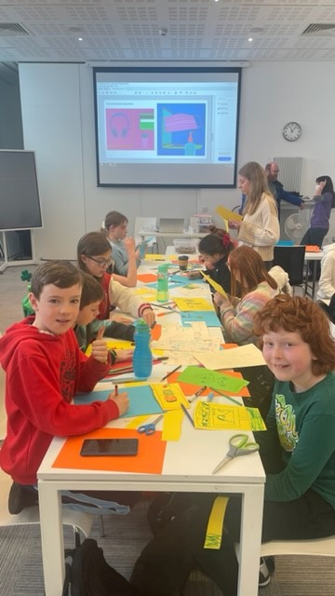
In the lead up to the centenary of these events, join historian Michael Fewer for a lecture on the opening battle of the Irish Civil War.

Covid Memories Project
South Dublin Libraries are working with primary schools all across the county on the Covid Memories Project which involves the Decade of Centenaries Historian-in-Residence, Liz Gillis and the Artist-in-Residence, Eva Kelly. Workshops have been held recently in Tallaght, Castletymon and Ballyroan Libraries where the students learned about primary sources, why they are important in telling stories from the past, and how art has been used to interpret historical events. The students will be asked to draw or paint an image of what living through the pandemic was like for them. The drawings will then be placed in the South Dublin Libraries Archive, where they will be stored safely for future generations to discover. Most importantly, this project ensures that the voices/memories of the children who lived during this momentous event will be seen and heard.

Regular Adult/Lifelong Learning Events
Every Monday 11:00am – 12:30pm
Every Thursday 6:30pm – 8:00pm
Stitched Together Craft Group Twice-weekly craft skills share sessions.

Every Wednesday 6:00pm from 15th June
English for Beginners 6 week course
(Drop In English classes also take place in Tallaght Library on Mondays-Thursdays from 11:30am-1:30pm)

Every Wednesday 7:00pm from 15th June
Ukrainian Meet Up A new weekly event aimed at providing a supportive meeting space for Ukrainians in the area.

Tuesday 21st June 11:00am
Floral Wreath Craft
with artist Kim Jenkinson.

Every Thursday 10:30am-12:30pm
Age Action Computer Classes

Wednesday 29th June 10:30am
Golden Moments Social Club: Chair Yoga
Regular Children’s Events
Every Tuesday at 3.30pm
Storytime Our weekly storytime suitable for 3-6 year olds and their grown-ups.

Thursday 16th June 4:00pm
Junior Book Club Monthly meeting of our children’s book club.

Tuesday 21st June 10:00am
Baby Book Club Monthly club aimed at encouraging a love of reading in your little ones!

Wednesday evenings fortnightly
Coderdojo Rathfarnham Coders of all abilities are welcome! Whether an absolute beginner or a more experienced coder, we'll cover something to interest everyone. Suitable for 7-17 year olds.

Fridays 10:00am
Toddler Time Songs, stories and play time for wobblers and toddlers.

Saturdays 10:00am
Chess Club Suitable for children aged 7-12, come along and try your chess skills against other enthusiasts! Our Chess Master Fred is on hand with tips and tricks.

Monday 27th June 3:30pm
Philosophy Club Philosophy Club is a fun, activity based club for children in 4th - 6th class. Anyone can come along and no experience in philosophy is needed. All we need are curious minds!

Libraries Report | Mobile Libraries | May/June 2022

During May we had 2652 visitors to our mobile stops averaging at 17.4 people per stop (36 stops).
Of the 9 new stops that were introduced in March, 8 of those are now in the top 50% for footfall in all our stops i.e. Shackleton drive, Rathfarnham Castle, Cuil Duin Avenue, Silken Park Avenue, Citywest Village, Templeroan Lawn, Greydon Terrace and The Priory Grange Road.

A new schedule for the Summer will include three new stops i.e. Parkland Green, City west, Moy Glass Wood in Lucan and Whitechurch Community Centre. After careful consideration we withdrew three stops that had very poor engagement over a long time i.e. Sruleen, Homelawn and Brittas. They consistently had zero and up to 4 visitors every week and these stops either have a library within 3kms or alternative stop with 3kms. The Britta’s stop is very close to a Wicklow library and despite heavy promotion, it often had no visitors. The new areas we are going to have expressed an interest in having a mobile library service. Again, we can review this in September.

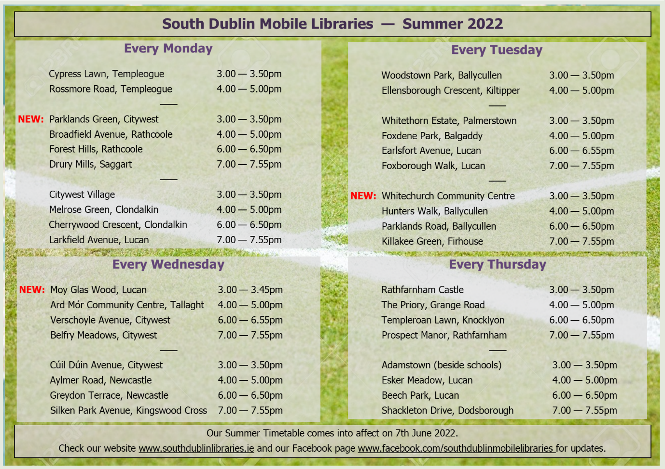

The Summer timetable takes effect on 7th June and will be reviewed in September.
The Library@Home will continue over the Summer as an essential service to people who cannot use a library, usually because of mobility issues. We visited Bloomfield Healthcare and due to its success we have now added Peamount Hospital to our visits. Creche drops continue to be popular and the demand for creche visits is high. We have some family fun days planned for July and August in Tymon, Corcagh and Griffeen parks. We will also have a presence at the Saturday Dublin Markets and Urban Picnics in Tymon and Corcagh with our library trucks and family entertainment.
The School service moves into the last month before we take break for the Summer. We have 16 Deis schools on our books that are visited every 3 weeks consistently over the school terms. There are a few Summer Camps at these schools that we have promised to visit as part of their literacy programmes. There also some bookings for creche visits and autism units over the Summer.

