**Tallaght ACM May 2022**

**Libraries Report | May 2022**

In the month of April, across the county, there were there were 451 events with an attendance of 5873. There were 444 in-person events with an attendance of 5650. There were 7 online events with an attendance of 223. There were 155 Mobiles outreach events in April with an attendance of 1176 covering Library@Home, school visits, hospitals, nursing homes, creche visit and drops.

**Tallaght Library**

**Exhibitions:**

**'Local Legacies Remembered'** is a collaboration between Artist in Residence Eva Kelly and Historian in Residence Liz Gillis and forms part of our Decade of Centenaries programme. The project is a celebration of eight women from this period of significance who played a vital role in shaping the history and culture of South Dublin County. The exhibition will be on display until June 3rd. All classes visiting the library will be brought to the exhibition also.

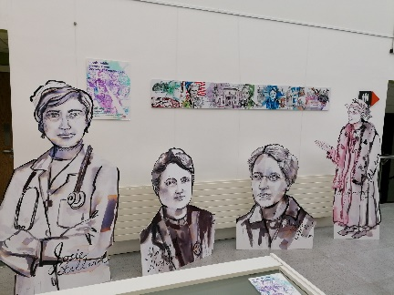

Artwork by local Jasmine Kenna was also displayed in the walkway from May 9th to 14th.

**Highlights from May**

**Children’s Events included**

Staff started May with a bang celebrating all things **Star Wars** on May 4th with the Jedi Academy STEAM workshop and Jedi Training including fun games and crafts.

A special four-week craft course to celebrate **Cruinniú na nÓg** began on May 10th. Children will be taught to make hand crafted products, which they will then sell at the craft fair on the 11th June.

Also, as part of Cruinniú na nÓg, **Music Generation Early Starter Music Classes** will run every Friday in May.

**Project Sums** which supports senior cycle maths students returned on April 29th and runs for 6 weeks every Tuesday evening.

**Saturday Club**: A brand new Saturday Club began in May to encourage families to come along to the library on Saturdays between 10am and 12pm where we will have a different activity each week.

A selection of books in the Ukrainian language have been purchased by library HQ and are now available in all libraries.

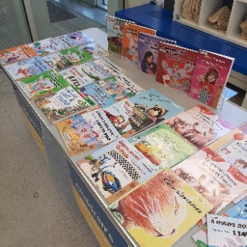

**My Little Library Book Bag**

All children starting school in September 2022 can get a free Book Bag at their local library.

The initiative is a collaboration between libraries and the Department of Children, Equality, Disability, Integration and Youth as part of the First 5 Strategy. Children and their parents or guardians can collect the bags at any library throughout South Dublin County, so we have been busy both giving out the bags and joining up those who come in to collect them and their child.

**Adult Events included**

The Maria Lane Choir opened the **Bealtaine Festival** with a choral performance on May 4th.

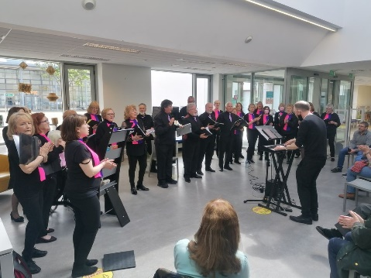

This was followed by **Chair Yoga** every Thursday in May and **Wreath Making** and **Portraiture** classes.

Information on **Volunteering for Over 50s** was provided at a talk on May 11th and through a number of information stands on the library floor on May 16th.

Our **Polish Seniors Group** continue to meet one Saturday per month, this month on May 28th at 12pm.

Other Adult Events in May included **What to do in the Garden in May** and the Tallaght Historical Society talk on **Brú na Bóinne and the Drought**.

English language conversation classes are ongoing Monday to Thursday 11.30am to 1.30pm.

**Coming up in June**

We are currently organising events for primary schools in June. We will be inviting schools to come in, join the library and sign up for Summer Stars, our annual programme to keep children reading through the summer holidays. Staff will also be out visiting schools promoting the programme.

We also have a busy day of activities lined up for June 11th, **Cruinniú na nÓg.**

**Castletymon Library**

**Crystal Crafts in Castletymon!**

On May 12th the Women Together Tallaght Network made crystal crafts in the library as part of the Bealtaine Festival. A calming and creative morning was had by all.

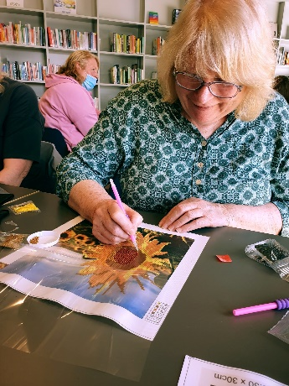

**Bingo for Bealtaine!**

Thursday 19th May @ 6pm

Come down to Castletymon for some bingo! Banter, laughter and some fun prizes are up for grabs!! Booking essential from Tues 3rd May @ 9.45am, contact the library

**Bealtaine Music Session**

Monday 23rd May @ 6.30pm

Following on from our brilliant music night during Seachtain na Gaelige, join us again for a lively session of tunes and singalong songs in the library! A night not to be missed.

**STEAM Saturdays**

**21st May at 11am**

Our STEAM Saturday this month is all about building bridges! Using our Engino Discovering Stem sets we will be building different types of bridges and finding out how architectural design can have a massive impact on the strength of a structure. This STEAM class is suitable for children aged between 10 and 12 and can be booked from the 16th May at 10am through Eventbrite.

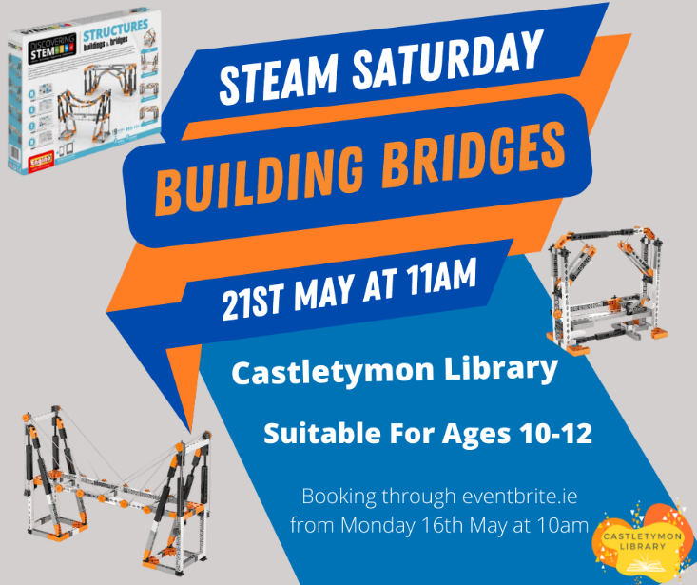

**Pop Up Library at St Kevins Family Resource Centre!**

On Saturday May 7th staff from Castletymon Library attended the Bealtaine Fair at St Kevins Resource Centre. These two little humans below got their Little Library Bag and their library card at the event. Staff made important local connections and had a great day!

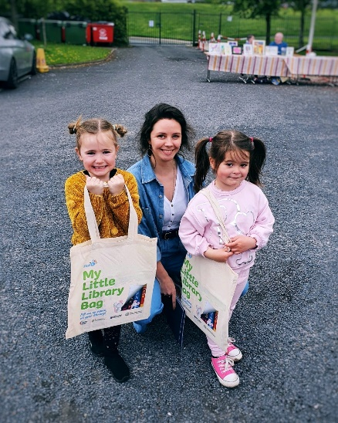 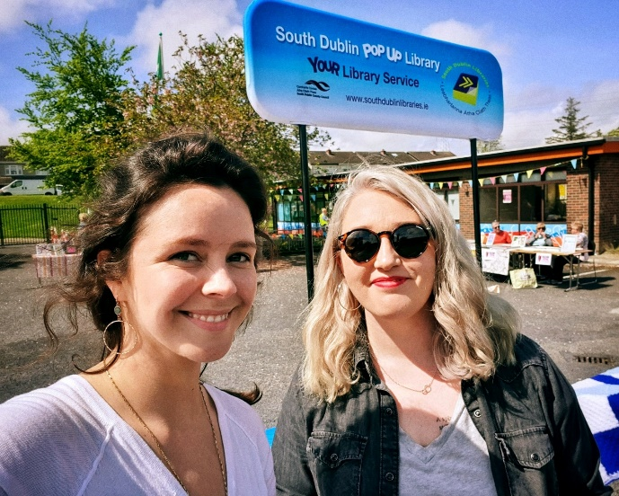

**Think Big Space**

On 7th April Libraries in partnership with Amazon Web Services launched the **Think Big Space** in Tallaght.

The AWS Think Big Space is a new educational lab located beside the Tallaght Luas stop, which aims to inspire an interest in science, technology, engineering, arts, and maths. It provides a dedicated space for students, educators, and communities to explore innovative and imaginative ideas through interactive hands-on technical education. AWS has opened AWS Think Big Spaces across the world; however, this is the first AWS Think Big Space to launch in Europe. An innovative programme of events in Think Big Space will be planned for the rest of the year. Events will take place every month and feature Lego robotics and virtual reality workshops.

Students and teachers will be encouraged to “Think Big” by using their creativity and imaginations as they explore the technologies on offer. The programme will support interactive hands-on learning and appeal to a range of ages. All May workshops in Think Big Space are now fully booked and there is a waiting list for June.

**Membership Drive**

On Monday April 25th South Dublin Libraries launched our membership drive **“Here for you in 2022 and Beyond”.**

We want to let all the citizens living, working, or studying in the South Dublin County Council area, know **who we are and what we do!** The **membership drive** will continue over the summer months and aims to boost active membership with a medium-term ambition of 30% being achieved by 2027. In terms of current active membership, 72% is shared between Ballyroan, Lucan and Tallaght. Library staff have manned pop-up libraries at various locations over the past two months. Outreach included City West Jobs Fair and a pop-up library at Palmerstown Shopping Centre. The mobile libraries signed up 500 secondary students in Adamstown and plan to visit more secondary schools in the coming weeks. Future pop-up libraries will be held in the parks, Clondalkin Round Tower and community centres around South Dublin.

**Libraries Report | Mobile Library | May 2022**

They have been named!

Molly and Billy were officially named on Good Friday. The inspiration for the names came from our recent prize winner of “names the vans” competition at the Rossmore Road stop, Aisha Culligan.

We have plans to respray another of our older vans in the SDCC colours and run another naming competition.

Since introducing the new stops in March, we have had a steady increase in our visitor numbers most notably at Shackleton Drive, Rathfarnham Castle and Cuil Duin. All of our school visits and class set deliveries are at full capacity. The Library@Home continues to be a valued service as many of our patrons have contacted to thank us around Easter time. We hope to continue this over the Summer months as demand is strong. The creche deliveries will ease as Summer holidays draw near and we will have time to focus on some outreach activities in our parks.

We have added Peamount hospital to our hospital visits in May.

See visitor stats chart below for all stops Jan to end of April 2022