Clondalkin ACM May 2022
Libraries Report | May 2022
In the month of April, across the county, there were there were 460 events with an attendance of 5982. There were 453 in-person events with an attendance of 5759. There were 7 online events with an attendance of 223. There were 163 Mobiles outreach events in April with an attendance of 1300 covering Library@Home, school visits, hospitals, nursing homes, creche visit and drops.

Clondalkin Library
April/May Events
On Monday April 11th at 7 pm we hosted a Joe Williams Lecture. This talk by Padraig Ó Murchú focussed on the Carmelite Monastery at Mount St Joseph in Clondalkin.
Who was Joe Williams? Joe Williams (RIP 15th April 2016) grew up in Mill Lane in Palmerstown and later moved to live in Clondalkin where he became the go-to person about the heritage of South Dublin and beyond, its people, industries and places. Joe wasn’t only interested in the area’s past – the present day was very much to the fore as well.
Joe was deeply knowledgeable about our local history and how it fits in with national and international perspectives. He took a broad view on historical conservation. Flora and fauna, canal pathways, castles and cottages were included because of their contributions to our heritage and present-day life. His published works and other writings are seen as reliable sources for the many people interested in further study on local and Irish history and its impact on our lives today.
After years of personal interest and after he retired, Joe Williams qualified as a local historian from Maynooth University with a Higher Diploma. There, he perfected his natural research skills and formed a foundation for his knowledge. He was accepted to do a B.A., but unfortunately had to withdraw just before he completed it due to ill health.
There were 40 attendees at the talk and the night was a great success.
Online Lecture with Clondalkin Library
On Monday May 9th at 7pm local historian in residence, Liz Gillis, will be giving an online talk with Clondalkin Library on the 4th Battalion Dublin Brigade and the Anglo-Irish Treaty.
Join Liz for a discussion of the impact of and reaction to the Anglo-Irish Treaty on the branch of the IRA operational in South Dublin county. There are currently 54 attendees booked in for this talk.

Liz Gillis is Historian-in-Residence with South Dublin County Council. She has a degree in Modern Irish History and specialises in the Irish Revolutionary period. She is a lecturer at Champlain College Dublin and a researcher on The History Show on RTE Radio. She is the author of several books including Revolution in Dublin: A Photographic History 1916-1923, Women of the Irish Revolution, and May 25: Burning of the Custom House 1921. She was the recipient of the Dublin City Lord Mayor’s Award in 2018 for her contribution to history.

School Visits
Clondalkin Library are delighted to announce that school visits at the library will recommence the week of the 16th May. We look forward to welcoming classes through the doors of our library once again.
County-Wide Library Initiatives

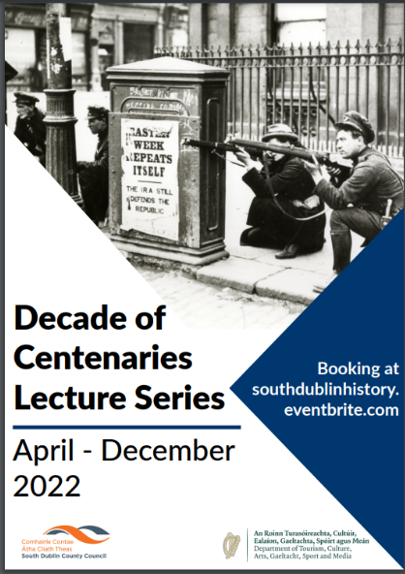
Decade of Centenaries Lecture Series 2022
The Decade of Centenaries Lecture Series for 2022 will explore and reflect on the impact of the pivotal events of a century ago at both a national and local level. The series will run from April to December and will feature historians including Dr. Michael Kennedy, Dr. David McCullagh, Michael Fewer, Cathy Scuffil and Ian Kennelly, as well as our historian in residence Liz Gillis.

Part of the series this year is an online Summer School with Liz Gillis which is a four-week course in July looking at the causes and legacy of the Irish Civil War.

In September and October, genealogist Fiona Fitzsimons will facilitate a six-week course in family history research.
The full list of talks and workshops can be found at www.southdublinlibraries.ie

Think Big Space
On 7th April Libraries in partnership with Amazon Web Services launched the Think Big Space in Tallaght.
The AWS Think Big Space is a new educational lab located beside the Tallaght Luas stop, which aims to inspire an interest in science, technology, engineering, arts, and maths. It provides a dedicated space for students, educators, and communities to explore innovative and imaginative ideas through interactive hands-on technical education. AWS has opened AWS Think Big Spaces across the world; however, this is the first AWS Think Big Space to launch in Europe. An innovative programme of events in Think Big Space will be planned for the rest of the year. Events will take place every month and feature Lego robotics and virtual reality workshops.
Students and teachers will be encouraged to “Think Big” by using their creativity and imaginations as they explore the technologies on offer. The programme will support interactive hands-on learning and appeal to a range of ages. All May workshops in Think Big Space are now fully booked and there is a waiting list for June.

Membership Drive
On Monday April 25th South Dublin Libraries launched our membership drive “Here for you in 2022 and Beyond”.
We want to let all the citizens living, working, or studying in the South Dublin County Council area, know who we are and what we do! The membership drive will continue over the summer months and aims to boost active membership with a medium-term ambition of 30% being achieved by 2027. In terms of current active membership, 72% is shared between Ballyroan, Lucan and Tallaght. Library staff have manned pop-up libraries at various locations over the past two months. Outreach included City West Jobs Fair and a pop-up library at Palmerstown Shopping Centre. The mobile libraries signed up 500 secondary students in Adamstown and plan to visit more secondary schools in the coming weeks. Future pop-up libraries will be held in the parks, Clondalkin Round Tower and community centres around South Dublin.

My Little Library Book Bag
All children starting school in September 2022 can get a free Book Bag at their local library.
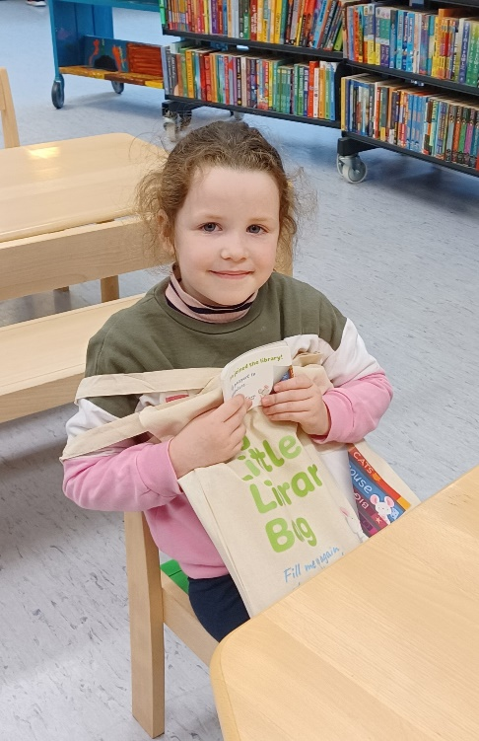
The initiative is a collaboration between libraries and the Department of Children, Equality, Disability, Integration and Youth as part of the First 5 Strategy.
As part of the initiative, a ‘My Little Library Book Bag’ is available free for every child starting school in 2022 to help them to prepare for this big step. Children and their parents or guardians can collect the bags at any library throughout South Dublin County.
Each My Little Library Book Bag contains:
• Three books on starting school, making friends and being comfortable to be yourself
• A story card on going to the library
• A postcard the child can write or draw on and send to their new teacher, or bring to give to the teacher on their first day at school
• Their very own library card and special ‘My Little Library’ cardholder
Book bags are available in both Irish and English.

Libraries Report | Mobile Library | May 2022

They have been named!
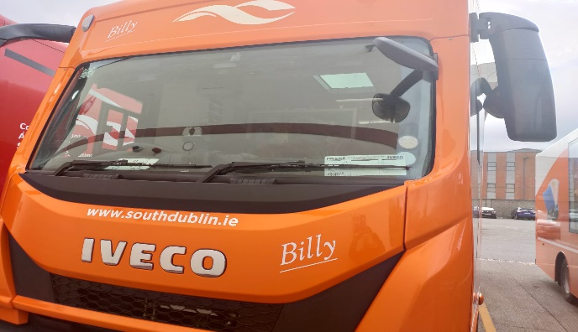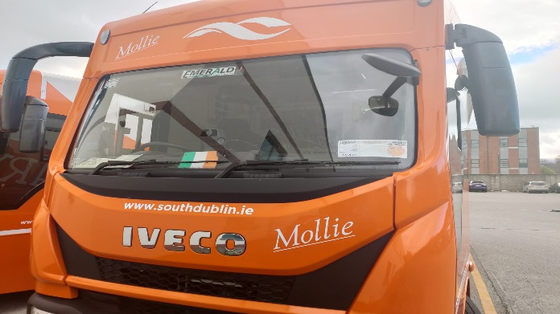

Molly and Billy were officially named on Good Friday. The inspiration for the names came from our recent prize winner of “names the vans” competition at the Rossmore Road stop, Aisha Culligan.
We have plans to respray another of our older vans in the SDCC colours and run another naming competition.
Since introducing the new stops in March, we have had a steady increase in our visitor numbers most notably at Shackleton Drive, Rathfarnham Castle and Cuil Duin. All of our school visits and class set deliveries are at full capacity. The Library@Home continues to be a valued service as many of our patrons have contacted to thank us around Easter time. We hope to continue this over the Summer months as demand is strong. The creche deliveries will ease as Summer holidays draw near and we will have time to focus on some outreach activities in our parks.
We have added Peamount hospital to our hospital visits in May.
See visitor stats chart below for all stops Jan to end of April 2022

