RTFB ACM May 2022
Libraries Report | Ballyroan Library | May 2022

In the month of March, across the county, there were 32,434 library visitors in person with 55,864 Items issued. Ballyroan Library had 12,553 visitors in March, and 14,224 in April.

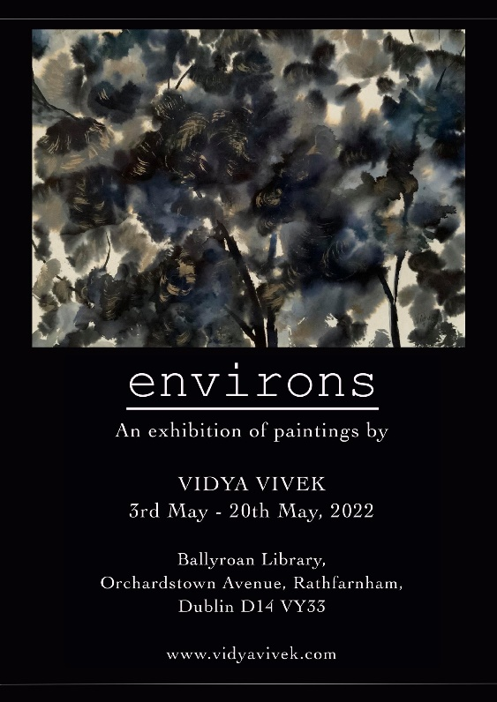
Ballyroan Library Event Highlights

Exhibition
Environs is an exhibition of paintings by artist Vidya Vivek.
Vidya Vivek is an artist from India, now residing in Dublin.
Her works are a reflection of the people, surroundings and the vibrant cultures of which she has been a part.

Lifelong Learning/Bealtaine Events

Every Monday 11:00am – 12:30pm (except Monday 2nd May)
Every Thursday 6:30pm – 8:00pm
Stitched Together Craft Group
Twice-weekly craft skills share sessions.

Monday 9th May at 7:00pm (online event)
4th Battalion Dublin Brigade and the Anglo-Irish Treaty
Join historian Liz Gillis for a discussion of the impact of and reaction to the Anglo-Irish Treaty on the branch of the IRA operational in South Dublin county.

Tuesday 10th May at 11:00am
Crafts with Kim
Learn a new craft with artist Kim Jenkinson.

Saturday 14th May 10:30am, 12:30pm and 2:30pm
Live History Show: Behind Glass
This exciting show has escape room, theatre, and murder mystery elements. Expect to work with all your fellow audience members and the actors as you try to discover which historical figure has been causing chaos at the library!

Wednesday 18 May 10am
Digital Folklore and Storytelling Course
Calling all those with an interest in history and folklore. Join Michael Fortune for the start of this eight-week online which will teach you how to capture and share these stories with easy-to-use technology (e.g. smart phones, tablets and pcs). This course is supported by the Creative Ireland Programme South Dublin County Council.

Wednesday 18th May at 1:00pm
Poetry at Lunchtime
As part of our Bealtaine events, join us for a reading with local poet Daragh Bradish and you’ll also get a chance to step up to the mic to read your own poetry, your favourite poem or reminisce about poems you learned at school.
All welcome!

Wednesday 25th May at 10:30am
Golden Moments Social Club Big Quiz
Test your general knowledge with our fun quiz. Bring a friend or just come along yourself. You might even win a prize!
All welcome!

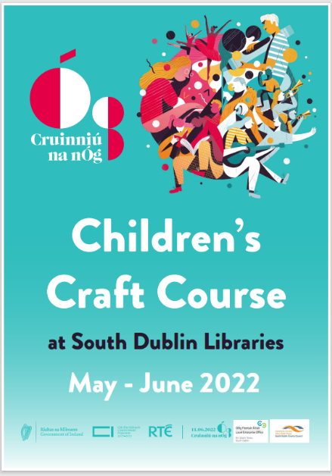
Children’s Events

Cruinniú na nÓg Children’s Craft Course

To celebrate Cruinniú na nÓg, South Dublin County Libraries are running a craft course for children aged 10-12yrs The course will take place one afternoon a week for four weeks in May/June which will be followed by a Craft Fair in Ballyroan and Tallaght Libraries on 11 June 2022. This is a fun creative course where children will be taught to make hand crafted products to sell at one of our fairs. Children will work in teams of 4 and each team will learn to produce a different craft. We will be using a wide variety of new and recycled materials. Children will work together, be taught to use craft tools, learn new skills and focus on their creativity while having fun producing
products for sale.

Regular events:

Every Tuesday at 3.30pm
Spring into Storytime
Our weekly storytime suitable for 3-6 year olds and their grown-ups.

Thursday 5th May at 4:00pm
Junior Book Club
Monthly meeting of our children’s book club.

Tuesday 10th May at 10:00am
Baby Book Club
Monthly club aimed at encouraging a love of reading in your little ones!

Wednesday evenings fortnightly
Coderdojo Rathfarnham
We're back live and in person with CoderDojo Rathfarnham at Ballyroan Library! Coders of all abilities are welcome! Whether an absolute beginner or a more experienced coder, we'll cover something to interest everyone. Suitable for 7-17 year olds.

Fridays at 10:00am
Toddler Time
Songs, stories and play time for wobblers and toddlers.

Every Saturday at 10:00am
Chess Club
Suitable for children aged 7-12, come along and try your chess skills against other enthusiasts! Our Chess Master Fred is on hand with tips and tricks.

Monday 16th May at 3:30pm
Philosophy Club Philosophy Club is a fun, activity based club for children in 4th - 6th class. Anyone can come along and no experience in philosophy is needed. All we need are curious minds!

County-Wide Library Initiatives

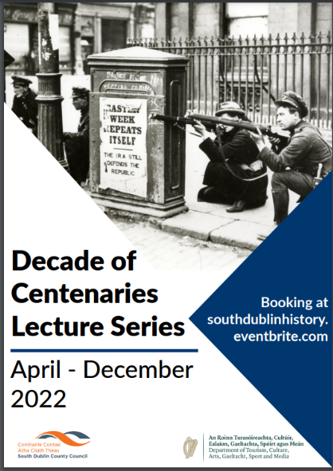
Decade of Centenaries Lecture Series 2022
The Decade of Centenaries Lecture Series for 2022 will explore and reflect on the impact of the pivotal events of a century ago at both a national and local level. The series will run from April to December and will feature historians including Dr. Michael Kennedy, Dr. David McCullagh, Michael Fewer, Cathy Scuffil and Ian Kennelly, as well as our historian in residence Liz Gillis.

Part of the series this year is an online Summer School with Liz Gillis which is a four-week course in July looking at the causes and legacy of the Irish Civil War.

In September and October, genealogist Fiona Fitzsimons will facilitate a six-week course in family history research.

The full list of talks and workshops can be found at www.southdublinlibraries.ie

Think Big Space
On 7th April Libraries in partnership with Amazon Web Services launched the Think Big Space in Tallaght.
The AWS Think Big Space is a new educational lab located beside the Tallaght Luas stop, which aims to inspire an interest in science, technology, engineering, arts, and maths. It provides a dedicated space for students, educators, and communities to explore innovative and imaginative ideas through interactive hands-on technical education. AWS has opened AWS Think Big Spaces across the world; however, this is the first AWS Think Big Space to launch in Europe. An innovative programme of events in Think Big Space will be planned for the rest of the year. Events will take place every month and feature Lego robotics and virtual reality workshops.
Students and teachers will be encouraged to “Think Big” by using their creativity and imaginations as they explore the technologies on offer. The programme will support interactive hands-on learning and appeal to a range of ages. All May workshops in Think Big Space are now fully booked and there is a waiting list for June.

Membership Drive
On Monday April 25th South Dublin Libraries launched our membership drive “Here for you in 2022 and Beyond”.
We want to let all the citizens living, working, or studying in the South Dublin County Council area, know who we are and what we do! The membership drive will continue over the summer months and aims to boost active membership with a medium-term ambition of 30% being achieved by 2027. In terms of current active membership, 72% is shared between Ballyroan, Lucan and Tallaght. Library staff have manned pop-up libraries at various locations over the past two months. Outreach included City West Jobs Fair and a pop-up library at Palmerstown Shopping Centre. The mobile libraries signed up 500 secondary students in Adamstown last week and plan to visit more secondary schools in the coming weeks. Future pop-up libraries will be held in the parks, Clondalkin Round Tower and community centres around South Dublin.

My Little Library Book Bag
All children starting school in September 2022 can get a free Book Bag at their local library.
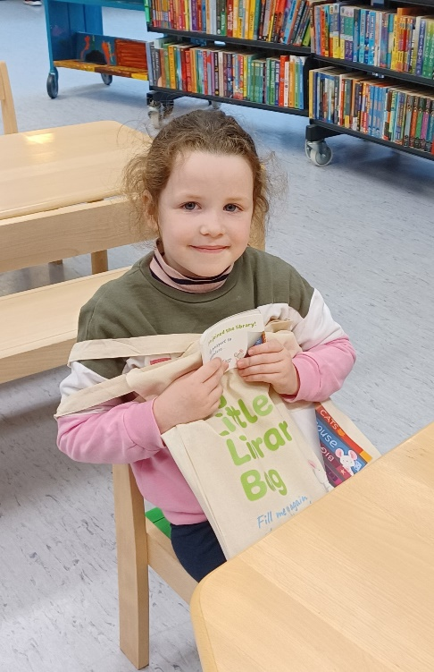
The initiative is a collaboration between libraries and the Department of Children, Equality, Disability, Integration and Youth as part of the First 5 Strategy.
As part of the initiative, a ‘My Little Library Book Bag’ is available free for every child starting school in 2022 to help them to prepare for this big step. Children and their parents or guardians can collect the bags at any library throughout South Dublin County.
Each My Little Library Book Bag contains:
• Three books on starting school, making friends and being comfortable to be yourself
• A story card on going to the library
• A postcard the child can write or draw on and send to their new teacher, or bring to give to the teacher on their first day at school
• Their very own library card and special ‘My Little Library’ cardholder
Book bags are available in both Irish and English.

Libraries Report | Mobile Library | May 2022

They have been named!
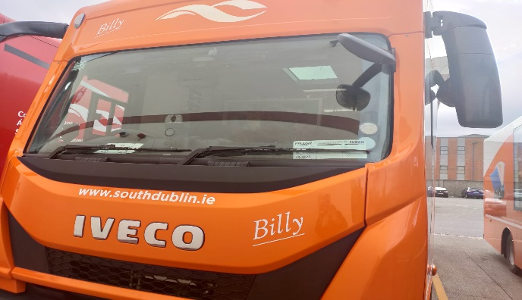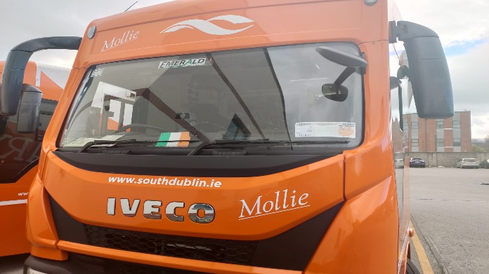

Molly and Billy were officially named on Good Friday. The inspiration for the names came from our recent prize winner of “names the vans” competition at the Rossmore Road stop, Aisha Culligan.
We have plans to respray another of our older vans in the SDCC colours and run another naming competition.
Since introducing the new stops in March, we have had a steady increase in our visitor numbers most notably at Shackleton Drive, Rathfarnham Castle and Cuil Duin. All of our school visits and class set deliveries are at full capacity. The Library@Home continues to be a valued service as many of our patrons have contacted to thank us around Easter time. We hope to continue this over the Summer months as demand is strong. The creche deliveries will ease as Summer holidays draw near and we will have time to focus on some outreach activities in our parks. The collaboration with Ballyroan’s Peter Rabbit event points to other such collaborations in the County. We are currently exploring options.
We have added Peamount hospital to our hospital visits in May.

See visitor stats cart below for all stops Jan to end of April 2022

