Clondalkin ACM April 2022
Libraries Report | April 2022
In the month of March, across the county, there were there were 546 events with an attendance of 8170. There were 338 in-person events with an attendance of 4931. There were 208 online events with an attendance of 3289. There were 153 public mobile stops with an attendance of 2117.

Clondalkin Library
Looking Back at March
We hosted an Awards Presentation, and Exhibition, of artwork for Fairtrade Fortnight. Attended by the Mayor and councillors, there were 25 attendees.
We hosted a successful online Work Matters event, How to Succeed at Online Interviews, on 11th March, which had 8 attendees.
We also hosted three events as part of Seachtain na Gaeilge:
- The History of The Gaelic League: A Talk by Patricia Fogarty (in person, 7 attendees)
- Óga Yoga (in-person, 45 attendees)
- Irish Dance Fitness with School Fitness Ireland (online, 30 attendees)
April
- The 2022 Joe Williams Memorial Lecture: a talk by Padraig Ó Murchú on the Carmelite Monastery at Mount St Joseph in Clondalkin (40 attendees)

Planned Refurbishment of Clondalkin Library
South Dublin County Council and the staff of South Dublin Libraries are fully committed to the delivery of an improved library service in Clondalkin.

Clondalkin is unique in South Dublin as the sole heritage building in the branch network. It is a two-storey building, with a total floor area of 330 Sq. M. This presents challenges, not only in terms of space provision but in terms of universal accessibility. From the point of view of overall visitor experience, Clondalkin doesn’t compare well with the other libraries in our network in terms of the range of services offered and quality of interior decoration. This is borne out by a comparison of visitor statistics from 2019, which showed that for every hour open, Clondalkin had one third of the visitors of Ballyroan and Tallaght, and half of Lucan’s.

Over the years use of space in libraries has changed; when Clondalkin Library opened it was a reading room, providing access to daily newspapers with very little publicly accessible shelving. It is time to look again at the allocation of space in Clondalkin to arrive at a stock level for the branch that is appropriate for the size of the building and that allows us the flexibility we need to deliver other services, such as study spaces, events, workshops, etc.

With the introduction of the national library catalogue and distribution service, library members have access to a collection of 12 million items. If we don’t have what you’re looking for on the shelf, we can get it for you within about a week.

In terms of the recommencement of in-branch events post-covid, this has been postponed until after the Easter weekend to allow for a deep clean of the building.

Although in the very early stages of concept development, it is our ambition to refurbish Clondalkin Library to provide a well-planned, effective public library and civic space, open, welcoming, and accessible to all.

Support for Ukrainians arriving into South Dublin
We in South Dublin Libraries wish to reach out and offer support in whatever way we can to Ukrainian refugees arriving into Ireland. We are currently putting together a welcome pack in Ukrainian and are in the process of acquiring suitable book stock. In addition we offer:
- Library membership (no ID or proof of address required)
- Meeting space
- ‘Hangout’ space for parents and children
- Quiet study space
- Computer/Internet access, printing, photocopying and scanning
- Online and in person language learning
- Regular children’s events including weekly Story Time and Parent and Toddler group
- Regular events for adults
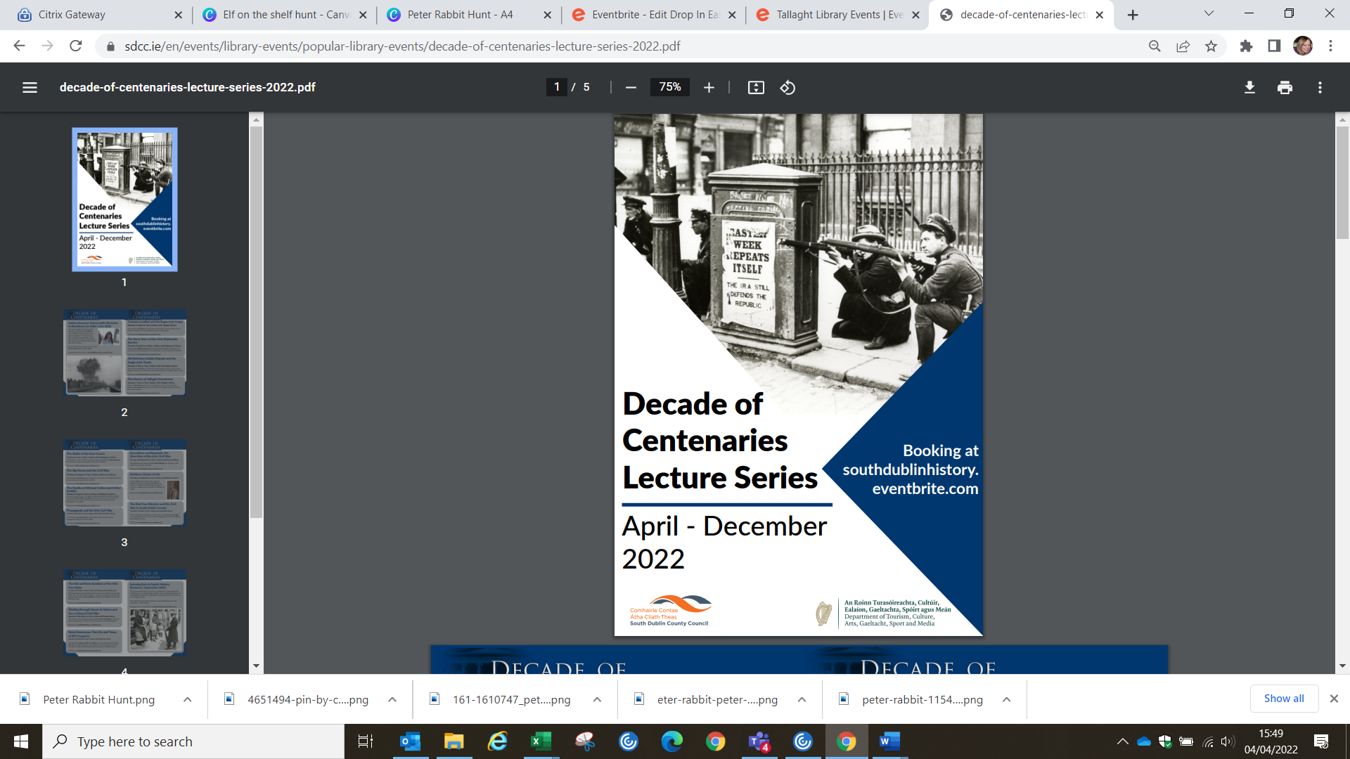
Decade of Centenaries 2022
Lecture Series
The Decade of Centenaries Lecture Series for 2022 will explore and reflect on the impact of the pivotal events of a century ago at both a national and local level. The series will run from April to December and will feature historians including Dr. Michael Kennedy, Dr. David McCullagh, Michael Fewer, Cathy Scuffil and Ian Kennelly, as well as our historian in residence Liz Gillis.

Part of the series this year is an online Summer School with Liz Gillis which is a four-week course in July looking at the causes and legacy of the Irish Civil War.

In September and October, genealogist Fiona Fitzsimons will facilitate a six-week course in family history research.

The full list of talks and workshops can be found at www.southdublinlibraries.ie

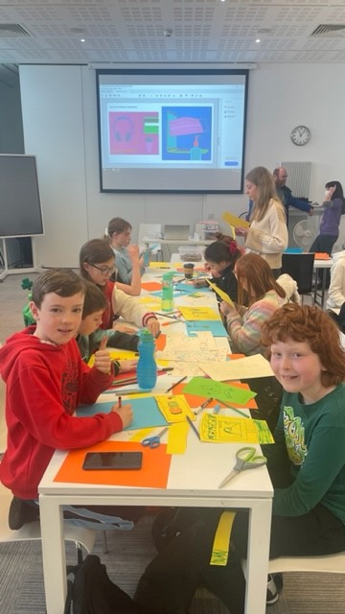
Children’s Covid Memories Project

South Dublin Libraries are working with primary schools all across the county on the Covid Memories Project which involves the Decade of Centenaries Historian-in-Residence, Liz Gillis and the Artist-in-Residence, Eva Kelly. We will hold a number of workshops with students in their local libraries where they will learn about primary sources, why they are important in telling stories from the past, and how art has been used to interpret historical events. The students will be asked to draw or paint an image of what living through the pandemic was like for them.The drawings will then be placed in the South Dublin Libraries Archive, where they will be stored safely for future generations to discover. Most importantly, this project ensures that the voices/memories of the children who lived during this momentous event will be seen and heard.

Speaking about the project, Liz Gillis said , "As Historian-in-Residence for South Dublin County Council, it has been my privilege to be engaging with schools, sharing the history of how their local community played a part in the Irish Revolution. However in my research of this time, one voice has always been missing – that
of the children who lived 100 years ago. 2020 was a year we will never forget, the pandemic hit and the whole world stopped. Everyone was affected in one way or another. It is a watershed moment in our lives, one that future historians will research and study. That is how the idea for this project came about. There will be many, many stories left by adults about what it was like to live through the pandemic, but what about the children. Their stories and how Covid impacted them is just as important and it is vital that we record their memories for future research."

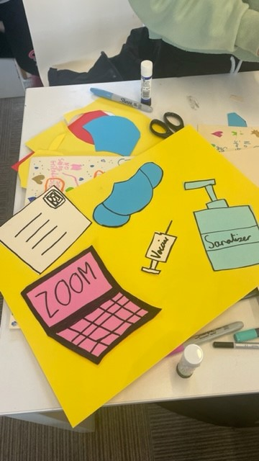
The project kicked off in Ballyroan Library with Rathfarnham Parish National School on 16th March, and workshops will take place in all libraries during May and June, ensuring that the whole county is represented in the archive.
Mobile Libraries | March/April 2022

Since introducing our new timetable, we have seen an increase in visitor numbers. In February, the average visitor number was 10.2 per stop. March average is 13.8 and noticeably 15.5 in the last 2 weeks in March.

The highest increase came from a new stop at Shackleton Drive in Dodsborough. Also, the Rathfarnham Castle stop is generating a lot of interest.
The City West, Rathcoole, Saggart, Newcastle , Kingswood Cross routes are performing very well.
Our home deliveries (109) and creche drops are busy as usual. We visited 15 schools in March as part of the scheduled school programme and we visited 2 extra who requested a visit. We are hoping to visit some Early learning Centres in the area that have asked for visits when the schools close for Easter. The Bloomfield Rehab. Centre visit is now scheduled for a monthly visit. We are hoping to add Peamount Hospital to our residential home visits.
Plans are still afoot to get names on our new Mobiles and organise a photo shoot in one of South Dublin’s beautiful parks.

