**ACM Report March 2022**

Including mobiles there were 466 events in South Dublin Libraries throughout February with an attendance of 5217. There were 421 in-person events with an attendance of 4411 and 45 online events with an attendance of 806.

**NCL:**

Total number of events = 107

Engagement with outside organisations:

GIY

Casp

Walk

HSE

Sports Partnership

South Dublin County Partnership:

**Highlights:**

Local Enterprise week took place from March 7th – 13th.

Each branch library held one event in their library during the week-organised through LEO.

On 10th March 2 Local Entrepreneurs were interviewed by Noel McNamara before 60 T/Y students in North Clondalkin library - with a view to encouraging to encouraging a spirit of entrepreneurship.

**SNAG events Programme**: As part of SNAG, NCL hosted 6 events ranging from STEAM events, arts & crafts to Irish dancing sessions.

Lego sessions with local schools were turned into graphic novels .

Creative Campus launch & exhibition:

Creative Campus project 2022-**Creative Campus** is an annual **Tallaght Community Arts project** in partnership with South Dublin County Council **Arts** Office and NCAD.

Two graduate students from NCAD worked with a secondary school group from Collinstown Park over 6 weeks - and produced an exhibition of the highest quality entitled ***Me-and-er-ing*** The Creative Works were inspired by the library and its geographical location, response from the public has been extremely positive.

**Lucan Library Highlights March 2022**

**Seachtain na Gaeilge 1st – 17th March**

Lucan Library will host events for schools including Oga Yoga; Irish Dancing Fitness; a Trath na gCeist created and facilitated by TY students for primary school group; and author Una Minh-Kavanagh who will be interviewed by TY students about careers in Irish.

**Monday 14th March 7pm**

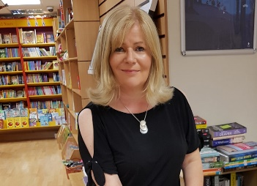 **Coping Strategies for Children with Anxiety** – online talk for parents by Fiona Forman, (*M. Sc Applied Positive Psychology).* Fiona will help participants to understand the symptoms and causes of anxiety in children; learn how to support children with anxiety and develop a range of evidence-based coping strategies to help children to manage anxiety.

Online talk, book via Lucan Library Eventbrite.

**Tuesday 29th March 11am**

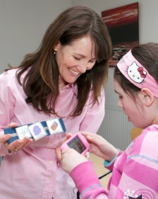**Autism 101 with Lisa Domican, founder of the Grace App**.

Autism 101 is a short, to the point, online video course to quickly help you get to grips with supporting someone with Autism. It will be available to you for free to view in your own time from 22nd March once you sign up for this workshop. At the 29th March Q&A workshop, Lisa will host a live zoom workshop to answer your questions, and help you tailor some strategies to your own circumstances.

Online talk, book via Lucan Library Eventbrite

**IT Services Update**

From March 29th, South Dublin Libraries, along with libraries all over the country, will introduce a new online library system with improved functionality to help us provide a better service to library members.

The new system will have many improved features.

• Logging into your library account, and managing your reserves, reading lists and contact information will be much easier.

• The catalogue will be easier to use and will have images and recommendations as well as themed bookshelves and links to useful resources.

• You will be able to find, borrow and reserve eBooks and eAudiobooks as well as physical books in one searchable catalogue.

• You will be able to renew your library membership online for the first time.

• Our new system will also look and work great on mobile phones and tablets.

Unfortunately, there will be some service disruption in the lead up to the launch of the new system.

From March 21st – 28th, your online account will be temporarily unavailable and you will not be able to reserve items online.

During this time, you will still be able to browse and borrow in your library and other library services, including eServices such as Borrowbox, Libby and PressReader will not be affected.

All loans will be extended so you don’t need to worry about renewing items while your account is unavailable.

Please keep an eye on our website and social media channels for further updates.