**Clondalkin Library ACM**

Since the lifting of Covid restrictions in-house events have resumed in South Dublin Libraries. There were 462 events in February with an attendance of 4397. There were 417 in-person events with an attendance of 3832. There were 45 online events with an attendance of 565 **Looking Back at February – Clondalkin Library**Kim Jenkinson hosted an online arts & crafts workshop for children, celebrating Chinese New Year, which was well-attended.  
  
We hosted a sold-out Creative Writing Workshop for children with Mad4Tales  
  
To celebrate Harry Potter Book Night, we hosted a Harry Potter themed Arts & Crafts for children with Aoife Munn, which sold out.   
  
We completed our popular 6 week Beginners & Improvers Irish Class and are looking at doing a follow-on course.

|  |  |  |
| --- | --- | --- |
| **March Events** | | |
| Title of Event/video | Blurb | Booking link |
| Fairtrade Fortnight Art Competition Presentations  2nd March, 4pm (in-person) | Local schools were presented with awards for artwork themed around Fairtrade Fortnight. Mayor Peter Kavanagh and Cllr. Francis Timmons were in attendance. | n/a |
| How to Succeed at Online Interviews, with Joe Morris from CATTS Ireland  11th March, 11am (online)  This event is part of Local Enterprise Week. | In this 60 minute talk, you will learn key tips and ideas from interview preparation to presentation to help you stand out in an online interview. (Or any interview!)  If you are interviewing for a role which will need to be performed from home all or some days of the week, you will learn what traits managers will need from people who are working from home.  Booking from Wednesday 23rd February at 10:00am | [http://clondalkinlibrary.eventbrite.com](http://clondalkinlibrary.eventbrite.com/?fbclid=IwAR3x1sXtIpArjV_7d8H-jjd5efYCX6HCYwmR31XCP1v1ZfgtaghOsO9z5ok) |
| The History of The Gaelic League: A Talk by Patricia Fogarty.   15th March, 7pm (in-person)  Presented as part of Seachtain na Gaeilge. | Join Patricia Fogarty as she gives an in-person talk on the History of The Gaelic League/ Conradh na Gaeilge, from its foundation in 1893 to its role in Ireland today.  Booking from Tuesday 1st March at 10:00am | [http://clondalkinlibrary.eventbrite.com](http://clondalkinlibrary.eventbrite.com/?fbclid=IwAR3x1sXtIpArjV_7d8H-jjd5efYCX6HCYwmR31XCP1v1ZfgtaghOsO9z5ok) |

**Libraries Report | Mobile Libraries | March 2022**

Mobile libraries have reviewed all the current stops and will operate a new timetable from 7th March. Stops which are very close to our two newest libraries, Castletymon and North Clondalkin will be taken off the schedule and replaced with stops where there is less access to a library. There are also a few stops where interest has significantly declined and our statistics will support these decisions. We also want to attract new families in new areas in the County. The new timetable will run for 6 months and will be reviewed according to public interest and attendance at each stop.

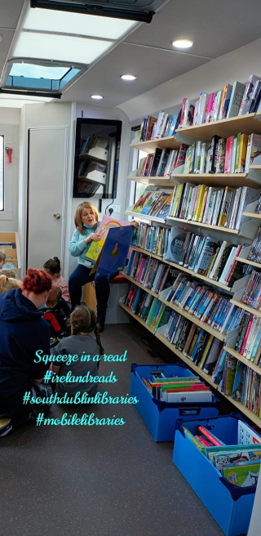

New stops are

* Silken Park Avenue, Kingswood Cross
* Johnsbridge Avenue, Griffeen
* Shackleton Drive, Dodsborough
* Parklands Parade, Citywest
* Citywest village
* Greydon Terrace, Newcastle
* Rathfarnham Castle
* The Priory, Grange road
* Templeroan Lawn, Knocklyon

Schools service has resumed almost fully now to the 16 schools we serve and added to this we also support the delivery of classroom book club sets to 25 Primary schools (Feb stats) from our book club services in HQ. The Library @Home still continues as a much appreciated and valued service to our 111 library customers as are the book drop off deliveries to creches (15 in Feb).

Mobile libraries got involved in the Squeeze in a Read events for Library Reads by bringing our vans out to two Early Learning centres in Jobstown and Firhouse. We also visited Bloom Field Health services on 23rd Feb for the residents to select some reading material. We hope to rollout a service to similar hospitals in the County on Wednesday and Thursday afternoons.

We look forward to some new stops and some new readers in March!

**Library Programming and Communications Update:**

**Seachtain na Gaeilge:**

South Dublin Libraries are heavily involved in the programming of South Dublin’s Seachtain na Gaeilge events. We have been working in association with Aras Chronain and South Dublin County Council Communications Department to bring the very best to the citizens of South Dublin this March.

**Highlights include:**

|  |  |
| --- | --- |
| * Bilingual Irish Dance Fitness sessions for Schools with School Fitness Ireland. * Irish Language Yoga for schools with Oga Yoga. * Bilingual Science workshops for schools with Anyone4Scince. * Coding workshops as Gaeilge with Academy of Code. * Pop up Gaeltachts * Story telling as Gaeilge le Seosamh Ó Maolalaí |  |

Click below for a brochure of SNAG events.

[https://www.sdcc.ie/en/news/snagact2022-web-.pdf](https://www.sdcc.ie/en/news/snagact2022-web-.pdf?fbclid=IwAR20nmopCiOp4tD4xaDrrhcg7VpTVeODe8gmlhfxJCf2mCLE30xVjanQenU)