Proposed Amendment (No. 1)

Adamstown Strategic Development Zone
Planning Scheme 2003

Manager’s Report on Consultation

28 April 2006

Proposed Amendment (No. 1)
Adamstown Strategic Development Zone Planning Scheme 2003

Manager’s Report on Consultation

28 April 2006

Contents

Part 1 : Introduction
Part 2 : Manager’s Recommendations

Appendices

- Summary of responses and recommendations on submissions
- Submissions
- Newspaper notices

Part 1 : Introduction

Background

  - The Adamstown Strategic Development Zone (SDZ) Planning Scheme was approved in September 2003 following an appeal to An Bord Pleanala. South Dublin County Council is both the Planning Authority and designated Development Agency for Adamstown.

  - Part IX of the Planning and Development Act 2000 deals with Strategic Development Zones and development thereof. Section 171 (1), (2) and (4) of the Act deal specifically with the amendment of planning schemes and state:
- A planning authority may by resolution, with the consent of the relevant development agency, amend or revoke a planning scheme made under this Part.
- Where a planning authority proposes to amend a planning scheme under this section it shall comply with the procedure laid down in section 169 and that section shall be construed accordingly.
- The amendment or revocation of a planning scheme shall not prejudice the validity of any planning permission granted or anything done in accordance with the terms of the scheme before it was amended or revoked except in accordance with the terms of this Act.

  - Section 169 referred to in (2) above sets out the procedures for preparing a planning scheme (and by default amendments to an approved planning scheme). Key items relevant to the consultation procedure are as follows:

- Notice & copies of the draft to be sent to the Minister, the Board and prescribed authorities;
- Notice to be published in one or more newspapers circulating in the area;
- A copy of the draft to be available for inspection at a stated place for a period of not less than 6 weeks;
- Written submissions or observations on the draft made within the stated period to be taken into consideration in deciding upon the scheme;
- A report on the submissions or observations to be presented to the Council not longer than 12 weeks after giving the newspaper notice.

Purpose of the Proposed Amendment

  - To facilitate an improved schools and leisure campus layout within Adamstown further to detailed design work in conjunction with the Department of Education & Science and Chartridge Ltd.

Description of Proposed Amendment

Relocation of the northern part of the combined schools and leisure campus site, to an immediately adjoining site to the south-west, which is currently within the ‘Adamstown Square’ development area. Concurrent relocation of the permissible housing development to be displaced from ‘Adamstown Square’, to the north-east. This includes revision of the boundaries of the ‘Adamstown Square’ and ‘Adamstown Castle’ development areas.

  - The overall quantum of residential and commercial development permissible in the Adamstown SDZ is to remain unchanged.

  - The phasing schedule set out in the SDZ Planning Scheme is to remain unchanged.

Details of Development to be Facilitated

  - The proposed amendment is to allow a more comprehensive layout for two x 16 classroom primary schools and a 1,000 pupil secondary school together with associated play areas, ball courts and playing pitches. A sports hall, community centre, crèche and commercial leisure facility with swimming pool are also to be provided. School access to the sports hall, pitches and swimming pool will be facilitated.

Consultation

  - Notice and details of the proposed amendment was sent to the Minister for Environment, Heritage and Local Government, An Bord Pleanala and the Environmental Protection Agency on 17 February 2006.

  - A copy of the proposed amendment to the Adamstown SDDZ Planning Scheme was made available for inspection in the Council offices at Tallaght, Lucan library and on the Council’s website for a six week period running from 17th February to 31st March 2006 inclusive. Two public notices to this effect were published in the Irish Times and the Lucan Gazette on 17th February advising that written submissions or observations on the proposed amendment would be accepted up to 4.30pm on Friday 31st March 2006.

Key issues arising from the submissions

  - Eight written submissions to the proposed amendment were made in total. A summary of the items raised in each submission is included in Appendix 1 to this report, and copies of the submissions are included in Appendix 2. A brief summary of the submissions is set out below with the key issues identified.

  - Health Service Executive - States that it welcomes the proposed ‘elongation’ of the school and leisure campus but note that provision has not been made for a Primary Care/Health Centre Site within the revised scheme. Request that the Council ensures, as a condition to the proposed amendment, that provision is made for a suitable site to accommodate a 2500m2 Primary Health Care facility within the scheme.

  - Tanaiste and Minister for Health and Children - Supports the views expressed by the Health Service Executive in respect of making provision for a Primary Healthcare facility in Adamstown.

  - Deliver it Right Campaign - Raises no problem with the changed layout of the primary & secondary schools but are concerned about the new location on Health & Safety grounds. States that the new proposed layout moves the schools approximately 57m closer to the power lines (from approx. 90-100m down to 30-40m) which is the minimum distance of 30m specified by An Bord Pleanala and stated in paragraph 2.3.61 of the Planning Scheme and that the electricity pylon is shown approximately 15m from the perimeter building which is in breach of paragraph 2.3.61. States that the amendment should state that the power line will be diverted to maintain the existing 90-100m distance from the schools or be placed underground; or the amendment should otherwise be rejected.

  - Councillor Derek Keating - Raises concerns that the proposal to move the schools means that the distance from them to the power lines will be reduced from approx. 90-100m to 30-40m. States that the power line should be diverted to maintain the existing 90-100m distance from the schools or be placed underground.

  - Paul Gogarty TD and Councillor Fintan McCarthy - Raises concerns about proximity of the 220KV power lines to the proposed school location. Requests that a condition be attached to the amendment requiring that the power lines are buried or diverted in the interest of public health.

  - Department of Education and Science - States that it has been involved in detailed design discussions regarding the school buildings in this area of Adamstown. Considers that the proposed variation to the planning scheme will enable an improved design of the layout for the schools’ site and welcome the initiative.

  - Department of the Environment, Heritage and Local Government - Is supportive of the proposed variation and has no comments to make.

  - Castlethorn Construction - States that it considers that the proposed variation to the planning scheme will enable an improved design of the layout for the schools’ site and welcome the initiative.
Part 2 : Summary of Manager’s Response and Recommendations

Manager’s Responses to issues raised

2.1 Two key issues were raised through the consultation process:

  - Provision of Primary Health Care facilities at Adamstown.
  - Proximity of the relocated schools and other buildings to overhead electricity power lines crossing the southeastern area of Adamstown.

Primary Health Care Facilities

  - The Adamstown SDZ Planning Scheme 2003 does not make any specific phasing provision for the provision of health care facilities as none were identified by the Health Board at the time the Planning Scheme was drafted. However, paragraph 2.6.40 states that it is expected that the Health Board would indicate a requirement for a health centre in the future.

  - Discussions between the developers and health providers including the Health Service Executive on the provision of health care facilities in Adamstown are currently in hand.

  - The provision of primary health care facilities to serve the new population of Adamstown is desirable in the interest of sustainability and it is considered that the Adamstown SDZ Planning Scheme 2003 should be amended to address the provision of a primary health care facility with a minimum floorspace of 2500m2 at latest by Phase 5 (3401 – 4200 dwellings).

Proximity to overhead electricity power lines

  - Key concerns raised by Deliver it Right Campaign, Cllr Keating, Cllr McCarthy and Paul Gogarty T.D. are that, as a result of the proposed amendment, the distance between the schools and the 220kv overhead power line will be reduced from approx. 90-100m to 30-40m (distances as stated in submissions), and that other buildings on the site will be located some 15m from the closest electricity pylon (distance as stated in submission). In view of this, they request that either the proposed amendment should be rejected or the power lines be relocated or undergrounded.

  - Paragraph 2.3.61 of the Planning Scheme is a direct requirement of An Bord Pleanala and states ‘There is a 220kv powerline traversing the south-eastern portion of the lands. This powerline shall be diverted or placed underground if permanent occupied buildings are constructed within a minimum distance of 30 metres of it.’

  - The proposed Amendment No. 1 includes a revised illustrative layout plan for the area of the Planning Scheme affected. The revised illustrative plan shows that the primary schools will remain within the ‘Primary and Post Primary Schools’ site allocated in the Planning Scheme 2003 while the post primary school is relocated immediately to the west of this site. The revised illustrative layout plan shows that both the primary and secondary schools will be located at least 70m from the northernmost conductor of the overhead power line located to the south. This minimum distance is more than double the 30m distance referred to in Paragraph 2.3.61 of the Planning Scheme and substantially greater that the 30-40m referred to in the submissions made on the proposed amendment. With respect to other ‘non-educational’ buildings proposed on the site, it is not intended to locate any of these buildings within 30m of either the power line or pylon.

  - The proposed variation will not therefore result in the schools and other buildings on the site resulting from the proposed amendment contravening the 30m minimum distance from the over head 220kv power lines specified in Paragraph 2.3.61 of the Adamstown SDZ Planning Scheme 2003 and therefore, the requirement to underground or divert the overhead power lines is not triggered.

  - It should be noted that, notwithstanding approval of the proposed amendment, the provisions of paragraph 2.3.61 of the Planning Scheme 2003 will continue to stand, i.e. the powerline will need to be diverted or placed underground if any permanent occupied buildings are constructed within a minimum distance of 30 metres of it.

  - The concern expressed by the public in relation to locating buildings in proximity to overhead power lines in the context of perceived risks from Electro Magnetic Fields (EMF) is understood. There has been significant research into the effects of EMF and proximity to power lines. In 1998, the International Commission on non-ionising radiation protection (ICNIRP) published guidelines on exposure to electric, magnetic and electromagnetic fields. For the general public these are 5kV/m for electric fields and 100 microtesla (uT) for magnetic fields respectively.

  - In the case of both electric and magnetic fields, the strength of the fields declines rapidly with distance from an overhead power line. At a distance of 70m from a 220kv powerline (as in the case of the Adamstown schools), the magnetic field will have declined to less than 0.1 microtesla (uT) which is less than many domestic appliances (the magnetic field 30cm from a TV screen is 2.0 microtesla). Electric fields are screened by buildings, hedges, fences and trees so that inside a building, there will be very little electric field from a near-by power line. At 50m from a 220kv tower, the typical electric field will be 0.06 kV/m.

Manager’s Recommendations in relation to submissions made

  - With respect to the issues raised in the submissions, it is recommended that:

- In order to address the submissions in respect of provision of health care facilities in Adamstown, that an amendment is made to Phase 5 (3,401 – 4,200 dwellings) of the Phasing and Implementation section of the Adamstown SDZ Planning Scheme 2003 (paragraph 4.2.11 on page 94) to include provision for additional floorspace in Adamstown (at least 2500m2) for a Primary Health Care as follows:
- The provision of a Primary Health Care Facility with a minimum floorspace of 2500m2

- That no provisions are made with regard to undergrounding or diverting the overhead powerline southeast of Adamstown to address submissions made in respect of the location of buildings arising from the proposed amendment.

Appendix 1

Summary of responses and recommendations on submissions

Submission | Summary | Response | Recommendation
Fergal Black  LHO Manager – Dublin West  Health Service Executive  Cherry Orchard Hospital  Ballyfermot  Dublin 10 | Welcomes the proposed ‘elongation’ of the school and leisure campus but note that provision has not been made for a Primary Care/Health Centre Site within the revised scheme. Requests that the Council ensures, as a condition to the proposed amendment, that provision is made for a suitable site to accommodate a 2500m2 Primary Health Care facility within the scheme. | Although, the Adamstown SDZ Planning Scheme 2003 does not make any specific phasing provision for the provision of health care facilities, paragraph 2.6.40 states that it is expected that the Health Board would indicate a requirement for a health centre in the future.  The provision of primary health care facilities is considered beneficial to support the new population at Adamstown. | It is recommended that the Adamstown SDZ Planning Scheme 2003 be amended to include a requirement that a Primary Health Care Facility with a minimum floorspace of 2500m2 be provided in Adamstown at latest by Phase 5.
Mary Harney TD  Tanaiste & Minister for Health & Children | Supports the views expressed by the Health Service Executive in respect of making provision for a Primary Healthcare facility in Adamstown. | The provision of primary health care facilities is considered beneficial to support the new population at Adamstown. | It is recommended that the Adamstown SDZ Planning Scheme 2003 be amended to include a requirement that a Primary Health Care Facility with a minimum floorspace of 2500m2 be provided in Adamstown at latest by Phase 5.
Deliver it Right Campaign  c/o Sean Giblin  2 Finnstown Fairways  Lucan  Co. Dublin | Raises no problem with the changed layout of the primary & secondary schools but are concerned about the new location on Health & Safety grounds. States that the new proposed layout moves the schools approximately 57m closer to the power lines (from approx. 90-100m down to 30-40m) which is the minimum distance of 30m specified by An Bord Pleanala and stated in paragraph 2.3.61 of the Planning Scheme and that the electricity pylon is shown approximately 15m from the perimeter building which is in breach of paragraph 2.3.61. States that the amendment should state that the power line will be diverted to maintain the existing 90-100m distance from the schools or be placed underground; or the amendment should otherwise be rejected. | The illustrative layout plan for the proposed amendment shows that the primary and secondary schools will be located at least 70m from the closest conductor of the overhead power line – a substantially greater distance that the 30-40m referred to in the submission and more than double the 30m minimum distance from the powerlines referred to in Paragraph 2.3.61 of the Planning Scheme. With respect to other ‘non-educational’ perimeter buildings proposed on the site, it is not intended to locate any of these buildings within 30m of either the power line or pylon.  The provisions of paragraph 2.3.61 of the Planning Scheme 2003, i.e. the powerline will need to be diverted or placed underground if permanent occupied buildings are constructed within a minimum distance of 30 metres of it, are therefore not triggered. | The proposed variation will not result in the schools and other buildings on the site resulting from the proposed amendment contravening the 30m minimum distance from the over head 220kv power lines specified in Paragraph 2.3.61 of the Adamstown SDZ Planning Scheme 2003, therefore no change recommended.
Cllr Derek Keating  66 Beech Park  Lucan  Co. Dublin | Proposed layout moves primary school to within 30-40m of overhead power lines. Therefore the lines should be undergrounded or diverted. | The illustrative layout plan for the proposed amendment shows that the primary and secondary schools will be located at least 70m from the closest conductor of the overhead power line – a substantially greater distance that the 30-40m referred to in the submission and more than double the 30m minimum distance from the powerlines referred to in Paragraph 2.3.61 of the Planning Scheme. The provisions of paragraph 2.3.61 of the Planning Scheme 2003, i.e. the powerline will need to be diverted or placed underground if permanent occupied buildings are constructed within a minimum distance of 30 metres of it, are therefore not triggered. | The proposed variation will not result in the schools and other buildings on the site resulting from the proposed amendment contravening the 30m minimum distance from the over head 220kv power lines specified in Paragraph 2.3.61 of the Adamstown SDZ Planning Scheme 2003, therefore no change recommended.
Paul Gogarty TD &  Cllr Fintan McCarthy  Lucan Green Party  Room 4  Muintir Na Tire Hall  Main Street  Lucan  Co. Dublin | Concerned about proximity of amended school location to overhead power lines. The lines should be undergrounded or diverted. | The illustrative layout plan for the proposed amendment shows that the primary and secondary schools will be located at least 70m from the closest conductor of the overhead power line – a substantially greater distance that the 30-40m referred to in the submission and more than double the 30m minimum distance from the powerlines referred to in Paragraph 2.3.61 of the Planning Scheme. The provisions of paragraph 2.3.61 of the Planning Scheme 2003, i.e. the powerline will need to be diverted or placed underground if permanent occupied buildings are constructed within a minimum distance of 30 metres of it, are therefore not triggered. | The proposed variation will not result in the schools and other buildings on the site resulting from the proposed amendment contravening the 30m minimum distance from the over head 220kv power lines specified in Paragraph 2.3.61 of the Adamstown SDZ Planning Scheme 2003, therefore no change recommended.
Tony Dalton  Principal Officer  Planning & Building Unit  Department of Education & Science  Portlaoise Road  Tullamore  Co. Offaly | Has been involved in detailed design discussions regarding the school buildings in this area of Adamstown. Considers that the proposed variation to the planning scheme will enable an improved design of the layout for the schools’ site and welcome the initiative. | Noted | No change recommended.
Brain Kenny  Spatial Policy Department of Environment, Heritage & Local Government | Supportive of the proposed variation and no comments to make. | Noted | No change recommended
Castlethorn Construction  c/o Stephen Little & Associates  87 Harcourt Street  Dublin 2 | Considers that the proposed variation to the planning scheme will enable an improved design of the layout for the schools’ site and welcome the initiative. | Noted | No change recommended

Appendix 2

Submissions received in relation to Proposed Amendment (No.1) to the Adamstown SDZ Planning Scheme 2003

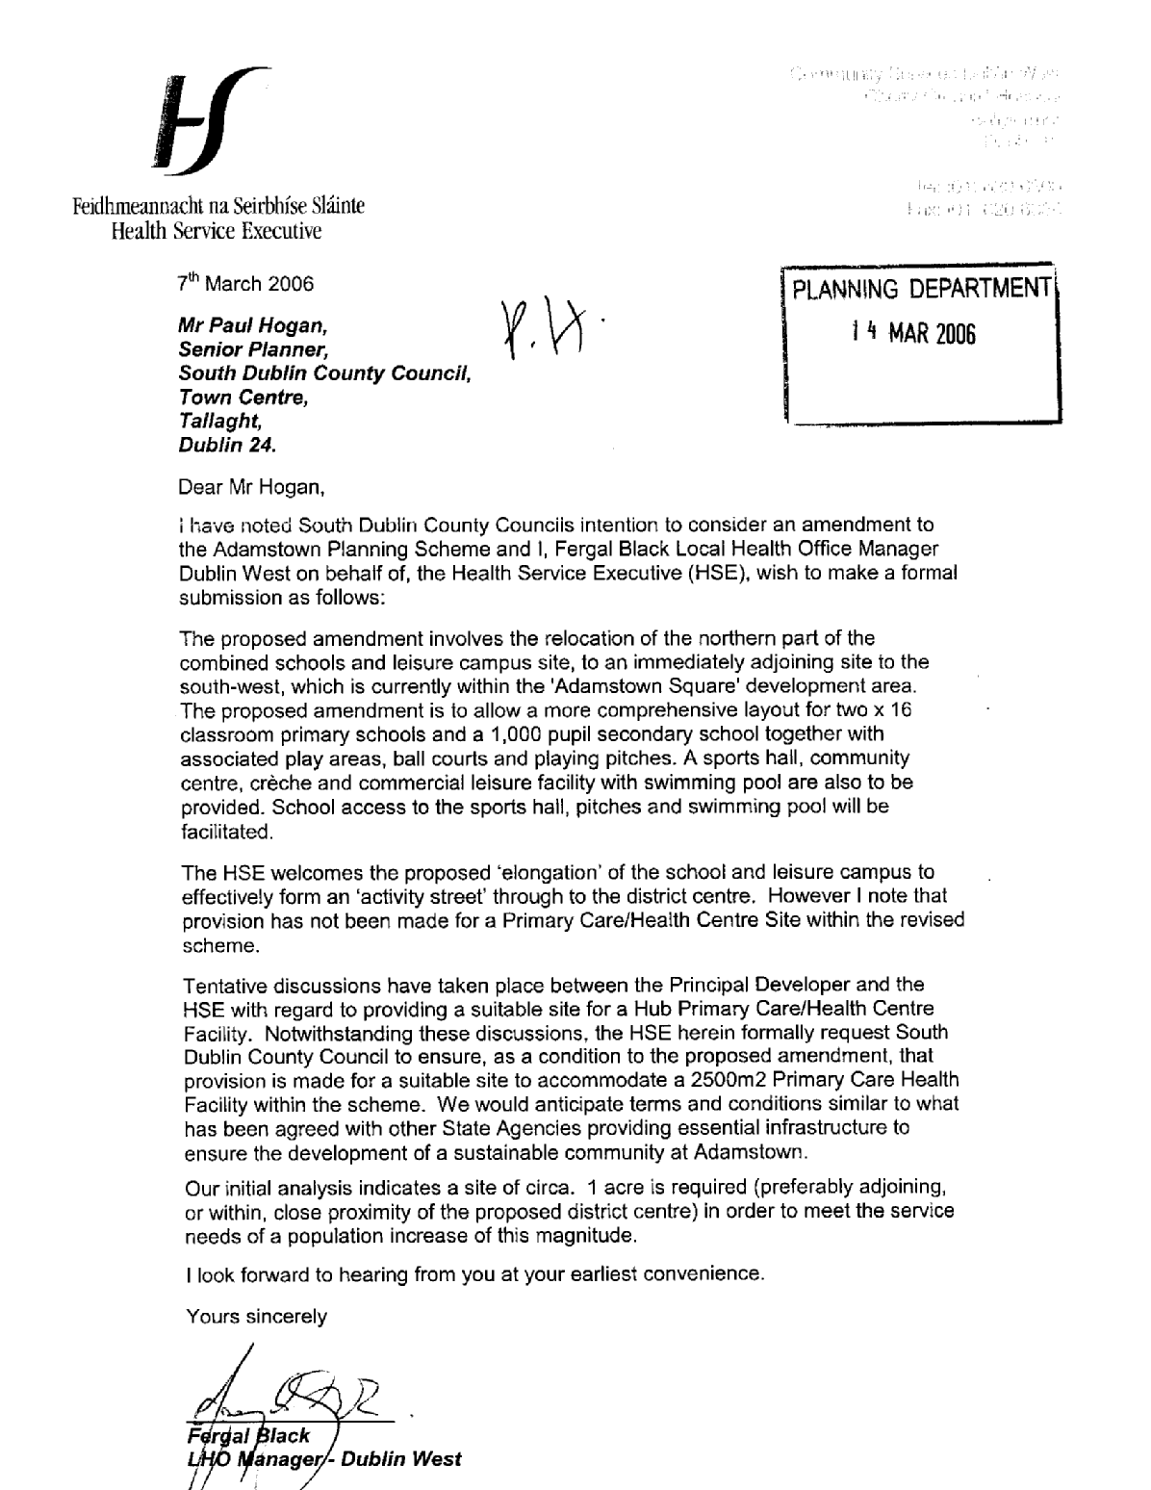

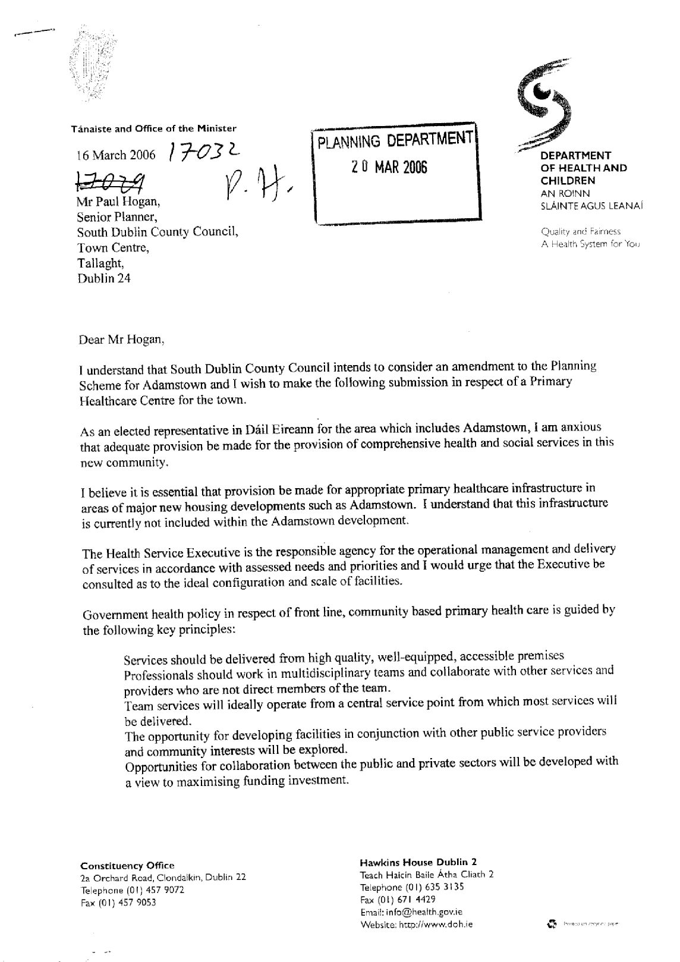

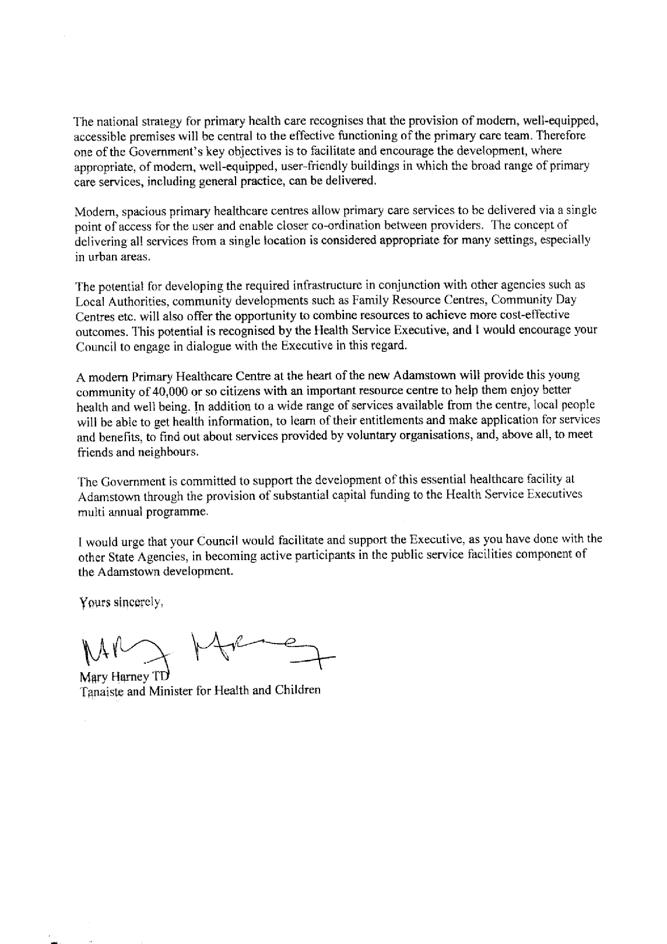

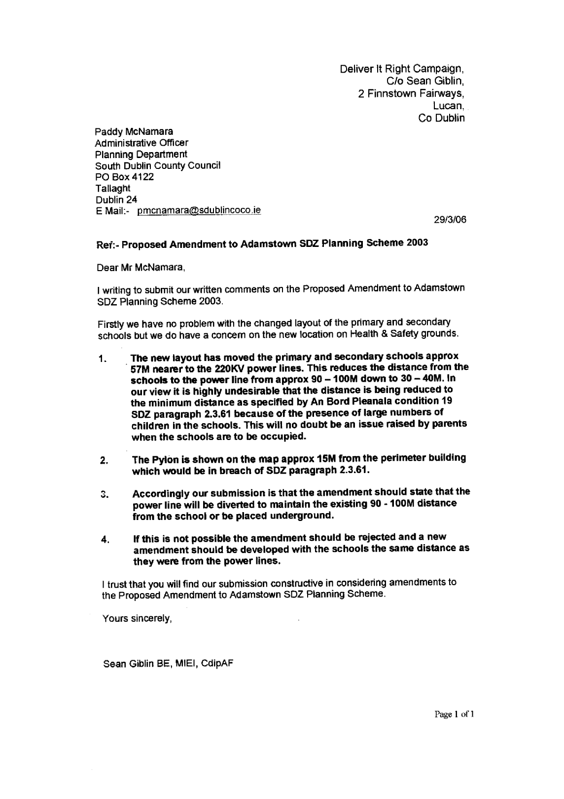

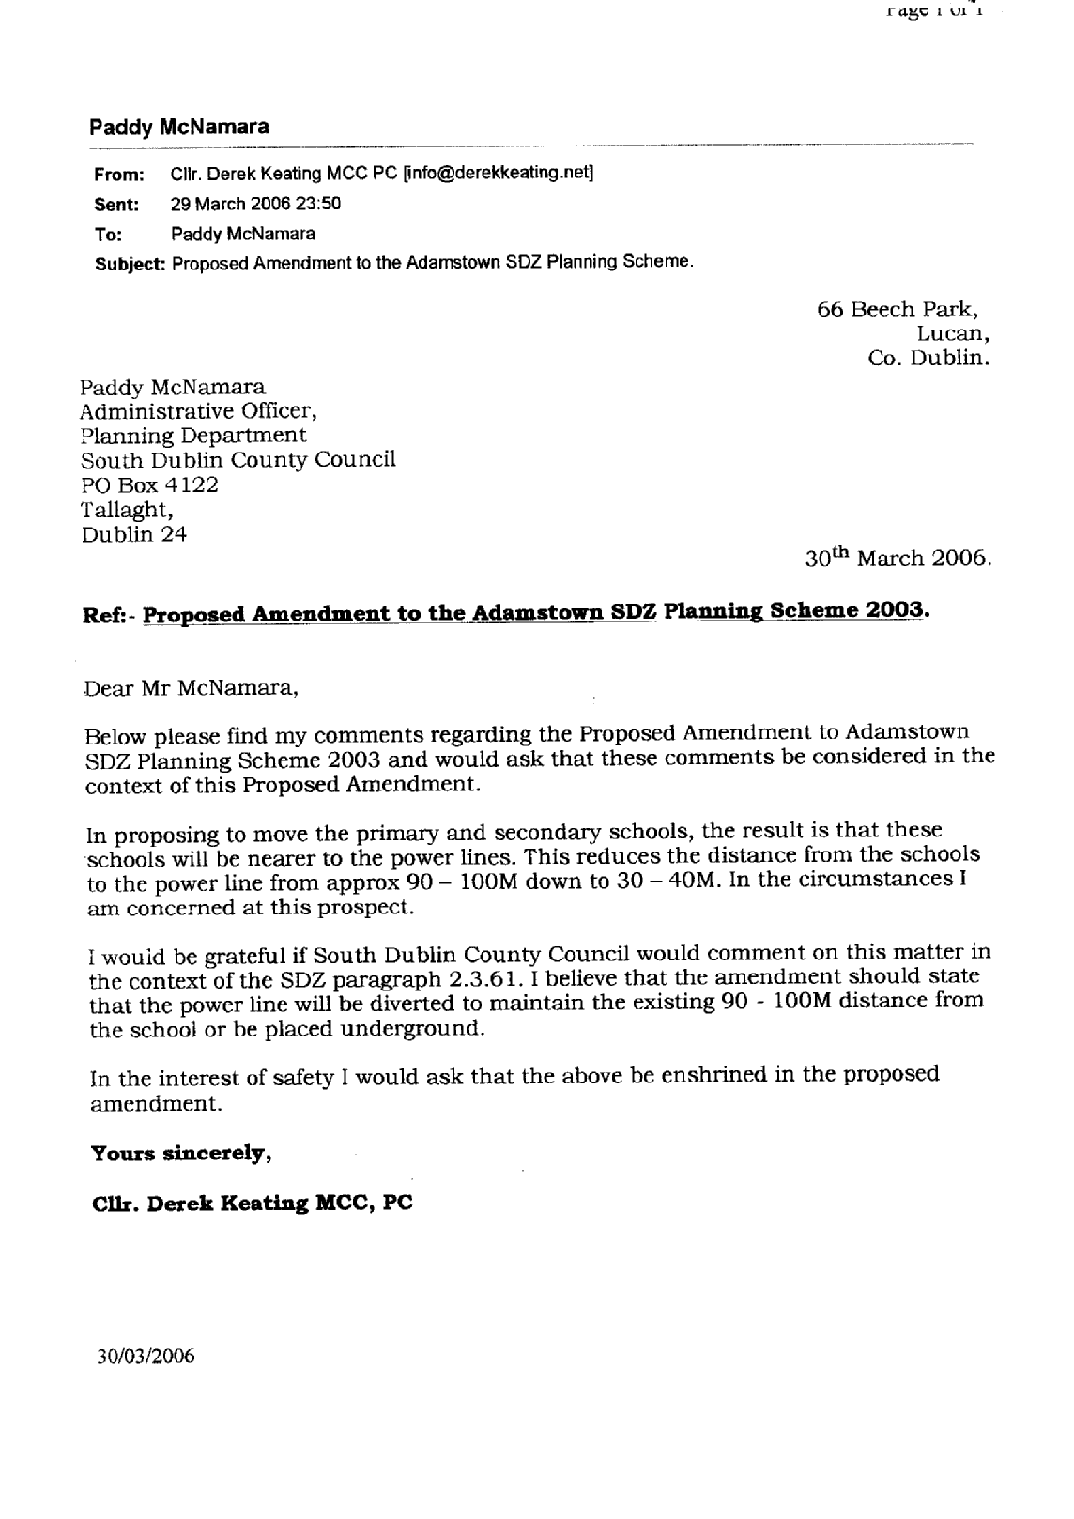

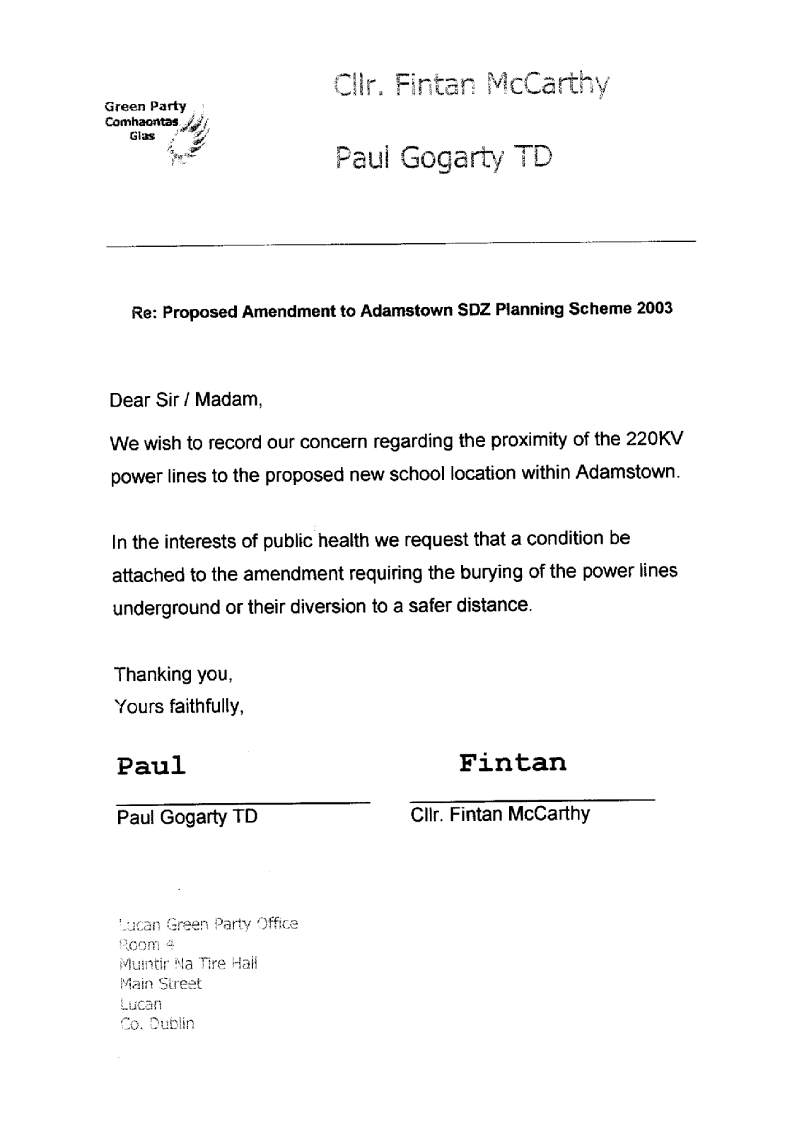

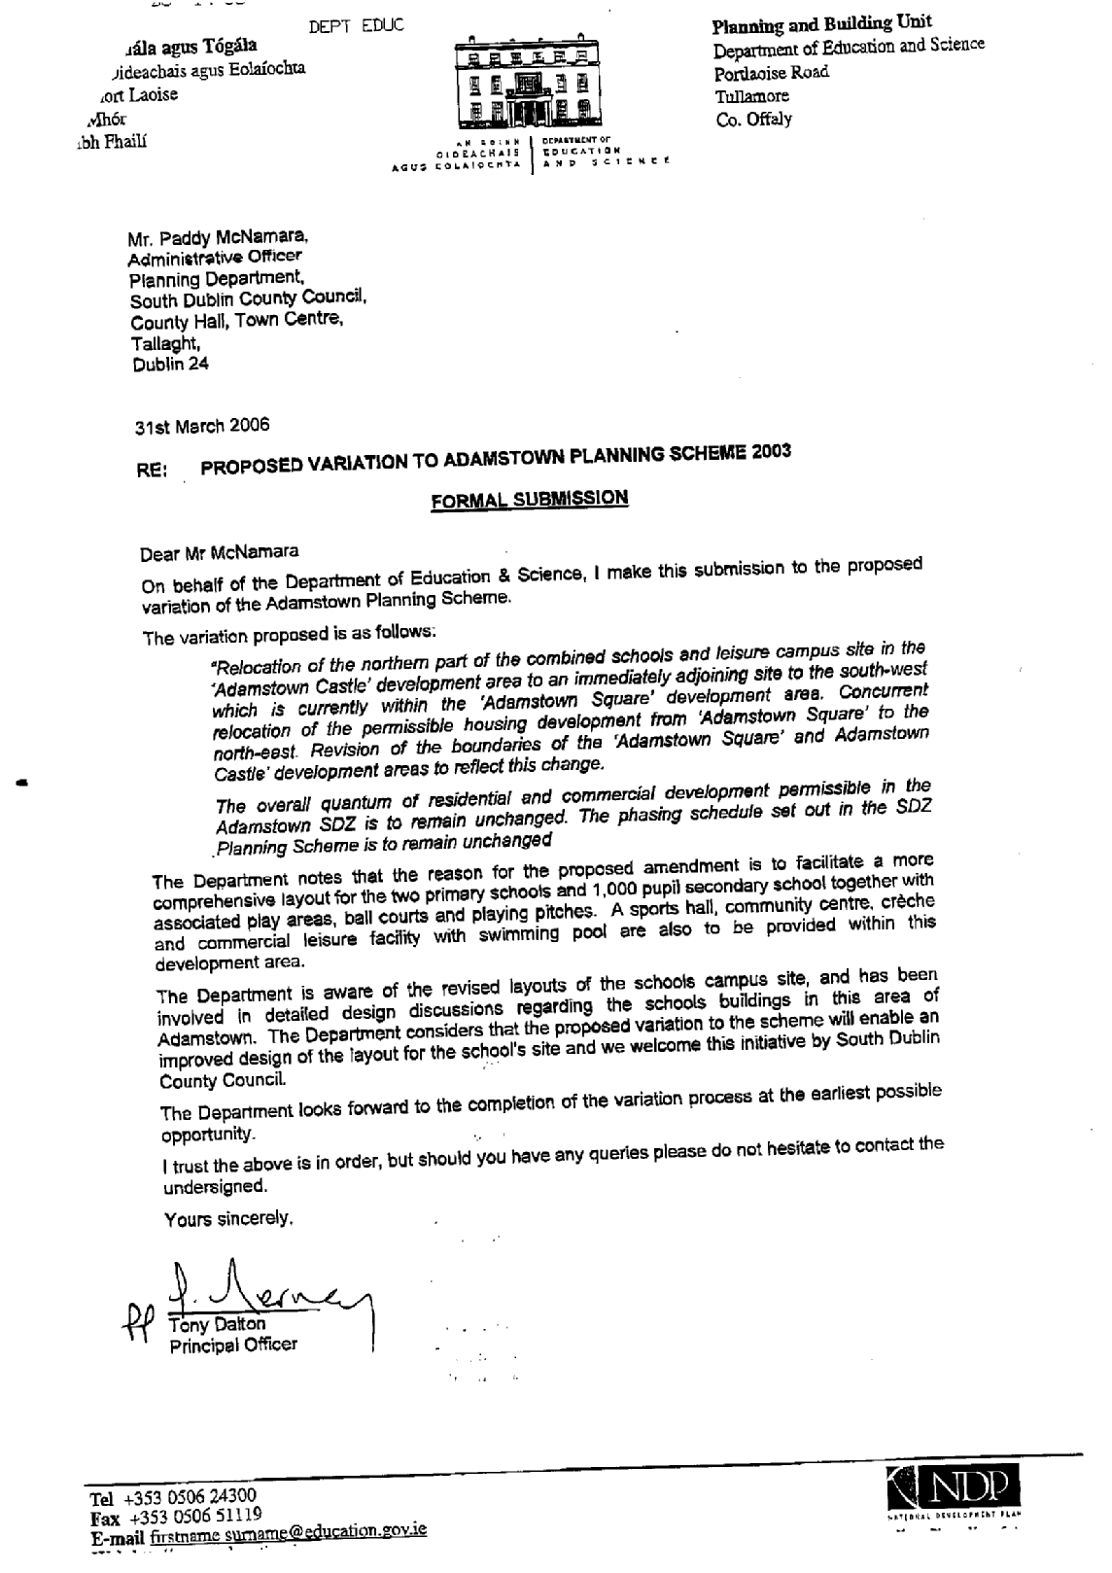

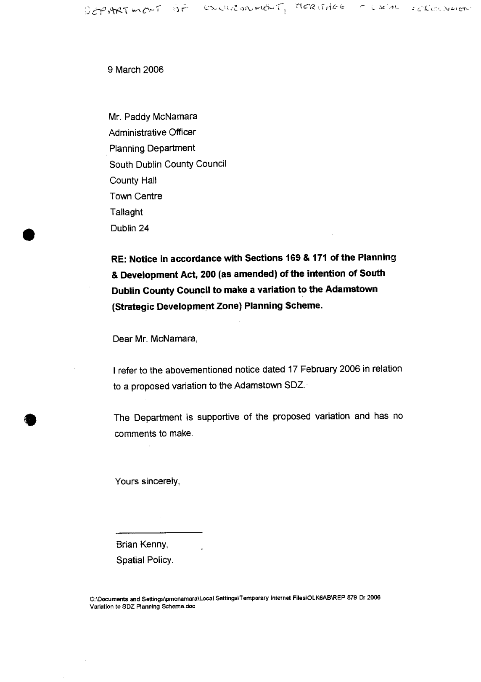

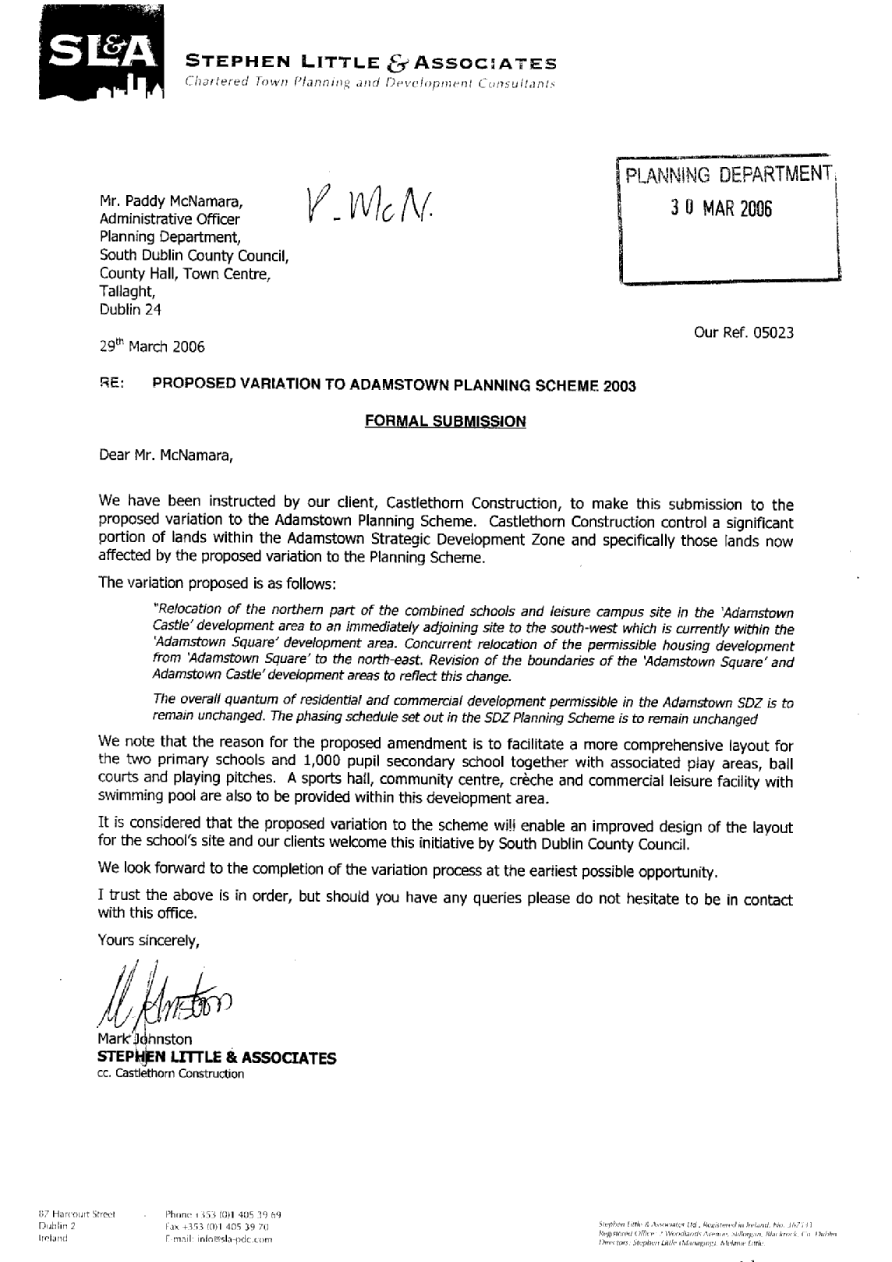

Appendix 3

Newspaper notices in relation to Proposed Amendment (No. 1) to Adamstown SDZ Planning Scheme 2003

