## COMHAIRLE CONTAE ATHA CLIATH THEAS

## SOUTH DUBLIN COUNTY COUNCIL

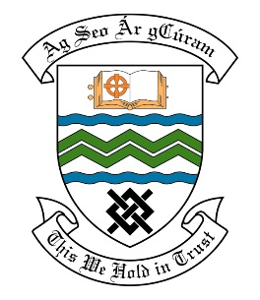

### MEETING OF THE RATHFARNHAM/TEMPLEOUGE/FIRHOUSE/BOHERNABREENA AREA COMMITTEE MEETING

## 8th March 2022

## HEADED ITEM NO. 9

**Deputation meeting – 26th January 2022 @ 4pm.**

**Temple Manor Wilkins Residents Association**

**Deputation** **attendees** – Proinsias Mac Fhlannchadha, Brian O’Neill & Dermot Stanley.

**Elected Members** – Cllr. P. Kearns, Cllr. A. Edge, Cllr. Y. Collins, Cllr. C. Bailey & Cllr. D. McManus

**Council Officials** – Brian Carroll, Fionnuala Keane, Margaret Farrell, Michael McAdam, Brendan Redmond, Maeve Cantwell, Máire Ní Dhomhnaill, Niall Noonan & Leo Magee.

Cllr. Alan Edge presided.

**Items discussed**:

1. School zone outside Holy Spirit School & provision of cycle lanes.
2. Biodiversity plan & tree planting.
3. Improvements to Greenhills Park.
4. Car Parking provisions with Temple Manor Estate.
5. Submissions made as part of public consultations
6. Commitments given.

**Commitments given**:

1. School zone & provision of cycle lane - Route is being worked on and options reports are being finalised. These will be brought before the Area Committee. In terms of the Section 38, a non-statutory consultation will take place – M. McAdam.
2. A trial location is being looked at, a review is taking place in terms of an alternative cut and funding is pending on wildflower planting, SDCC will look at planting more pollinator friendly bulbs in the larger area in the future and the flooding issue is to be discussed with the residents – B. Redmond & L. Magee.
3. Examples of submissions sent by the residents to be looked at to see if improvements can be made. The issue of discrepancies to be also looked at – N. Noonan.