## COMHAIRLE CONTAE ATHA CLIATH THEAS

## SOUTH DUBLIN COUNTY COUNCIL

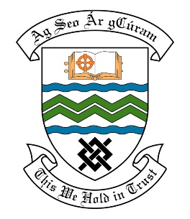

### MEETING OF THE RATHFARNHAM/TEMPLEOUGE/FIRHOUSE/BOHERNABREENA AREA COMMITTEE MEETING

## 8th March 2022

## HEADED ITEM NO. 9

## Deputation meeting – 26th January 2022 @ 3pm

**Moyville Residents Association**

**Deputation** **attendees** – Michael Clarke, Sinead Lalor & Amanda Burns.

**Elected Members** – Cllr. D. O’Donovan, Cllr. A. Edge, Cllr. E. Murphy & Cllr. D. McManus

**Council Officials** –Fionnuala Keane, Brian Carroll, Margaret Farrell, Liam McNeela, Brendan Redmond, Maeve Cantwell, Máire Ní Dhomhnaill, Niall Noonan & Leo Magee.

Cllr. Alan Edge presided.

**Items discussed**:

1. Path around green.
2. Footpath repairs.
3. Commitments given.

**Commitments given**:

1. Site meeting to take place with residents to examine site – Brendan Redmond.
2. Brendan Redmond to liaise with the Climate Change and Environmental Awareness Officer regarding pending grant application – Brendan Redmond.
3. Relevant house numbers where footpath repairs are to take place will be emailed to the residents – Liam McNeela.