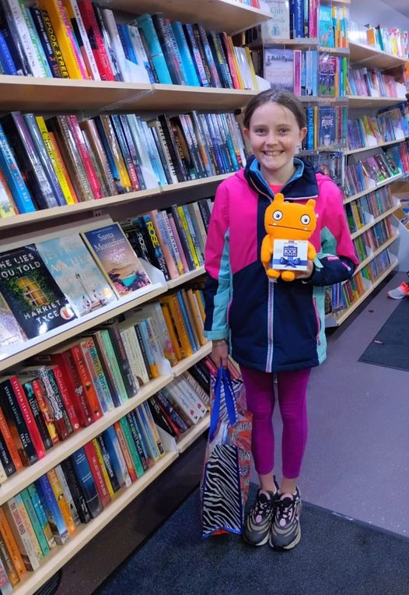This is Aisha who won our “Name the new mobiles competition”. She very cleverly rearranged the letters from Mobile Library and came up with **Moli** and **Billi.** Watch out for the new names up on our new vans for the Springtime! Well done Aisha.

There are currently 9 mobile stops in the Tallaght area. With the opening of our new library in Castletymon, some of the stops close to the library will be replaced with stops that are further away from a library. We are restructuring our Mobile stops presently to ensure that we reach the less serviced areas and hope to launch a new timetable on 7th March. Moli and Billi will be venturing into new areas and engaging with new people and new families.

School visits resumed on January 31st after being suspended in Dec and Jan because of Covid restrictions. There has been a good take up from schools we had previously set up and we are now visiting 16 schools once a month, 4 of which are in the Tallaght electoral area. We also provide an additional book club service to Primary and Secondary schools (Class sets) delivering to local schools.

The Library at Home service operates from Mobiles and continues to support people who cannot physically use a library or a mobile library. We have 111 people on our books for this service, 22 in Tallaght Central and 6 in Tallaght South.