In 2021,South Dublin Libraries were delighted to help stock the library in the brand new Stewarts School at Rosse Court avenue, Balgaddy, Lucan, Co. Dublin.
Back in March last year, one of the teachers approached me about advice on stocking their new library space. Using a special fund for start up projects, Anne Dunne approved funding and allowed myself and a teacher to select suitable stock from IES in Leixlip during Summer 2021. We wish them well with their new library and hope to provide further services as their library is a unique and essential resource for the children and teachers at Stewarts School .
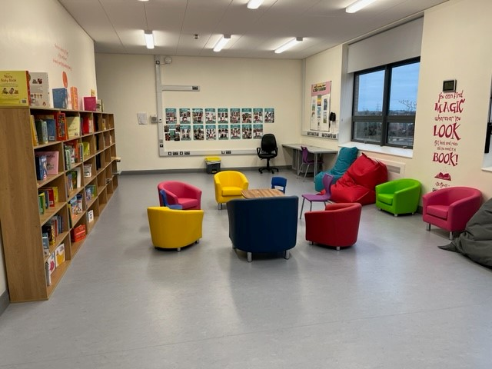
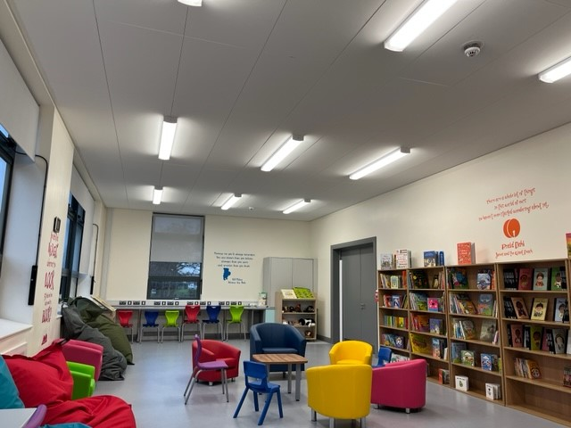

“I just wanted to send you some pictures of the Library and say thank you for everything that you did to help me get it set up.
The students are loving the space and all of new books.” Anna Lombard. Teacher.

Stewarts School caters for 120 students with moderate, severe and profound general learning difficulties. Many of our students present with additional needs including, autism, sensory difficulties, physical and medical needs. The school seeks through education to provide each individual student with the relevant and appropriate opportunities and experiences to reach their full potential and become valued and active members within our society. We recently moved into a new purpose built school in Lucan and this has changed the lives of so many of our students. One of the curricular areas that is so important for our students is Literacy and setting up our library space has allowed our students to access reading in an innovative way and created the opportunity for them to have meaning literacy experiences in a relaxing calm space.

Siobhan McCrystal
Executive Librarian

