**Libraries ACM Report**

There were 123 events held in **South Dublin Libraries** throughoutJanuary with a total attendance of 1970.

77 events were in-branch with an attendance of 777 and 46 were online with an attendance of 1193.

Following the lifting of government restrictions, all public spaces in the library have reopened. We are delighted to welcome the return of regular in-person events.

**NCL Highlights: February 2022**

Over-all for the month of February, NCL had:

* 23 Junior Events, 25 Class visits.
* 34 Adult events
* 5 Y/A /secondary school events.

**Music Generation South Dublin**

Noise Music is delighted to present a live Q.&A hosted by Max Zanga on 22nd February and a series of free workshops in beat-making, producing, rapping, singing, D’jing and performing from 23rd-25th February at North Clondalkin Library.

**24th February: Celebration of Ireland Reads**

Celebrate Ireland Reads with a Family Night of Spoken Word Craic!

This will be followed by A Book Launch with Local Author Dean Walsh.

Date: Thursday 24th February @ 7pm

**Celebration of Chinese New Year with our lego-making workshops; (STEAM event)**

[](https://www.bing.com/images/search?view=detailV2&ccid=FFhy4rd6&id=6707BFD109CE1976351257AA09C8E3D707A0507B&thid=OIF.kI%2bjzg%2btRF6Hg7KhCVqd8w&mediaurl=https%3a%2f%2fi0.wp.com%2fcheckusout.blog%2fwp-content%2fuploads%2f2022%2f01%2fChinese-New-Year.jpg%3fssl%3d1&cdnurl=https%3a%2f%2fth.bing.com%2fth%2fid%2fR.145872e2b77a5ac546a8c1d9685d6ac6%3frik%3d%26pid%3dImgRaw%26r%3d0&exph=922&expw=1920&q=chinese+new+year+2022&simid=7086591775344&FORM=IRPRST&ck=908FA3CE0FAD445E8783B2A1095A9DF3&selectedIndex=0)

Over 4 once off sessions were held with classes form local primary school children. School groups worked together to build their story scene-by-scene, and then take home their

storyboard.

87 children attended.

**Lucan Library February Highlights**

Two events for families funded by the Toys Technology Training DAF project:

**Tuesday 15th Feb 7pm, online talk:**

**Acceptance of a Diagnosis for You and/or a Family Member by Michael Ryan Counsellor/Psychotherapist and Author who works with children and teenagers in primary & secondary schools**

This talk will explore the ways in which Children/Teenagers can handle their diagnoses, how to boost their self-esteem and confidence and allow them to come to a place of ownership and acceptance of their diagnoses.

**Saturday 19th February 2pm-4pm**

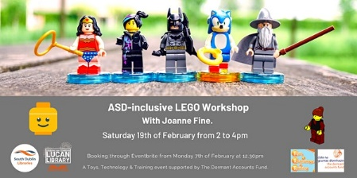

**Lego Workshop for Children with ASD and their siblings – in the library**

This workshop for children with ASD is designed to focus on improving children’s strengths in a social context and to make learning fun. Its aim is to improve motivation to initiate social contact and sustain inter-action. This event will be held in Lucan library delivered by facilitator Joanne Fine.

_______________________________________________________________________

**Ireland Reads takes place Friday 25th February. Lucan has events celebrating this national festival:**

**Thursday 24th February, 7pm**

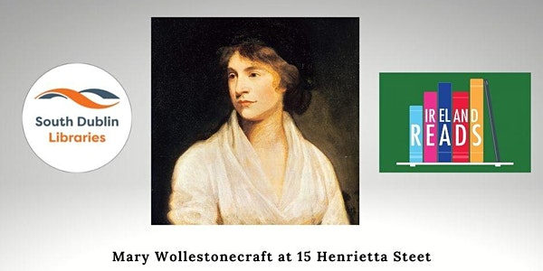

**Online Talk: Mary Wollstonecraft at 15 Henrietta Street, by historian Fergus Whelan**

Fergus Whelan will discuss the life of the writer, philosopher, and advocate of women's rights Mary Wollstonecraft who arrived in Ireland to take on the role of governess to 14-year-old Margaret King. He will talk about her impact on Margaret's life, and the links that bound the two women, even after Wollstonecraft's untimely death. The family town house was 15 Henrietta Street.

**Palmerstown Hub:**

9/2/2022:

LED light-up Valentine Cards (8–12-year-olds) Workshop in library

Ireland Reads Events:

* Storytime for 3–5-year-olds (15/2/ & 22/2) (In library)
* Myles Dungan -for the love of Crime Fiction. On-line talk
* Date: 23/2/22

Mid-Term activities: Design & 3D Bookmark

**Library Programming and Communications Update:**

**Seachtain na Gaeilge:**

South Dublin Libraries are heavily involved in the programming of South Dublin’s Seachtain na Gaeilge events. We have been working in association with Aras Chronain and South Dublin County Council Communications Department to bring the very best to the citizens of South Dublin this March.

**Highlights include:**

Bilingual Irish Dance Fitness sessions for Schools with School Fitness Ireland.

Irish Language Yoga for schools with Oga Yoga.

Bilingual Science workshops for schools with Anyone4Scince.

Coding workshops as Gaeilge with Academy of Code.

Pop up Gaeltachts

Story telling as Gaeilge le Seosamh Ó Maolalaí

Further details will be available once all events are confirmed, and a brochure of SNAG events will be published.