Road Connection to Whitton Avenue into the Clonburris SDZ:
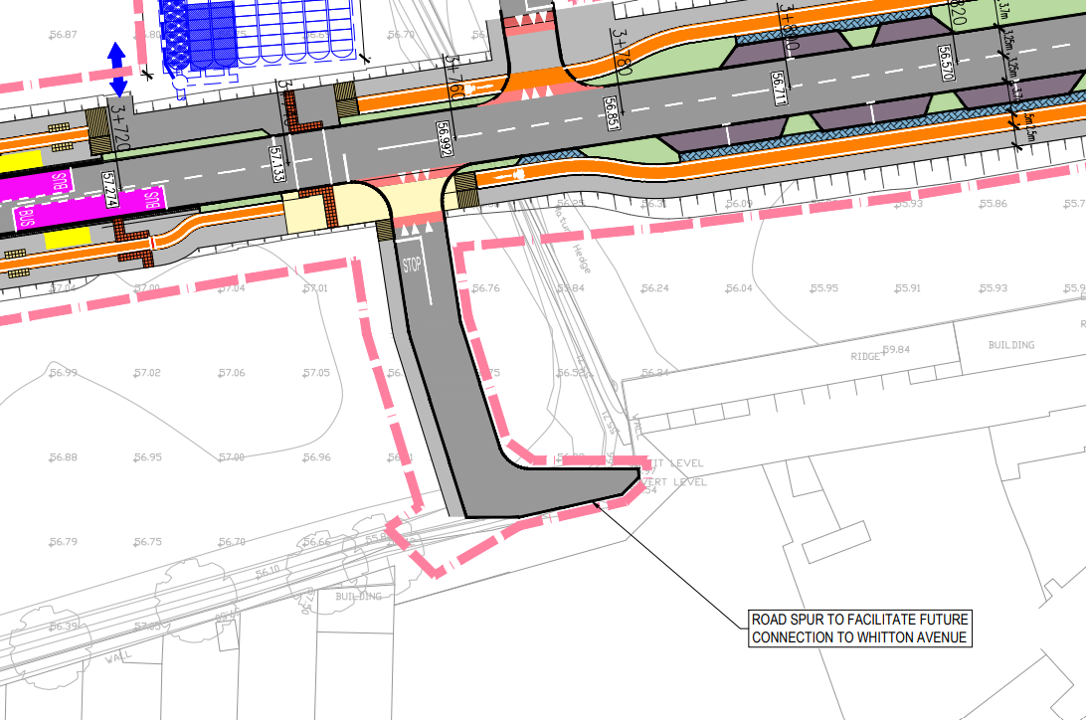

Proposed Sewer and Storm Drainage into Clonburris SDZ:

