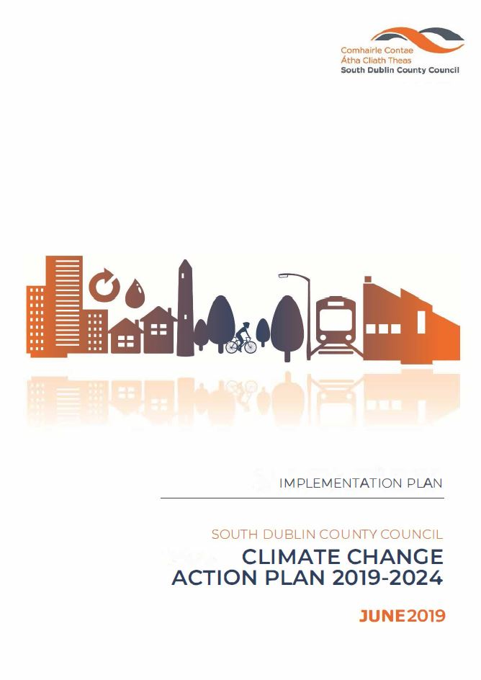

**January 2022**

**Implementation Plan for SDCC CCAP 2019-2024 (2022)**

Contents

1.0 Background 4

2.0 National Targets 5

3.0 Introduction 5

4.0 Delivery 6

4.1 Administration of the CCAP 6

4.2 Teams 6

4.3 SDCC Climate Action Steering Group (CASG) 6

4.4 Action Teams 7

4.5 Action Team 6: Citizen Engagement 7

4.6 Budget 9

4.7 Meetings 9

4.7.1 SDCC Climate Action Steering Group 9

4.7.2 Action Teams 9

4.8 Reporting 9

4.8.1 Environment, Public Realm and Climate Change SPC and Council 10

4.8.2 Covenant of Mayors for Climate and Energy 10

4.8.3 Climate Action Regional Office (CARO) 10

4.8.4 DECC 10

4.8.5 LGMA 11

4.9 Risk 11

5.0 Actions/ Priority projects 11

5.1 Energy and Buildings 12

Key Actions 12

Actions progressing in 2022. 13

5.2 Transport 16

Key Actions 16

Actions progressing in 2022. 16

5.3 Flood Resilience 19

Key Action currently progressing and to continue in 2022 19

Action progressing in 2022 20

5.4 Nature Based Solutions 23

Key Actions 23

Action progressing in 2022 23

5.5 Resource Management 26

Key Actions 26

Action progressing in 2022 26

5.6 Citizen Engagement 29

Climate Change Newsletter & Website 29

Sustainable Energy Communities 29

Climate Action Week 2022 29

Media 29

Promotion 30

6.0 List of Acronyms Used 31

7.0 APPENDICES 32

7.1 Appendix I – Steering Group and Action Teams 32

7.2 Appendix II - ACTIONS 36

7.2 Appendix III -Climate Action Innovation Fund Request Sheet 42

Document Control:

|  |  |  |  |
| --- | --- | --- | --- |
|  | Author | Approved | Date |
| Draft | DM/CG |  | Jan ‘22 |
| Final |  |  |  |
|  |  |  |  |

# 1.0 Background

The EU Adaptation Strategy to Climate Change was published in 2013, setting out a framework and mechanism for enhancing the preparedness of the EU for the current and future impacts of climate change.

In 2014 the EU Climate & Energy Framework was agreed, defining policy objectives in the 2020-2030 period and mandatory EU wide targets.

The Paris Agreement (COP 21), December 2015, Ireland, as a party to this agreement, recognises both the right and responsibility of all parties to pursue low carbon, climate resilient development and its supporting initiatives.

Ireland responded with the publication of the National Climate Action and Low Carbon Development Act 2015 (commonly known as the Climate Act 2015) which provides the required policy context for a strategic national adaptation response to climate change. The aim, as a fundamental national objective, is to achieve a transition to a competitive, low carbon, climate resilient and environmentally sustainable economy by 2050.

Under the Climate Act 2015, reductions in greenhouse gas emissions and adaptation to the impacts of climate change are being addressed through national plans, the National Low Carbon Roadmap, the National Mitigation Plan (NMP) and National Adaptation Framework (NAF).

Irelands NAF and NMP were developed by the DCCAE and provides for an all of government approach to adaptation and mitigation and requires the development of local and sectoral plans.

South Dublin County Council Climate Change Action Plan 2019-2024 (CCAP) was launched in September 2019 and submitted to the Minister for Communications, Climate Action and Environment. This was done in accordance with the requirements of the National Adaptation Framework (NAF) 2018, as local adaptation strategies were required to be submitted by 30th September 2019.

The National Climate Action Plan 2019 ‘To Tackle Climate Breakdown’ was published in 2019. The National plan describes 183 actions aimed at enabling Ireland to meet its EU carbon reduction targets by 2030 and build the foundations for a carbon zero economy by 2050. A key action in the national plan was to have Local Authorities develop and sign up to the Climate Action Charter for Local Authorities.

In September 2021, SDCC was presented with the 2020 Energy performance Figures. The report indicated that by end of year 2020, SDCC had reached 45.7% improvement in energy efficiency over the baseline figure.

In October 2021 SDCC presented its first annual progress report to DECC. The report indicated that 91.5% of the 130 actions had either started or were complete, 7.7% had not yet started and 0.8% (one action) of actions had been postponed due to Covid-19.

The Climate Action and Low Carbon Development (Amendment) Act 2021 was published in July 2021 enshrining in law the approach and actions outlined in the National Climate Action Plan. The Act provides a legal commitment for net-zero greenhouse gas emissions by 2050, through the establishment of a ‘National 2050 Climate Objective’ by which the State will pursue the transition to a ‘climate resilient and climate neutral economy’ by the end of the year 2050.

The National Climate Action Plan 2021 ‘Securing Our Future’ was published in November 2021. It provides a detailed plan for taking decisive action to achieve a 51% reduction in overall greenhouse gas emissions by 2030 and setting Ireland on a path to achieve net-zero emissions by no later than 2050, as committed to in the Programme for Government and set out in the Climate Act 2021.

# 2.0 National Targets

Energy Efficiency across the public sector in Ireland is mandatory. Targets are set through Ireland’s EU and national commitments and through our wider climate change goals. A target of 33% energy efficiency improvement over baselines to be achieved by all Irish public bodies by 2020 was outlined in National Energy Efficiency Action Plan 2009 and subsequent iterations. SDCC surpassed this target by the end of 2019. Under the National Climate Action Plan 2019 and as signatories to the Climate Action Charter for Local Authorities, SDCC has committed to a new target of 50% improvement in energy efficiency by 2030, in line with national targets outlined in the Government of Ireland’s Climate Plan 2021 (Securing our Future)

As a signatory to the EU Covenant of Mayors for Climate & Energy since 2018, this Council has voluntarily committed to **a 40% reduction in its greenhouse gas emissions by 2030** and become a more climate resilient region. This target was adopted by SDCC in the CCAP 2019-2024. The Programme for Government presented in 2020, outlines an ambition to reduce national carbon emissions by 7% per annum with a minimum reduction of 51% by the end of the decade (compared with 2018 levels), and to be carbon neutral by 2050.

# 3.0 Introduction

The Climate Change Action Plan 2019-2024 (CCAP) defines how South Dublin County Council continuously improves its energy efficiency profile and reduces greenhouse gas emissions associated with its own buildings and operations, while making the functional area more adaptive to the impacts of future climate change.

The CCAP presents a twin approach to tackling climate change. The first, mitigation, include actions aimed at reducing current and future GHG emissions; examples of which include reductions in energy use, switching to renewable energy sources and developing carbon sinks.

The second approach, adaptation, involves measures aimed at reducing the impacts that are currently being experienced through our changing climate and at those that are projected to happen in the future. The measures include flood protection, increased resilience of infrastructure and emergency response planning. The approaches are interconnected and should be planned simultaneously.

There are four key targets of the South Dublin County Council CCAP are;

1. 50% improvement in the Councils energy efficiency by 2030
2. 51% reduction in the Councils GHG emissions by 2030 – Net Zero CO2 by 2050
3. To make Dublin a climate resilient region by reducing the impacts of future climate change related events
4. To actively engage and inform our citizens on climate change

The Plan includes a range of actions, organised across five key action areas;

1. Energy & Buildings
2. Transport
3. Flood Resilience
4. Nature Based Solutions and
5. Resource Management

# 4.0 Delivery

## 4.1 Administration of the CCAP

The Management Team is key to driving the ownership of the actions to the managers within their departments, to ensure that climate change becomes part of the culture and day to day business of South Dublin County Council

There are five Action Areas in the Plan as identified above and delivery of the plan will be based around these five action areas. Action team will be tasked with delivery of the action in their area.

In order to satisfy the key target of actively engaging and informing our citizens on climate change, an additional team **Action Team 6 - Citizen Engagement** was created;

## 4.2 Teams

Ownership and implementation of this Climate Change Action Plan resides within each department of South Dublin County Council. The Plan demands an inclusive approach by the full Council, as the 130 actions listed interconnect all directorates and sections through common objectives. The Management Team is key to driving the ownership of the actions to managers within each department, to ensure that climate change is fundamental to the ethos and the day-to-day operations of SDCC.

Given the complexity and long-term nature of climate change, it is essential that progress on the actions is continuously monitored, and that the delivery of actions is subjected to periodic review, both in terms of the validity of the underlying scientific assumptions and the appropriateness of projects, policies and programmes. Lessons learned and good practices identified during the monitoring and evaluation of ongoing and completed projects, policies and programmes should inform future actions, creating an iterative and evolutionary process.

## 4.3 SDCC Climate Action Steering Group (CASG)

To ensure the 130 actions in the CCAP are delivered a dedicated Climate Action Steering Group (CASG) was established, the CASG takes forward the governance of the CCAP in this county. This team includes Senior Management, the chairs of the five Action Teams as outlined in the CCAP and the chair of the additional Action Team entitled Citizen Engagement. The members of the Steering Group are outlined in Appendix 1: Steering Group and Action Teams.

The objectives of this steering group are;

* To ensure alignment with National legislation
* To work to achieve the commitments made in the Local Authority Climate Charter.
* To ensure alignment with the other Dublin Authorities and the CARO’s
* To meet the targets of the CCAP
* To ensure budgets are aligned with targets of the CCAP
* To ensure projects are completed and on budget
* To ensure the actions of the CCAP are being carried out by relevant sections
* To ensure reports are issued and deadlines met
* To remove and include new and revised actions at annual revisions and iterations
* To receive the required information in order to report on the Action Teams
* To ensure all reporting requirement are completed e.g. SPC’s Covenant of Mayors CARO etc.

The purpose of this group is to bring the findings and reports from the Six Action Teams to this group for regional and national reporting purposes.

## 4.4 Action Teams

There are six action teams;

Action Team 1 - Energy and Buildings

Action Team 2 - Transport

Action Team 3 - Flood Resilience

Action Team 4 - Nature Based Solutions

Action Team 5 - Resource Management

Action Team 6 - Citizen Engagement

The purpose of these teams is to manage and deliver the actions of the CCAP, to ensure new actions are included and all work streams that can be captured are recognised and included.

The inclusion of Action Team 6; Citizen Engagement, acknowledges our role in increasing citizen awareness and public participation in climate change solutions.

## 4.5 Action Team 6: Citizen Engagement

This team’s role is to fulfil the underlying theme of the CCAP which includes engagement with our citizens. The objective of this team is to ensure a unified approach of engagement is conducted by each of the Action Teams for all citizens, those who live and work in our functional area. The members of this team will include the Climate Change and Environmental Awareness Officer, Community, LEO, Communications and Corporate Support.

Members of each action team are identified in Appendix 1. It is anticipated that membership will evolve as different action in the CCAP are progressed.

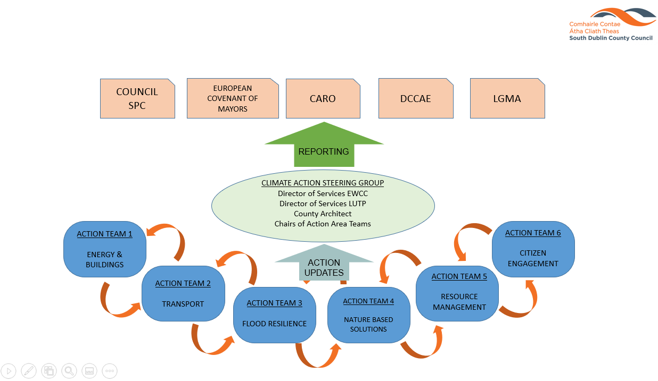

DECC

## 4.6 Budget

A Climate Action Innovation Budget of €300,000 has been approved for 2022 to deliver action plan initiatives across the areas of energy, transport, biodiversity, resource management and community engagement projects. New and non-budgeted actions in the CCAP may avail of this Climate Action Innovation allocation through an application process.

It is proposed that projects or actions, once appraised and justified and confirmation that procurement criteria have been satisfied, they can be fully or partially funded from the Climate Action allocation.

Projects and actions that have been approved for the Climate Change Action Plan have been included on an action tracker to allow progress, budgets and actual costs are to be monitored.

The Climate Action budgeted items are recorded in Agresso. In order to monitor additional cost and spending pertaining to Climate Change but external to the Climate Action budget, an additional accounting tag will be introduced.

## 4.7 Meetings

### 4.7.1 SDCC Climate Action Steering Group

The inaugural meeting of this group was held on 27th June, 2019, subsequent meetings occurred every month for three months reducing to every quarterly meeting thereafter. Provisional dates and times are arranged through our administrative support team. These dates will align with the Environment, Public Realm & Climate Change SPC meetings.

### 4.7.2 Action Teams

It is proposed that each Action Team meet bi-monthly throughout 2022. The dates and times agreed at the inaugural meeting are arranged through our administrative support team. Action from the CCAP will be updated on a tracker on a monthly basis by nominated personnel in relevant sections.

Actions should be reviewed by all team members prior to meetings. During the meeting team members will report on actions that are under their management.

## 4.8 Reporting

The following is the current list of bodies that the SDCC is responsible for reporting to, and from whom they take instruction regarding their reporting obligations;

* Environment, Public Realm and Climate Change SPC and Council
* Covenant of Mayors for Climate and Energy
* Dublin Metropolitan Climate Action Regional Office (CARO)
* DECC
* LGMA

To reduce the risks of omitting actions and significant items a dual approach of top down and bottom up is required.

The Action Teams will be expected to report to the CASG through their Chairs, including reporting on the actions and their associated budgets and introducing and revising actions on an annual basis.

The delivery of the CCAP will be a flexible process and subject to regular reviews in terms of the appropriateness of projects, policies and programmes, as well as climate projections.

### 4.8.1 Environment, Public Realm and Climate Change SPC and Council

The Climate Action Co-ordinator will provide a report to the EPR & CC SPC at each of their meetings and in turn report to the full council.

This reporting system will be quarterly at each SPC meeting highlighting a specific theme from the CCAP.

### 4.8.2 Covenant of Mayors for Climate and Energy

As the council is a signatory to the Covenant of Mayors for Climate and Energy, which is the world’s largest movement for local climate and energy actions, SDCC has pledged to support implementation of the EU 40% GHG reduction target by 2030 and to make SDCC a more resilient region. Accordingly, SDCC submitted (14/11/2019) a Sustainable Energy and Climate Action Plan (SECAP), outlining the key actions it plans to undertake. The Plan will feature a Baseline Emission Inventory to track mitigation actions and a Climate Risks and Vulnerability Assessment. This commitment marks the beginning of a long-term process, a commitment has been made to submit a report on the implementation process every two years. The required information is provided to Codema, who compile and file the reports for all the Dublin LAs.

This reporting system is every two years.

### 4.8.3 Climate Action Regional Office (CARO)

Climate change is a transboundary challenge. A Dublin regional approach has been adopted and will be overseen by the Dublin Metropolitan CARO. The task of the Dublin Metropolitan CARO is to liaise with the Dublin LA’s under their remit, the other three regional CAROs and respective central government departments to ensure alignment of actions. The CARO will also work with Third Level institutions in relation to research and education on Climate Action.

Reporting to CARO by SDCC will be carried out formally on a quarterly basis in advance of Regional Climate Action Team meetings, whilst informal reporting will occur weekly through associations.

### 4.8.4 DECC

South Dublin County Council and all public bodies, are required to report annual energy efficiency data to the Sustainable Energy Authority of Ireland (SEAI) which manages the reporting process on behalf of the Department of Environment, Climate and Communications (DECC). The required information is provided to Codema, who compile and file the reports for all the Dublin LAs.

An action progress reporting template was developed in 2020 for all LAs to complete and return to the DECC by End of October. The reporting term is October through September. Submission of the completed template to DECC will be followed by a CCAP Annual Report after approval by the Elected members.

This reporting system is annual.

### 4.8.5 LGMA

The LGMA circulated a research questionnaire to all LA’s in February 2019, the research was undertaken in partnership with the Climate Action Regional Offices (CAROs) on behalf of the County and City Management Association (CCMA) and the Environment Climate Change and Emergency Planning (ECCEP) Committee.

The questionnaire was devised to assist local authorities in developing a baseline assessment of local climate change actions. Nationally, local authorities are developing Climate Adaptation Strategies and Climate Change Action Plans throughout 2019, which indicate mitigation and adaptation responses. ECCEP indicated that emergency response (remediation) following extreme weather events should also form part of the baseline assessment to facilitate a thorough understanding of all climate change actions local authorities are currently engaged in.

This reporting system is annual.

Summary list of external bodies SDCC will be required to report to;

* CARO
* DECC through SEAI
* LGMA
* Covenant of Mayors for Climate and Energy through Codema

## 4.9 Risk

A high-level risk assessment was carried out as part of the CCAP process, but as described on page 31 of the CCAP a more detail risk assessment must be carried out. The aim is to identify potential future climate impacts, vulnerabilities and risks that are of greatest relevance to the council according to the key operational areas. There will also be new opportunities and benefits that will emerge during this exercise, these will also be logged and reviewed.

The key tasks are:

* Further assessment of potential future climate impacts and vulnerabilities
* Development of a Risk Register for each Action Team
* To prioritise climate risks

# 5.0 Actions/ Priority projects

It should be noted that actions identified in the CCAP are not listed in specific order. Actions must be prioritised and revised as agreed by each of the Action Teams.

The following is a list of projects that are scheduled to commence in 2022. The initial cost of each project will be appraised, and spending will be monitored by the lead section. Funding shall be arranged through the relevant section and Government procurement guidelines will be adhered to.

Projects scheduled to progress in 2022 are described below;

## 5.1 Energy and Buildings

### Key Actions

Heatnet **–** Work will continue to progress on the Tallaght District Heating Scheme. The system is expected to be commissioned in Q2 of 2022. The management company, Heatworks, set up and managed by South Dublin County Council, will progress the project rollout in 2022 and seek to attract new customers to the scheme. South Dublin County Council Civic Offices will be the first building to benefit from the surplus heat. The benefits to SDCC will include low-cost heating, improved energy efficiencies and reduced CO2 emissions compared with current natural gas heating. The project allows for additional heat sources to connect to the network providing future opportunities for business and homes to enjoy the benefits of low-cost sustainable energy. The expected cost of the initial scheme is €8 M, with €4.5 M coming from the National Climate Action Fund.

Public Lighting upgrades – With in excess of 30,000 units across the county, public lighting accounts for approximately 44% of the energy used by South Dublin County Council (2019 Energy Review). SDCC has committed to upgrading the public lighting network from older Sodium Oxide to more energy efficient LED units. Phase 2 of the upgrade, scheduled for completion between 2020 and 2025 will see 10,000 of the older lighting units being replaced at a total cost of €11M. 1500 replacements are scheduled for 2022. Energy savings of between 50% and 65% are expected between the old and new equipment.

County Hall Lighting upgrades - Phase 2 of the upgrade of lighting in County Hall commenced in 2020. Works included individual offices, open plan work areas, elected members facilities and public spaces. Works involve the removal of older lighting systems and replacement with low energy consuming LEDs, Passive Infrared (PIR) sensors, dimmer controls and emergency lighting.

Progress ISO 50001 Certification – SDCC will progress the steps towards ISO 50001 in 2022. ISO 50001 is a voluntary accreditation system based on continual improvement to facilitate the integration of energy management across all aspects of our operations. A series of training sessions were held in 2021 to introduce the Climate Action Team to the process of achieving ISO 50001 Acreditation.

Energy Management System – South Dublin County Council has engaged Energy Elephant to set up a cloud-based Energy Management System. The proposed cloud-based energy data management solution will assist South Dublin County Council in efficiently managing and reduce ongoing energy use, carbon emissions and utility costs for our buildings, assets, public lighting, and vehicles. This solution will help to provide a strategic overview of energy use and costs, promoting user engagement, building a comprehensive searchable energy database, facilitating ISO 50001, recording energy initiatives and verifying energy savings. The solution will manage both billing data from invoices, and interval data from smart metering. The pilot project will run for 2 years and will be funded by the Climate Innovation Fund. The system will assist SDCC in meeting EU 2030 Carbon-reduction targets.

Progress Arthurstown Sustainable Energy Project – South Dublin County Council has identified the site at the disused Arthurstown Landfill as a potential renewable energy project. A report was commissioned to investigate the potential to develop a renewable solar energy project at the site. Recommendations include a 2 stage approach, to include;

• An initial 75kw project to cover the base load requirements of the leachate treatment plant,

• A subsequent 5MW commercial PV farm.

SDCC will establish a review group to assess the feasibility of the options presented in the report and progress a business case for the proposed development.

### Actions progressing in 2022.

* Action E.1 - Create energy master plan for the Dublin Region. The energy masterplan has been developed by CoDEMA. A final report is currently being prepared and will be presented in Q.1 2022.
* Action E.2 - Develop public lighting master plan – The public lighting replacement programme phase 2 commenced in September 2020. The programme expects to replace 1,500 SOX lanterns with LED units in 2022.
* Action E.3 - Prepare South Dublin Sustainable Energy and Climate Action Plan. CoDEMA submitted the SECAP to the Covenant of Mayors in September 2019. The four Dublin LA’s will review their commitments made under the CoM to align with current National and European CO2 reduction targets
* Action E.4 - Evidence-based Climate Change chapter in County Development Plan 2022-2028 - South Dublin County Development Plan 2022-2028 is currently being prepared for publication in 2022. Climate Change will be fundamental to the CDP.
* Action E.5 - Evidence based Climate Change chapter in Tallaght Town Centre Local Area Plan - The elected members of South Dublin County Council resolved to make the Tallaght Town Centre Local Area Plan on 8th June, 2020. Chapter 7 of the Tallaght LAP is dedicated to Climate Change: Mitigation and Adaptation.
* Action E.6 - Comply with obligations for local authorities under S.I. No. 426/2014 - Initial Energy Audits for SDCC Buildings were completed. Detailed Energy Audit for County Hall and Clondalkin Offices to be completed in 2022. Detailed Energy Audits have been commissioned for Tallaght and Clondalkin Leisure Centres.
* Action E.7 - Display energy certificates for SDCC's public buildings – Display Energy Certificates on SDCC buildings over 250m2 and frequently visited by the public are updated annually.
* Action E.8 - Annual Monitoring and reporting to SEAI – Annual reporting to SEAI is ongoing
* Action E.9 - Total emissions in South Dublin updated every two years in accordance with EU Covenant of Mayors for Climate & Energy - Total energy use and emissions will be updated every two years for South Dublin County Council and every five years for South Dublin County (in line with the publication of the Census results). The current iteration is complete.
* Action E.10 - The Council Energy Review will include a glide path illustrating the energy efficiency and Greenhouse Gas emission targets for the council up to and including 2030 – Figures for the 2020 South Dublin County Council Energy review were presented in September 2020. The full energy review will be presented by CoDEMA in early 2022 including a glide path on Energy Efficiency and GHG emissions.
* Action E.11 - Development of yearly Energy Review for SDCC – Figures for the 2020 South Dublin County Council Energy review were presented in September 2021. The report highlights that South Dublin County Council achieved a 45.7% improvement in Energy Efficiency in 2020. The full energy review will be presented by CoDEMA in early 2022
* Action E.12 - Development of the Tallaght District Heating Scheme – Works are ongoing and project is expected to be commissioned in Q.2, 2022. County Hall will be one of the first buildings to benefit from the district heating project. When fully commissioned the Tallaght District Heating Scheme will reduce CO2 emissions by 1,500 tonnes per annum.
* Action E.13 - Retrofits of the Council's housing stock. SDCC has received approval of funding to carry out deep energy retrofit to 117 housing units at a cost of €3.1 Million in 2021. The funding is part of a 10 year program. Retrofits will continue throughout 2022
* Action E.14 - Energy efficiency works in Council owned and operated buildings - Energy efficiency works in County Council owned buildings are progressing including design and development of NZEB and installation of renewable energy systems.
* Action E.15 - Ongoing upgrading of lights in County Hall to LED's - Phases 1-3 of retrofitting LEDs in County Hall has been completed with a calculated annual saving of 53 tonnes of CO2 emissions and 68% energy savings. Phase 4 of the programme will commence in 2022 to complete 50% of the remaining area. The project will be completed in 2023
* Action E.16 - Energy Performance Contract carried out in Tallaght and Clondalkin Leisure Centres - Preliminary research and feasibility study has been carried out. Programme will be progressed in Q2. 2022. Detailed Energy Audits have been commissioned for Tallaght and Clondalkin Leisure Centres.
* Action E.17 - Replace 4000 SOX lamps with LEDs. – This action has been completed
* Action E.18 - Expand and develop Small Business Innovation and Research (SBIR) programme - SDCC is partnering with DCC and Smart Dublin on the delivery of Phase 2 of Smart Mobility Hub. SDCC will continue to liaise with business groups in 2022
* Action E.19 - South Dublin County Council is committed to participating with the RIAI in particular the Sustainability Task Force in seeking new and innovative approaches to Climate action in the built environment – This Action has not commenced yet
* Action E.20 - Identify sites for trialling renewable energy projects, including solar PV and Geothermal – SDCC has identified sites for trialling renewable energy projects. A joint submission was made to the CAF by the 4 DLAs in 2020. Additional renewable energy projects will be examined in 2022 including potential of Geothermal energy
* Action E.21 - The Council will investigate the Lifecycle Assessment of traditional and new construction methods for residential projects in Dublin - This Action has not commenced yet
* Action E.22 - In all building projects, new build or retrofit, Swift Bricks or other nesting sites for swifts will be provided where practicable. The presence of swift breeding sites will be identified to ensure that known breeding sites are not lost - SDCC has installed boxes and roosting sites for bats, birds of prey and smaller garden birds on several building conservation projects, additional sites will be investigated in 2022
* Action E.23 - Monitor and develop the Home Energy Savings Kit scheme in SDCC libraries - SDCC have 8 Home Energy Saving Kits located at our libraries. The kits were borrowed 31 times in 2020 and 23 times in 2021. The project will be expanded in 2022 with the introduction of a Community Climate Action Programme, being run by Codema and the 4 Dublin Local Authorities Libraries. The aim is to help build capacity and know-how within communities to develop low carbon communities and to further engage in Climate Action.
* Action E.24 - Assess feasibility of additional low carbon district heating networks: Clonburris and Grange Castle - SDCC established a special purpose vehicle 'Heat Works' to advance the District Heating Programme. Additional low carbon district heating networks at Clonburris and Grange Castle have been identified as priority locations.
* Action E.25 - Expand housing assistance programme to include tenant energy awareness – SDCC will review existing tenant guidance documentation in 2022.
* Action E.26 - Develop maintenance and condition survey programmes for Council owned historic and ancient monuments that are informed by climate change impacts – Carry our initial survey to develop a scope for the project and Identify required resources in 2022.
* Action E.27 - Conduct research and seek to develop Council based case studies on appropriate and sensitive retro-fitting/energy upgrading of traditional buildings to inform works both to Council owned properties and to guide private owners – Identify suitable projects, outline required specifications and develop project brief.

## 5.2 Transport

### Key Actions

Electric Vehicle – SDCC currently have 5 Electric Vans in its service fleet. The annual vehicle replacement programme typically replaces 30 vehicles per annum. Electric and low carbon alternatives will be given appropriate consideration for all replacements in 2022.

Smart Mobility Hub – In partnership with SmartDublin.ie SDCC are trialling a pool-car and 3 electric bicycles to afford staff (who travel as part of their duties) the opportunity to choose alternative commuting modes, reducing CO2 emissions and freeing parking space in staff car parks. Progress was curtailed in 2021 due to Covid-19. Corporate section have taken possession of 2 e-bikes for staff and are currently developing guidance for usage.

Charging Network - SDCC, in partnership with the other 3 DLAs, have commissioned a report on an integrated strategy for the roll-out and management of an EV charging infrastructure across the Dublin region. SDCC has identified locations within communities where EV charging infrastructure can be installed to best serve the needs of current and future EV drivers. SDCC are working with national service providers to trial fast charging equipment in public areas.

Cycle South Dublin – As part of SDCC's commitment to making the County a national leader in providing a quality network of routes for cyclists, the Cycle South Dublin Plan is in development. This plan will provide comprehensive guidance for the planning, construction and upgrading of cycle tracks and junctions for all vulnerable road users. The plan will identify existing cycle routes and future strategic links it will include 263km of infrastructure to promote active travel options for both leisure and commuter users. Delivery of the plan will be staged over short-medium term goals and long-term objectives.

### Actions progressing in 2022.

* Action T.1 - Implement transport energy management system – SDCC have implemented a fuel management system for its fleet. A comprehensive energy management system (Energy Elephant) is currently being trialled. This will include facilities transport energy use.
* Action T.2 - Ongoing replacement of Council vehicles with more energy-efficient alternatives, including EVs. – EV and low carbon alternatives will be considered when replacing vehicles in 2022.
* Action T.3 - Use mobile canteens with operational crews – This action was postponed due to Covid-19. The action will be reviewed in 2022.
* Action T.4 - Promotion of Cycle-to-Work Scheme to Council staff. – This action is ongoing. Staff participation will be accommodated.
* Action T.5 - Strengthen traditional villages by improving the public realm through enhancement of green infrastructure and sustainable transport linkages. - This action is ongoing through the Urban and Village Renewal Scheme, and district enhancement programme.
* Action T.6 - Regular maintenance of regional and local roads. - This action is ongoing, road sweeping and gully cleaning contract is being monitored.
* Action T.7 - The Council will undertake an assessment of the number of existing and potential future Electric Vehicle Charge points in its jurisdiction. – SDCC are examining potential locations for on-street EV charging. SDCC will progress the recommendations of the regional EV charging strategy
* Action T.8 - Improve road safety at schools with additional school wardens. – Road safety measures including ‘School Streets’ are being implemented in 2022.
* Action T.9 - Organised walks to promote healthy lifestyles, i.e. Clondalkin Route. - This action is ongoing, SDCC promote healthy walking programmes through activitetravellogger.ie, SDCSP provide details on walking routes in the County.
* Action T.10 - Develop cycle network strategy. - Cycle South Dublin Plan is currently being progressed. The plan will provide comprehensive guidance for the planning, construction and upgrading of cycle tracks and junctions for all vulnerable road users.
* Action T.11 - Development of cycle/pedestrian greenways. – Work to continue on the delivery of cycle and pedestrian routes including the Dodder Greenway,
* Action T.12 – Build out County Cycle Network. – Cycle South Dublin will identify existing cycle routes and future strategic links it will include 263km of infrastructure to promote active travel options for both leisure and commuter users.
* Action T.13 – Increase number of public bicycle facilities. - Additional bicycle parking facilities will be considered in 2022. Programme of mapping existing cycling facilities is underway.
* Action T.14 - Extend public bicycle scheme. – SDCC will engage with bicycle sharing schemes to develop mobility hubs and facilitate public bicycle sharing. SDCC are engaging with ESB to identify suitable locations for electric bicycles and e-scooter hubs.
* Action T.15 - SDCC will continue to seek new and expand on existing partnerships to encourage sustainable travel for safer travel behaviours. – Progress smart mobility hubs at SDCC offices. Road safety and cycling training programme for schools will continue.
* Action T.16 - SDCC will establish a portal dedicated to communication and promotion of active travel within existing platforms. – SDCC have received €50,000 in funding for an Active Travel website from the NTA. A specialist contractor has been appointed to design and develop a web portal. It is anticipated that the portal will go live in early 2022.
* Action T.17 - SDCC will engage with local communities to develop a vision for the future of their neighbourhoods with a strong focus on local living, sustainable mobility and quality of life. – SDCC will continue to engage with local communities through online presentations, workshops and consultation portals. SDCC will continue to engage with new and existing Sustainable Energy Communities to facilitate the delivery of suitable projects identified in their Energy Masterplans.
* Action T.18 - Facilitate the delivery of public transport routes. – SDCC will continue to support the delivery of public transport routes including Bus Connects, and local link transport programmes.
* Action T.19 - Cycle training programme for 6th Class students/pedal power labs. - Cycle Right Training was provided at 11 schools across the county, 631 students participated. This action will continue to be delivered in 2022.
* Action T.20 - Pilot VMS on Naas Road. - This Action has not commenced yet
* Action T.21 - Expand availability of EV and other facilities for non-fossil fuel powers vehicle charging points in the County. – SDCC will continue to support and encourage the rollout of EV charging across the county in accordance with the recommendations of the regional EV charging strategy.

## 5.3 Flood Resilience

### Key Action currently progressing and to continue in 2022

Development of SuDS Guidance Documents

South Dublin County Council are currently developing a SuDS Explanatory, Design and Evaluation Guide in accordance with international best practice, emerging international guidance, SDCC’s County Development plan objectives and under target action areas detailed in SDCC’s Climate Change Action Plan 2019-2024 involving flood resilience and nature based solutions. The Guidance document will be an “easy to follow” document that explains and promotes best practice Sustainable Drainage Systems (SuDS) to architects, engineers, developers and local authority stakeholders involved with developments within the county of South Dublin. It will be guidance on how to implement SuDS schemes rather than explaining what SuDS is. The Guide will facilitate pre-planning consultations and promote sustainable integrated developments in the county of South Dublin.

4 workshops were delivered to staff in 2021. Following the publication of the guidance, a series of training sessions will be presented to staff. Further training opportunities will be offered to developers

The final guidance document to be completed in February 2022 will include a Home owners guide to implementing SuDS projects.

#### Poddle Flood Alleviation Scheme

The Poddle FAS with an estimated value of €8m will protect 920 properties when completed. The scheme is currently in Part 10 planning with ABP. Design works are progressing on items such as the proposed defence embankments, structural defence walls and a flow control structure in Tymon Park. Design has also commenced on an Integrated Constructed Wetland to be located in Tymon Park along with the design of the proposed section of river realignment using natural river restoration and bank stabilisation methods. These designs are being carried out in conjunction with the Dublin Urban River Life project and SDCC Public Realm. Subject to a favourable decision from An Bord Pleanála, construction will commence in 2022. Details for this scheme are available on [www.poddlefas.ie](https://eur04.safelinks.protection.outlook.com/?url=http%3A%2F%2Fwww.poddlefas.ie%2F&data=04%7C01%7Ccgalvin%40SDUBLINCOCO.ie%7Cdd0c182d17d04f68481808d8c39f47d6%7C6a3c00c019d0492da8de95fad8fda1d4%7C0%7C0%7C637474436150976995%7CUnknown%7CTWFpbGZsb3d8eyJWIjoiMC4wLjAwMDAiLCJQIjoiV2luMzIiLCJBTiI6Ik1haWwiLCJXVCI6Mn0%3D%7C1000&sdata=OTO34THwW69j3PoVtXXQeQ%2B29WRBilD9kczZoXr9PVk%3D&reserved=0).

#### Whitechurch Flood Alleviation Scheme

The Whitechurch FAS with an estimated value of €2m will protect up to 100 properties when completed. Preliminary Design was completed in July 2020 and the scheme was submitted on August 4th 2020 to An Bord Pleanala for planning approval under Section 177AE of the Planning and Development Act 2000. Public consultation on the scheme concluded on September 17th 2020.

As part of the public consultation process, individual meetings were held and a Virtual Consultation Room was developed that could be accessed through the project website, this allowed interested stakeholders an easy interactive way to view the proposed scheme, and the associated environmental reporting. In December 2020, planning approval was granted for the scheme by ABP. A judicial review was sought by a local group of the project against ABP and Chief State Solicitor and SDCC were a notice party. Case was heard in October 2021 and judgement found no grounds for Judicial Review. Subject to a favourable legal conclusion to the process enabling works will commence in 2022. Full details of the proposed scheme can be found at [https://www.whitechurchfas.ie/](https://eur04.safelinks.protection.outlook.com/?url=https%3A%2F%2Fwww.whitechurchfas.ie%2F&data=04%7C01%7Ccgalvin%40SDUBLINCOCO.ie%7Cdd0c182d17d04f68481808d8c39f47d6%7C6a3c00c019d0492da8de95fad8fda1d4%7C0%7C0%7C637474436150976995%7CUnknown%7CTWFpbGZsb3d8eyJWIjoiMC4wLjAwMDAiLCJQIjoiV2luMzIiLCJBTiI6Ik1haWwiLCJXVCI6Mn0%3D%7C1000&sdata=3eP56dAbxhpFcUM1cIqDDppuqf4VIVobTGGQktlNYHY%3D&reserved=0)

#### Camac Flood Alleviation Scheme

Preliminary design commenced in November 2019. Data collection has been completed which included a groundwater survey, contaminated land desktop survey and the hosting of local information events. Stage 1 works have now moved on to the hydraulic and hydrological analysis of the river which included the completion of a topographic survey and a level bed survey of the ponds within the catchment.

Seasonal environmental reporting on the scheme has been completed on the relevant field surveys required for birds, flora and fauna, bat, habitat and aquatic organisms which were carried out alongside a hydromorphological assessment of the river.

Progress on the scheme can be found at [www.camacfas.ie](https://eur04.safelinks.protection.outlook.com/?url=http%3A%2F%2Fwww.camacfas.ie%2F&data=04%7C01%7Ccgalvin%40SDUBLINCOCO.ie%7Cdd0c182d17d04f68481808d8c39f47d6%7C6a3c00c019d0492da8de95fad8fda1d4%7C0%7C0%7C637474436150986990%7CUnknown%7CTWFpbGZsb3d8eyJWIjoiMC4wLjAwMDAiLCJQIjoiV2luMzIiLCJBTiI6Ik1haWwiLCJXVCI6Mn0%3D%7C1000&sdata=sNSG3%2BA%2BsTlORc6SvnN8p7SXo4imiQqLaaTb2t5f7cw%3D&reserved=0).

#### Integrated Constructed Wetlands

The Dublin Urban Rivers Life Project is part funded by the European Commission under their Life Programme. This is an important project for the treatment of surface water and will see the delivery of five Integrated Constructed wetlands (ICW) in 4 River catchments. Part 8 Planning was approved in 2020 for 4 ICW’s in 3 locations, these are the Griffeen Valley ICW the Kilnamanagh ICW and two ICW’s in the Dodder Valley Park. The fifth ICW is part of the Poddle Flood Alleviation Scheme and is currently awaiting approval from An Bord Planeala under the Part 10 Planning process. Tenders were received in December 2021, assessment of tenders will commence in Q.1 2022 with the intension to commence construction on site in 2022.

### Action progressing in 2022

* Action F.1 – Transpose national Legislation and regulation on Climate Change adaptation and flood management into SDCC development guidelines. This will continue in 2022, SuDS Guidance document and training to be presented in 2022
* Action F.2 – Implement Flood Risk Management Guidelines. This will continue in 2022 through the planning assessment process
* Action F.3 – Cross-boundary flood management with neighbouring local authorities. Work will continue in 2022 in relation to flood alleviation schemes and on operational issues.
* Action F.4 – Flood event emergency plans This action is complete, this plan will be reviewed periodically.
* Action F.5 – Support the development of flood forecasting and warning system. SDCC will continue to work with Met Eireann as they work to progress this national flood forecasting system. Flood forecasting pilot programme is ongoing. SDCC have 2 Severe Weather Flood Liaison Managers (SWFLM). Workshops between SDCC and Met Eireann will continue in 2022.
* Action F.6 – Implement and demonstrate SuDS guidelines in own buildings and Land, SDZs and LAPs. 2022 will see the publication of SDCC’s SuDS Guidance document. SDCC are exploring suitable locations to design and implement SuDS project for 2022.
* Action F.7 – Undertake strategic flood risk assessment of all LAPs, SDZs and Development Plans. The Strategic Flood Risk Assessment Work as part of the County Development Plan Review is complete. SDCC will work to fulfil the flood risk management objectives of the CDP 2022-2028.
* Action F.8 – Tree planting for water attenuation. This work will progress in 2022 as part of the Village improvement schemes, in development such as Kilcarbery and on flood alleviation schemes.
* Action F.9 – Develop demonstration sites to show how to combine SuDS/flood attenuation systems with existing land uses. SDCC are currently examining potential SuDS demonstration sites to showcase SuDS guidance documents. SDCC have installed a number of SuDS projects in the public realm with support from the Climate Innovation Fund.
* Action F.10 – Protect and conserve floodplains, wetlands, rivers and watercourses subject to flooding. This action in policy terms will continue in 2022 through the Green Infrastructure Strategy and the County Development Plan.
* Action F.11 – Integrated constructed wetlands for water attenuation and purification. Tenders being assessed in Q.1 2022 proceeding to construction in 2022.
* Action F.12 – Develop a Climate Change impact GIS risk map with scenarios for the Dublin Region. This action will commence in 2022 in line with regional guidance.
* Action F.13 – Develop template to capture impacts, response and costs (including ecosystem services/natural capital costs) for all major climate events. SDCC are working with the CARO on the development and roll out of the WIRE Weather Impact REgister App.
* Action F.14 – Update DLA urban drainage and flooding policies for current knowledge of flood risk and the latest best practice in drainage design, promoting natural flood measures as a priority. The SuDS Guidance documents, County Development Plan and Strategic Flood Risk Assessment and the Green Infrastructure Strategy have been completed and will feed into updating the current policies.
* Action F.15 – Establish a working group to deal with the issue of pluvial flood risk, this shall include; How to manage Urban Creep and the increase in impermeable surfaces; Promotion of SuDS early in design process; development of pluvial flood forecasting through use of point rainfall forecasting. The working Group was established in 2020 and will continue its work in 2022
* Action F.16 – Risk workshops to assess impacts on Council services. This action will commence in 2022.
* Action F.17 – Whitechurch Flood Alleviation Schemes. Planning approved December 2020, Subject to Judicial Review this project will proceed to construction in 2022.
* Action F.18 - Poddle Flood Alleviation Schemes. Awaiting final planning approval, this project will then proceed to construction in 2022.
* Action F.19 – River Camac Flood Alleviation Schemes. This scheme is at the preliminary design stage. The project will be progressed in 2022.
* Action F.20 – Minor flood schemes and general maintenance that are designed and implemented to promote Nature Based Solutions where practical. Works will continue in 2022. The Minor Work Plan is issued to the Environment Public Realm and Climate SPC and Full Council annually.
* Action F.21 – Communication and awareness campaigns on flood risk management and natural flood management measures. Work has progressed her through the flood alleviation schemes public consultation engagement will continue in 2022. SDCC Climate Action Team published the Flood Resilience edition of their newsletter in January 2022. Updates will be available and the new SDCC Climate Action Website to be launched in 2022.
* Action F.22 – Promote and encourage community involvement in the retrofit of SuDS in existing developments. This action has progressed through the planning process where SuDS installations are conditioned through planning. SDCC SuDS guidance documents to be presented in 2022 which will include a homeowners guide to SuDS installations.

## 5.4 Nature Based Solutions

### Key Actions

#### Implementing SuDS Projects

Sustainable Drainage Systems (SuDS) are accepted as the preferred solution to managing our pluvial drainage requirements. Incorporating wetlands and swales into our amenities and developments provide many benefits such as the removal of many of the contaminants often picked up by flood waters and also the control of the discharge rate of rainwaters into rivers and streams preventing downstream flooding. SuDS solutions can include strategic planting and maintaining trees, hedgerows and grasses, grass-crete and permeable paving as alternatives to impermeable parking areas and maintaining and incorporating natural drainage paths and floodplains into our amenities and developments.

#### Biodiversity

South Dublin County Council is a listed partner with the National Pollinator Plan. SDCC supports the NPP by undertaking a range of projects to assist native pollinating insects including honeybees, bumblebees, hoverflies and butterflies. The projects includes reduced mowing of grass areas to encourage the growth and development of wildflower areas. As of Jan 2022, SDCC manage approximately 150 Ha of pollinator friendly meadows.

#### GI Strategy

The SDCC County Development Plan 2022-2028 will contain a Green Infrastructure strategy for the very first time. This will assist in mapping, protecting and developing Green Infrastructure across the County. Linking up Green Infrastructure corridors strengthens and supports biodiversity within the county.

### Action progressing in 2022

* Action N.1 - Establish regional working group to identify areas and priorities for action. – Working group established. Meetings to be progressed in Q.1 2022
* Action N.2 – Establish a cross departmental trees and SuDS Working Group to promote and pilot water-sensitive urban design (WSUD) incorporating urban tree planting – SuDS Guidance documents and training programme to be delivered in 2022.
* Action N.3 – Workshop to develop Dublin Risk Assessment for nature and Climate Change. – This action has not commenced yet.
* Action N.4 - Workshop on NBS, green infrastructure and Sustainable Urban Drainage Systems (SuDS) – Workshops and training on GI Strategy and SuDS will be delivered in tandem with the development and post-delivery of the documents.
* Action N.5 – Produce regional floodplain management guidelines. - This action has not commenced yet.
* Action N.6 - Finalise Draft Biodiversity Action Plan – This action has been completed implementation of the actions contained in the Biodiversity Action Plan will continue in 2022.
* Action N.7 – Develop Green Infrastructure Strategy that identifies areas and priorities for green infrastructure and investment. – The GI Strategy is in final stages of development and will be delivered as a suite of documents supporting the CDP 2022-2028.
* Action N.8 – Develop Public Open Space and Parks Strategy that incorporates climate change mitigation and adaptation The Public Open Space and Parks Strategy is at development stage and will be delivered 2022/2023.
* Action N.9 – Incorporate natural play space into existing parks for recreation and as SuDs. - This action has been completed.
* Action N.10 – Implement policies in the development plan avoiding artificial underground storage of water where possible in favour of nature-based solutions. – Implementation of policies as per the CDP are ongoing.
* Action N.11 - Develop a hedgerow plan for the County, with actions to map, protect and develop hedgerows county-wide. – Mapping of hedgerow in SDCC is included in the Tree Management Strategy.
* Action N12 – Develop urban woodland management strategy and action plan. –SDCC Tree Management Policy ‘Living with Trees 2021-2026’ was launched in December 2021. The objectives contained in the policy will be implemented on an ongoing basis.
* Action N.13 – Implement Tree Management Policy. – Implementation of SDCC Tree Management Policy is ongoing.
* Action N.14 – Increase tree canopy cover in the County through annual planting and maintenance. – Approved Tree Management Strategy is in place.
* Action N.15 – Develop coordinated regional planning approach to prevent the removal of healthy, established trees. – Regional tree management steering group has been established.
* Action N.16 – Measure and maintain species diversity in urban tree population. – SDCC use arbortrack to record tree species. This programme is ongoing.
* Action N.17 – Develop and promote establishment of tree trails in public parks across the County. – Promotion of tree trails and walking routes is ongoing.
* Action N.18 – Develop demonstration projects for successful planting and establishment of trees in urban hardscapes. – Demonstration sites for trees in urban hardscapes have been developed in Templeogue. Additional sites are under consideration.
* Action N.19 - Provide opportunities for community engagement, involvement and activities to raise awareness. – Community engagement will continue in 2022 through workshops, Climate Action newsletter, Climate Action Week and consultation.
* Action N.20 – Review and climate-proof Biodiversity Action Plan, Invasive Alien Species Plan, and tree management Policy. – The SDCC Biodiversity Action Plan and Tree Management Policy have been reviewed and Climate Proofed. Invasive Alien Species are being mapped and a management plan will be developed under the Biodiversity Action plan.
* Action N.21 – Develop list of species native to County and map of habitats that are at risk for use in EIAs. – This action will be progressed in 2022 under the Biodiversity Action Plan and the development of the GI Strategy.
* Action N.22 – Include native species into local authority plans as a key nature-based measure where appropriate. - This action is ongoing through the planning process.
* Action N.23 – Survey, map and implement control of invasive species. – Identification and mapping of invasive species is ongoing.
* Action N.24 - Incorporate actions from national pollinator plan into Green infrastructure Strategy. – This action is currently underway.
* Action N25 - Manage and monitor identified ‘pollinator protection sites’. – This action is ongoing. SDCC manage over 1,500 hectares of parks and open spaces and have been implementing a decreased mowing regime in recent years. SDCC is establishing grassland management regimes which will help to establish habitats for wildlife and nesting birds. SDCC currently manage approximately 150 Ha of Pollinator friendly meadows. SDCC have also signed up to the National Pollinator Plan.
* Action N26 – Maintain and expand community gardens and allotments for local food production. – SDCC Currently manages 425 allotments. A review of the allotments strategy is underway.
* Action N.27 – Support local communities with biodiversity education. – Support for communities through the CEAF is ongoing.
* Action N.28 – Sustainable gardening workshops. – Sustainable gardening workshops and educational programmes are ongoing. Master composter programme training provided communities an opportunity to manage and develop community composting demonstration site. Pilot Composting for Schools Campaign will progress in 2022. All schools in South Dublin have been asked to participate.
* Action N.29 – Develop demonstration sites to show how to combine nature conservation with existing land uses. – This action will be delivered through the delivery of the GI and Open Spaces Strategies.
* Action N.30 – Deliver Green Roof on Civic Buildings. – This action is ongoing. Additional green roofs will be considered in future developments.
* Action N.31 – Maintain and increase Green Schools Programme participation. – This action will continue in 2022
* Action N.32 – Engage with residents and relevant stakeholders on Climate Change and Biodiversity to incorporate their ideas into Council strategies and plans. – Public consultation on Council strategies and plan is ongoing.
* Action N.33 – Assess the benefits of increasing buffer distances of 10m from watercourses to protect biodiversity and provide greater flood attenuation for distances of 20m, 50m and 100m. – As an addition to the development of strategic flood risk assessment for the CDP, the consultants were engaged to carry out a hydrological assessment at a strategic level. The Draft County Development Plan includes mapped riparian corridors for the first time and associated policy which has been developed on foot of the hydromorphological assessment.

## 5.5 Resource Management

### Key Actions

#### Arthurstown PV Project

In August 2020, CoDEMA presented an options report to South Dublin County Council outlining available options to develop a renewable electricity project at the disused Arthurstown Landfill Site. The primary aim of the project is to generate a sufficient supply of renewable energy to cover the site demands (i.e. daily treatment of 30m3 of leachate and ancillary site operations). This energy demand could be managed with a 75kW zero-export project. A secondary aim is to maximise the potential of the site to deliver a commercially viable renewable energy project. For both aims, a solar photovoltaic solution is seen as the most suitable technology. Initial indications reveal that the site has potential for a 5 MW commercial PV farm.

### Action progressing in 2022

* Action R.1 – Monitor and enforce waste regulation. – This action is ongoing.
* Action R.2 – Introduce measures to reduce waste in Council Buildings. – Ongoing measures to reduce waste include LED lighting and PIR upgrades, segregation of waste and composting, printing management systems. Re-introducing deposit and return coffee cup scheme in Council Canteen after Covid-19 impacted the programme.
* Action R.3 – Introduce measures to increase recycling in Council buildings. – Ongoing. Measures to increase recycling in council buildings include segregated waste and composting, elimination of single use cups and cutlery, battery recycling, promotion of WEEE programme will be managed in 2022.
* Action R.4 – Civic amenity waste stations. – Management of civic amenity waste stations is ongoing. A paint reuse scheme will be introduced in Ballymount Civic Amenity site in 2022
* Action R.5 – Apply for Local Authority Prevention Network grants. – Applications for funding are submitted annually. SDCC applications to the fund have not been successful in recent years.
* Action R.6 – Create 'Stop Food Waste' campaign for businesses and schools. – This action is ongoing, online and social media campaigns aimed at households in South Dublin are being run. A pilot project to encourage composting in schools in collaboration with DLAs and Eastern Midlands Regional Waste office is being launched in 2022
* Action R.7 – Promote Eco-week. – Eco-week 2022 is currently being planned for March.
* Action R.8 – Promote Re-use month annually. – Annual promotion of re-use month is ongoing, re-use month is planned for October 2022.
* Action R.9 – Promote programmes to advise businesses on reducing waste, e.g. EcoMerit. – Sustainable business training will be provided in 2022. SDCC are working with LEO and the Chamber of Commerce to develop a sustainable business network in South Dublin, to deliver Sustainable Business Network, aimed at service industry sector. A Sustainable Business Event will be run in March as part of Local Enterprise Week.
* Action R.10 – Eliminate single use plastics at Council organised events. – SDCC continue to support Conscious Cup campaign and to eliminate SUPs at Council organised events. Conscious Cup was suspended due to Covid-19. SDCC will create sustainable events guidance/advice for 2022.
* Action R.11 – Ongoing support of the Conscious Cup Campaign / promotion of reusables over disposables. – Conscious Cup Campaign was suspended due to Covid-19. Social media campaigns to promote the CCC were introduced in 2021 and will continue in 2022
* Action R.12 – Ongoing support of the Small Business Innovation Research (SBIR). – Support for small business is ongoing. Small business initiatives including cigarette butt and plastic recycling and smart-tech litter bins have been supported. SDCC will continue to progress the Sustainable Business project.
* Action R.13 – Run anti-dumping / anti-litter campaigns. – This action is ongoing. Anti- dumping/litter Campaigns will continue to run in 2022.
* Action R.14 – Waste Prevention Fund. –This action is ongoing, proposals for projects under the WPF will be considered.
* Action R.15 – Introduce measures to reduce waste and increase recycling. – This action is ongoing, SDCC continue to operate recycling facilities and run amnesties annually for mattresses and hazardous household waste. SDCC will introduce a paint reuse scheme at Ballymount Civic Amenity centre in 2022
* Action R.16 – Provide more glass recycling in public realm. – Currently glass recycling is available at 71 facilities.
* Action R.17 – Introduce leaf composting programme. – This action has been implemented and is ongoing.
* Action R.18 – Support and promote tidy towns initiative in County. – SDCC will continue to support Tidy Towns groups in 2022 with funding and training.
* Action R.19 – Examine the potential of Arthurstown Landfill for development of green energy uses. – Options report was presented in 2020. The project was included in the DeliveREE project in June. A management plan was developed by CoDEMA for the 75kW project. The project will progress in 2022. A feasibility study for a commercial 5MW PV project will also be progressed.
* Action R.20 – Implement water conservation campaigns in civic buildings. – Additional pilot measures including aerators and low flush toilets for 2022.
* Action R.21 – Identify pilot locations for water access points (Single-use plastic elimination). – This action has been completed with funding support from the Climate Innovation Fund. Installations at 14 locations. Additional units will be considered as appropriate.
* Action R.22 – The Council will work with the Local Authority Waters Programme in its support of communities and stakeholders in the delivery of local water quality projects and initiatives. – This action is ongoing, bi-monthly meetings with SDCC and LAWPRO.
* Action R.23 – Trial of low-flush toilets in Council headquarters and social housing. – Low flush toilets to be trialled in County Hall on a phased basis starting in 2022
* Action R.24 - Research feasibility of rainwater harvesting in Council Buildings. – This initiative has been reviewed and deemed unfeasible at County Hall. Rainwater harvesting will be considered for future projects.
* Action R.25 – Promote recycling and the circular economy to householders through a range of workshops, talks and programmes. – This action is ongoing, a range of workshops were delivered in 2021 through DCAW21 additional public engagements will take place in 2022.
* Action R.26 – Explore collaborations with stakeholders such as Refill.ie to reduce single use items. – SDCC has collaborated with refill.ie and waterstations.ie. to reduce single use plastics. World Water Day engagements were affected by Covid-19 in 2020 and 2021.
* Action R.27 - The Council will strengthen existing networks and create new climate change links to encourage all business community stakeholders to engage with Climate Change action and enhance existing projects and initiatives. Interest areas could include energy efficiency measures, renewable energy opportunities, climate adaptation and resilience measures, access to funding sources, etc. – This action is ongoing, collaborations with local business and educational facilities will continue throughout 2022 under the Tallaght District Heating Scheme, Sustainable Business Networking, Sustainable Energy Communities, Corporate Social Responsibilities Network group, Culture Committee, Tallaght Community Arts group, Comhairle na nÓg and Tallaght Stadium.

## 5.6 Citizen Engagement

We understand the importance of engaging with our citizens on all of our actions. Through representations and questions from our elected members, public consultation sessions and our own Customer Care management system, we are aware of the significant level of interest and concern that the public hold regarding the environment and climate change. Citizen engagement, including our use of social media, provides a platform to SDCC to discuss our activities and achievements with the public, and collect valuable feedback to benefit the scope of future works.

### Climate Change Newsletter & Website

The Climate Action Team is committed to communicating the full breadth of work being carried out by different departments in South Dublin County Council through day-to-day work.

A range of communication strategies are being deployed to keep the people of South Dublin informed on how we are progressing towards achieving the targets of the Climate Change Action Plan.

The South Dublin County Council’s Climate Change Newsletter will continue to keep subscribers up to date on what the council is doing to tackle climate change. Each edition of the online newsletter will examine the actions under the 6 key areas of the plan.

The South Dublin County Council Climate Action website will be launched early in 2022 to inform and educate the citizens of South Dublin what the Climate Change Action Plan (CCAP) is and to provide transparency on the execution of the plan and progress towards achieving our targets. The website will be a portal for citizens to engage and learn practical solutions to reducing carbon emissions at individual and local levels.

### Sustainable Energy Communities

South Dublin County Council is facilitating the Sustainable Energy Communities programme developed by the SEAI. The programme gives interested groups the opportunity to develop energy masterplans for their community, identify and develop energy saving projects and develop networks to share knowledge and experience with other communities. SDCC has set up a fund to allow communities to engage consultants to develop energy masterplans. The cost of developing energy masterplans is recoupable from the SEAI.

### Climate Action Week 2022

South Dublin County Council was a leading partner on the delivery of Dublin Climate Action Week in September 2021. The programme included open discussions, workshops, family events, webinars and open-air cinema, all highlighting climate change and presenting opportunities for local and regional participation in developing solutions.

The partners have agreed to collaborate on a programme of events for 2022.

### Media

Our Climate Change Action Team liaise with the Community Development section to provide interactive workshops and discussions with communities, youth groups and the wider community. Our recent interactions with RTÉ, Radio Na Life, Tidy Towns groups and Comhairle na nÓg presented us with opportunities to showcase our CCAP, and to form a foundation for building worthwhile relationships.

### Promotion

Our Climate Change Action Team will also continue to promote Climate Change awareness and provide educational material and engagements at public events including the Flavours of South Dublin festival.

In association with CARO and CoDEMA, South Dublin County Council will take an active role in promoting events during Climate Action Week and Eco Week in 2022.

# 6.0 List of Acronyms Used

LAs Local Authorities

DLAs Dublin Local Authorities

NMP National Mitigation Plan

NAF National Climate Change Adaptation Framework

NEEAP National Energy Efficiency Action Plan

CARO Climate Action Regional Office

CCAP Climate Change Action Plans

LAPs Local Area Plans

ABP An Bord Pleanála

FAS Flood Alleviation Scheme

SDZ Strategic Development Zone

GHG Greenhouse Gases

SUP Single Use Plastics

ETS Emissions Trading Scheme

CAT Climate Action Team

CASG Climate Action Steering Group

LGMA Local Government Management Agency

SEAI Sustainable Energy Ireland

ECCEP Environment Climate Change and Emergency Planning committee

CCMA County and City Management Association

SECAP Sustainable Energy and Climate Action Plan

CFRAM Catchment Flood Risk Assessment and Management

DECC Department of Environment, Climate and Communications

DHLGH Department of Housing, Local Government and Heritage

Codema City of Dublin Energy Management Agency

# 7.0 APPENDICES

## 7.1 Appendix I – Steering Group and Action Teams

|  |  |
| --- | --- |
| Climate Action Steering Group |  |
| Teresa Walsh | DoS (EWCC) |
| Eddie Conroy | County Architect |
| Mick Mulhern | DoS (LUPT) |
| Chris Galvin | Senior Engineer |
| Suzanne Furlong | Senior Parks Superintendent |
| John Hegarty | Senior Engineer |
| Sharon Conroy | Senior Executive Officer |
| Fionnghuala Ryan (Chair) | CCEAO |
| Darby Mullen | Climate Action Officer |
| Niall Noonan | Communications Manager |
| Hazel Cragie | Senior Planner |
| Anne O'Gorman | Administrative Officer |

|  |  |
| --- | --- |
| Energy and Buildings |  |
| Eddie Conroy | County Architect (Chair) |
| Chris Galvin | Senior Engineer |
| Galen Doran | Facilities Manager |
| Caitriona Lambert | Senior Executive Engineer |
| Darby Mullen | Climate Action Officer |
| Margaret Horan | Tenant Liaison Officer |
| Irenie McLoughlin | Conservation Officer |
| Damien McNulty | Senior Executive Engineer |
| Hazel Cragie | Senior Planner |
| Stephen Byrne | Executive Engineer |
| Adam Adderley McCabe | Graduate Engineer |
| Ian Jackson | Graduate |
| Fionnghuala Ryan | CCEAO |
| Anne O'Gorman | Administrative officer |
| Sonia Lavelle | Senior Staff Officer |

|  |  |
| --- | --- |
| Transport |  |
| John Hegarty | Senior Engineer |
| Chris Galvin | Senior Engineer |
| Sheila Kelly | Administrative officer |
| Ally Menary | Road Safety officer |
| Kilian McCrann | Fleet |
| Fionnghuala Ryan | Climate Change and Environmental Awareness Officer |
| Mick McAdam | Senior Executive Engineer |
| Thos McDermott | Sports Partnership |
| Gary Walsh | Senior Engineer |
| Hazel Cragie | Senior Planner |
| Darby Mullen | Climate Action Officer |
| Camille Bleytou | Assistant Planner |
| Stephen Willoughby | Senior Execuive Planner |
| Caitriona Lambert | Senior Executive Engineer |
| Claire Cummins | Senior Executive Engineer |
| Simon Palmer | Senior Staff Officer Active Travel |
| Stephen Byrne | Executive Engineer |
| Adam Adderley McCabe | Graduate Engineer |
| Ian Jackson | Graduate |
| Anne O'Gorman | Administrative officer |
| Sonia Lavelle | Senior Staff Officer |

|  |  |
| --- | --- |
| Flood Resilience |  |
| Chris Galvin (Chair) | Senior Engineer |
| Brian Harkin | Senior Execuutive Engineer |
| Darby Mullen | Climate Action Officer |
| Gabrielle McGee | Senior Execuutive Engineer |
| David Grant | Project Resident Engineer |
| Richard Fitzpatrick | Executive Environmental Scientific Officer |
| Hazel Cragie | Senior Planner |
| Ronan Toft | Assistant Engineer |
| Stephen Byrne | Executive Engineer |
| Adam Adderley McCabe | Graduate Engineer |
| Ian Jackson | Graduate |
| Fionnghuala Ryan | CCEAO |
| Anne O'Gorman | Administrative officer |
| Sonia Lavelle | Senior Staff Officer |

|  |  |
| --- | --- |
| Nature Based Solutions |  |
| Suzanne Furlong | Senior Parks Superintendent |
| Leo Magee | Senior Engineer |
| Chris Galvin | Senior Engineer |
| Darby Mullen | Climate Action Officer |
| Hazel Cragie | Senior Planner |
| Maire NiDhomhnaill | Senior Executive Parks Superintendent |
| Tracy McGibbon | Executive Planner |
| Rosaleen Dwyer | Heritage Officer |
| Anne Hyland | Senior Executive Planner |
| Laurence Colleran | Senior Executive Parks Superintendent |
| Ronan Toft | Assistant Engineer |
| Stephen Byrne | Executive Engineer |
| Adam Adderley McCabe | Graduate Engineer |
| Ian Jackson | Graduate |
| Fionnghuala Ryan | CCEAO |
| Richard Fitzpatrick | Executive Environmental Scientific Officer |
| Anne O'Gorman | Administrative officer |
| Sonia Lavelle | Senior Staff Officer |

|  |  |
| --- | --- |
| Resource Management |  |
| Sharon Conroy | Senior Executive Officer |
| Leo Magee | Senior Engineer |
| Chris Galvin | Senior Engineer |
| Darby Mullen | Climate Action Officer |
| Fionnghuala Ryan | CCEAO |
| Thomas Rooney | Local Enterprise Office |
| Justin Mulhern | Local Enterprise Office |
| Michael Heffernan | Senior Executive Engineer |
| Galen Doran | Facilities Manager |
| Bernard Gaugahan | Assistant head of IT |
| Stephen Byrne | Executive Engineer |
| Adam Adderley McCabe | Graduate Engineer |
| Ian Jackson | Graduate |
| Anne O'Gorman | Administrative officer |
| Sonia Lavelle | Senior Staff Officer |

|  |  |
| --- | --- |
| Citizen Engagement |  |
| Fionnghuala Ryan (Chair) | CCEAO |
| Chris Galvin | Senior Engineer |
| Darby Mullen | Climate Action Officer |
| Ian Jackson | Graduate |
| Adam Adderley McCabe | Graduate Engineer |
| Selina Bonnie | Disability Liaison / Access Officer |
| Ally Menary | Road Safety Officer |
| Niall Noonan | Communications Manager |
| Ian Farrell | Sports Partnership |
| Simon Palmer | Senior Staff Officer Active Travel |
| Rosaleen Dwyer | Heritage Officer |
| Su Clarke | Community Officer |
| Anne O'Gorman | Administrative officer |
| Sonia Lavelle | Senior Staff Officer |

## 7.2 Appendix II - ACTIONS

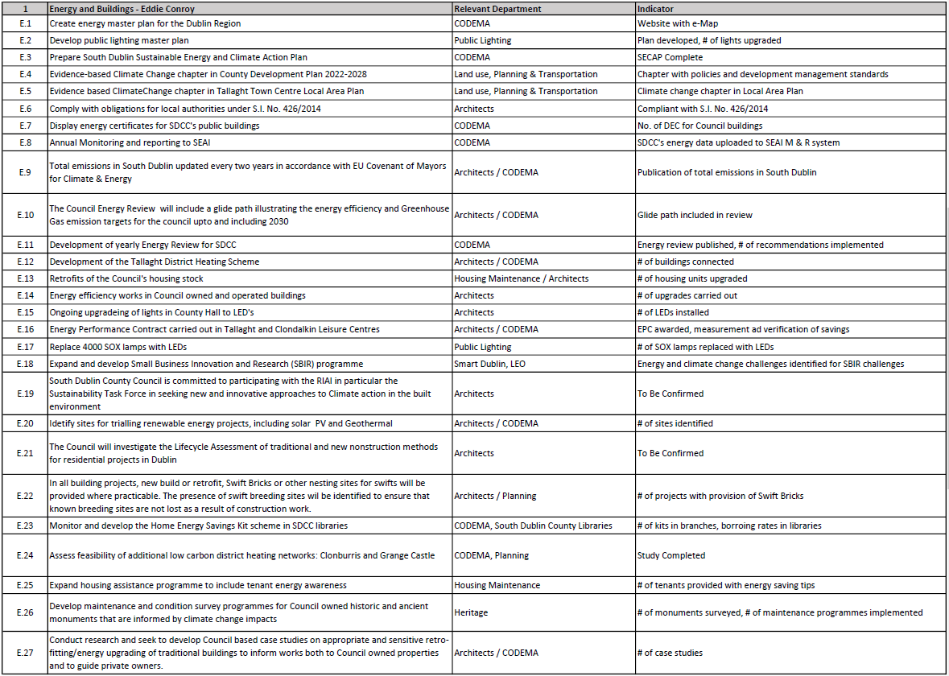

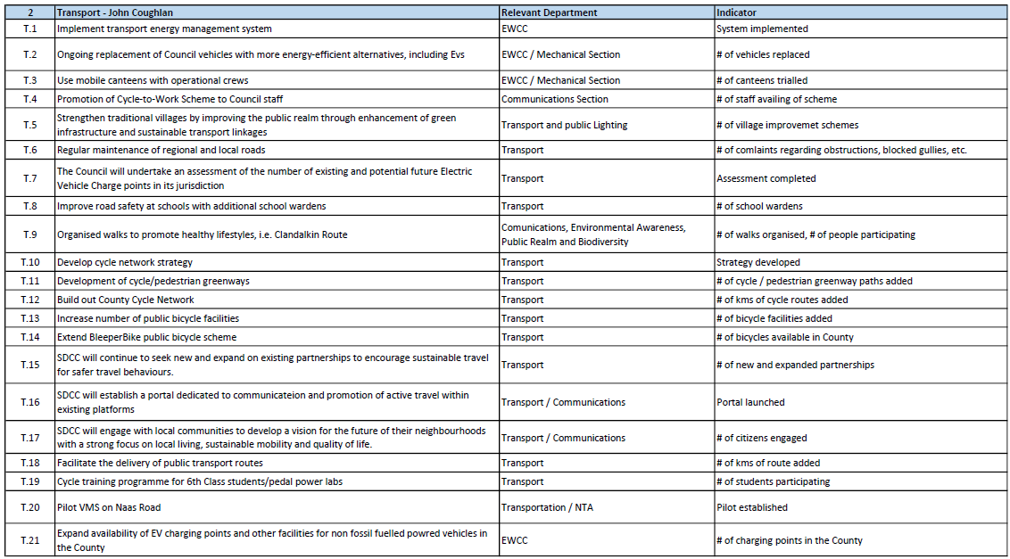

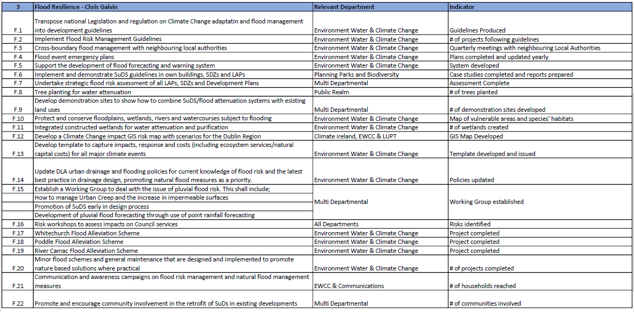

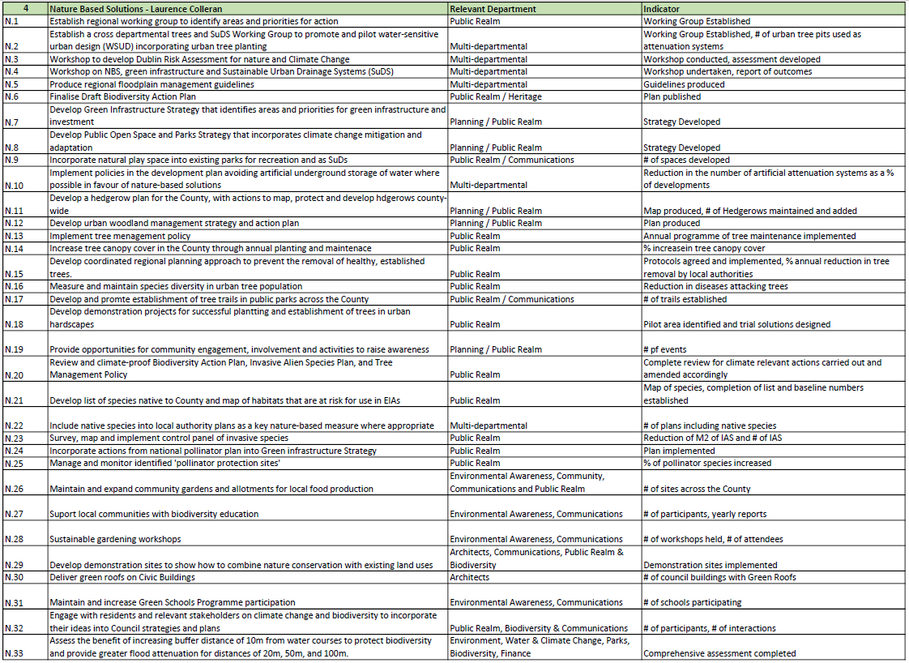

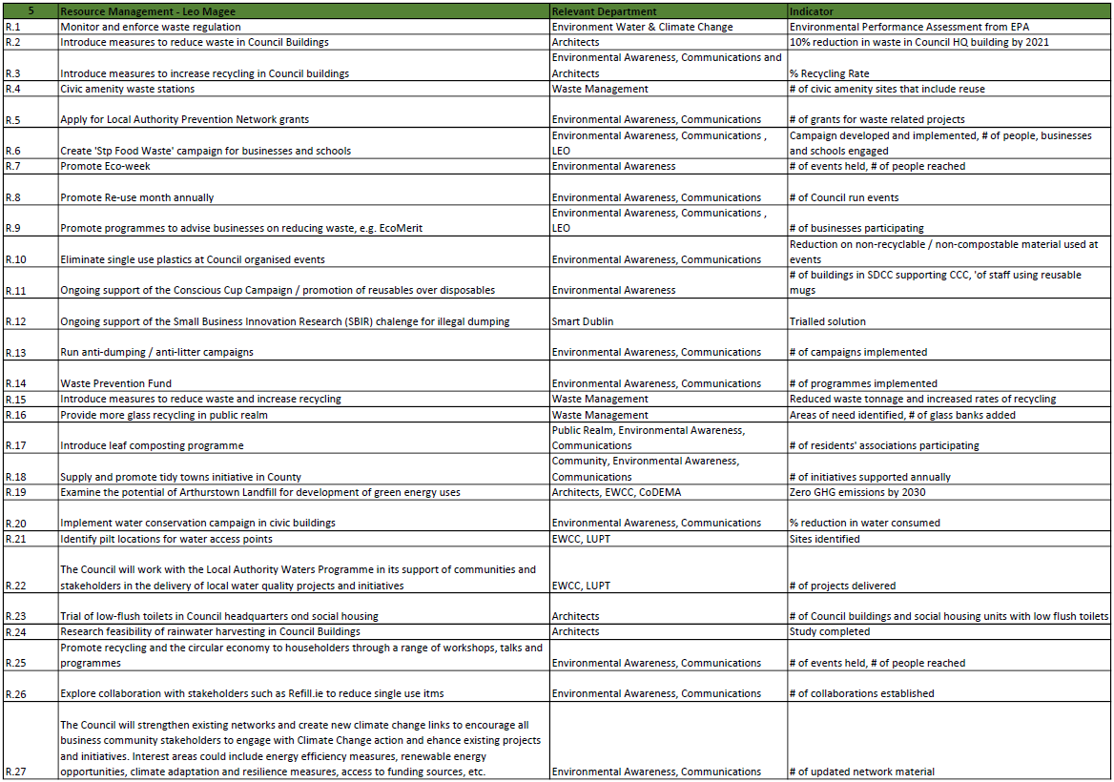

## 7.2 Appendix III -Climate Action Innovation Fund Request Sheet

