Clondalkin ACM February 2022
Libraries Report
There were 121 events held in South Dublin Libraries throughout January with a total attendance of 962.
77 events were in-branch with an attendance of 208 and 44 were online with an attendance of 754.
Following the lifting of government restrictions, all public spaces in the library have reopened. Planning is in progress for the return of regular in-person events.
Clondalkin Library

Looking Back at January

As part of the Toys, Training and Technology Series of talks in South County Dublin Libraries Clondalkin Library hosted 2 online talks.

- Parenting while you live with a Limiting Condition/Disability – Overcoming the Challenges an online talk with Michael Ryan.

- Teaching and Learning Intervention for Autistic Children and Adults - Online Talk with Dr. Susan Crawford.

January was also the start of a 6 weeks Beginners & Improvers Irish Class. These classes are always very popular in the Clondalkin area.

As part of First Fortnight, Clondalkin Library hosted an online workshop with Deirdre O’Shea. Growing Resilience and Overcoming Challenges.
Forthcoming Events for February

Title of Event/video | Blurb (which should be spell checked) | Booking link
Online Chinese New Year Arts & Crafts with Kim Jenkinson - Ages 6 + | Tuesday 1st February at 3.30 pm  Join artist Kim Jenkinson for this children's Chinese New Year themed art workshop.  Pick up your arts and crafts pack from Clondalkin library then follow along on zoom with Kim.  Booking from Friday 21st January | http://clondalkinlibrary.eventbrite.com  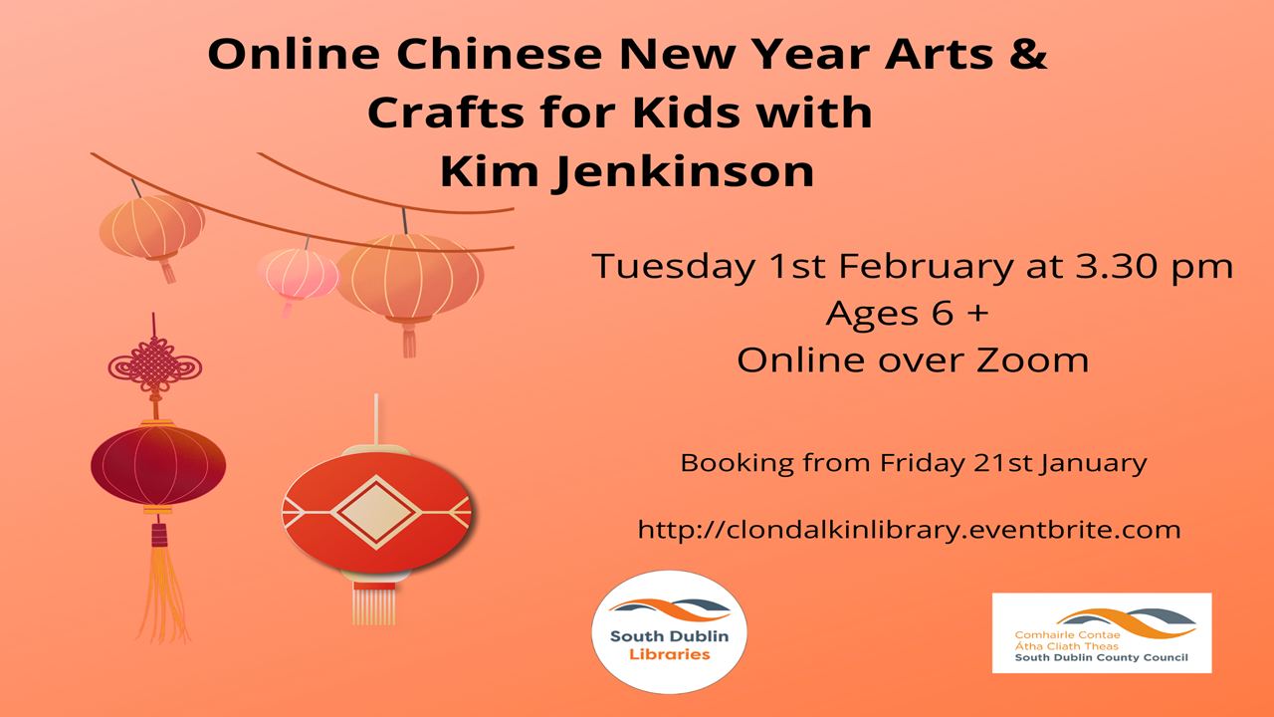
Harry Potter themed Arts & Crafts for Kids with Aoife Munn - Ages 6 + | Thursday 3rd February at 3.30 pm  Join us for a Harry Potter Crafting session and learn how to make your own book eating Bookmark, Origami Sorting Hat and Cornish Pixie Night Light.  You will need some Colours, Paper, Card, Glass Jar, Pritt Stick and Scissors.  Booking from Friday 21st January | http://clondalkinlibrary.eventbrite.com  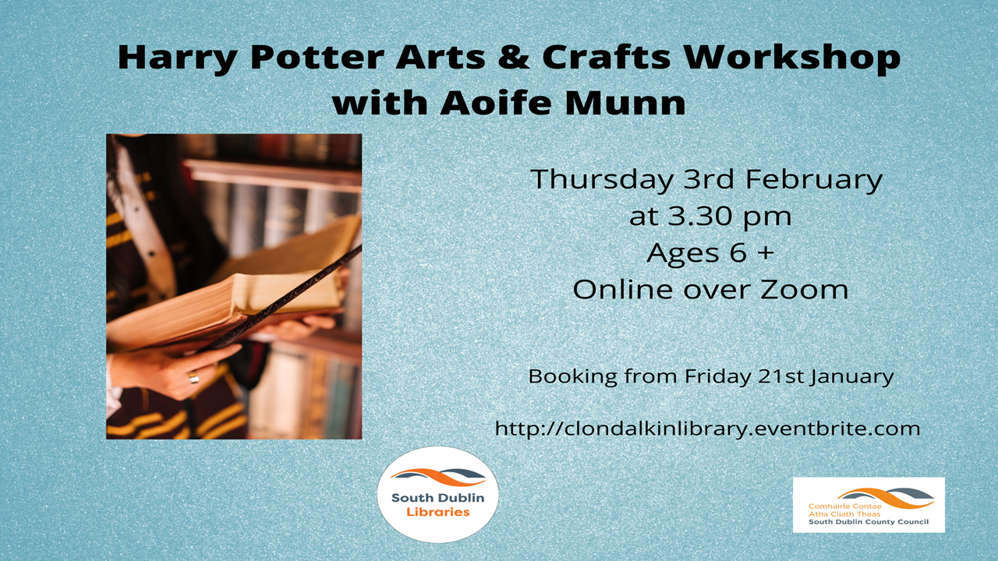
Creative Writing Workshop for Kids with Mad4Tales - Ages 7 -12 | Thursday 24th February at 4.00 pm  Online Workshop over Zoom  The Hero's Journey –  In this workshop/course, the author, Maeve A. Devoy will take her students through The Hero's Journey - a classic guide to writing adventure stories.  She will detail each stage of the form and provide literary examples, before the students create their own heroes and set off on their own adventures.  Focused on fun and creativity, this workshop promises to leave the students with a tried and tested remedy for the stories they want to tell.  Booking from Friday 4th February | http://clondalkinlibrary.eventbrite.com  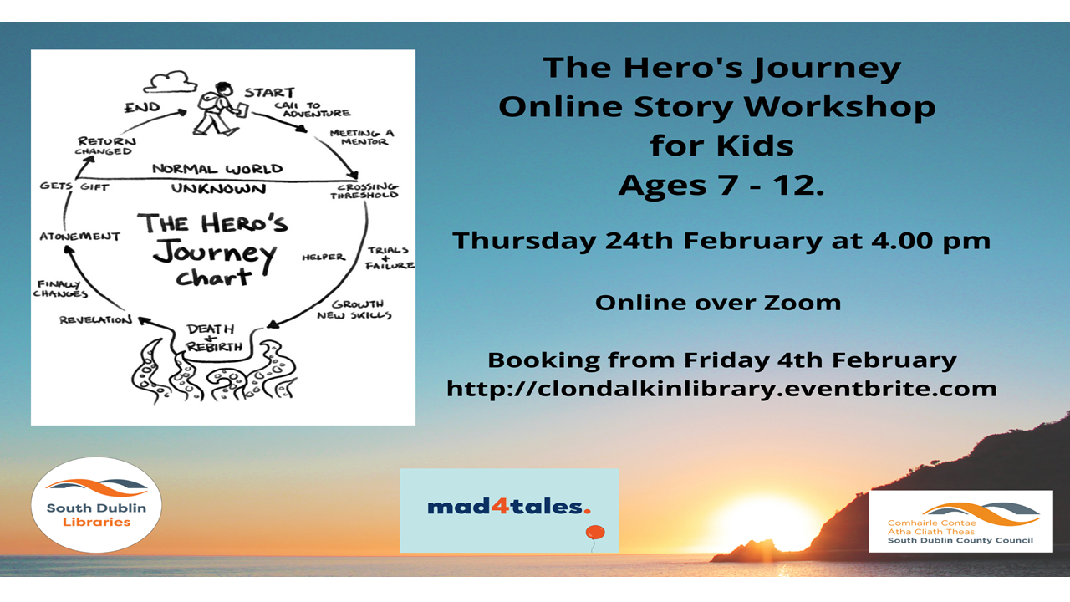

Mobile Library Service
The Mobile Library visits 32 public stops every week. Each stop lasts about 1 hour. In January we welcomed an average of 10.4 visitors at each of our public stops. Our Library@Home delivery service for people who have difficulty leaving home to visit the library continued in January. We delivered to 110 people’s homes in January. Our creche delivery service brought books to 15 crèches in January. Our regular school visits service was suspended for much of January because of Covid-19. However we are delighted to say it resumed on Monday 31st January and is scheduled to visits four schools every week during school term.
We also have a new service that is ready to go- we will visit once a month to a rehabilitation service. Starting this month the mobile library will visit
Bloomfield Health Services,
Stocking Lane,
Rathfarnham,
Dublin 16.

