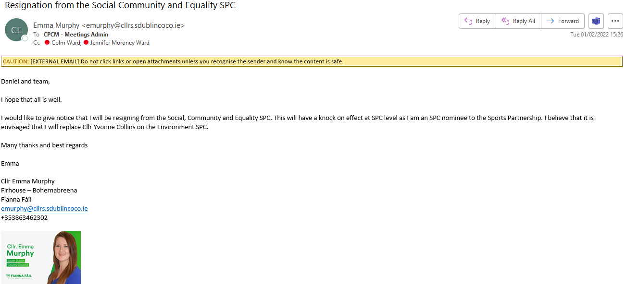

Daniel and team,

I hope that all is well.

I would like to give notice that I will be resigning from the Social, Community and Equality SPC. This will have a knock on effect at SPC level as I am an SPC nominee to the Sports Partnership. I believe that it is envisaged that I will replace Cllr Yvonne Collins on the Environment SPC.

Many thanks and best regards

Emma
Cllr Emma Murphy
Firhouse – Bohernabreena
Fianna Fáil
emurphy@cllrs.sdublincoco.ie
+353863462302



