RTFB ACM February 2022
Libraries Report | Ballyroan Library | February 2022

There were 121 events held in South Dublin Libraries January with a total attendance of 962.
77 events were in-branch with an attendance of 208 and 44 were online with an attendance of 754.

Following the lifting of government restrictions, all public spaces in the library have reopened, including the first-floor study space. Planning is in progress for the return of regular in-person events.

Event Highlights

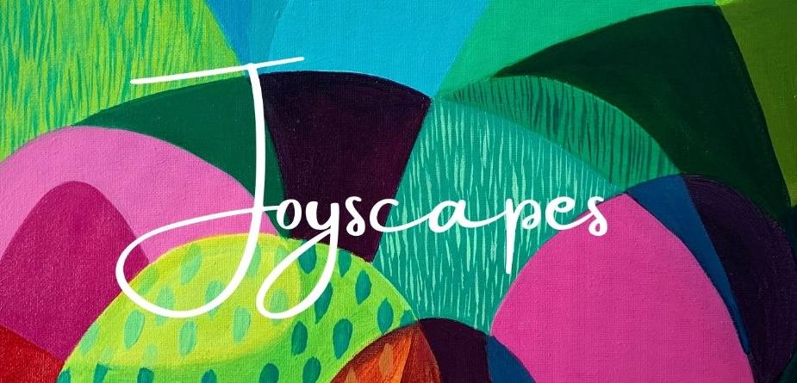
Exhibition
5th – 25th February
Joyscapes by Emma Higgins
Joyful, vibrant and beautiful, ‘Joyscapes’ is a contemporary collection of abstract landscape paintings created by NCAD Textile design graduate Emma Higgins, she has been working as an artist in Dublin for over 12 years and believes in the uplifting power and positive energy of living with colour.

Lifelong Learning Events

Tuesday 1st February from 6:00pm and every Tuesday for 10 weeks (in person)
Irish Language Courses for Beginners and Improvers.

Tuesday 8th February at 7:00pm (online)
To Game or Not to Game: Everything Parents Need to Know
With games like the latest hyperreal Cyberpunk 2077, we have come a long, long way from the days of Tank Attack, Pac Man and joysticks! Aimed at parents and guardians of pre-teen and teen children, this webinar with Cyber Safe Kids will take parents on a tour through the often baffling gaming landscape to equip them with the knowledge to make more informed decisions, by covering the positives and negatives of this now multi-billion dollar industry which employs hundreds of thousands worldwide.

Wednesday 9th February at 6:30pm and every Wednesday for 5 weeks (in person)
Beginners Irish Dance Classes for Adults
A five-week course with Leanne Gaffney where participants will learn popular Céilí dances in time for St. Patrick’s Day: the Walls of Limerick and the St. Patrick’s Day Traditional Set Dance.

Thursday 17th February 10:30am and every Thursday thereafter
Age Action Computer Classes
These one-to-one classes for older people facilitated by Age Action will resume this month.

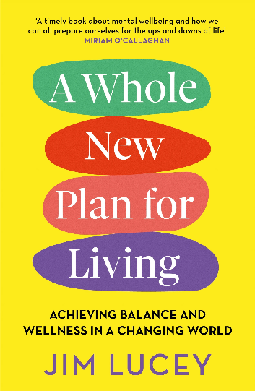
Wednesday 23rd February at 5:30pm (online)
A Whole New Plan for Living with Professor Jim Lucey
In this talk, leading psychiatrist Prof Jim Lucey will talk about the subject of his book A Whole New Plan for Living in which he presents ten powerful steps to show us how, by maintaining balance and wellness in our daily lives we can achieve overall health and wellbeing, ready for the challenges life presents to us. From understanding wellness, to managing stress and distress, to the opportunity for mental health recovery no matter the circumstances, A Whole New Plan for Living shows us how by making small changes, we can achieve optimum mental health, become more resilient and live with hope for the future.

Children’s Events
As well as regular events including STEM Studio and Coderdojo, the following will take place this month:

Wednesday 2nd February
Harry Potter Book Night
Harry Potter Book Night is a chance for fans of the series to take part in events and festivities in libraries worldwide, celebrating the world of Hogwarts.
All Evening: Harry Potter Treasure Hunt - find the golden snitches hidden around the library!
4:00pm Sorting Hat Ceremony: Take our personality test to find out which Hogwarts House you'll be sorted into. Then take a seat, put the sorting hat on your head and let it work its magic!
6:00pm Harry Potter Crafts: Create Customised Wizarding Wands
7:00pm Harry Potter Family Quiz: Test your knowledge against other Potter Heads!

Week Beginning Monday 21st February
Ballyroan Library will host various children’s event over the mid-term break including:
Monday 21st: Spring Crafts Nature Art Workshop with horticulturalist Aoife Munn
Philosophy Club – monthly club for 7-12 year olds with our resident philosopher
Tuesday 22nd: Storytime for little ones
Wednesday 23rd: Create your own Garden - Spring themed children's art workshop.
Thursday 24th: Fun Food Workshop Join the Cool Food School for a look at apples
culminating in making apple doughnuts with fun toppings!

Ireland Reads Events
Ireland Reads is a national reading campaign aimed at promoting the benefits of reading. There will be a national communications campaign on 25th February, where the public will be encouraged to go to www.irelandreads.ie to pledge reading time and to use the ‘book picker’. As well as story telling events for children, we will host the following talks to promote the campaign:

Tuesday 22 February at 7pm (online)
Ireland Reads 2022 | Myles Dungan: the books that inspire me Join Myles Dungan for a discussion of his favourite books. Myles is one of Ireland’s best-known and most respected broadcasters, hosting current affairs, arts and sports programmes on both radio and television for more than two decades. Currently the presenter of The History Show on RTÉ Radio 1, he is the author of a multiple books, both academic and fiction, including Irish Voices From The Great War (1995) and Mr. Parnell’s Rottweiler: Censorship & the United Ireland Newspaper (2014) and Four Killings (2021)

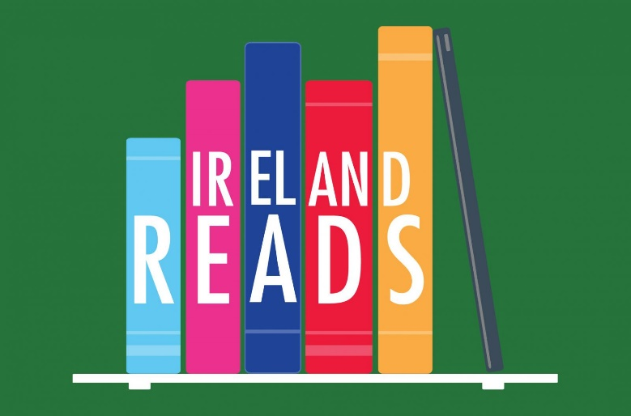
Thursday 24th February at 7:00pm (in person)
Ireland Reads 2022: The joys of reading about nature
The Ireland Reads campaign celebrates reading and all the benefits it can have for wellbeing and enjoyment. What better way to provide a respite from our hectic modern lives than to squeeze in a read about the natural world around us. Join author, historian and naturalist Michael Fewer for this talk on the best books in which to escape into nature! The Ireland Reads campaign reminds us of the importance of taking time out to read.

Mobile Library Service
The Mobile Library visits 32 public stops every week. Each stop lasts about 1 hour. In January we welcomed an average of 10.4 visitors at each of our public stops. Our Library@Home delivery service for people who have difficulty leaving home to visit the library continued in January. We delivered to 110 people’s homes in January. Our creche delivery service brought books to 15 crèches in January. Our regular school visits service was suspended for much of January because of Covid-19. However we are delighted to say it resumed on Monday 31st January and is scheduled to visits four schools every week during school term.
We also have new service that is ready to go- we will visit once a month to a rehabilitation service from next Wednesday is to
Bloomfield Health Services,
Stocking Lane,
Rathfarnham,
Dublin 16.

