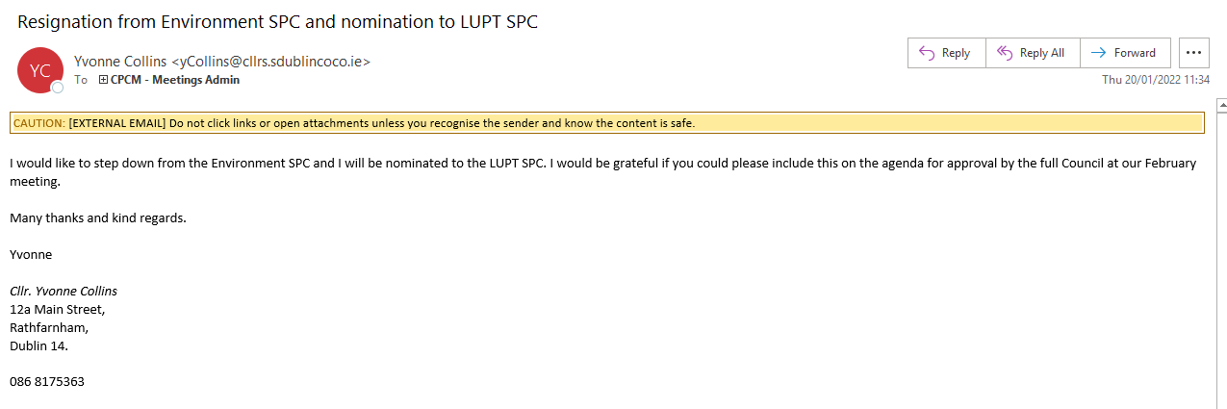

I would like to step down from the Environment SPC and I will be nominated to the LUPT SPC. I would be grateful if you could please include this on the agenda for approval by the full Council at our February meeting.

Many thanks and kind regards.

Yvonne

Cllr. Yvonne Collins
12a Main Street,
Rathfarnham,
Dublin 14.

086 8175363

