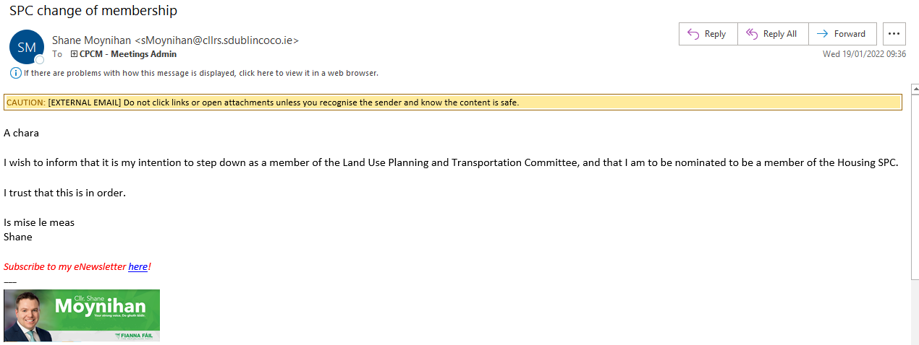

A chara

I wish to inform that it is my intention to step down as a member of the Land Use Planning and Transportation Committee, and that I am to be nominated to be a member of the Housing SPC.

I trust that this is in order.

Is mise le meas
Shane

Subscribe to my eNewsletter here!
---


