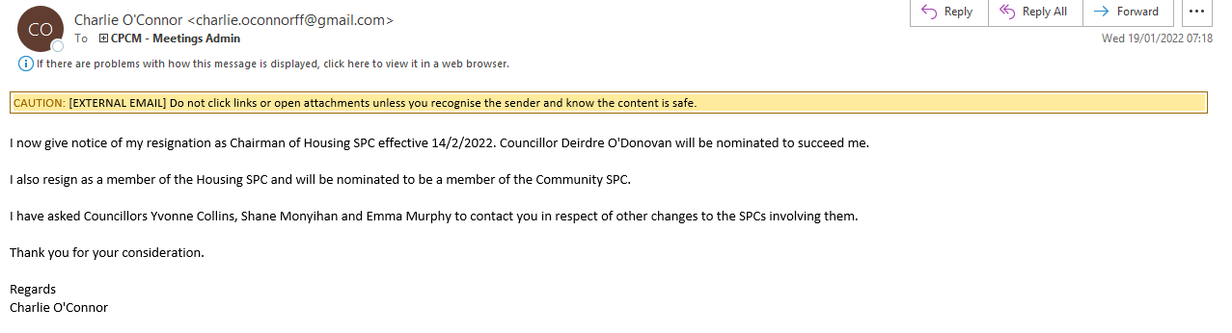

CAUTION: [EXTERNAL EMAIL] Do not click links or open attachments unless you recognise the sender and know the content is safe.

I now give notice of my resignation as Chairman of Housing SPC effective 14/2/2022. Councillor Deirdre O'Donovan will be nominated to succeed me.

I also resign as a member of the Housing SPC and will be nominated to be a member of the Community SPC.

I have asked Councillors Yvonne Collins, Shane Monyihan and Emma Murphy to contact you in respect of other changes to the SPCs involving them.

Thank you for your consideration.

Regards
Charlie O'Connor

