North Clondalkin Highlights: January 2022

Focus: Assessibility

**TTT Programme:**

**AUTISM Talks for Parents, carers and Teachers**:

* Wednesday 12th January 2022: Pathological Demand Avoidance Talk with Dr. Alison Doyle (online talk). Bookings 100. Attended by 90 people.
* Wednesday 19th January 2022: Engaging Autism with Amanda Mc Guinness (AsIAm) (online talk) Bookings: 70
* NCL: Currently in the process of getting Autism accreditation with AsIAm.

**Collaboration with NCBI:**

North Clondalkin Library are engaging with NCBI to build a collection of Braille books from our existing stock of Junior Fiction Books. This has involved the purchase of braille paper and transcribing the text into double spaced braille. I have attached a story of Georgia below and some images.

**One of our junior members Georgia is blind.  She is a regular visitor to NCL with her family and her school.  She is learning braille but struggled with the commercially produced braille books which are not books that were appealing to a little girl.  The books are also single-spaced braille which is difficult to read when learning braille and they are not Twin Vision books.   Twin Vision books allow a sighted reader to read alongside a Braille reader. This is great for those learning to read and looking to practice with simple text on something other than schoolbooks.  Braille books are available at the Child Vision Library located in Drumcondra.  However, at the moment books can only be ordered online and are posted out.  We were keen to ensure that Georgia could enjoy her library visits with her classmates and family.    Georgia and her teacher chose suitable books from NCL and Rebecca Curtis from NCBI has transcribed them to double-spaced braille so that Georgia and her family can read them together.  Her favourite is The Very Hungry Caterpillar.  She is looking forward to bringing some of her friends who are visually impaired along to NCL to enjoy the books.  Going forward we hope to build on our relationship with NCBI and build up our collection of Braille books.**

Lucan Library Highlights: January Focus: Health & Well-being

**Theme: Health & Well-being 3 Online Talks**

* On 20th Jan, we have an online talk by sleep expert Tom Coleman. Bookings: 79 people

* On 24th January author visit: Is Homeopathy part of your First Aid kit? Why not?

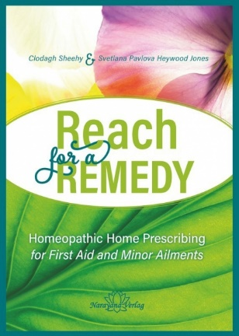Svetlana Pavlova and Clodagh Sheehy, authors of “Reach for a Remedy” will guide you through using Homeopathy at home for everyday conditions from bruises to wounds and stomach upsets to anxiety.

26th January: Natural Skincare with Barbara Mc Ateer

|  |  |  |  |  |
| --- | --- | --- | --- | --- |
| Story Time. A selection of winter tales for 3-5 year olds. | 18/01/2022 | 1 | Library Branch | 15:30 |
| Get Healthy with Plants! How to get healthy following a plant-based diet, with Dr. Ailis Brosnan. Whether you're just trying to reduce your meat intake or go fully plant-based, Ailis will talk about all the benefits of a plant-based diet and what to include to ensure proper nutritional balance. It'll do you good, and the environment too! | 24/01/2022 | 1 | Zoom | 19:30 |
| 3D workshop for 8-12 year olds - Design Your Own Snowflake | 26/01/2022 | 1 | Library Branch | 15:30 |