RTFB ACM January 2022
Libraries Report | Ballyroan Library | January 2022 Highlights

Cheeverstown Film Making Project
Ballyroan Library will host the DAF funded project: 'Let's Make a Movie: Film-making workshops'. This lifelong learning programme will be delivered to the adult day users of Cheeverstown centre in collaboration with Burning House Productions. The programme is intended as a series of six workshops culminating in the production of a short film on the part of the participants. The participants will be introduced to visual storytelling, cinematography, scene-lighting, scene structuring and directing. The participants will be taught using a mix of professional film-making equipment and smart devices. A short 'behind the scenes' documentary will also capture the film-making process.

Wellness Events
Wednesdays in January 10 am to 11.15 am
Mindful Chair Yoga (online event)
Beat those winter blues with gentle movement and mindfulness. Join Sally Dunne, a qualified yoga therapist for these sessions via Zoom.
Tuesday 11th January 7.00pm
Winter Gardening for Well-Being (online event)
Join horticulturalist Aoife Munn to discover the health benefits and joys of gardening throughout the winter season.
Tuesday 18th January 7.00pm
The Winter Garden Workshop (online event)
In this practical workshop, horticulturalist Aoife Munn will demonstrate winter gardening tasks. Lots of practical advice and tips on how to make the most of your garden space in the winter season.
Thursday 27 January 7:00pm
Winter Wellness for the Mind (online event)
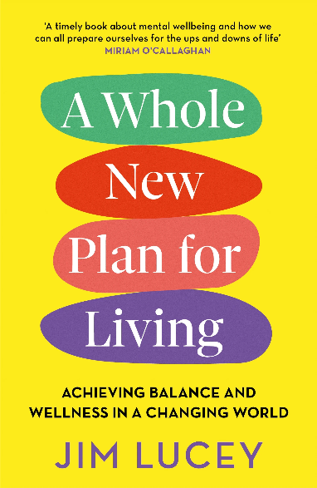
Join psychologist Dr. Aoife Quinn for an online lecture outlining some tips and guidance as to how we can look after our mental wellbeing in the winter months.

January - date and time TBC
A Whole New Plan for Living with Professor Jim Lucey. (in person event)
In this talk, leading psychiatrist Prof Jim Lucey will talk about the subject of his book A Whole New Plan for Living in which he presents ten powerful steps to show us how, by maintaining balance and wellness in our daily lives we can achieve overall health and wellbeing, ready for the challenges life presents to us. From understanding wellness, to managing stress and distress, to the opportunity for mental health recovery no matter the circumstances, A Whole New Plan for Living shows us how by making small changes, we can achieve optimum mental health, become more resilient and live with hope for the future

TTT Programme
Thursday 20th January 7:00pm
Exploring Autism and Anxiety with Dr Susan Crawford (online event)
In this lecture we consider what the research tells us about autism and anxiety. We look at typical markers of anxiety and explore strategies for managing anxiety. Dr Susan Crawford is a lecturer and researcher in University College Cork, Ireland with a particular interest in autism. She has been the recipient of The Digital Champion Award (2016), a Fulbright Scholar (2015), The President's Award (2014) as well as book deals for developing programmes both digital and hard copy for children and adults with autism to address movement skills. As the mother of a young man with autism, she is passionate about addressing quality of life issues for individuals on the spectrum.

History and Heritage Events
Thursday 13th January 7:00pm
The Handover of Dublin Castle: an oral history (online event)
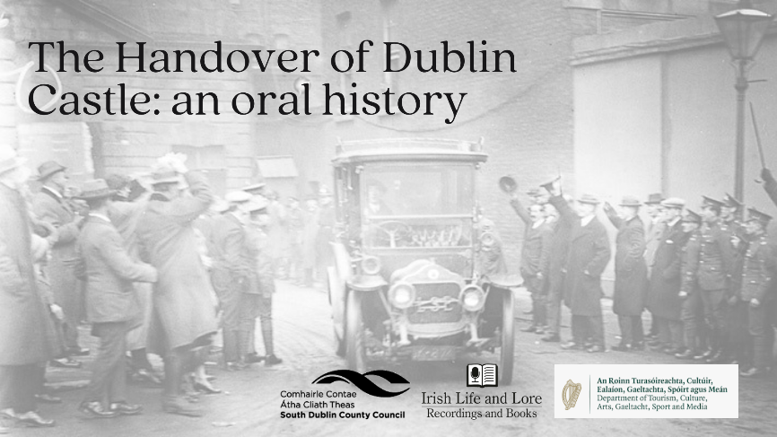
Ninety-six years ago, on 16 January 1922, an event that The Irish Independent described as ‘certainly the most significant event in Irish history for hundreds of years’, took place on a cold Monday at Dublin Castle. At 1.45 pm that afternoon the machinery of government, and the Castle itself, were formally handed over by the last Lord Lieutenant, or Viceroy, of Ireland to the new Provisional Government. In this presentation from Maurice O’Keeffe of Irish Life and Lore, we’ll hear first-hand accounts of this momentous occasion from contemporary witnesses.

Thursday 20th January 7:00pm
Josie Stallard and Liam Clarke: A Revolution Love Story (online event)
While fighting in the GPO in the Easter Rising, Volunteer Liam Clarke, a member of 'E' Company, 4th Battalion, Patrick Pearse's Company, was horrifically wounded. He evaded arrest and went to Kilkenny where he was cared for by Josie Stallard, his future wife. The two were inseparable, working together for the cause of Irish freedom. Josie was the dispensary doctor in Rathcoole. Historian in Residence Liz Gillis will talk about this remarkable couple whose love survived war, imprisonment and the legacy of the conflict.

Life Long Learning Events
Wednesday 12th January or Monday 24th January at 7pm TBC
Healthy Tech Habits at Home (online event)
This live, tailored webinar with CyberSafeKids aims to equip parents with the tools to help their children navigate the online world in a fun, safe and responsible manner. For parents of children aged 2-10.

Tuesday 25th January 7:00pm
What Makes a Book a Classic? (in-person event)
What do writers have to do to achieve the timeless glory of a ‘classic read’? Join librarian Emma Edwards for this talk on classic literature. This talk will explore the contested criteria for awarding certain books the coveted status of ‘classic.’ Is this process fair? Impartial? Subjective? Inclusive? Please come armed with your own opinions!

The Mobile Library Service
The mobile library services have continued to deliver the service to the public and stops are more popular that ever. The vans have been decorated with fairy lights to bring a bit of joy to the users. The mobile service is continuing with the Library@Home deliveries which started as a small housebound service but flourished into a very large part of our offerings with over 100 citizens receiving deliveries on a monthly basis.

South Dublin Libraries continues to offer online services including E resources, Universal Class and other online events.

