## COMHAIRLE CONTAE ATHA CLIATH THEAS

## SOUTH DUBLIN COUNTY COUNCIL

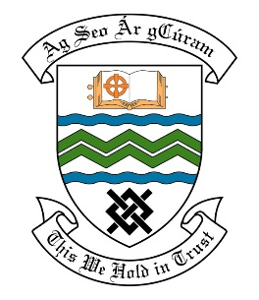

### MEETING OF THE RATHFARNHAM/TEMPLEOGUE/FIRHOUSE/BOHERNABREENA AREA COMMITTEE MEETING

## 14th December 2021

## HEADED ITEM NO. 3

**Deputation meeting – 15th November @ 2pm.**

**Orwell Park Residents Association**

**Deputation** **attendees** – Kieran Boylan, Betty Collard, Miriam McGuinness & Sean Ward.

**Elected Members** – Cllr. Alan Edge, Cllr. Lynn McGrave, Cllr. Ronan Mahon & Cllr. Yvonne Collins.

**Council Officials** – Brian Carroll, Fionnuala Keane, Brendan Redmond, Angela Kelleghan, Máire Ní Dhomhnaill, Leo Magee, Eamon Harnett, Michael Murtagh & Bill Fowler.

Cllr. Alan Edge presided.

**Items discussed**:

1. Orwell Park Green
2. Tree Maintenance
3. Yellow Box Orwell Roundabout exiting from Orwell Road & Stop Sign Orwell Park Dale
4. Commitments given.

**Commitments given**:

1. Site meeting to take place in December to discuss Orwell Park Green. – Brendan Redmond.
2. Orwell Park to be listed on the 2022 programme. A survey will be carried out in Q1 of 2022. – Máire Ní Dhomhnaill.
3. Will meet to group on site to explain the process – Máire Ní Dhomhnaill.
4. Can arrange for repeat visit by contractor for leaf removal. – Leo Magee.
5. Will request for the Yield Markings to be refreshed. Will come back to the group following an inspection to establish if a Stop Sign in appropriate. - Angela Kelleghan.