**HIGHLIGHTS from NCL December 2021:**

**National Accessibility Week:**

1. **Launch of Sensory Garden in NCL: (DAF Funding)**

On Tuesday 30th December, NCL launched its sensory garden. This ties in with SDCC commitment to ensure NCL is an inclusive library and is a welcome addition to the accessible features already available in NCL. (Changing places facility, Sensory equipment, braille stock, wheelchair accessible opacs and garden spaces) A local autism unit were invited down to plant bulbs and celebrate the sensory space. This project was enabled as a result of DAF funding received.

1. **Acorn Tablets launch and demo:**

Acorn tablets were designed specifically for people who do not have much experience in using the internet and are available to borrow from the library. 7 people turned up for this event and were delighted to get some initial training on the use of Acorn tablets. All 5 tablets were borrowed on the night -with the Mens shed being particularly delighted to borrow one.

**Installation of Urban Art Project: Friday 10th December – Creative Ireland Funding**

NCL commissioned a piece of Urban Art last year -courtesy of funding received from Creative Ireland. Everything was delayed due to Covid. I am attaching a copy of the final design.

The design incorporates elements from the local area including Baldonnell, Collinstown Park, words of local spoken artist Natalya O’ Flaherty along with popular pursuits like horses & scooters.

We engaged with local schools and community groups during the process. The art piece will be installed on the outside fence of the junior garden in NCL.

The idea behind the Urban Art piece is to create a sense of pride among locals in the North Clondalkin Area. 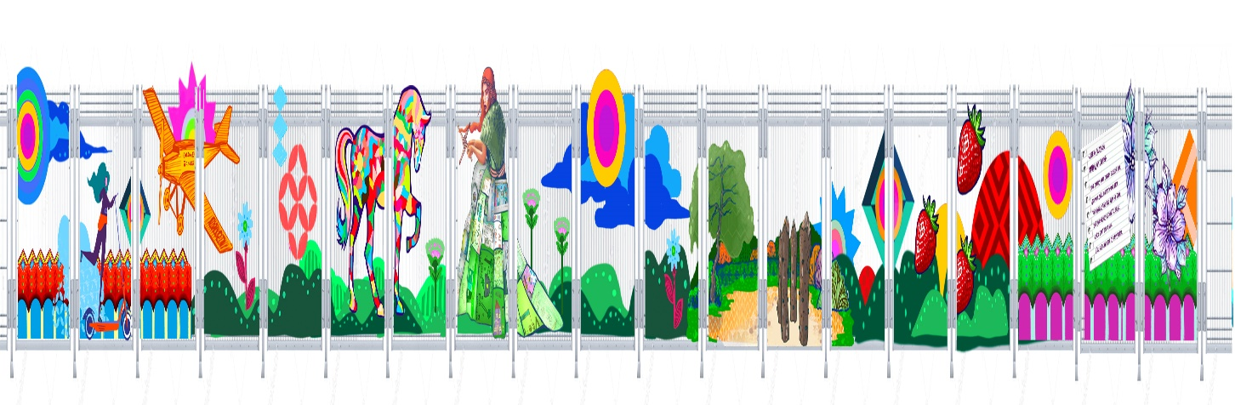

On Friday 10th December Urban Artist *KinMx (aka Kathrina Rupit) will give a talk to secondary school art students on her art work. is a Mexican street artist who lives in Dublin, Ireland. Her work is multifaceted in its beauty and appeals to a broad international audience, as evidenced by her success and the demand for her art in cities all around the world.*

*This will be followed by a photo op with some of the children and community groups who participated in the project.*

**Christmas Events: Including Christmas Craft Fair:**

Our First ever Christmas Craft Fair takes place on Saturday 11th December. We have 14 stalls – with our weekly women’s craft group participating.

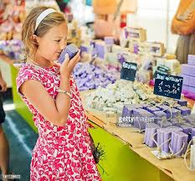

Entertainment will be provided by Music ensemble “Pennies from Heaven” , and there will also a special Christmas story-time along with a Family LEGO Storytelling Workshop.

**December Highlights: Lucan Library:**

The above events represent some online and in person events throughout December. December began with Accessibility week. We borrowed The Magic table from NCL for a group of service users from Stewarts Care and they are very interested in following up with more visits to NCL or to Lucan when we have the equipment again.

Our family music workshop on 4th Dec has an Elf on the Shelf theme and will have 16 families join this online panto like event. Nuala O’Connor will be in conversation with Siobhan McCrystal, librarian at Lucan library on 7th December. Nuala’s book, Nora , is the One Dublin One book choice for 2022.

We have a few in person childrens events with the ever popular Musical tots on 1st Dec with children with additional needs and for toddlers on 9th Dec. We are also running a Brick 4 Kidz lego workshop on 16th which is booking fast.

In the last week before Christmas we will have pop up story times for children with some of the beautiful Christmas story books we have to lend over the holiday period.

**Palmerstown Hub: December Highlights**

**LED Christmas Cards**

From Thursday 9th December, book a kit to take home.

Make a unique card and learn about electronic circuits in this STEAM activity for 8-12 year olds.

Booking via palmerstownlibrarydigitalhub.eventbrite.ie

(*Originally was to be in branch but changed due to current Covid situation*.)

**Seasonal Story Time**

A selection of winter and holiday themed tales for young readers.

Tuesday 14th December, 3.30pm - for 3-5 year olds.

Thursday 16th December, 7pm - 5-7 year olds.

This activity takes place in the library. Spaces are limited to ensure social distancing.

Booking via palmerstownlibrarydigitalhub.eventbrite.ie

(*Lasts only about half an hour*)