Clondalkin Library ACM Report

**Highlights in November**

Joan Connolly Art & Crafts are always popular. The November Class covered the paper craft of Quilling with Card Making.

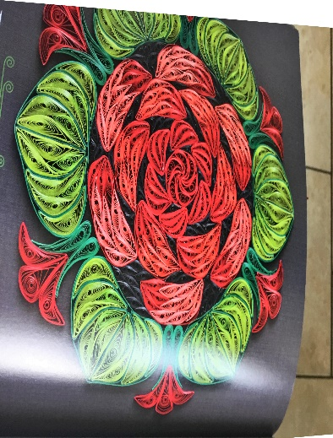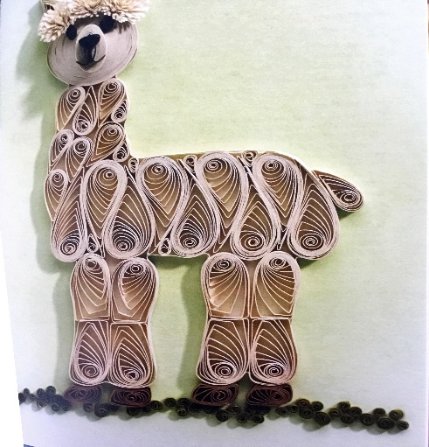

Season of Science took place in November. The Rediscovery Centre and Anyone4Science ran Space themed Workshops for Clondalkin Schools.

Reflexology Classes are starting on 26th November.

The sessions are suitable for any parent who has a Baby or toddler up to age of 4, who has:

➢ trouble sleeping

➢ colic/reflux

➢ digestive issues

➢ respiratory issues such as asthma

➢ teething pain

➢ or any parent who would like to promote bonding and over health and wellness

|  |  |  |
| --- | --- | --- |
| **Clondalkin Library Events in December** | | |
| Title of Event/video | Blurb (which should be spell checked) | Booking link |
| An Online Social Stories talk with Joanne Fine  (Speech and language Therapist). | Wednesday 1st December at 7.00 pm.  Online Over Zoom.  Using Social Stories to help children with ASD understand and interact with others.  One of the biggest challenges faced by children on the ASD spectrum can be their lack of comprehension with changing social and emotional situations in life.  Some children find it simply impossible to naturally understand the difference between two seemingly obvious social scenes and can often react in a socially inappropriate manner.  This talk aims to explore some of the reasons for these issues and go through series of Social Stories specifically designed to help children understand and more appropriately deal with various social scenes.  The Talk will address the following issues:  • Children with ASD rely heavily on the use of Visual learning  • Children’s senses can often be overwhelmed by sensory input which can lead to reactions  • How to use social stories to explain social situations  • Examples and recommendations  Part of National Accessibility Week 2021.  Booking from Monday 15th November. | [http://clondalkinlibrary.eventbrite.com](http://clondalkinlibrary.eventbrite.com/?fbclid=IwAR3x1sXtIpArjV_7d8H-jjd5efYCX6HCYwmR31XCP1v1ZfgtaghOsO9z5ok) |
| Christmas Craft Art Class for adults with Joan Connolly | Friday 10th December at 11.00 am  This Christmas themed Art Class will cover making a Christmas tree from old books and magazines.  All materials will be supplied on the day.  **This will be a live event in the library.**  Booking essential  Booking from Monday 22nd November. | [http://clondalkinlibrary.eventbrite.com](http://clondalkinlibrary.eventbrite.com/?fbclid=IwAR3x1sXtIpArjV_7d8H-jjd5efYCX6HCYwmR31XCP1v1ZfgtaghOsO9z5ok) |
| Christmas Themed Storytelling & Creative Writing Workshop - Ages 5 - 11. | Monday 6th December at 4.00 pm  Online Storytelling & Creative Writing Workshop with Storygate.  Booking from Monday 22nd November | [http://clondalkinlibrary.eventbrite.com](http://clondalkinlibrary.eventbrite.com/?fbclid=IwAR3x1sXtIpArjV_7d8H-jjd5efYCX6HCYwmR31XCP1v1ZfgtaghOsO9z5ok) |
| Online Christmas Arts & Crafts with Kim Jenkinson - Ages 6 + | Tuesday 7th December at 3.30 pm  Join artist Kim Jenkinson for this children's art workshop to create your own Christmas hanging decorations for the season.  Pick up your arts and crafts pack from Clondalkin library then follow along on zoom with Kim.  Booking from Monday 22nd November | [http://clondalkinlibrary.eventbrite.com](http://clondalkinlibrary.eventbrite.com/?fbclid=IwAR3x1sXtIpArjV_7d8H-jjd5efYCX6HCYwmR31XCP1v1ZfgtaghOsO9z5ok) |
| The Revolution and Civil War in Clondalkin - an Online History Talk with Liz Gillis. | Tuesday 7th December at 7.00 pm.  Online Over Zoom.  Part of the Historian in Residence Talks.  The narrative of the Irish Revolution has been dominated by the big events and big names of the revolutionary movement.  However, what happened in the towns and villages across Ireland is just as important as those big actions.  The national story can not be told without looking at what happened at the local level, and all of our communities have a story to tell.  Our Historian in Residence Liz Gillis will talk about the War of Independence and Civil War and the many events that took place in the Clondalkin area.  Booking from Monday 22nd November. | [http://clondalkinlibrary.eventbrite.com](http://clondalkinlibrary.eventbrite.com/?fbclid=IwAR3x1sXtIpArjV_7d8H-jjd5efYCX6HCYwmR31XCP1v1ZfgtaghOsO9z5ok) |
| Teaching and Learning Intervention for Autistic Children and Adults –  Online Talk with Dr. Susan Crawford. | Wednesday 8th December at 7.00 pm.  Online Over Zoom.  Part of the TTT Series of Talks.  This topic explores the different teaching and learning approaches that are useful when planning programmes and developing skills for autistic children and adults.  It will include an overview of applied behaviour analysis, TEACCH, Pivotal Response Therapy, Use of Technology and others.  The talk will provide guidance on how to adopt an “eclectic” approach where the best of all approaches are combined or adapted to meet the learning needs of the child or adult.  Dr Susan Crawford is a lecturer and researcher in University College Cork, Ireland with a particular interest in autism.  She has been the recipient of The Digital Champion Award (2016), a Fulbright Scholar (2015), The President's Award (2014) as well as book deals for developing programmes both digital and hard copy for children and adults with autism to address movement skills.  Susan is also a qualified Nurse, Midwife, Sport and Exercise Scientist, Occupational First Aid instructor/Examiner and have completed further post graduate study in Teaching and Learning in higher Education to Masters level (Hons).  Susan has worked both nationally and internationally in all of these fields.  Booking from Wednesday 17th November. | [http://clondalkinlibrary.eventbrite.com](http://clondalkinlibrary.eventbrite.com/?fbclid=IwAR3x1sXtIpArjV_7d8H-jjd5efYCX6HCYwmR31XCP1v1ZfgtaghOsO9z5ok) |
| Online Christmas Crafts for Kids with Aoife Munn - Ages 6 + | Monday 13th December at 3.30 pm  Christmas Crafts  Join us online for a Christmas crafting session.    We will be making everything you need to get your home decorated and looking amazing for Christmas.  **All you will need is some colours, white paper (and coloured paper if you have it), some card, Pritt stick and sellotape and either ribbon or string.**  Booking from Monday 22nd November |  |