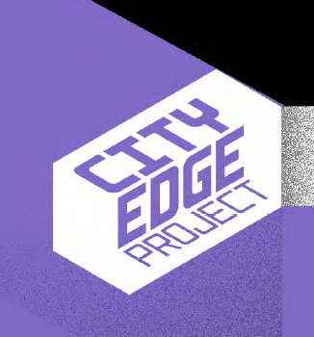

STRATEGIC FRAMEWORK CONSULTATION

CITY EDGE PROJECT

CHIEF EXECUTIVE’ S REPORT ON SUBMISSIONS RECEIVED

December 2021

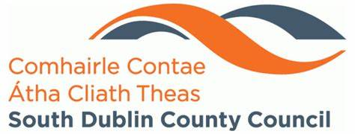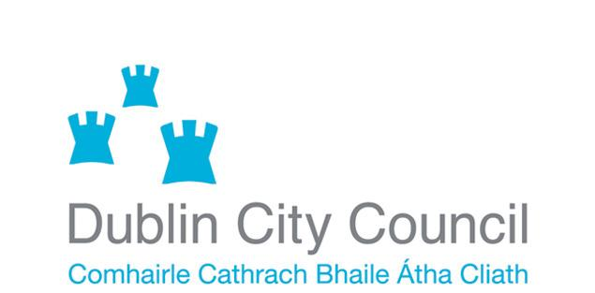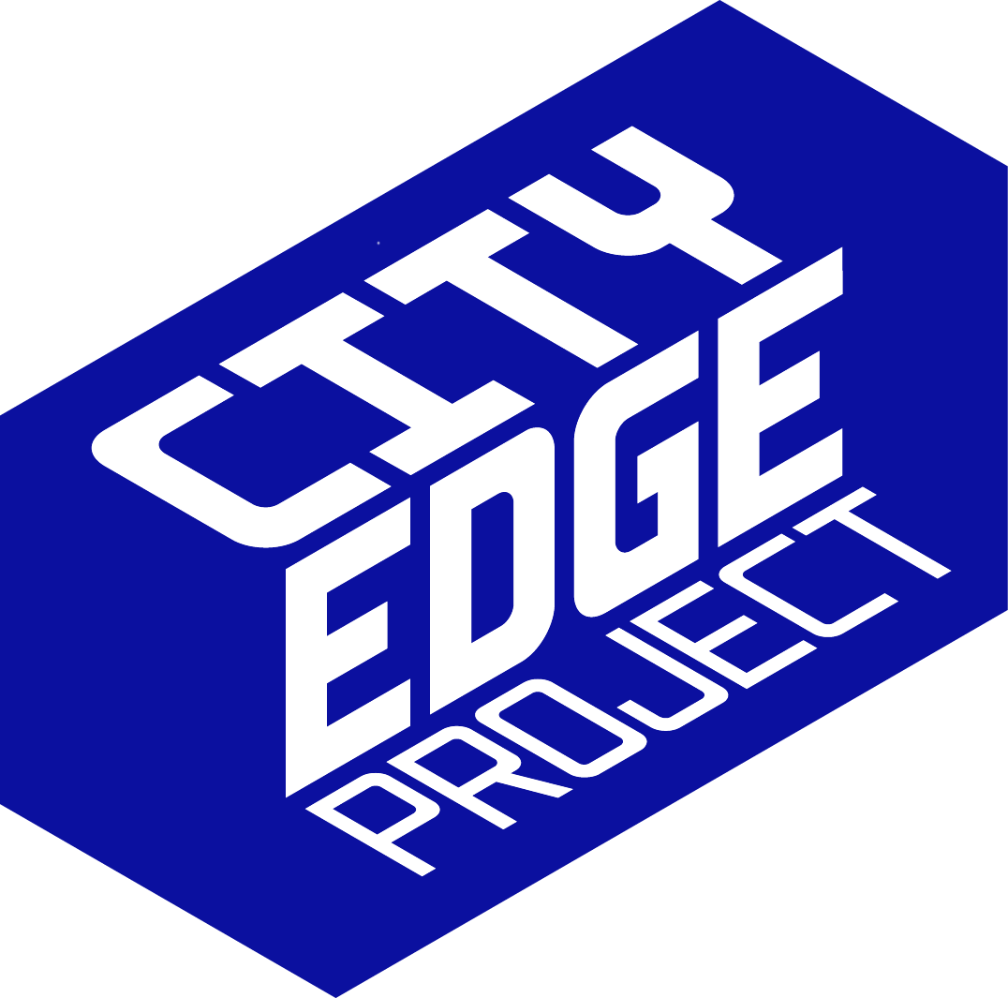
Table of Contents

1.0 Introduction

2.0 Public Consultation Process

3.0 Details of Submissions

4.0 Summary of Issues Raised and Chief Executive Responses

5.0 Conclusion and Next Steps

Appendices

Appendix A: Public Consultation Portal

Appendix B: Newspaper Notices

Appendix C: Public Consultation Launch Press Release, September 9th, 2021

Appendix D: Press release 19th of September, announcing the opening of registration for live online events including the Online Public Presentations and City Edge International Conference.

Appendix E: Press Release from 27th of September, announcing the speakers and details for the two-day City Edge International Conference as part of the project launch and public consultation events.

Appendix F: Social Media Posts

Appendix G: International Conference Evite

Appendix H: International Conference Evite Mailing List

- Introduction

1.1 Purpose of the Report
In order to meet the objectives of the National Planning Framework which seeks to make better use of land close to cities, South Dublin County Council (SDCC) and Dublin City Council (DCC) have come together to undertake a joint urban regeneration initiative known as the City Edge Project. SDCC and DCC are currently in the process of preparing a Strategic Framework for the project area which comprises lands in the Naas Road, Ballymount and Park West areas.

Located at the western edge of Dublin City Centre, the City Edge Project lands cover an area of 700 hectares and are strategically positioned to become one of Europe’s largest urban regeneration projects and an attractive extension of the city where people will be able to live, work, and socialise. The regeneration scheme is part of a national strategy to rejuvenate our cities and large towns by concentrating new housing and employment in existing urban areas.

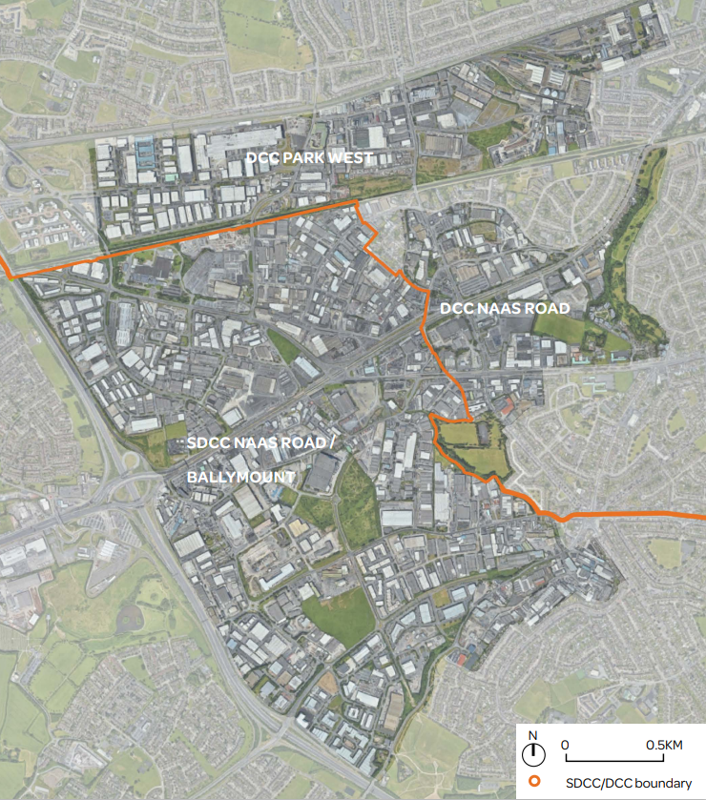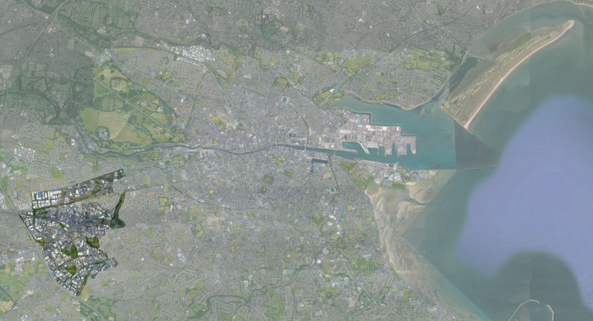
Figure 1.1: Study Area – Orange line denotes the SDCC/DCC Administrative boundary; and City Edge in the context of the Greater Dublin Area.

The two Councils undertook non-statutory public consultation from the 9th September to 6th October 2021 to inform the preparation of the draft Strategic Framework. A total of 106 submissions were received through the online portal and by post. The purpose of this Chief Executive’s Report is to summarise and respond to issues raised during this non-statutory public consultation process.

1.2 Background
The National Planning Framework (NPF) places an emphasis on more concentrated growth in urban areas, with a target of at least 50% of all new housing to be delivered in existing built-up urban environments of the five Cities and suburbs of Dublin, Cork, Limerick, Galway and Waterford. Central to achieving this target is the role of compact growth and the optimisation of underutilised and strategically located brownfield land. In such areas, large scale regeneration can deliver a critical mass of housing supply in locations that are well served by public transport and public amenities, thereby creating the conditions for the establishment of more sustainable communities, whilst also facilitating a greater return on capital investment in supporting infrastructure. City Edge, which at 700 hectares, is likely to be the largest and most transformational regeneration project in Europe, is an opportunity to implement compact growth policy at scale.

South Dublin County Council and Dublin City Council are together currently undertaking a significant strategic masterplanning exercise for the City Edge area. The project, which began in July 2020, is supported by funding which was obtained under call 1 of the Urban Regeneration Development Fund (URDF) for the preparation of a masterplan for lands located around the Naas Road area, in both Dublin City Council’s and South Dublin County Council’s functional areas.

The first stage of Phase 1 of the project involved an examination of the existing situation in the area and the production of a Baseline Study and the second stage of this phase involves the preparation of a Strategic Framework for the regeneration of the area which is currently underway.

Some of the salient points from the Baseline Study are:
• There are over 1,500 existing businesses employing some 25,000 people and representing 4% of Dublin’s jobs.
• The area houses some of Dublin’s biggest and most recognisable businesses.
• 5,000 people live in the area in 1,600 existing homes in well-established communities that are intertwined with the surrounding areas of Walkinstown, Drimnagh, Clondalkin and Ballyfermot.
• The area is criss-crossed with existing road and rail infrastructure, utilities and disparate landownerships

Following the Stage 1 Baseline exercise, Stage 2 is aimed at arriving at a preferred scenario for the development of the area, through the preparation of the Strategic Framework. The Emerging Preferred Scenario, presented as part of the public consultation exercise, comprises a mix of residential-led development with significant employment, based around the creation of a number of development nodes of different character.

The non-statutory public consultation requested feedback on the future of these lands and the work completed to date, including in relation to the Emerging Vision as below and the Emerging Preferred Scenario, Figure 1.2.

The Emerging Vision is:
‘to create a new mixed use and climate resilient high density urban quarter in the city, where the citizens of the Greater Dublin Area will be able to access affordable homes, live close to where they work, in an area home to outstanding public amenities and public transport services.

Building upon its rich history of employment, the area will support the retention, consolidation and the creation of new employment opportunities, culminating in the creation of a self-sustaining and integrated part of the city, where family, community, visitors and the economy can prosper in a distinctive Dublin setting.’

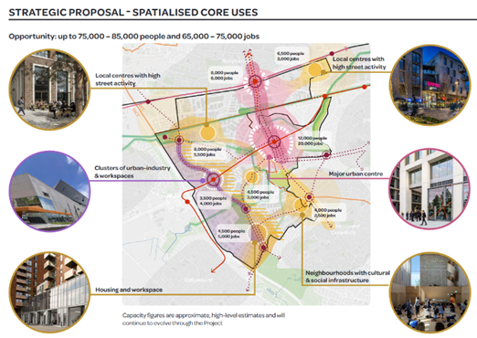
Figure 1.2: Emerging Preferred Scenario

- Public Consultation Process

  - Details of the Consultation Process
In the interests of engaging with stakeholders and informing the process of developing a Strategic Framework for the City Edge Project, the two Councils engaged in non-statutory public consultation over a four-week period from 9th September to 6th October 2021. Submissions to this pre-framework consultation stage could be made online via the Council’s consultation portal or by post to a dedicated address. The Councils also utilised Facebook and Twitter to notify the public of the public consultation events. A total of 106 submissions were received.

The pre-framework public consultation involved the following steps:
- The creation and launching of a dedicated website, www.cityedge.ie, to act as an information hub and point of contact during the worldwide Covid 19 pandemic, where in-person consultation could not take place.

- Information was made available on the City Edge website and submissions were invited on the work done to date including the Baseline Study, Emerging Vision and Objectives and Emerging Preferred Scenario via the South Dublin County Council Online Consultation Portal at https://consult.sdublincoco.ie. (see Appendix A).

- Notification of pre-framework consultation was published in the Irish Times, Gazette, People and Echo newspapers (see Appendix B).

- A Press Release was issued to local and national media outlets from Communications Clinic consultants, launching the Public Consultation period on Thursday the 9th of September (see Appendix C)

- A second Press Release was issued to local and national media outlets from Communications Clinic consultants on the 19th of September, announcing the opening of registration for live online events including the Online Presentations and City Edge International Conference. (see Appendix D)

- A third Press Release was issued to local and national media outlets from Communications Clinic consultants on the 27th of September announcing the speakers and details for the two-day City Edge International Conference as part of the project launch and public consultation events. (see Appendix E)

- The two Councils hosted two live online presentations followed by question and answer sessions at 3pm on Wednesday 22nd September 2021 and Thursday 30th September 2021 at which the Project was presented and questions were invited from the public in order to engage residents, businesses, landowners and state agencies.

- The pre-framework Public Consultation was promoted over a two day ‘City Edge International Conference’ with speakers including European experts in the delivery of large-scale regeneration projects and placemaking, and hosted by Newstalk’s Shane Coleman. These took place from 9-11am on the 29th and 30th September 2021.

- The website was viewed by 8,800 people over the public consultation period and approximately 6,000 people attended the live events, with over 400 additional offline views. This is a significantly greater level of engagement than is generally achieved by more traditional means.

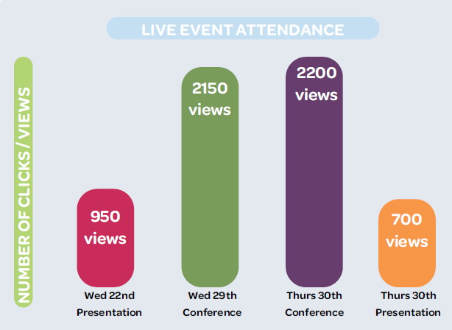
Figure 2.1: Live Event Attendance

- A Facebook, Instagram and Twitter campaign took place during the four-week consultation process, informing and directing citizens to engage with the website. (see Appendix F)

- Letters of notification and how to access information were emailed to local community and residents’ groups through the South Dublin and Dublin City Public Participation Network (PPN).

- Letters were issued to the Prescribed Authorities. This information included an invitation for submissions/observations up to midnight on the 6th of October.

- Letters of information and notice were issued to known Landowners in the City Edge Study area inviting submissions and a series of landowner briefings took place online via Microsoft Teams. Meetings were also held with new Landowners and representatives who came forward through the ‘contact us’ function on the website.

- The City Edge Project received significant media coverage at the launch of the consultation process and around the International Conference. News items were delivered on television (RTE Six One News and the 9 O’clock News), on radio (RTE Radio News, Newstalk, 98FM and Dublin City FM) and in print media (Irish Times, Irish Independent, Sunday Business Post, The Echo, The People, The Gazette) and in online media (The Journal, Dublin Live, Construction Network Ireland, The Planner Newsgroup, Dublin Inquirer).

Following the publication of the Strategic Framework, further public consultation will be undertaken as part of the next steps in the process which will involve preparing a statutory plan for the area.

2.2 Landowner Briefings
SDCC and DCC hosted a series of briefing meetings with landowners and/or landowner representatives during the 4 weeks of the consultation process. Due to the Covid 19 pandemic, all briefings occurred online. At the briefings, presentations were given setting out the following;
- Site and regional context of the City Edge Project
- Planning Policy Background
- Key Issues
- Key Challenges
- Overview of the City Edge Strategic Framework preparation process & timelines.
- Public consultation process.

The main Issues raised by the landowners included the following;
- Delivery
- Infrastructure
- Relocation
- Providing for existing uses/industry
- Funding
- Mixing land uses in mainly industrial area
- Transport capacity.

2.3 Public Information Sessions
Public information sessions were held online via the City Edge website. The first was held on Wednesday the 22nd of September at 3pm and the second on Thursday the 30th of September at 7pm. The sessions provided the opportunity to gain further understanding of the project proposals and challenges. The live forum format provided the opportunity for people to pose questions on the Emerging Preferred Scenario which were responded to by the project panel. Live recordings of the information sessions were uploaded to the website following the presentations. Submissions were encouraged during the presentations.

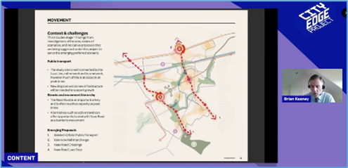
Figure 2.2: Online Public Information Session

2.4 City Edge International Conference
SDCC and DCC hosted the City Edge International Conference events on September 29th and 30th. This live event series provided a unique opportunity to discuss and learn about best global practice approaches to designing and delivering large scale regeneration projects. Hosted by Newstalk’s Shane Coleman over 2 days, the online event was open to the public and featured a range of high profile national and international speakers from Dublin, London, Amsterdam, Copenhagen and Singapore, all of whom have been involved in significant and successful urban regeneration projects. They shared their experiences of designing and delivering complex regeneration projects and how the lessons from their projects could be applied to the City Edge project. Exemplar projects that the international speakers have been involved in include:
- London 2012 Olympic and Paralympic Games
- Old Oak and Park Royal Development Corporation in London, which is supporting the delivery of 25,000 new homes and 40,000 new jobs around a new High Speed 2 station
- Gardens by the Bay, which is a significant new flagship park delivered by the state in Singapore and has become a key new destination
- Royal Docks in London, close to Canary Wharf, where the regeneration of these lands is underway and will support 25,000 new homes and 60,000 new jobs.
- Orestad in Copenhagen with a new population of 15,000 people in a mixed-use urban quarter based around a new metro
- Nordhavn in Copenhagen, where the delivery of 40,000 new homes and 40,000 jobs is progressing around new public transport within an existing industrial area of the city.
- Sizeable state and private sector regeneration collaborations at Ijburg Eastern Docklands and in Haven-Stad in Amsterdam
- Adamstown Strategic Development Zone in Dublin, the first plan of its kind in Ireland supporting 9,000 new homes based on the principles of the Liveable City, and which is over halfway delivered

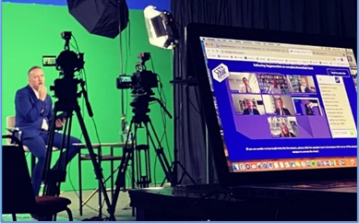
Figure 2.3: City Edge International Conference Studio

E-vites were sent to State bodies, local representative groups, councillors, landowners and professional bodies to attend the international conference and partake in the events. The full list can be seen in Appendix H. Live Recordings of the Conference were posted on the City Edge website shortly after the events. It was highlighted throughout the conference by presenter Shane Coleman, that the reason behind the conference was to get the conversation started and encourage as many submissions as possible on the Emerging Preferred Scenario.
3.0 Details of Submissions

3.1 Introduction
A total of 106 submission were received during the City Edge Project consultation period in relation to the Strategic Framework, either through the online consultation portal or by post. Of these, 103 submissions were received during the 4-week consultation period and a further 3 submissions were received after the consultation period. As this is a non-statutory public consultation these late submissions were accepted and have been included in the overall assessment.

The highest number of submissions came from residents outside the City Edge Project Area (42), followed by Landowners (24) and public bodies (14). The breakdown of where submission came from is provided in the graph below.

Figure 3.1: Origin of Submissions Received (No.)

A list of the 106 persons, organisations and bodies that made submissions is provided under Section 3.2 and a breakdown of the issues raised together with a general an overview is provided in Section 3.3. Full summaries are collated under the relevant headings in Section 4 of this report and these are accompanied by responses from the Chief Executive.

3.2 List of Persons, Organisations and Bodies
The following table lists the persons, organisations and bodies that made submissions on the City Edge Project Strategic Framework Consultation.

Table 3.1 Lists of Persons, Organisations and Bodies that made Submissions
Person | Body/Organisation Represented (if applicable)
Carl Kilbride
Valeriy Alushkin
Simon McCartney
David Build
Dave Fadden
Niall Cronin
Ed Brophy
Stephen Walsh
Joe O'Connor
Peter O’Connor
Proinsias Mac Fhlannchadha
Natasha Alekseeva
Michał Bromboszcz
Paul Brunel
Niall Mahon
Emma Curran
John Corr | Drimnagh Residents Community Group
James Mckee
Oisin Murphy
Stephen Foskin
Ger Mcging
Brian Coughlan | Killeen Properties
Brian Coughlan | Kilsaran Concrete Unlimited Company
Louisa McGrath
Sean Byron
Hannah Bulger
Paulo Reilly
Gary Gill
Mark Sweetman
Jane Bloggs
Michael O'Reilly
Shane O'Brien
Brendan Heneghan
Joseph Monks
David Armstrong | Galco Steel Ltd
Glen Jenkins | BOC Gases
Rebecca Mullin | Office of Public Works
Simon Dyke | Cricket Leinster
Ruth Brady
Constantin Roman
Declan Hanley
Eugene Barrett | Knocklyon Network
Laura Cunningham
Maria Riordan
Mark Byrne | Transport Infrastructure Ireland
Rachel Daly
William Riordan | Motor Import
Pauline Foster | Recorder Residents Association
John Nolan | Nolan Transport
Roisin Kearney | Ballyfermot Travellers Action Group
Michael Byrne | Creedon Group Limited
Eoin O'Driscoll | Mobility Partnership Ireland
Mary-Liz Walshe | Camac Flood Alleviation Scheme - Steering Group
David Courage | Hibernia REIT plc
John O'Shaughnessy | Irish Water
Don Watchorn | Department of Defence
Therese O'Reilly
Pauline Foster | Metro South West Group
Trina Milner
Andy Walsh | Dublin City Council (Environment/WFD)
Paul Wise | Britvic plc
Cllr. Carly Bailey
Phoebe Duvall | An Taisce
Jack Brennan
Michael Cosgrave | Cedar Brook Residents Committee
Sharon Matthews
Paul Matthews
Paula Galvin | O’Flynn Group
Brian McArdle
Niall Bolger
Mary Seery-Kearney
South Dublin Conservation Society | South Dublin Conservation Society
Feljin Jose | Dublin Commuter Coalition
Aodhan King | Dublin Cycling Campaign
Mary Weir
David Clements | National Transport Authority
Patricia Ryan | The Dynamic Drimnagh Forum
Mary Weir | Event Industry Association of Ireland
Fergus Sharpe | Dublin Chamber
Pauline Riordan | Eastern and Midlands Regional Assembly
John Spain | Mashup Group Limited and Autofulfil Limited
Frank Masterson | CIE
Brian Wylie | Iarnród Éireann
John Spain | Park Development
Declan Brassil | Harris Group
James Byrne | Motor Distributors Limited
Ann Mulcrone | John Sisk and Sons Ltd
John Spain | Search 4 Alpha Ireland Limited
Margaret Commane
Ciaran Murdock | Murdock Distribution (Ireland) Limited
Padraig Kehoe | Development 8
Ciaran Murdock | Murdock Distribution (Ireland) Limited
Sorcha Turnbull | Watfore Ltd
Trevor Sadler | Kylemore Road Landowners
Paula Galvin | McCutcheon Halley Planning Consultants
Tomas Bradley | EirGrid plc
Niall O'Byrne | Land Development Agency
Kieran Kennedy | Diageo
Harry Walsh | AAI Walkinstown
Harry Walsh | Irish Distillers Pernod Ricard
Dermot Devoy
Geological Survey Ireland | Geological Survey Ireland
Anne-Marie Shalloe | An Post
 | The Irish Academy of Engineering
Deirdre Forrest | Irish Aviation Authority
Denis Cadogan

3.3 Categorisation of Observations Raised in Submissions

All 106 of the submissions received by the City Edge Project Team were read, analysed and summarised. A total of 290 themes were identified when summarising the submissions, many of which related to the public consultation material on the City Edge Project. As illustrated in Table 3.2, the Emerging Preferred Scenario attracted the highest number of observations (205) in terms of themes.

Table 3.2 Breakdown of Observations According to Main Category
Category | Observations Raised (No.)
Baseline Study Findings | 39
Emerging Vision and Objectives | 7
Emerging Preferred Scenario | 206
Environmental Reports | 4
Issues beyond Scope of Current Project Stage | 35

In terms of the detailed subject matter contained in thesubmissions , these were grouped into 36 further separate themes. Many of the identified themes related to detailed aspects of the public consultation material on the City Edge Project and each of the observations was further collated according to sub-category theme headings as per Table 3.3 below.

In terms of the themes that were raised most frequently, the highest number (43 times) related to Movement and Transport. The second most frequent theme raised (27 times) related to Economy and Employment while the third highest theme raised related to the Liveable City and Sustainability (21 times). Other themes that featured prominently related to Housing (18 times); Community, Sports and Cultural Amenities (18 times); and Natural Infrastructure & Camac Flood Alleviation (17 times).

Section 4 of this report summarises all 290 observations that were raised under of each of the category theme headings. These observation summaries are accompanied by responses of the Chief Executive.

Table 3.3 Breakdown of Observations According to Sub Category
Category | Sub Category/Theme | Observations Raised
Baseline Study Findings | The Study Area | 4
Baseline Study Findings | Planning Policy | 4
Baseline Study Findings | Environment | 2
Baseline Study Findings | Utilities and Contamination | 5
Baseline Study Findings | Large Landowner in Favour of Redevelopment | 13
Baseline Study Findings | Large Landowner Neutral to Redevelopment | 4
Baseline Study Findings | Large Landowner Not in Favour of Redevelopment | 6
Emerging Vision & Objectives | Vision and Key Objectives | 7
Emerging Preferred Scenario | Major Urban Centre & Local Centres | 9
Emerging Preferred Scenario | Housing | 18
Emerging Preferred Scenario | Economy and Employment | 27
Emerging Preferred Scenario | Natural Infrastructure & Camac Flood Alleviation | 17
Emerging Preferred Scenario | Movement and Transport | 42
Emerging Preferred Scenario | Energy, Utilities & Heat Network | 5
Emerging Preferred Scenario | Liveable City & Sustainability | 21
Emerging Preferred Scenario | Big Moves | 3
Emerging Preferred Scenario | Western Orbital Public Transport | 10
Emerging Preferred Scenario | Kylemore Rail Interchange | 6
Emerging Preferred Scenario | Naas Road Crossings | 3
Emerging Preferred Scenario | Naas Road Luas Stop | 1
Emerging Preferred Scenario | Tymon to Phoenix Greenway | 4
Emerging Preferred Scenario | Undergrounding Electricity Lines | 5
Emerging Preferred Scenario | Flagship Parks | 9
Emerging Preferred Scenario | Community, Sports and Cultural Amenities | 19
Emerging Preferred Scenario | Phasing | 7
Environmental Reports | Strategic Flood Risk Assessment (SFRA) | 2
Environmental Reports | Strategic Environmental Assessment (SEA) | 1
Environmental Reports | Appropriate Assessment (AA) | 1
Issues beyond Scope of Current Project Stage | Housing | 4
Issues beyond Scope of Current Project Stage | Implementation/Delivery | 6
Issues beyond Scope of Current Project Stage | Detailed Development Proposals | 3
Issues beyond Scope of Current Project Stage | Project Boundary/Area | 8
Issues beyond Scope of Current Project Stage | Wider Transport Issues | 4
Issues beyond Scope of Current Project Stage | Tax | 3
Issues beyond Scope of Current Project Stage | Public Consultation | 4
Issues beyond Scope of Current Project Stage | Project Name | 3

4.0 Summary of Issues Raised and Chief Executive Responses

Baseline Study Findings – Submission Summaries

The Study Area
- There are too many derelict and rundown sites so close to the city that are underutilised. The fact that a light rail link and a number of bus routes pass through the area and pick up so few passengers indicate how the potential of the area is not being realised.
- There are a number of OPW/state owned sites located in close proximity to the study area such as the Irish National War Memorial Gardens, the Royal Hospital Kilmainham, Kilmainham Courthouse and the Phoenix Park. It is considered that the development of new communities in proximity to these heritage sites offers a key opportunity to maximise their use and potential and the OPW is keen to liaise further in order to ensure that this is managed in a sustainable way.
- Submission made on behalf of John Sisk and Sons Ltd states that the location on the edge of the city isn't accidental. It combines the necessary logistics, accessibility to the city centre, nationwide and internationally and to employees. Many businesses may already be the product of earlier urban economic forces of increased land values in city centre locations driving relocation to edge of city from historic dockland or inner urban locations.
- All 28 heritage buildings and features as recorded in the Records of Protected Structures, the NIAH and the Record of Monuments and Places should be retained. Archaeological sites, both existing and newly discovered, should be left in situ and incorporated into green spaces. Consideration should be given to retaining some rediscovered industrial buildings. New taller buildings should be well spaced away from older buildings.

Planning Policy
- The objectives and targets contained within the NPF are of particular relevance to the City Edge Project and should be reflected in the upcoming Strategic Framework.
- Submission on behalf of the EMRA notes that the subject lands are identified in Table 5.1 of the Dublin Metropolitan Area Strategic Plan (MASP) as a strategic long-term landbank for Dublin City with the potential to deliver on the NPF and RSES strategic outcome of Compact Growth and to drive the sustainable growth of the Dublin Metropolitan Area. Given the scale and transformational potential of the City Edge Project, it is considered to be of strategic importance.
- Submission on behalf of the EMRA considers that the next stages of plan making could be further strengthened by reference to the spatial planning context of Project Ireland 2040 - National Planning Framework (NPF), the Regional Spatial and Economic Strategy (RSES) and Dublin Metropolitan Area Strategic Plan (MASP), and the relevant National and Regional Strategic Outcomes and Policy Objectives, which establish the policy framework for local authority land use plans. It is noted that the project has received funding commitments under the Project Ireland 2040 - Urban Regeneration and Development Fund (URDF) for Stage I and 2 and it is recommended that any future plan for the City Edge lands ensure good policy alignment with RSES and MASP to enable efficient drawdown of future funding opportunities and delivery of key projects.
- The submission notes that the NPF also calls for major growth in the regions outside Dublin. It is intended that Cork, Limerick, Galway and Waterford will each grow by at least 50% to 2040. In the circumstances the submission asks if it is legitimate to question the scale of the proposal in the Irish context and whether it conforms to the vision of the (NPF) National Planning Framework.

Environment
- There is already a surprising amount of urban wildlife in the Kylemore/Ballyfermot area. Bats roost along the railway tracks and foxes live in larger backyards. A wildlife survey should be done so as to minimise disruption.
- Submission from Geological Survey of Ireland encourages the use of their datasets that may be useful for environmental assessment and as part of the planning process in relation to Geoheritage; Geological Mapping; Geotechnical Database Resources; Geohazards; Natural Resources; Geochemistry of Souls, Surface Waters and Sediments; and Geophysical Data.

Utilities and Contamination
- We also need engagement with us on the issues of the main Drimnagh Sewer which has almost reached full capacity. What will be the consequences of this and the impact of additional redevelopment of the City Edge Project.
- Submission on behalf of BOC Gases Ireland Limited welcomes the findings of the Baseline Study in relation to Seveso sites and agrees that the risk of accidents is low due to stringent safety procedures, however, it is advised that the consequences of a major accident are significantly adverse to human life and that that SDCC and DCC must proceed in accordance with the precautionary principle. It is also noted that the Baseline Study correctly highlights the potential for increased safety precautions and restrictions on development in the vicinity of Seveso sites. In addition, it is advised that changes in the operation of Boc Gas's business may result in amendments to the risk contours for their Bluebell facility and it is essential that the City Edge project does not restrict the ability to respond to future requirements.
- Submission on behalf of Search 4 Alpha Ireland Limited notes that Document 3- Baseline Study Findings includes details of the Seveso sites in the Plan area. We note that in the Naas Road corridor area, which is identified for higher density mixed use development plan, that recent applications for residential / mixed use developments, have been subject to third party objections from the owners of a Seveso site. Our client therefore fully supports the reference in the emerging preferred scenario to 'seek relocation' of the four Seveso sites. However, we believe that even greater emphasis should be placed on this objective, as it is one of the key challenges to the redevelopment of the area. We respectfully submit that the objective to relocate the four Seveso sites should be one of the initial primary objectives / tasks for the planning authorities, i.e. to encourage the Seveso sites to relocate, and therefore removing a health and safety risk from the area and a development risk for developers / funders.
- Submission on behalf of Eirgrid notes that as identified in the Baseline Study findings report, there is significant electricity transmission infrastructure in the area. This infrastructure is primarily fed from Inchicore 220kV station which is located North of the Grand Canal and off the Kylemore Way. Eirgrid is keen to stress that the Inchicore BSP (Bulk Supply Point) is a significant node on the Dublin network. Furthermore, it is currently undergoing a substantial and costly refurbishment and reconfiguration which will reinforce its importance into the future.
- Consideration should be given by the project to the wider context of the lands and how regeneration of the study area can readily be achieved in light of existing infrastructure in place within the study area (e.g. rail lines, ESB infrastructure, EPA licensed sites and Seveso sites etc).

Chief Executive’s Response
The Study Area, Planning Policy, Environment, Utilities and Contamination
The Baseline Study was prepared as part of Stage 1 of the City Edge Project and sets out a summary profile of the area as it is today, looking at various aspects of the study area including an analysis of existing community, housing, employment, economy, transport, infrastructure, historical and archaeological features, and environmental aspects. It also contains a review of planning policy documents including Project Ireland 2040, the Eastern and Midlands Region - Regional Spatial and Economic Strategy 2031, South Dublin County and Dublin City Development Plans 2016-2022, the Transport Strategy for the Greater Dublin Area 2016-2035, the Climate Action Plan 2019 and Ministerial Guidelines including the Urban Development and Building Height Guidelines (‘the Building Height Guidelines’) and Sustainable Urban Housing: Design Standards for New Apartments (‘the Apartment Guidelines’). Engagement with landowners was also carried out and a desktop survey of utilities and contaminated lands was undertaken.

The various issues raised in relation to the Baseline Study findings are acknowledged, including the problem of dereliction and run-down sites close to the City, opportunities presented by heritage sites and the locational advantages of the City Edge area. The key role of the regeneration of the area in the context of national planning policy seeking compact growth was emphasised in the submission from the Eastern and Midland Regional Authority. The challenge of achieving regeneration taking account of sewer capacity, SEVESO sites and electricity infrastructure was highlighted in other submissions while the urban wildlife and geological assets of the area were emphasised. The key findings, challenges and opportunities highlighted throughout the Baseline Study including the issues raised in the submission will inform the preparation of the Strategic Framework.

Landowner Supportive of Redevelopment
- Submission on behalf of Killeen Properties states that it is considered that early phases should be more residentially focused to assist in achieving National Policy to Deliver at least 40% of all new homes nationally, within the built-up footprint of existing settlements and Deliver at least half (50%) of all new homes that are targeted in the five Cities and suburbs of within their existing built-up footprints. It is of vital importance that there is no lag in delivery of housing. The potential phasing for the development sites owned by the company making the submission is welcomed. The lands at Killeen Road are located at an area identified as a local centre has the potential to be the catalyst for regeneration for the surrounding sites.
- Kilsaran strongly welcomes the ambition and scale of the City Edge Plan and is keen to highlight to the City Edge team the potential for their South Site to also be considered a 'Potential Early Development Site'. It is noted that there is little information given with regard to the potential for development north of the Canal at Killeen Road. Kilsaran would welcome future engagement on this point.
- Submission on behalf of the O’ Flynn Group (OFG) states that the approach applied to this first stage of the project is welcomed. OFG is the owner of a strategic 7.33-hectare brownfield site with frontage onto the Naas Road, Walkinstown Avenue and Longmile Road (the former Nissan site). The extant Naas Road Local Area Plan (LAP) required the preparation and submission of a Masterplan with an application for development, which aligns with the overall LAP vision and provides for a high-density mixed-use scheme. Phase 1a, 1b, 2a and 2b of the Masterplan have received development consent and a separate application will be prepared for Phase 3. It is submitted that the plan making team for the City Edge project should engage with the O’ Flynn Group to consider the optimum land use strategy for Phase 3. Implementation of the permitted development would act as a catalyst for regeneration and it is important that the City Edge plans align with this existing permission and do not affect the delivery of this permission including in relation to the phasing and sequence of development, which can have unintended consequences for permitted developments.
- Submission on behalf of Steeplefield Limited, who own 2.75 hectares known as the Former Chadwicks Site off Greenhills Road, requests that in the next phase of the City Edge Project, being the development of a framework plan, that cognisance is given to the capacity of the submission lands to accommodate substantial residential development in line with the regeneration of the wider area. The submission also states that the submission lands are appropriately sited and of an appropriate size to accommodate high quality residential development which will support existing services within the immediate area and help to regenerate the area as that of a live work community, the benefits of which cannot be understated.
- Submission made on behalf of the Harris Group advise that they have control 31 ha of lands within the City Edge Area that are zoned objective "Regen" and these lands are strategically located adjacent to established and proposed Luas Stops and a bus Connects Corridor with frontage to the Naas Road, Long Mile Road and Grand Canal. The City Edge initiative is welcomed and the Harris Group looks forward to interacting with the project team.
- Submission on behalf of Motor Distributors Limited advises that they own a large site situated between the Naas Road, Walkinstown Avenue, Long Mile Road and Robinhood Road. The site is within regeneration zoning Z14 and is designated as an SDRA in the Dublin City Development Plan forming part of a Key District Centre. Pre planning consultation has been with Dublin City Council and a number of planning permissions have been granted in the immediate vicinity including the Royal Liver, Nissan, Concorde and Carriglea site (under construction). Whilst the preparation of a strategy to integrate the Naas Road LAP is welcomed, it is important that the City Edge project enables the continuity in delivery of projects. The area at the junction of Long Mile Road and Walkinstown Avenue, should be identified as a priority area for regeneration in the short term with consistency of policy between the existing Dublin City Development Plan, the Naas Road LAP and the new Framework Plan.
- Submission on behalf of Watfore Ltd advises that their lands have approx. 150m of frontage to the Long Mile Road with frontage to the Robinhood Road and abuts the significant public amenity of Walkinstown Park. The lands currently accommodate 2-storey warehouse-type structures with extensive surface parking and are largely under-utilised.
- Submission on behalf of Corcom Development Partners and the "Kylemore Road Landowners', comprising a group of up to 9 landowners at Kylemore Park Estate with a combined landholding comprises approx. 2.7 ha with approx. 225m of frontage along Kylemore Road, seeks to progress the redevelopment of their lands. The site is currently occupied by a range of commercial businesses including furniture retail warehousing, a printing company and car sales and repair units. The National Learning Network (Rehab Ireland) also own and occupy two units. The site is located within the 'DCC Park West' development area and their potential for new mixed use/residential areas to be considered in the first phase of development and in the short term. The identification of the area for the delivery of an additional 8,000 people and 6,000 jobs and ail interchange is welcomed along with the designation of the Kylemore Road Area for a new urban centre. It is important that the City Edge Plan supports early development sites that benefit from existing transport and it is considered that the Kylemore Site would be a "kickstart" location.
- Submission on behalf of Mashup Group Limited and Autofulfil Limited states that are eager to promote redevelopment and regeneration on the lands in their ownership (former Clayton Love site and the former John O'Brien Freezer Foods site at Jamestown Road, Inchicore and Knockmitten House Lane, Walkinstown) and wish to make the case for the early delivery of development on these lands, and to ensure that the new City Edge Project allows regeneration to proceed under a suitable framework, while recognising that some sites would appropriately see short term redevelopment having regard to their location and characteristics. As well as the 10 'Big Moves' the framework should also set out a series of short-term objectives to realise the significant benefits that may be delivered in a shorter timeframe on suitable sites within the overall area.
- Submission on behalf of Mashup Group Limited and Autofulfil Limited states that the City Edge project should take cognisance of the proposals to transfer the Inchicore Substation lands (currently in ESB ownership) and the CIE lands at Inchicore Works to the Land Development Agency under the recently published Housing For All plan. Having regard to the role of the LDA in realising swift delivery of housing and associated development on state-owned lands, it is imperative that the City Edge project allows for the early delivery of development and regeneration at these locations and their vicinity, including lands at Jamestown Road in our clients' ownership.
- Submission made on behalf of Murdock Distribution (Ireland) Limited states that their lands are located on Ballymount Road Lower, Dublin 12 within the Howard McGarvey Industrial Estate, a long-established commercial area characterised by light industrial, showroom, trade retail and general employment uses. Submission supports the principles of the project but requests that the project appreciate the capacity of lands within the area, including the lands subject to this submission, to accommodate significant residential development and that guidance and support for residential regeneration within the area should be a key consideration in the preparation of the next phase of the project. Submission lands are situated in close proximity to both existing residential development in Walkinstown Crescent/Park and residential development permitted under ABP Ref. No. 309658-21 and it is thus considered that the submission lands are appropriately located so as to accommodate the further expansion of residential development in close proximity to Walkinstown Avenue. Residential-led regeneration would be in accordance with the REGEN zoning and it is considered that the lands could accommodate an increased density of development (subject to design) given their area and comparably increased separation from existing low density residential development. They area also appropriately serviced by both local centre and public transport facilities so as to provide a comparable quantum of residential development, to the permitted SHD.
- Submission on behalf of Murdock Distribution (Ireland) Limited state their lands are located within close proximity to existing residential development and high-capacity public transport services and are strategically located within the identified cluster of residential development forming on the eastern portion of the study area along the eastern extent of Naas Road. It is thus considered that the submission lands are appropriately located so as to accommodate the further expansion of residential development within the area and given the proximity of existing residential development, we would consider the lands to be well suited for the provision of mixed-use development comprising both employment and residential uses. Therefore, in the development of a framework plan, cognisance should be given to the capacity of the submission lands to accommodate substantial residential development in conjunction with offering an employment use. This transition is considered appropriate in ensuring that these well-serviced urban lands yield an appropriate density of development whilst retaining their original employment purpose.
- AAI Walkinstown are the owners of a 0.93ha site on Ballymount Road lower, Walkinstown, approximately 230m west of the Walkinstown roundabout, close to the designated local centre. It is highly accessible in terms of public transport, being on a number of high frequency bus routes and with the Kylemore Luas stop located about 1km to the north. The subject lands were granted permission under the SHD process for 163 residential units and a creche and the submitter's clients are now taking steps to implement this.

Chief Executive’s Response
The submissions from landowners who would like to see redevelopment of their lands are acknowledged.

As part of the Draft Strategic Framework, which is currently being prepared, a phasing and sequencing strategy will be drawn up identifying which parts of the study area could be regenerated initially and over time. The rationale for this will take account of several factors including current and future availability of public transport, utilities and other services, the contribution a particular site could make to achieving the wider objectives of the framework, connectivity with the surrounding area, market considerations, and availability of land/sites for redevelopment.

Landowner Neutral to Redevelopment
- Kilsaran are the owners of two sites within the study area as shown in red on Figures 1 and 2. Both sites are to the west of Killeen Road; a larger site to the south of the Grand Canal and a smaller site to the north. The South Site comprises approximately 3.5ha. The North site is smaller and comprises approximately 1.1ha.
- Submission on behalf of Motor Import states that they are an interested party in the City Edge project with a number of business interests in the area which have been established over many years and employ in excess of 100 people in the locale. We are very committed to and engaged with the local area and would like to be involved in the decision-making process as the project develops.
- CIÉ is the owner of the lands at Inchicore works which are operated by its subsidiary, Iarnród Éireann, who will make a separate and detailed submission. CIÉ has already engaged with the Land Development Agency around the potential development opportunity for elements of the site and adjoining lands. Inchicore works are currently fully operational. As lands are declared surplus to requirements over the coming years, CIÉ will be supportive of Transport Orientated Development. Any consideration of a potential change in zoning of the lands owned by CIÉ must allow for and support present and future public transport uses, as well as the envisaged potential alternative use(s). It may be, for example, that the possibility of areas becoming surplus is dependent on rationalising operational uses into a smaller footprint, so it would be important for any proposed zoning to be carefully constructed so as not to preclude measures that may be required to facilitate the redevelopment envisaged.
- As a company, Iarnród Éireann is open to inviting proposals from developers that would encourage greater usage of the railway, have greater integration with the other transport modes (including cycling/walking) and promote urban renewal in the areas concerned, whilst respecting first and foremost the operating requirements and future development of the railway. It should be noted that Inchicore Works are operational landholdings. Public transport operational uses must be supported as part of the City Edge Project and any potential change in zoning of lands must allow for and support present and future public transport uses. In relation to Inchicore, strategic depot requirements for rail fleet maintenance are being prepared as part of the DART+ Programme, to facilitate master planning for potential development opportunities at Inchicore. Any future measure or proposal by SDCC/DCC as part of the City Edge project, which may directly impact on the property of the CIE Group or on the operation of the railway, must be fully discussed and agreed with the CIE Group Property Division/ Iarnród Éireann in advance. The railway must continue to operate and serve the wider public during any planned redevelopment in the vicinity of the Railway Works at Inchicore and the active rail line. As Iarnród Éireann grows to meet the future transport needs of the country, the operational needs on our existing lands may also grow and should not be precluded in any future zoning.

Chief Executive’s Response
The summaries of the submissions above reflect the views of landowners who are neutral regarding the issue of redevelopment of their lands. Some expressed the wish that they would like to be involved in future discussions regarding any decisions that would affect their land.

As previously stated, a phasing and sequencing strategy will be drawn up as part of the preparation of the Strategic Framework, identifying which parts of the study area could be regenerated initially and over time. The rationale for this will take account of several factors including current and future availability of public transport and other services, the contribution a particular site could make to achieving the wider objectives of the framework, connectivity with the surrounding area, market considerations, and availability of land/sites for redevelopment. Engagement with landowners will continue to be carried out as part of this process.

Landowner Not Supportive of Redevelopment
- Galco Steel own and operate a large operation at the Ballymount Industrial Estate, is a major employer and carry out galvanising processes that are of strategic importance. The City Edge Project envisions the large-scale regeneration of the area and our client is concerned in relation to the impact on their heavy industry operations and processes including the 100 HGV accessing the site per day. Galco Steel plans to make significant investment in their site in the short term and intend to expand operations that are incompatible and would conflict with residential use and amenity. This could threaten the operation and viability of the plant. This conflict would threaten the viability of industrial uses in the City Edge Project Area and their contribution to the economy.
The plant is optimally positioned beside the M50 with access to the national road network. The locational benefits would be difficult to replicate elsewhere and would be costly and the sustainability of its operations. The Galco steel site is EPA licensed and its relocation would necessitate a costly new licence application thereby threatening its viability.
- Submission on behalf of BOC Gases Ireland Limited advises that their headquarters is located in Bluebell off the Naas Road; has operated from this site for
over 60 years; currently employs over 150 on-site staff; represents a significant and long-term investment and is a main facility for the production and distribution of industrial, medical and special gases. It is advised that the Bluebell site is an Upper Tier Establishment, as defined by the Control of Major Accident Hazards (COMAH) Regulations 2015, due to the possibility of major accidents from the production and distribution of dangerous substances at the site. Concerns are raised in relation to the investment locked into the highly specialised and high-cost plant that cannot be easily moved elsewhere and would require decommissioning. It is advised that Due to the significant cost of acquiring and developing a new Seveso site, it is not financially feasible to relocate. It is requested that provision be made for retention and potential expansion of the existing facility and the immediate area surrounding the site must be retained as business.
- Park Developments landholding at Calmount Road and Ballymount Avenue is indicated in the 'Emerging Preferred Scenario' as part of a 'Flagship Park' for the area. The site is one of the last large-scale undeveloped enterprise / employment zoned sites in the Ballymount Industrial Estate area. It would appear that our client's site was identified as part of the southern Flagship Park based on its existing undeveloped nature. There is significant demand for large scale warehouse / logistics units in the Dublin area and the landowner has immediate interest in this site for such a unit and intends to bring forward a planning application in the short term. Such a proposal on the subject site would accord with the current EE- Enterprise and Employment zoning objective. The site is also subject to a 'Road Proposals - 6 Year' objective, with the identification of a north-south road objective through the site and the adjoining Galco Steel premises to the north.
It is requested that our client's site, and the Galco site to the immediate north, be removed from the area designated as a 'Flagship Park' for reasons relating to impact on the development potential of the site; contravention of the County Development Plan and Draft County Development Plan and planning legislation; proximity to Tymon Park; location outside route of Camac; potential to create urban blight; need for realism in the plan; absence of gain for landowners; and likely costs of CPOs.
- Submission from An Post advises that they own and operator 4 no. postal facilities within the City Edge Study Area. These include the Dublin Mail Centre and the Dublin Parcel Hub both located on Oak Road, a Delivery Service Unit on Holly Road, and the South Dublin Parcel Centre on Ballymount Road Lower. An Post are considering a programme of works to ensure these facilities are best in class and are capable of accommodating modern delivery operations to serve new and expanding catchment areas. We are eager to ensure that the postal facilities in the area can continue to operate in this location and it is possible that An Post will seek to improve these facilities. It is requested that the Project Team carefully consider the potential impacts that may arise as a result of new land uses being established adjacent to existing An Post facilities in relation to heavy goods vehicular (HGV) movements, variations in operating hours, parking, lighting, generators and noise etc. Given the nature of their role providing an essential public service, it is imperative that An Post's services in this area can continue undisrupted and without any conflict that may arise as a result of the redevelopment. It is essential that the Local Authority and Project Team ensure that the operational requirements of existing business's in the City Edge Project Study Area are protected; subsequent operational needs of established industrial/commercial businesses within the industrial park are facilitated; and support is given to the enhancement/expansion of existing Industrial/commercial activity. In this regard, the Framework for the City Edge Project must Include principles and detailed design measures to protect the relationship between existing commercial/industrial uses and any new sensitive land uses such as residential, community and educational uses.
- Irish Distillers are significant landowners in the City Edge area. The Fox and Geese facility has been in operation at this location since the 1950s and has been subject to ongoing development during this time. Operations on the site include vatting and blending, bottling and case assembly, logistics operations and new product research and development. The facility is a significant employer locally providing a total of 289 jobs and is of significant value to the Irish economy in terms of exports (worth â‚¬890 million in 2019). There has been significant investment in the site over the last 11 years. The facility is a 'Lower Tier' Seveso site. There is no commercial intention to relocate the Fox and Geese facility to an alternative location at this time and we are confident that the continued presence of this facility within the study area will be a key benefit for the City Edge project as well as a significant ongoing asset for the Irish economy.
- Submission made on behalf of R & A Bailey & Company notes that the Key Diagram for the Emerging Preferred Scenario indicates that a local centre with high-street activity is proposed directly adjoining the landowners major plant facility. In addition, the diagram indicate that the plant forms a central part of a proposed interconnected residential-led mixed-use neighbourhood with supporting employment activity and approximately 4-8,000 new residents. This is entirely unacceptable to the landowner/company. It would seriously compromise the operational feasibility of the existing facility and impact on its viability as one of the most important and valuable food and drink production sites in Ireland.
A local centre directly adjoining the subject site, with a sizable residential population in the immediate surrounds, cannot be considered appropriate in planning or environmental terms. New residents have a right to expect a high-quality residential environment, free from the noise of industry and significant heavy goods traffic. Long standing, major industrial facilities such as with the submission site, have a right to continue to carry out their operations without the restrictions that a large resident population on its doorstep, will impose. The two land uses, cheek-by-jowl are not compatible. We would respectfully request that the proposed local centre and residential-led mixed use neighbourhood in this location be deleted.
- Submission from Britvic plc highlights concerns around the security of their site and staff due to the addition of substantial housing and antisocial behaviour that a project of this magnitude can bring to the area. Health and Safety concerns around the influx of children as part of the housing development. Concern also expressed regarding traffic impact of redevelopment, ground disturbance and impact on water quality.

Chief Executive’s Response
The City Edge Study Area has a diverse mix of mainly industrial, commercial and employment uses that sustain approximately 25,500 jobs across some 1,500 different businesses. These existing businesses and jobs are a cornerstone of the Dublin economy and are key to the continued success of the City.

The submissions from landowners who are not in favour of redevelopment of their lands are acknowledged. As described in the submissions, some of these businesses have invested significantly in plant and other infrastructure on particular sites, while others wish to remain in situ to continue to benefit from the locational advantages of the City Edge area.
The Strategic Framework currently being prepared will recognise the critical importance of the employment role of the area including the many businesses rooted in the area. As such, the Framework will incorporate a flexible approach to phasing and sequencing which will seek to accommodate the intentions of businesses who wish to remain in situ, where feasible.

Emerging Vision and Objectives – Submission Summaries

Vision and Key Objectives
- This city has so many pressing problems, and this seems to be a waste of resources that could be put toward solving them. We need a better vision than what we're seeing now.
- The Mobility Partnership Ireland (MPI) is a coalition of Ireland's leading private sector mobility providers. Founded to ensure effective policy at the national, regional and local level and combining with new technology, MPI supports better mobility that helps to tackle the major challenges of congestion, air quality and climate change.
Considering the project's ambition of developing a new city in Dublin, there is a major opportunity for City Edge to develop as an exemplar for how sustainable mobility can be effectively implemented in Ireland.
By embracing Mobility as a Service solution, City Edge can play an important role in signposting Ireland's sustainable mobility future.
- The City Edge Project has the potential to be a transformative example of urban regeneration through sustainable mixed development, contributing to the relief of Dublin's housing pressures, the improvement of quality of life, and the advancement of national planning goals. We welcome the emerging vision and the emerging objectives outlined in the Project Overview. We particularly welcome the inclusion of 'Housing', 'Liveable City', 'Sustainability', and 'Movement' as objectives.
- The OPW is particularly keen to engage with Dublin City Council on this project through the role of the State Architect as set out in the National Policy on Architecture to prioritise 'quality' in the built environment, which can enhance the quality of lives for all the citizens of Dublin.
- The submission states that the LDA is supportive of the vision and aims of the Project which seeks to plan for compact urban growth at scale and in particular to prioritise redevelopment of underutilised brownfield lands.
- The City Edge Plan should develop design guidelines that provide direction but still allow creativity and flexibility. Design standards should establish the aim of design quality and create a framework within which good quality architecture and design can flourish. Large-scale urban regeneration projects require immense resources. partnership with the private sector is needed to share the risks and technical capacities
- Iarnród Éireann fully supports the policy of Transport Oriented Development - examples include Silicon Docks at Grand Canal Docks; and the emerging North Docklands development in Cork. IE and CIE are currently engaged with DCC on the preparation of a Heuston masterplan, bordering the City Edge area.

Chief Executive’s Response
To help provide a basis for how the regeneration of the City Edge area could be best achieved, South Dublin County Council and Dublin City Council have developed an emerging set of objectives together with an emerging vision for the Study Area. The emerging vision is:

‘To create a new mixed use and climate resilient high density urban quarter in the city, where the citizens of the Greater Dublin Area will be able to access affordable homes, live close to where they work, in an area home to outstanding public amenities and public transport services
Building upon its rich history of employment, the Study Area will support consolidation and the creation of new employment opportunities, culminating in the creation of a self-sustaining and integrated part of city, where family, community, visitors and the economy can prosper in a distinctive Dublin setting.’

The key objectives are as follows:
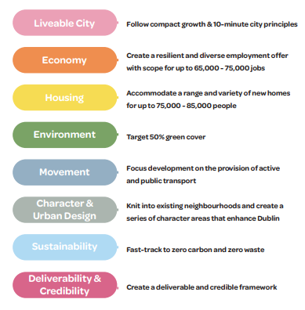

Some of the submissions relating to the Emerging Vision and Objectives referred to issues including solving the many problems of the city such as the major challenges of congestion, air quality and climate change. Other submissions welcomed City Edge and referred to major opportunities including the potential for City Edge to be transformative through being an exemplar for urban regeneration through sustainable mobility, increasing housing supply and providing an improved quality of life. The potential for quality in the built environment was raised by the OPW while Iarnród Éireann lent their full support to the Transport Oriented Development approach of City Edge. The need for design guidelines allowing creativity and flexibility was raised in another submission while the LDA stated their support for the aim of the project to achieve compact growth at scale.

It is important to note that the Vision and Objectives will evolve as the project progresses and as key stakeholders are consulted with, including existing businesses, landowners, employees and residential communities. This includes the outcome of this consultation process and the issues raised will be considered in the preparation of the Draft Strategic Framework

Emerging Preferred Scenario – Submission Summaries

Major Urban Centre & Local Centres
- Submission on behalf of Killeen Properties states that the major urban centre is well placed to be developed at an early stage due to close proximity to the Luas. The undergrounding of existing overhead power lines would have significant benefits for the area. Additional greening works proposed throughout the site including parks and works to the Camac river are supported.
- A crucial part of making the Emerging Preferred Scenario (EPS) will be to ensure that there are sufficient and suitable town centres in the wider area to provide for the significant increase in population and activity. The EPS offers the opportunity to align with the proposed redevelopment of Inchicore as set out in the Government Housing for All plan. The EPS must align closely with DCC's plans for Inchicore in particular in respect of the National Children's Hospital (NCH), the Guinness St James Gate development, the CIE Works/Jamestown Road/Bluebell/Naas Road area, approved residential density, the Dart Underground, the War Memorial Gardens, St Patrick's Athletic. Taken together, these all present huge opportunities for the area. Inchicore could re-establish itself as one of Dublin's main urban towns.
- Kilsaran's South Site is located at the edge of an area identified as a local centre. This general location, with the amenities of the Grand Canal to the north, is an excellent location for a local centre and has the potential to be the catalyst for regeneration for the surrounding sites. Its inclusion in a local centre is strongly welcomed. Kilsaran's and Killeen Group's sites combined would create a significant urban design opportunity. Killeen Group's site to the south of Kilsaran's South Site is identified as a potential early development site in the City Edge Project Overview. Kilsaran's South Site shares many of the characteristics with Killeen Group's site and it is requested that the South Site is also considered a potential early development site.
- The northern quarter should be razed and made into a grid pattern of apartment buildings 6 stories high (similar to grid pattern and architecture in Barcelona).
- Proposed are south of Greenhills Road (where Brennan’s Bakery is) could be a Shopping Centre (similar) to Dundrum SC) called "Greenhills Town Centre".
Inclusion of a market square and new town centre at the heart of the area (somewhere near Western Parkway Business Centre).
- Submission on behalf of BOC Gases Ireland Limited notes that the BOC Gases site forms part of the proposed 'major urban centre' and that this major urban centre will be a mixed-use environment with a significant quantum of residential development. It is advised that an Upper Tier Seveso operation within major high-density urban centre is not feasible and that Development Scenario 2 'Enterprise and Urban Industry-led Mixed-Use' is more deliverable and appropriate compared to the 'Emerging Preferred Scenario' and should be progressed. It is advised that the significant infrastructural expenditure required to deliver residential and mixed-use development across the Naas Road could be better directed to other locations and that retaining the Naas Road area as principally an industrial, enterprise, and employment location would provide a more efficient use of existing infrastructure without displacing a highly successful economic engine.
- Submission on behalf of the EMRA states that the project envisages the creation of a major urban centre supporting c.20,000 jobs, and a new commercial centre, local centres and urban industry area supporting c.65-75,000 jobs. This is underpinned by economic analysis to identify existing and future growth sectors. The upcoming Framework plan will need to manage the balance between potential relocation and retention of existing employment and the attraction of new investment, while providing for sustainable quality jobs for both existing and future residents. The Guiding Principles for Integrated Transport and Land use in Section 8.3 of the RSES provide guidance in this regard to promote increased employment densities in sustainable locations near high quality public transport nodes, third level institutions and existing employment hubs, and to relocate less intensive employment uses outside the M50 ring and built-up areas, in order to ensure the most efficient use of urban lands and maximise the return on public investment in infrastructure. In planning for the current and future needs of residents, employers and employees in the City Edge lands, the Framework plan should also consider the Guiding Principles for the location of strategic employment and investment prioritisation set out in Section 6.3 of the RSES including access to suitable locations, serviced sites, connectivity, skilled labour force and local strengths (a diverse sectoral mix, research and technology centres, start-up incubators, emerging clusters or value chains).
- The anchors in the Emerging Preferred Scenario don't have to be global or international. It is also important to have local anchors that can occupy the Local centres with high street activity such as a skatepark. There are plenty of precedents that demonstrate the benefits of having a specific anchor like a skatepark from increased footfall to the economic impact they can bring to the local area.
- Submission on behalf of the O’ Flynn Group (OFG) states that the changing character of the lands identified as the Major Urban Centre character area, from low intensity commercial uses to high-density mixed use developments, is reflected in the recent permissions for development at the former Nissan site, the Royal Liver site and Concorde. Together, these permitted developments would provide approx. 2,700 new homes and having regard to the mix of homes permitted would accommodate a population of at least 6,000. These 3 no. extant permissions alone would generate half of the population target of 12,000. Southwest Gate is approved to deliver approx. 17,800 sq.m and the Royal Liver site includes approx. 20,700 sq.m. The combined total is approx. 38,500 sq.m and includes office accommodation, a hotel, retail floor space, café/bar restaurants, health care, childcare, a gymnasium, and a cultural hub. These schemes would provide approx. 2,400 employment opportunities or 12% of the envisaged jobs allocated to this character area in the City Edge project.

Chief Executive’s Response

Submissions on this aspect of the City Edge Project are largely in favour of the Emerging Preferred Scenario’s Major Urban Centre and Local Centres particularly in the context of location relative to public transport. A submission from the Eastern and Midland Regional Assembly (EMRA) references guidance in the Regional Spatial and Economic Strategy to promote increased employment densities in sustainable locations near high quality public transport nodes, third level institutions and existing employment hubs, and to relocate less intensive employment uses outside the M50 ring and built-up areas.

A submission from BOC Gases raises concern in relation to the location of their Seveso site within the Major Urban Centre and suggests that an alternative scenario be progressed while submissions from two other landowners are supportive of the Major Urban Centre and Local Centre by reason of (inter alia) the location and proximity to their lands.

Support for the concept of the Major Urban Centre and Local Centres are noted. Further to the concerns that have been raised in relation to the location of the Major Urban Centre relative to some existing industry operating in the area, it is advised that the Emerging Preferred Scenario is an indicative concept and the precise boundaries and location of the Major Urban Centre and Local Centres are to be refined through block testing as part of the Strategic Framework and the preparation of a statutory plan. This will be progressed in tandem with an Economic Analysis of potential employment typologies and the future economy of the City Edge Area as well as a Viability Analysis of development. The City Edge Project Team will continue to engage with landowners in this regard while testing proposals against the City Edge objective of Deliverability and Credibility which was identified early in the project as part of a set of emerging objectives.

Housing
- Submission states that there is an oversupply of houses and 2-bed apartments with a shortage of studio apartments, 1-bed apartments and 3-5-bed apartments with 3-4-bed houses and 2-bed apartments in Dublin being shared amongst different households that are not suitable to personal housing needs. The global trends are to build smaller housing units or larger apartments, which should be followed. To accommodate demographic trends, housing mix in the entire City Edge Project should be:
- Studio Apartments - 30% (20-35 sq.m.)
- 1-bed Apartments - 40% (35-50 sq.m.)
- 2-bed Apartments - 0%
- 3-bed apartments - 20% (100-150 sq.m.)
- 4-bed apartments - 7% (120-200 sq.m.)
- 5-bed Apartments - 3% (180-250 sq.m.)
- Take care not to build high buildings close to boundaries with existing properties. Orientate balconies towards the South & West so that people can enjoy sunlight. Where possible do not have balconies overlooking existing properties.
- The focus on the development of residential led communities and neighbourhoods in which residents can have high living standards as well as work in close proximity to their homes and enjoy high standards of private and public amenities and modern carbon free transport links to the city ties in closely with the Group's [submitter's] own organisational vision for the future.
- Who is going to want to live there? Who will these new homes be targeted at? who wants to live in an industrial area next door to factories, recycling plants? And along one of the worst roads in Dublin for congestion. The infrastructure in this area is already over capacity during peak times, plus the noise from both the N7 and the M50 would not make for pleasant living.
- It's seems from the map of the area you are proposing to extend Ballyfermot and Parkwest residential areas right up to Bluebell, how is it proposed to both integrate these areas with the new development?
- Of the 5000 population of the area it is estimated that 10% would be from the Traveller community. The Traveller Population is expanding and in need of additional accommodation specifically, culturally appropriate Traveller accommodation. To meet additional demands as well as current demand, both local and national government have set out targets for house building through the local and National Traveller Accommodation Plans. We believe that this development offers the opportunity to meet some of the housing needs set out in these plans.
- Submission states that seeing the emergence of a new village between the junctions of Nangor Road, Kylemore Road and Walkinstown Avenue is anticipated. We welcome the introduction of housing for all which should include cost rental, built to rent, affordable and build to buy units.
- The considerable size of the City Edge area, combined with the long-term horizon of the project, represents an extremely valuable opportunity to advance the goals of the NPF and MASP. It is important that this is reflected in an appropriately high ambition for the residential capacity of the area. Dublin Chamber would welcome further information on the residential density estimates which underpin the residential figures set out in the preferred scenario. The Strategic Framework should also consider the contribution of the City Edge Project to the achievement of the NPF population target in the context of other contributions likely to be made.
- Submission on behalf of the EMRA states that the new Framework plan will need to ensure the creation of new residential-led mixed use neighbourhoods that successfully integrate with the well-established residential communities in the surrounding areas of Walkinstown, Drimnagh, Templeogue, Clondalkin and Ballyfermot and to address significant issues with housing delivery and affordability.
- Submission states that housing supply challenges could partly be solved by relocating industrial estates to green or brown field sites in Kildare or Meath and repurposing the lands around the Naas Road for residential development. The type of housing units is also of paramount importance. The recent trend has been to build high density apartment blocks in suburban settings, and we must once again start building 2, 3 and 4 bedroom affordable family homes. A mix of private and social housing stock should also be considered. Assisted living for older residents would be welcome, especially for those looking to trade down but want to continue living independently in a community.
- It would be a mistake to build more impractical housing that people want to move out of as soon as they move in. Provide homes that people can grow in and have families in and make connections in. Such homes need space and storage and gardens and parking spaces as well as their own front door and insulation from noise
- Developments including SHDs and student accommodation builds are being developed by international institutional real estate investors and funds, via build-to-let which have to date delivered only unaffordable, low quality, rental homes. First time buyers and other individual groups must also have the opportunity to be able to purchase. I don't have an issue per se with medium density (subject to public transport reform) but if this leads only to the development of medium and high-rise apartments then the evidence is very clear that first time buyers don't stand a chance against these funds. There is talk of homes for up to 80,000 people so it is imperative that we provide more than just social and high-cost private housing. There is significant scope to consider not for profit cost rental estates, alongside private, social and affordable housing development. It is unclear to me at this stage, how much land is private and how much is publicly owned. Depending on the process, if a S183 comes into play, Local Authorities should be mindful that any attempts to sell off public land to private developers will be resisted. Wherever possible, public land should be developed in partnership with Co-Ops, AHBs and directly by Local Authorities using smaller, local builders.
- Submission from the LDA notes that Housing for All contains a list of State lands deemed appropriate for housing and are proposed for transfer to the Land Development Agency (LDA) as soon as practical. The list of lands for transfer includes significant areas within the Project Study Area, namely the Inchicore Railway works, ESB depot and surrounding land and a nearby site owned by the OPW. These sites represent a substantial area within the project boundary with potential for regeneration and transport orientated development (TOD). It is submitted that the forthcoming Framework Plan should emphasis the potential contribution these lands can have in initiating regeneration and the potential delivery of homes in this new City Quarter acting as a catalyst for the regeneration of the wider study area.
- Submission from the LDA notes that within the emerging preferred scenario under section entitled 'Housing', affordability and the role of the State are identified as potential challenges and opportunities. The emerging brief seeks to place an emphasis on solutions for first time buyers and seeks to investigate different approaches to affordable housing. This aligns with the remit of the LDA and the Agency can make a significant contribution in that regard. The LDA are mandated to provide affordable housing on relevant State lands and the OPW/CIE and ESB lands have significant potential to contribute to affordable housing delivery.
- Submission from the LDA notes that the scale of the project and its associated constraints potentially represents an opportunity to utilise the new Urban Development Zone (UDZ) process envisaged in the 'Housing for All' Strategy. It is considered that UDZs, may have a role in the City Edge regeneration effort subject to Government clarifications and further discussions to explore potential to support achieving the aims for rejuvenation and development of strategic areas such as City Edge. The LDA would welcome discussions regarding the potential for such a process to support with putting in place a framework to enable the regeneration of the area.
- There needs to be a good mix of housing for all stages of life - first time buyers, single people, families, older person’s needs. There should be a mix of purchased housing as well as rental, social and affordable. To really achieve a 10-minute city we need to increase the height of developments and increase the density of housing. The right balance between amenity provision and residential density must be struck.
- To ensure that higher density apartment developments are desirable for long-term occupancy/ownership and coherent communities, apartments should have decent storage, balconies, roof gardens and courtyards where children can play etc.). There should be at least 40% social and affordable homes, which will help control housing prices in general.
- New housing units cannot be delivered and then sold to vulture funds.
- It is absolutely vital and necessary that the plans for the redevelopment of this area in relation to housing be majority public housing, owned and operated by the state, with rents linked to income.

Chief Executive’s Responses

A number of submissions make reference to the unit and tenure mix. To facilitate this, the team is currently undertaking a Housing Analysis study for the area, which will aim to take a holistic and long-term view in terms of support the delivery of a sustainable community with an appropriate mix of tenures, unit mix and provide direction on the future role of housing as noted by the EMRA submission. This study will critically evaluate the impact of national housing policy on the area and explore measures that will help meet projected future demand in a manner that avoids the proliferation of mono-tenure or market-led housing types.

With increasing levels of planning activity associated with housing development in the study lands, it will be important that the City Edge Strategic Framework, whilst not statutory planning policy, should set the Direction of Travel for the area’s housing requirements. This would then be developed for inclusion in a statutory plan.

The team will also work closely with the LDA, who as stated in the submission, are mandated to provide affordable housing on relevant State lands, which include the OPW/CIE and ESB lands in the study area and have significant potential to contribute to affordable housing delivery.

Following the preparation of the Strategic Framework, the next phase of the Project will involve preparation of a statutory plan. This will provide a statutory footing within which the approach recommended in the Housing Analysis will be developed, taking account of the findings of any other higher-level requirements such as a Housing Needs Demand Analysis, and set in policy.

However, it is considered to be beyond the scope of the Strategic Framework to intervene in some areas alluded to in submissions that would be more correctly within the remit of Central Government housing policy.

Economy and Employment
- Submission sates that Inchicore's decline started when the railway works shrank. The best prospects are offered by the NCH, increased tourism opportunities & growing the area's food and retail offering.
- JFK Industrial estate has always been a desolate place, with no merit in its planning or design. There are no facilities for anything other than work, nowhere to go for lunch, for a drink or cultural event after work. It has been neglected for years and is deserted outside business hours. It's not cleaned and not a place to visit late at night to answer an alarm call. Cars rule. Industrial estates are a vital part of Dublin and they are workplaces for many thousands of people. This workforce deserves better. If we have learnt nothing in the last 18 months, it is that the delivery driver is just as important in life as the gaming software developer. My aspiration for this project would enable many of the business types currently working here to remain, develop and enjoy much improved local 'city' experience in their everyday. What's to happen to the sheds? Are we to be banished to some distant outer ring of 'shed-space' with long car commutes, and no lifestyle facilities? Or worse will we be sold out to developers? Hope the answer is no! Is it not possible to have apartments over a car dealership? Or combine distribution warehouses with retail in the same building? Or to live adjacent to the workshop with a loft style industrial apartment space that can be easily re-purposed for work or family needs? My daughter wants to use part of this shed to setup a film production business. Will there be room for her? Can we convert some shed space to affordable living spaces for the homeless generation? Hope the answer is yes! Dublin city has a major brewery operating at its very heart after all, side by side with housing and a vibrant local community. Workplace v home boundaries are increasingly blurred and the greater the urban mix, the better. The greater the flexibility of use in new and existing buildings, the better. Not sure which of the three options would best support this aspiration for a diverse mixed-use urban place, for old and new, but whichever it is that the one we'd favour. Congratulations on the scheme. Very exciting!
- This is a stupid idea. This is an industrial section of Dublin with industrial and business parks. And with that it brings a lot of employment, what will happen to these businesses in the regeneration? In terms of the existing businesses, their employees and customers/clients. What is being done to protect their interests?
- Submission from Nolan Transport states that if you are going to move out a lot of Existing businesses e.g. car sales, logistics, Factories and others they need to go somewhere. They all have in Common the arterial road N9. On this, Junction 6 is not very well developed to date. This would be a natural place for some of these businesses to relocate to. Therefore, there is a need to involve Kildare Co Council with regard to this. Then 2 areas can benefit for this proposal, one Dublin and one Kildare in an organised fashion for the benefit of all.
- Galco Steel is a significant employer in the area with the majority of its workforce residing in close proximity. Forcing the relocation of the plant would result in job losses, with a consequent effect on commuting times and travel patterns and jeopardise a strategic important regional component of the construction industry.
- In terms of the potential industries that could populate this new urban area, the Event Industry employs approx.. 35,000 people and is worth â‚¬3.5 billion to the Irish economy with a need to have an event campus/ hub that would accommodate our industry. I have attached here a link to Production Park in the UKhttps://www.productionpark.co.uk/about/for reference purposes. Production Park is a unique community of the live events industry, that unites technology, creative spaces and education.
- Submission from Britvic plc raises concern regarding the environmental impact that such a development could have on our onsite water supply, around our water extraction licence and terms and condition of same. If there is any ground disturbance this could have a serious impact to our water quality and put our business at risk. Ground disturbance a long distance from our site could have a considerable impact. We would need to understand any potential risk to water quality from any new business in the area and any future planning projects would need to engage with us.
- The project suggests that some 75,000 jobs could be created by this regeneration scheme. I wish to remind the group that some 25,000 jobs, 4% of Dublin's total, are held in this area currently. This will mean the uproot or even closure of many existing workplaces, some of which are considered heavy/dirty. I have repeatedly requested that a just transition principle be captured as part of any new scheme, to ensure that workers who lose their job or who are unable to relocate, are not left behind when newer 'cleaner' jobs open up. A lot more data needs to be collected to better understand the current workforce of the area and to look at ways to mitigate any changes on the horizon.
- As a resident of Ballyfermot who lives close to the Kylemore Park industrial area I've strong concerns about how well some of the industries will co-exist with the proposed new residentials areas particularly in relation to foul odours, low level noise. Any industries that cannot coexist with residential areas should be moved further away or much stronger mitigation measures put in place.
- Submission made on behalf of John Sisk and Sons Ltd states that if the edge of city development potential and urban economic land values are to be realised then the question must be addressed as to where these businesses are to relocate. The drive for new housing on brownfield sites stems from the National Planning Framework 2040. There is no mandate, policy or financial incentives for a major relocation of existing business operations from the City Edge Project area and no assessment of the implications of potential losses of revenue to the Dublin area of such a movement. Without this the City Edge Project will remain a theoretical exercise but one that could cast a depressive and dampening effect on such business enterprises and their growth or expansion.
- Submission made on behalf of John Sisk and Sons Ltd states that the co-location scenario envisaged in the background studies suggests a gradual transition to higher densities and new emerging business sectors as part of a mixed use quarter using new methods and concepts to bring forward new homes where the local community can live and work alongside. These methods and concepts don't address the fundamental conflicts of HGV traffic, 24-hour working and residential amenity and potential future constraints on business operations for
those occupiers who wish to remain.
- The vision for the area needs to be the subject of detailed consultation with the landowners with a view to facilitating incremental development rather than potentially sterilising business growth and opportunities in the interim awaiting long-term regeneration, which may ultimately result in stagnation.
The Docklands regeneration was underpinned by the economic vision of the IFSC. The existing City Edge Project area is host to a myriad of successful business operations, which will be impacted by the regeneration project and there is no coherent business vision to supplant the existing. Any industrial location incentive policy needs in parallel to support an alternate coherent business and economic vision to underpin successful employment and investment strategies that will underpin the vision concept.
- The Council application for funding under the Urban Regeneration Development Fund (URDF) is to support a series of studies to inform the future spatial planning of the area. In this context we respectfully submit that this requires focus on the facilitation of a newly emerging urban village context and character as a priority. In that context need, location and future function of a series of urban villages to sustain the diversification and mix of uses to secure regeneration of the subject lands. While the lead in time for the regeneration of the lands is considered to be medium to long term, we submit this could be accelerated by consultations with the landowners to enable key decisions on function and clarity on industrial relocation and new economic policy and fiscal incentives.
- We need to ensure that there is an adequacy of remote working hubs, carparking spaces to accommodate people who work in trades and need a van, who work as taxi drivers and need somewhere safe to park their vehicle.
- Submission on behalf of Motor Distributors Limited states that there are limited opportunities for additional employment and commercial development in the area. New office developments in this area are currently not considered viable in this location, and this is not considered likely to change in the short or medium term. Projects which have recent permission in the area are residential led with supporting retail, hotel, office and other employment uses. Residential led regeneration with supporting services and a commercial element is appropriate going forward.
- Submission on behalf of Watfore Ltd advises that their lands sit at the edge of the "Major Urban Centre" and represent a key opportunity for early delivery of residential development. It is stated that would displace existing permanent employment as it is an underused site with temporary employment uses.
- The Plan should enable the temporary 'pop-up' use of vacant buildings and sites, such as for pop-up shops, cafes, pocket gardens, sports, or cultural activities. An example of this is the conversion of a former hospital site in Paris for a 5-year temporary use as the Les Grands Voisins (The Great Neighbours) facility hosted allotments, a boules court, football pitch, urban campsite, a market, cafés, live performances, start-ups, pop-up shops and a homeless shelter. It will gradually be redeveloped into a new neighbourhood.
- Submission on behalf of Mashup Group Limited and Autofulfil Limited notes that the emerging preferred designations for the Jamestown Road (local centre) and Knockmitten Lane (cluster of urban industry workspaces) areas are logical based on their location and characteristics. The recognition that more employment-focused locations within the overall project area will support commercial uses alongside significant resident populations is welcomed.
- Submission on behalf of Mashup Group Limited and Autofulfil Limited states that, noting the statement at Page 10 of the Emerging Preferred Scenario document in relation to SEVESO sites, our clients would support the relocation of SEVESO sites to more appropriate locations outside the M50.
- Submission made on behalf of Murdock Distribution (Ireland) Limited states that it is essential that existing businesses in the City Edge are protected and supported in the continued operation, growth and expansion of such businesses.
- Submission from Development 8, who have properties on Naas Rd and Ballymount Rd Lwr, states that the main problem with delivering the regeneration of City Edge is the lack of available zoned lands outside the M50 where existing occupiers can be relocated to. At present there is a huge shortage of zoned industrial/Z6 lands. There will be the demand from the 700 hectares of existing premises (mainly domestic businesses) to be relocated in addition to the expected demand from big box logistics companies, data centres, etc. The preparation in terms of zoning lands needs to start now to facilitate the City Edge proposal.
- Submission on behalf of Murdock Distribution (Ireland) Limited state that their lands are located on Naas Road, Dublin 12 within the Royal Liver Assurance Retail Park. The lands extend to 1.05ha and are occupied by a wholesale warehouse for timber and building supplies, and external storage yard and an extensive vehicular car park. The City Edge project is welcomed, however, it is requested that the project appreciate the capacity of lands within the area, including the lands subject to this submission, to accommodate significant residential development in conjunction with their capacity to accommodate employment uses and that guidance and support for residential and mixed-use regeneration within the area should be a key consideration in the preparation of the next phase of the project.
- Submission on behalf of Murdock Distribution (Ireland) Limited states that it is essential that existing businesses are protected and supported in the continued operation, growth and expansion of such businesses.
- Submission made on behalf of R & A Bailey & Company states that the landowner is fully supportive of the principle of regeneration of existing underutilized and vacant industrial land and buildings. However, this must not be at the expense of potentially undermining the viability of existing thriving businesses within the 'Regen' area.
- Submission made on behalf of R & A Bailey & Company states that the protection of existing jobs and the operations and sites where they are located, must form the basis of any regeneration scenario.
- Submission made on behalf of R & A Bailey & Company states questions the need for, and wisdom of, such large-scale intervention in what is currently a major centre of employment. Large scale and best practice in Europe has generally tended to focus on the regeneration of disused and/or redundant land. In contrast, the Ballymount/Naas Road area in many ways is fundamentally different to the European examples quoted above. Currently, it is one of the most economically active and successful centres in the Dublin region. The Ballymount/Naas Road area would certainly benefit according to the submission from environmental upgrading, the development of existing vacant sites and buildings, and improvements to the transportation network and infrastructure, but it is not in need of wholesale transformation in the manner proposed.
- Submission made on behalf of R & A Bailey & Company states notes that the Emerging Preferred Scenario refers to the creation of 65-75,000 jobs in the area. It is unclear whether these jobs are new to the Irish economy and the Dublin region, or existing jobs relocated from elsewhere in Dublin or the country generally. This is a crucial issue to be addressed. If a sizable proportion of these are simply relocating from elsewhere in Ireland, the regeneration of this area will take place at the expense of other locations. This cannot be considered a sustainable approach to regeneration.

Chief Executive’s Response
The many submissions that raised issues in relation to economy and employment are acknowledged. Concerns raised included the decline of some neighbourhoods and the lack of facilities for workers in industrial estates. Several submissions mentioned the need for sites for businesses to relocate to and for transition to happen incrementally. The need for consultation with landowners and the application of the ‘just transition’ principle was also highlighted. The concept of mixed-use development where employment and residential uses co-exist was both emphasised as a positive while also cautioned in terms of residential amenity impacts and constraints on business operators. Concern was expressed regarding the future for existing businesses in addition to the environmental impact of regeneration on existing operations in the area and the support needed for their continued growth. The need for large-scale intervention in an area that is already a thriving employment area was questioned, while concern was expressed that future jobs in the area could be at the expense of other locations. General support was expressed for the idea of relocating SEVESO sites.

Several submissions were very positive about the potential for mixed-used development to transform the area. The potential for new industries such as live events and film production was raised as was the possibility of ‘pop-up’ use of vacant buildings, their conversion to homeless shelters and the need for remote working hubs. One submission considered that focus was required on the facilitation of a newly emerging urban village context and character as a priority, in the context of URDF funding.

Several supporting studies are currently being undertaken which will inform the preparation of the Strategic Framework including an Economic Analysis and Viability Study. This study will analyse the economic viability of regeneration, and in doing so, will provide a greater understanding as to where and when development may be possible. The analysis will consider, at a high level, cost of infrastructure investments, phasing, delivery and potential funding streams. The study will look at appropriate and viable land use mix and quanta to meet demand and policy constraints and will evaluate workspace demand and requirements to facilitate this.

With regards timing and early areas where development could take place, consideration will be given to wider context at places like Inchicore, Heuston and the NCH, and the work being progressed by Land Development Agency (LDA) will be assessed. Consultation with key stakeholders including landowners will continue throughout the process of preparation of the City Edge Strategic Framework and the statutory plan that will follow.

Natural Infrastructure & Camac Flood Alleviation
- As the site has water features such as the Grand Canal and River Camac etc., I would like it if the streetscape and architecture of some of the streets was heavily influenced by European cities such as Amsterdam.
- Given its strategic location, the Grand Canal Greenway should become a focal point of this vision, with protection for the existing infrastructure and enhancement of the Greenway as a safe place and an amenity for relaxation & exercise.
- The Camac Flood Alleviation Study Steering Group and Project Team congratulates the City Edge Team on the exciting emerging strategies and concepts. We welcome measures and policies that improve the management of flood risks and climate resilience within the Camac Catchment and that can support and integrate with potential future scheme options, once identified by our catchment-wide study.
- Irish Water provides an update in their submission on the Ringsend Wastewater Treatment Plant upgrade and Greater Dublin Drainage project. Irish Water strongly encourages the removal (or significant reduction, if full removal is not feasible), of surface water inflows to the wastewater system. In order to support this objective, Irish Water encourages the inclusion of policies and objectives on the use of Sustainable Urban Drainage Systems and Green Infrastructure in both existing and new development areas.
- We would like to see pathways and cycleways with greenery along them to link the Luas line more easily to the canal and allow wildlife to more easily navigate between Tymon Park, Walkinstown Park, etc to the canal.
- Including public realm space that is biodiverse, sheltered and where people can linger is important to promote social cohesion and community. Ensuring that lighting is not too intrusive to wildlife and I would like to see the old Guinness water reservoirs in Parkwest by the canal cleaned up and made into a nurtured wild space for locals and employees in the park to gather.
- The Dublin City Council Environmental Protection Division welcomes the emerging strategies from the City Edge Project. We both share a strong commitment to meeting EU Water Framework Directive (WFD) obligations, particularly in regard to the restoration of the River Camac. Currently, Dublin City Council is in the process of devising new plans and policies on the following pertinent topics which may form the basis for future discussions and collaborations relating to the WFD between us, neighbouring local authorities and other relevant bodies:
- Camac River Restoration Plan to establish a vision for the river and identity opportunities to improve hydro morphology and water quality for the city parts of the catchment; and
- A set of Sustainable Surface Water Management Policies for Dublin City relating to SuDS.
We look forward to collaborating further with the City Edge Project to achieve exciting new synergies.
- The Dynamic Drimnagh Forum would welcome further engagement from the City Edge Planners on Lansdowne Valley incorporating Drimnagh Castle, Lansdowne Valley Park, The Camac and its tributaries from Longmile Road towards the Grand Canal from Locks 4-1 incorporating the proposed Linear Park between Blackhorse and Suir Bridge. We welcome any promotion of our greenways' biodiversity programme but emphasise the need to maintain the beauty of our parkways.
- Submission on behalf of the EMRA states that the Assembly welcome the holistic approach to different aspects of sustainability in the Emerging Preferred Scenario and the focus on integrating biodiversity and nature-based solutions into placemaking, which is consistent with the requirement in the RSES for local authorities to incorporate an eco-system's approach in the preparation of statutory land use plans. The stated intention to develop flagship parks that incorporate SUDs to address biodiversity, climate and flooding issues on the Camac River and the development of greenways and ecological corridors between Tymon and Phoenix Park and a blue way along the Grand Canal.
- Green space needs to be prioritised and used as sound barriers against traffic noise as well as providing fresh air and links to other parts of the city. Micro forests can be placed along the motorway to act as a sound barrier, flood defence and visual interest. Living walls on office buildings can also be part of this plan.
- There are many close by amenities that could be linked up. I would add the Strawberry beds to these as well as Luttrellstown Castle and surrounding golf clubs. These could all be linked up with a walking and cycling route or a world class mountain bike trail.
- The Canal Way walkway in Park West is an area of diverse wildlife population. I have observed vast species of invertebrates, mammals and birds that all need to be protected through regular and on-going monitoring. It is an important to link wildlife corridors so they are not fragmented. I have identified a potential route for a wildlife corridor running from Cherry Orchard Community Gardens to this area of the canal. This could involve simply planting native trees, wildflower patches in parks and long grass meadows.
- There is huge potential to improve and enhance the natural environment of this area. Wetlands, the river Camac, a new Greenway from Tymon Park to Phoenix Park and new parks, greens paces offer the potential to greatly increase tree cover and carbon capture. As always, development must take cognisance of the surrounding environment and planning must allow for members of the public and environmental NGOs to have access to justice if there are any issues around planning.
- A robust urban greening plan should form a key part of the City Edge Project. In May 2020, in furtherance of the European Green Deal, the European Commission published the 'EU Biodiversity Strategy for 2030 - Bringing nature back into our lives'. The Biodiversity Strategy includes 14 key targets, one of which being that 'Cities with at least 20,000 inhabitants have an ambitious Urban Greening Plan" Section 2.2.8 of the EU Biodiversity Strategy states that "These should include measures to create biodiverse and accessible urban forests, parks and gardens; urban farms; green roofs and walls; treelined streets; urban meadows; and urban hedges. To facilitate this work, the Commission will in 2021 set up an EU Urban Greening Platform, under a new 'Green City Accord' with cities and mayors. This will be done in close coordination with the European Covenant of Mayors. The Urban Greening Plans will have a central role in choosing the European Green Capital 2023 and European Green Leaf 2022." Such an urban greening plan should be prepared as part of the City Edge plan, particularly given that the study area is currently one of the least green areas of the city and with the least accessibility to green spaces. An urban greening plan would also help ensure the realisation of the 50% green cover target named as one of the emerging objectives. Any urban greening plan should be targeted and timetabled to ensure implementation.
- Submission from Walkinstown Resident looks forward to positively influencing and participating in the ambitious strategy and plans, however concern has arisen from the documents on the City Edge website, where drawings show the existing parts of the residential community of Drimnagh and Walkinstown becoming part of the Greenway and part of the Riparian zone for the work needed on the Camac River. The submission questions if the current high-level plan for City Edge has a desire to compulsory purchase (CPO) existing homes in the Slievebloom Park and Lansdowne Valley as part of its current preferred scenario document.
- Submission states that the proposed target of 50% green cover is welcomed. Retain all existing parks, green spaces, and vacant plots of open grassland or similar, which should be studied first. As many trees as possible should be planted. Consideration should be given to setting aside an area for horticultural and community projects. All the streams in the area should be opened and incorporated into linear green spaces with at least 15-20m either side and pedestrian/cycling routes. Where land is particularly wet then natural-type flood alleviation methods can be incorporated such as wetlands.
- The target of 350 hectares of green cover within the City Edge area is welcomed. The World Health Organization recommends the availability of a minimum of 9 sq.m of green space per individual with an ideal urban green space value of 50 sq.m per capita. We note that the population target is up to 85,000 for City Edge and to achieve WHOs ideal target, an area encompassing 425 hectares would be required. Consideration should be given to the contribution the land within the corridor of the ESB infrastructure could provide in achieving this target together with its ability to facilitate permeability.

Chief Executive’s Response
Submissions that reference the Natural Infrastructure and Camac Flood Alleviation aspects of the City Edge Project are largely supportive of the blue and green infrastructure elements of the Emerging Preferred Scenario particularly the proposed target of 50% green cover; the use of Sustainable Urban Drainage Systems; the incorporation of the Grand Canal and River Camac and the potential to integrate such with greenways; and the potential to upgrade and integrate with existing parks, spaces and water bodies including the old Guinness water reservoirs in Park West. There are a number of submissions that place emphasis on the need to strengthen biodiversity through increased planting of trees, protection of flora and fauna

The Camac Flood Alleviation Study Steering Group and Project Team welcomes the approach to manage flood risk and climate resilience while Irish Water is supportive of the removal or reduction of surface water to the wastewater system. Similar sentiment is reiterated in a submission from Dublin City Council’s Environmental Protection Division.

The Eastern and Midland Regional Assembly welcomes the holistic approach to sustainability, biodiversity and placemaking, which is deemed to be consistent with the Regional Spatial and Economic Strategy.

The support for the Natural Infrastructure and Camac Flood Alleviation aspects of the project is noted. The City Edge Project Team will continue to work with the Camac Flood Alleviation Study Steering Group and Irish Water in terms of dealing with issues of flooding and sewerage capacity in the area. It is within this context that the City Edge Project seeks to re-naturalise and to support the de-culverting of the Camac river where possible. This will serve to address extensive flooding risk issues in the area but also serves to present an opportunity to provide green and open space in an integrated manner. The Strategic Framework that will follow the Emerging Preferred Scenario will also be supported by a more detailed surface water management and SUDS design strategy.

The diagrams presented as part of the Emerging Preferred Scenario, are at concept stage only and are drawn to give an indication of proposals. Any land required to enable delivery of the infrastructure identified would need to be considered in more detailed at the next stages.

As the City Edge Project evolves, the approach to achieving a net gain in biodiversity will be informed by the Ecological Appraisal carried out as part of the baseline analysis of the City Edge Area and future ecological survey work.

Movement and Transport
- Increasing the population in the Ballymount area will have detrimental effects on the traffic not only in the immediate area, but in the areas surrounding. The traffic in this area is at a standstill, adding an additional 40,000 to 70,000 commuters to the area is considered to be illogical.
- A challenge listed in your Preferred scenario, is public transport that is already at capacity at peak times and there is existing planning for 3,500 units already in this area. Further to delays in other rail plans, how can we expect the proposed transport hub in Kylemore to be delivered in a reasonable timeframe? The Luas cannot increase capacity / frequency to cater for an influx in population and we can't increase frequency without stopping more traffic. Without a guaranteed rail link into the city centre buses/cars then become the main option but due to congestion issues this is not appropriate for catering for an additional 80,000 people.
A solution would be to deliver on a rail link before commencing the construction of an additional 40,000 units in the area. Lack of direct north / south active travel cycling routes also require a land take to resolve.
- Businesses will be impacted by the massive increase in traffic / parking issues from current proposals in the area. Similarly, if you look at the massive amounts of apartments already planned locally the already creaking infrastructure cannot deal with the influx of people and business will be impacted due to issues with deliveries and customers being massively delayed.
- There should be high-quality segregated cycle lanes along all main routes in the study area. Traffic calming needs to be considered as well here.
- Submission on behalf of Killeen Properties states that they welcome and support proposed transport improvements, in particular: the development of orbital routes, the provision of the New Kylemore Transport Interchange and any future Luas extensions through the area.
- This is a development of an already extremely congested area of Dublin.
Has anyone planning this tried to get into a packed Luas at Heuston at 8:35am?
- The whole area could technically have a subterranean road network, leaving the ground level pedestrianised.
Greenhills Road, Naas Road, Long Mile Road and Kylemore Road could remain intact.
- No definition of what well serviced by public transport means is provided. Public transport links are directed to the city centre only and provide no transport to the local and surrounding areas. Without these links the residents and employees in the area will still depend on cars as a mode of transport. Public modes of transportation need to be considered providing the amenities within reach of the majority of residents
- Submission advises of serious concerns as to the impact on established residential areas in close proximity and in particular the effects of an extra-large influx of vehicular and pedestrian traffic using Davitt Rd as a main arterial route to these developments.
- Davitt Rd. already is one of the busiest access routes to the south inner city and has become synonymous with traffic delays. There are major problems with wait times for the Luas and adequate cycle lanes along that stretch of the canal. The additional extra capacity proposed by proposed developments along the City Edge project will only exasperate these problems.
- Development from the Canal "ring" in Dublin out to the m50 has been marked by chaotic and unfriendly road layout patterns. So can you please grid the area with respect to parallel and perpendicular lines to the m50 and Grand Canal. Perhaps even expand your remit to remove the abomination that is the Walkinstown roundabout. There is little point in regeneration unless you fix the road and rail network underneath.
- What will be done about the traffic? Unless people live in an area that is on a direct public transport line to their work. Public transport is too expensive, not frequent enough, the buses/trains/trams primarily go in and out of the city centre and not between suburbs meaning people have to go into the city centre to come back out on a different route. There are not sufficient bike lockers for people to get a bus or a train in to Dublin and then cycle to their work. The issue with infrastructure needs to be considered before any talks of introducing new housing/developments can be made.
- Impact on our area: Situated at the top and bottom of Whitehall Road are two of the main arteries to and from the Naas Road area, the City Edge Proposal site. They are the R112 and the R818. They cater for much business/work related journeys for us and for commuters from the East Coast to industrial parts of the Naas Road and indeed to the gateway to rural Ireland, the N7. The residential component of 40,000 homes with about 75,000 to 85,000 people will put exponential pressure on these road systems.
- We welcome this City Edge Proposal in principal, we don't think that the project has been thought out sufficiently in terms of public transport and schools. Nor have the issues relating to the R112 and R818 been given the consideration they will eventually warrant. Although the concept is to have a self-sufficient suburb located on the edge of the metropolis there is every reason to believe that it will have to interact with a work-force from many 'outside' areas and relatives who will need a quick commute to visit family scattered across the south west of the city.
- Submission from TII states that there are a number of strategic infrastructure assets in and adjoining the City Edge Project area including Luas red line and associated infrastructure and the M50, national road, including Junction 9 (M50/N7), one of the most critically important national roads and national road junctions in the country which is also identified as part of the EU TEN-T Core Network. In accordance with Government policy, it is critical that the investment in such infrastructure is safeguarded to ensure that the networks continue to perform their intended purpose.
- Submission from TII states that, having regard to the strategic infrastructure assets in and within the vicinity of the Project Area, TII recommends the following principles that should be used to guide the preparation of the study wide strategies, development scenarios, including the preferred development scenario, and the Movement Strategy, the latter of which is considered critical in TII's opinion.
Any Movement Framework should apply the provisions of the NTA Transport Strategy for the Greater Dublin Area,
The Movement Framework should also be prepared in accordance with the approach advocated in the NTA/TII Area Based Transport Assessment Guidelines, including the accompanying Implementation Guide, as recommended in the (Draft) Development Plan Guidelines for Planning Authorities (2021),
Having regard to the potential for significant interactions with the M50, national road, Junction 9 (M50/N7) and the strategic national road network, the Movement Framework and Development Scenarios should address the provisions of the Section 28 Ministerial Guidelines 'Spatial Planning and National Roads Guidelines for Planning Authorities' (DoECLG, 2012). TII welcomes the progress of this Project and will continue to support the development of City Edge Project.
- Submission is broadly supportive of this plan; however we don't think the project works properly in terms of public transport and schools or services. In the next draft, these issues need to be addressed comprehensively.
You seem to envisage that the primary public transport artery will be the Red Line Luas. We are highly sceptical that this will have the capacity to service the needs of 80,000 people. We believe that there are already capacity issues with the two branches from Saggart and Tallaght. There is also the very dubious proposition repeated in today's National Development Plan that a third Luas line ex Lucan will link into the existing system at Blackhorse. I don’t believe the line from there to the city can absorb three Luas lines with an effective new city of 75-85k people.
The alternatives you mention are the Cork main line (where there is no feasible station) and buses. The buses would likely feed into the D spine on the very narrow Crumlin Road axis, where there are already 5 proposed services. This is likely to be unworkable.
There are two possible solutions, both of which are needed. You could relieve the pressure on the Tallaght branch by extending the MetroLink airport metro into the south west city. This would likely divert traffic currently using the Tallaght branch and possibly also the Saggart extension. The second suggestion is an I spine on the Naas Road axis joining the G Spine at Inchicore.
- Submission advises of concern and intrigue about a new bus station at Lansdowne Valley and want more engagement with you on this. We have three schools within the locality of Longmile Road and a number of pre-school education centres. Safety of our children to/from school needs to be identified.
- Dublin Chamber is a strong supporter of public transport and recommends that the Strategic Framework embrace public transport-orientated development, alongside emphasis on active travel infrastructure. It is important that this should include both existing infrastructure and future projects which are planned under the revised National Development Plan and the Greater Dublin Area Transport Strategy. It would be a mistake to reduce population density
on the basis that timelines have not yet been confirmed for future projects. The City Edge Project can aid the progression of public transport infrastructure across the Greater Dublin Area by providing a supportive demographic and urban environment for future investments.
- Submission on behalf of the EMRA states that the Assembly welcome the stated intention to significantly improve active and public transport infrastructure to create liveable neighbourhoods, which is supported by RSES policies to promote a 10-minute city where people have easy access to local services by walking, cycling or public transport. The RSES and MASP support the phased delivery of high-quality public transport infrastructure, existing and planned, to enable the sequential development of these lands, including Busconnects, DART+ and Luas expansion programmes, and the NTA Metropolitan Cycle Network. The emerging transport interventions in the Framework should be proofed against the Guiding Principles contained in Chapter 8 of the RSES - Connectivity, which require that land use plans within the Greater Dublin Area (GDA) demonstrate consistency with the NTA's Transport Strategy for the GDA (currently under review) and with the Guiding Principles for Integration of Land Use and Transport set out in Section 8.3 of the RSES and the Transport Investment Priorities in Section 8.4 of the RSES. The Assembly recommend early engagement with the transport agencies and also highlight the role of the MASP Implementation Group in providing a forum to ensure the co-ordinated provision of transport and infrastructure in tandem with planned growth in the Dublin Metropolitan Area.
- A good bus network, cycle tracks and bike storage should all be planned for.
- Kylemore Road, Naas Road and the Long Mile Road to the Ballyfermot roundabout is already heavily trafficked and there is a need for a fly-over between Walkinstown and Ballyfermot.
- Submission from Britvic plc advises that they are located in a busy industrial area which is Kylemore Park and the Industrial Park of Park West. This area is currently very busy with Industrial traffic, the majority of which is HGVs. Any addition of new traffic to the area and the traffic congestion it will cause we believe will leave us at a disadvantage as a manufacturing site in the dispatch of product to our customers and third-party warehousing. There will also be potential problems with the delivery of manufacturing materials by HGVs to the site.
- A wide concern held by the local community is how the local area will deal with any further increases in traffic congestion. Bus Connects and Cycle South Dublin may go some way to reducing car dependency and improving bus, walking and cycling routes, but it won't solve the Walkinstown Roundabout conundrum or other traffic concerns held by local people. Bus Connects doesn't even take this new regeneration scheme into account. A new Luas and rail stop will provide some improvement but given how large a town it might be, I would recommend that discussions with other stakeholders such as the NTA begin immediately in order to future proof any proposed new transport links.
I have been a strong supporter of the Metro South-West idea for some time now. Given the increase in housing in the Ballycullen/Rathfarnham parts of the county, coupled with the Naas Road regen scheme, this is a proposal that now must be given serious consideration as we move forward.
- The City Edge project has the potential to make significant steps towards creating a modal shift in transport in the Dublin area and breaking dependence on private car use, particularly for short journeys. We therefore submit that, in addition to developing robust active and public transport networks and capacity as is already emphasised in the emerging objectives, the City Edge plan should explicitly focus on making the area as car-free as possible. This is a realistic objective given the existing public transport network in the area and the opportunities to expand and improve it further. We recommend that car sharing schemes be provided for in the plan to facilitate lower levels of car ownership while maintaining a variety of options for mobility. Similarly, bicycle sharing schemes should also be provided for. We are pleased to see that the 10-minute city concept is already a focal point of the project and submit that this should be a core element of the forthcoming plan.
- In order to achieve a high level of cycling and walking to schools, schools should be located in places that are close to where families live to facilitate and encourage active travel to schools. We believe enhanced cycling infrastructure adjacent to schools should be installed enabling school children to cycle to schools safely. At a minimum a few hundred metres surrounding each school, but potentially up to 2km, should be capable of being safely navigated by a primary school age child walking/by bike, on their own or accompanied by a parent.
- The speed limits are reduced in alignment with DMURS. A default limit of 30 km/h should be introduced in the City Edge area in compliance with the Stockholm Declaration, as endorsed by the UN General Assembly Technology should be used to automatically monitor and enforce speed limits.
- There needs to be implementation of an ambitious program to design the City Edge Project as a world class cycling area.
- There needs to be widespread wide cycle tracks suitable for bikes, e-bikes, scooters, mobility scooters and wheelchairs where Commercial vehicles are segregated as much as possible from cyclists and are offered safe, time-appropriate provision for loading / unloading activities.
- Creating a more liveable urban area through investing in cycling will help to achieve 'Compact Growth', a key objective of the National Development Plan
- Just over half of journeys in Dublin are made by car, with 20% on foot or by bike. If people are to be encouraged to walk and cycle there needs to be a more equitable distribution of the available road space. This will need to be accounted for at key design stages. Junction Sequencing - Pedestrians and cycle priority should be implemented at junctions. Current wait times penalise those choosing active travel. We are aware of systems in the Netherlands that detect precipitation and alter the traffic light sequencing to shorten the wait times for pedestrians and cyclists so as to reduce exposure to rain.
- The NTA is supportive of the broad thrust of the City Edge project.
- The Transport Strategy has sought to provide the transport infrastructure and services. The scale of development will present challenges. The NTA is of the view that this challenge can be met by close cooperation and liaison between all stakeholders which will ensure that major transport infrastructure projects and service uplifts can be delivered in tandem with development. The main elements intended to be delivered by the NTA up to 2030 are the following:
- The GDA Cycle Network;
- BusConnects New Dublin Area Bus Service Network;
- BusConnects Clondalkin to Drimnagh Core Bus Corridor;
- DART+ and new station at Kylemore; and
- Luas Red Line capacity enhancements.
Beyond 2030, the new Transport Strategy will provide for an uplift in high-capacity radial public transport, including potential changes to the Luas Red Line in order to accommodate higher levels of demand which will be generated by the City Edge project.
- Submission from NTA states that the design and land use proposals at the proposed interchanges will be critical in maximising the accessibility of the study area. There are 4 key interchanges proposed within the study area as follows:
- DART / Bus at Cherry Orchard / Park West station;
- DART / Bus at the new Kylemore station;
- Luas / Bus at a new Naas Road Luas stop; and
- Luas / Bus at Kylemore Luas stop.
Additional interchanges between high capacity services may also emerge in the review of the Transport Strategy. A Transit-Oriented Development (TOD) approach would be appropriate at these locations. The NTA recommends that, in the crafting of the detailed proposals for the study area, particular attention is paid to ensuring that the intensity, scale and mix of uses distributed to interchanges seeks to maximise the level of accessibility that will be available at these locations, and that they will act as the focal points of the planned new neighbourhoods. Additionally, it is recommended that policies and objectives are incorporated into the Masterplan which emphasise the critical transport function of these interchanges reflecting the following TOD requirements:
- A high-quality walking network focussed on the interchanges;
- The development of a high-quality public realm at the interchanges, with potential landmarks to act as Wayfinding measures;
- A high-standard, safe, convenient and seamless cycle network linking all parts of the study
area to the interchanges;
- Provision for cycle parking to meet forecast demand;
- Provision for seamless physical interchange between modes; and
- Potential for incorporating transport functions into any proposals for development, such as bus stopping and layover, taxi ranks etc.
In this manner, the status of sustainable transport within the study area will be appropriately elevated thereby encouraging the use of public transport, walking and cycling as a choice for travel ahead of the private car.
- Cycle Network and Greenways - The study area is within approximately 6km of a range of attractors, the NTA expect that cycling will be to the forefront in the transport proposals for the study area and that the policies and objectives of the Masterplan will reflect the fact that practically all travel demand could potentially be met by this mode. The NTA recommends that the Masterplan fully reflects the critical role that cycling will play in meeting travel demand from the study area. This relates to full commitment to the provision of safe, segregated cycle tracks on all major roads, and the incorporation of policies and objectives.
- Active travel corridors should criss-cross the area including the Naas Road and Long Mile Road. Crossings that require pedestrians to wait should be avoided. All ages should be able to walk and cycle safely throughout the entire area. There should be no through roads for private motor traffic in any residential area. Put any parking in dedicated multi-storey car parks. With all services and workplaces within a 15-minute cycle, the car will only be needed for longer trips.
- Consideration should be given to bringing forward development that would allow the bridges to be widened and realigned as part of the DART + South West project. More than one new Luas stop should be considered and the City Edge project should be based around the concept of low car development. Through traffic should be reduced or restricted to main roads only where possible. A walking and cycling route linking Old Nass Rd. and Mourne Rd. should be considered.
- Public transport as it stands or is envisioned is not sufficient. We need a metro, additional Luas services, bus services, local connection services, as well as room for private transport. Proper modelling must be undertaken.
- The existing road network is not conducive to enabling quick and easy walking and cycling trips. Permeability for pedestrians and cyclists should be a core principle of the project. Given the challenges we face around traffic, healthcare and climate change, it's critical that this new city is designed for walking-first. Ideas like the Barcelona Superblocks concept can provide inspiration for how to make this work.
- Comments in relation to provision of sustainable transport; removal of the heavy rail and Luas Line constraints; the Luas Line to Lucan; and Long-Term Development.
- The new City Edge project and any statutory plan arising therefrom should recognise the importance of existing public transport infrastructure and the potential for the realisation of short term redevelopment on lands in the area which already benefit from access to high capacity, high frequency public transport infrastructure.
- Iarnród Éireann is planning for a significant expansion of the rail network and fleet, to provide higher frequency higher capacity rail services on the northern fringe of the proposed scheme lands. The existing Cherry Orchard/Park West station will benefit from this enhanced service provision directly serving the area just west of the proposed redevelopment zone.

Chief Executive’s Response

It is noted that submissions on Movement and Transport can be divided into two separate groups. Some submissions raised concern in relation to the extent of vehicular traffic in the area, capacity of existing public transport and the potential for further development to aggravate this with a subsequent impact on businesses, roads, commuters and residents. Some submission suggested the provision of vehicular underpasses and overpasses to overcome these issues as well as removing the Walkinstown Roundabout.

Other Submissions support Transit-Oriented Development with the management or removal of vehicular traffic and an increase in public transport infrastructure and services in the form of rail, bus and light rail (radial and orbital) with designed and connected networks of pedestrian and cycle routes. Suggestions are made in relation to transport projects outside the City Edge lands also.

Separately, a submission from Transport Infrastructure Ireland highlights the need to safeguard investment in national roads with reference to the M50 and N7 and the junction between these. A submission from the National Transport Authority outlines public transport and cycling infrastructure that will be delivered up to 2030. Beyond 2030, it is indicated that the new Transport Strategy will provide for an uplift in high-capacity radial public transport, including potential changes to the Luas Red Line to serve demand from the City Edge Project.

The concerns in relation to the capacity of roads and public transport in the City Edge Area are noted. As a response to this, the Emerging Preferred Scenario seeks to capitalise on existing transport infrastructure in the area in the form of the Dublin -Cork/Kildare railway line, the Luas Red Line, the Grand Canal Greenway and the impending plans for Bus Connects Corridors (Clondalkin to Drimnagh and Greenhills to City Centre) and augment these with new infrastructure and services in the form of the following proposals:

• Orbital Public Transport corridors that will provide for north-south movement;

• A new rail interchange and station at Kylemore as part of the Dart +SW Project;

• Improved pedestrian and cycle crossings on the Naas Road;
- Active Travel corridors on the Canal and the Tymon to Phoenix Greenway; and

• A new Luas stop along the Naas Road to interchange with an orbital transport corridor.

This holistic approach of the Emerging Preferred Scenario seeks to improve services, street design and modal choice in favour of public transport and active travel for both orbital and radial trips while reducing car dependency though demand management.

This is strengthened by the recent publication of the NTA’s Draft Greater Dublin Area Transport Strategy 2022 – 2042, which includes additional transport infrastructure that will serve the City Edge lands in the form of an Orbital Bus Corridor, a proposed additional Luas line (Lucan), a new heavy rail train station and the GDA cycle network. This draft plan is currently under review by the City Edge team.

The City Edge Strategic Framework that will follow the Emerging Preferred Scenario will also be informed and supported by a transport assessment that will model the build out of the City Edge lands on transport infrastructure. As part of this work, we will consider additional demand management measures and servicing requirements. The City Edge Project Team will continue to work with TII to safeguard investment on the national road network in this regard.

Energy, Utilities & Heat Network
- Irish Water is fully committed to supporting the development of this project and will continue to engage with South Dublin and Dublin City Council as the project progresses. They will provide updates on Irish Water plans and projects as further details are provided by the project team and updates become available. Irish Water provides an update in their submission on the National Water Resources Plan and the Water Supply Project (WSP) which is the project identified to deliver a 'new source' water supply for the Eastern and Midlands area. Irish Water recommends that the City Edge Project promotes water conservation and demand management measures among all water users, and to support Irish Water in implementing water conservation measures such as leakage reduction and network improvements, including innovative solutions. A major upgrade at Ringsend Wastewater Treatment Plan, which serves Dublin is being delivered on a phased basis with work to be completed in 2025. A new regional wastewater treatment facility and associated infrastructure including pipelines to serve the Greater Dublin Area is also being progressed.
- New building projects should have renewable heating (heat-pumps) or district heating and energy production (solar panels) priced into their construction. It is also relatively low cost compared to the overall building costs and is much cheaper to do at construction rather than trying to retrofit buildings down the line to align with Ireland's carbon reduction commitments. Mandating that flat roofs in the area must have bio-solar, solar or be green and that competitive pricing is offered to buildings in the locality to add these for energy production and biodiversity.
- What water/drainage services are proposed for the development? Building new developments without increasing water supply and ensuring treatment plants can handle the additional demand is both ridiculous and reckless. Waiting until this project gets underway and when Irish Water get involved to tell you this is just wasting time and money.
- Submission on behalf of the EMRA states that the Assembly commends the stated approach to develop large scale, coordinated heat and energy networks across new development and to host a green anchor project as a catalyst for the area to become a green hub.
- There should be on-site power generation through solar and wind turbines.

Chief Executive’s Response

It is noted that some submissions on the City Edge Project made specific suggestions in relation to the composition of the area’s energy and heat networks and have sought the incorporation of district heating and renewable energy solutions such as heat pumps, solar panels and wind turbines. The submission of the Eastern and Midlands Regional Assembly (EMRA) goes further and commends the stated approach of the Emerging Preferred Scenario to develop large scale, coordinated heat and energy networks.

In response, the Emerging Preferred scenario aspires to achieve net zero-carbon development. The Strategic Framework that will follow the Emerging Preferred Scenario will be informed by a Climate Action Study that is being progressed. This will incorporate a profile of energy demand for the area with a view to identifying net zero carbon supplies. Solutions that are being explored include storage of energy from renewables, a district heat network and capture of waste heat from buildings, sewers and processes.

Further to a submission from an individual that seeks to ensure that there is adequate water supply and treatment plants that can handle additional demand from the City Edge Area, the submission from Irish Water addresses these issues by advising that a new source water supply for the Eastern and Midlands area and a new regional waste water treatment facility is being progressed while the Ringsend Waste Water Treatment Plan, which serves Dublin City, is being upgraded.

Further to this, local level requirement for a new trunk sewer and water storage for the City Edge Area are being explored as part of initial capacity testing and as part of an implementation strategy on utilities that will accompany the Strategic Framework that follows the Emerging Preferred Scenario.

Liveable City & Sustainability
- Adequate facilities are required for new residents e.g. Parks with playgrounds and pitches, Childcare Facilities, schools and segregated Cycling Infrastructure.
- Please prioritise housing and the environment in this project, namely, mixed use apartment blocks designed on the principles of the 15 minute city and as close as possible to an A energy rating to help achieve our 2050 carbon neutrality goal; prioritise walking, cycling and public transport; and address the biodiversity crisis.
- Park West needs more retail facilities for the people who live and work here such as, a supermarket, a post office, a coffee shop, and a large chemist.
- Submission queries access to Children's hospital, green space and leisure, Impact on transport and Camac river/flooding.
- A key part of this project should be about creating communities - and to do this, you need to look beyond businesses and set up locally run community facilities. The area needs a library, a community centre and a Local Enterprise Centre, as well as transport links. As shown on your map of social infrastructure, there is currently only one community centre within the entire area, so this should be a priority. You should avoid the delays and mistakes that occurred in the development of Adamstown.
- Include a mix of property types, houses should all have both from and back gardens with a park or sizeable green space no more than 300 meters away; a municipal park should include cycle and walking trails, play spaces for children and teenagers, a skate Park, sustainable energy generation with Wind Turbines, Cultural Spaces and town Square; Museums; Galleries and Theatres etc; bars and restaurants; a civic community centre; co-Working serviced hubs; and an integrated a transport hub for Bus, Luas, Rail, Taxi, Scooter etc; large areas managed for biodiversity and wildlife, Schools and Roads etc. These need to be built in Tandem to the housing. NO Hotels as there are already too many in close proximity.
- Submission indicates support of the City Edge Project, and are in favour of the "Emerging Preferred Scenario'', particularly the focus on climate resilience in the strategy, re-imagining the use of green and blue infrastructures as low carbon public amenities and transport amenities including the protection and development of natural biodiversity via greenways and ecology corridors.
- Shops and cafes must be eco-friendly and have refill options to make this the first city wide area to ban sale of single use objects (Return and refill shops already in existence are the model). Consider creating a space to give to The Green Door Market, established in Bluebell, where the market can continue to be a space for organic produce, refills and community building.
- Submission advises that its author would like to see this area used to encourage the use of the Irish language. It could also have:
(a) Be a bike/pedestrian only area, with off street car parking for vehicles
(b) It could have pedestrian only streets with off street car parking and lots of bike storage areas.
(c) It could have charging points for electric cars and bikes
(d) All houses and buildings have solar panels.
(e) It could have an outdoor cinema area. With ability to put in cover of course
(f) Have a Church, a GAA club and a Post office.
(g) Gaeilscoil agus naionrá and all road signage in Irish.
(h) There should be plenty of trees for climate protection. Also, a Garda sub substation there. To discourage anti-social behaviour.
- National Policy Objective 4 within the NPF is to: 'Ensure the creation of attractive, liveable, well designed, high quality urban places that are home to diverse and integrated communities that enjoy a high quality of life and well-being.' This is well reflected in a general manner by the emerging vision outlined in the City Edge Project Overview. The focus on green and blue space, and on public transport infrastructure, is welcome, but further consideration to maximise quality of life and provide a metric to realise this.
- The City Edge Project represents an invaluable opportunity to realise the 15 Minute City concept by incorporating into plans from design stage. Dublin Chamber encourages the South Dublin and Dublin City Councils to incorporate the following into its objectives for the City Edge project: All residents of the City Edge area should be connected to their local community through safe, accessible and well-connected footpaths and cycle paths, and within 15 minutes of walking or cycling should have access to a public transport hub, open greenspace and high-quality public realm, and facilities and services that support local living and a local economy.
- Submission on behalf of the EMRA states that the Assembly welcomes the undertaking of demographic analysis of the Study Area in order to develop the 'Liveable City' concept. The Assembly suggests this could be strengthened by further consideration of the changing demographic trends, including an increasingly diverse and rapidly ageing population, which will require a policy response over the long lifetime of this project. This will include access to healthcare, services, and a range of appropriate residential choice, also recognising that many factors that contribute to a good quality of life for older people are community based, and the need to design accessible buildings and public spaces.
- Submission on behalf of the EMRA states that the Assembly welcomes the stated focus on principles of the Liveable City that embed climate resilient measures from the outset of the regeneration programme, and the inclusion of targets for the provision of green infrastructure and a zero carbon and zero waste ambition for the project.
- The vision for City Edge should be to create vibrant communities that are provided with schools, churches, creches, parks, playgrounds, gyms, libraries, cultural centres, theatres, community centres, swimming pools, running tracks, allotments, community gardens, other sports facilities etc. Small local shopping complexes should be built (one for every 2000 houses would be optimal) and each should include a convenience store, etc. One larger supermarket/multiple could service the wider area and could be accompanied by other services.
- All transport infrastructure in the City Edge Project needs to be measured against its impact on climate action. Any project that is shown to encourage a shift to a sustainable mode of transport needs to be prioritised, and any project that will lead to an increase in Greenhouse Gas Emissions should be cancelled.
- A series of urban villages - The work of EF Schumacher in 'Small is Beautiful as opposed to 'bigger is better' warrants consideration. Schumacher highlights the principles of convenience, humanity and manageability of smallness working towards a coherent ecological sustainability with many different structures, the virtues of
smallness versus the idolatry of gigantism. In all it points to the need to step back and discriminate to distinguish and find the appropriate scale and ask the right questions in terms of what we are trying to do at the edge of the city. It is too early in the process to suggest that an emerging preferred option of a major urban centre as the favoured strategy as this of itself defeats the concept and vision of a series of urban villages based on the 15-minute city. It suggests a love of large scale and large infrastructure. All options should remain open for the present until further consultation with landowners and further urban design work is undertaken.
The conference presentations suggest a 10-minute public transport journey to the city centre. This is dependent on major public transport investment and presents a vision of place that is dependent on the city centre undermining the viability of services designed to sustain the local community and establish a real sense of place and community. There is a need to limit and use infrastructure wisely and to provide a toolbox of ideas and concepts and infrastructure elements to progress incremental development in a coherent manner. There is a need for an articulated framework and master plan that can cope with and facilitate the evolution of a series of urban villages and multiplicity of small scale projects that can coherently and incrementally and cumulatively support a structural shift in the urban dynamic of the area from a shed scape that is space extensive HGV dominant to a streetscape that sustains an urban form of human scale, supporting economic and cultural vibrancy and pedestrian priority.
- Submission from the LDA states that the City Edge Project will be important in enabling the realisation of sustainable growth targets set out in the National Planning Framework. Moreover, the regeneration and optimisation of under-utilised and brownfield/infill sites in well-connected and highly accessible areas such as these will be crucial to achieving national objectives of sustainable and compact growth.
- Quality of life must be to the fore where people can live and work locally. This means ensuring that there is adequate provision of playgrounds, green spaces, parklands, sports facilities, community centres, libraries, swimming pools, cinemas, playcentres, amenities for people of all ages.
- The 15-minute city will be realised if there are hubs of shopping, employment and amenities close to transport hubs with denser population in immediate proximity to these hubs including ample green spaces, playing fields and play areas.
- Defining the 10/15-minute City is important. Clarity is required on whether it refers to employment, services, amenities, and education all being within a walk time/cycle time, or does it also include a 15-minute public transport journey?
- The sustainability of the proposed 'big bang' model of regeneration needs to be addressed. While the proposed new buildings may well be designed on a carbon neutral basis, the impact on the carbon footprint of the city of the demolition of existing buildings, the displacement of the existing uses and the construction of new buildings has not been considered. These issues must be fully explored and analysed. The submissions states there is a lack of consideration given to retention, refurbishment and re-use in the Emerging Preferred Scenario which must be addressed. It is evident that the approach being taken to regeneration will involve wholesale demolition and site clearance. The landowner would estimate that the provision of some 40,000 new housing units, even at densities of 100 DPH or thereabouts, will require some 400ha of existing land (densities as high as 150 DPH will require 300ha). Given that the entire area comprises 700ha, the provision of 40,000 housing units will have very significant implications in economic, social and sustainability terms. Regeneration and sustainability are not necessarily always about the creation of 'statement architecture' and 'hard-edge landscaping'. The submission would respectfully suggest that perhaps a more targeted and sensitive approach to regeneration be taken in the new framework plan. One that protects existing jobs, but nevertheless maximizes the opportunities to develop vacant and derelict land and buildings, promotes re-use of existing buildings wherever possible, and secures improvements to the existing environment and infrastructure.

Chief Executive’s Response
Many of the submissions on the City Edge project have picked up on the related issues of delivery of a Liveability City and Sustainability. These submissions highlight the need to achieve sustainable and vibrant communities that benefit from a choice of different residential typologies and different transport modes with access to elements such as employment, retail, parks, community facilities, schools, playgrounds, public transport and active travel infrastructure. There is also support for development that aligns with the 15 Minute City concept. A key thread throughout some submissions also relates to the need to protect biodiversity while ensuring that development is carbon neutral.

Similar observations are made by the Eastern and Midlands Regional Assembly (EMRA), which welcomes the approach of the City Edge project in relation to the Liveable City, climate resilience, green infrastructure and carbon neutral development. The EMRA elaborates that a diverse and ageing population will require access to healthcare and residential choice.

A submission from the Land Development Agency advises that the City Edge Area will play a key role in the delivery of targets set out in the National Planning Framework and highlights the need for the regeneration and optimisation of well-connected brownfield lands to achieve sustainable and compact growth.

It is noted that many of the submissions touch on issues that are encapsulated by the holistic approach of the Emerging Preferred Scenario, which seeks to harness interacting aspects of the environment, society and the economy in a manner that can help achieve sustainable development and a Liveable City at various levels. This is summed up by the wheel of sustainability that is incorporated in the public consultation material on the Emerging Preferred Scenario (see below), which recognises that a Liveable and sustainable city can counteract climate change and habitat loss while providing equitable access to resources and fostering mental and physical wellbeing through development that (inter alia):
- Reduces commuting and is accessible to sustainable transport modes;
- Is carbon neutral through low energy and renewable energy use;
- Incorporates blue and green infrastructure with sustainable urban drainage systems and a high proportion of green cover; and
- Seeks to achieve zero waste as well as a circular economy and energy recovery.

This holistic approach will be pursued and developed as the City Edge Strategic Framework progresses and will be informed by the various supporting studies and strategies on transport, green cover, implementation, surface water management, SUDS, Climate Action, economic demand and economic viability.

Big Moves
- The next stage of the project development should include a scoping exercise that would identify potential projects that might be initiated for 'early wins'. Such 'early wins' analysis might include: - criteria for generating employment, delivering housing (including typologies, mix and tenure), building community capacity etc; and - early projects that can produce positive results e.g., drainage and water supply infrastructure, enhanced transport etc. The establishment of a steering committee would act as a forum to bring together the diverse interests engaged in the regeneration project to monitor the plan making process, implementation, resolve problems, and provide advice on project-related issues.
- Submission on behalf of Motor Distributors Limited states that the City Edge project has the potential to delay development. Further to the 10 'Big Moves' over a 30+ year period, the framework should also set out a series of short-term objectives to further increase public transport services.
- The submission suggests that the framework plan should focus on the re-development and/or re-use of existing vacant land and buildings, environmental upgrading, improvements to the transportation network and upgrades to infrastructure. This area is not in need of wholesale transformation in the manner proposed.

Chief Executive’s Response

The ‘Big Moves’ comprise large scale infrastructure that may be required in the City Edge area both to act as a catalyst for redevelopment but also to create a sustainable, liveable and climate resilient place into the future. The moves include western orbital public transport; Kylemore rail interchange; an additional Luas stop; crossings of the Naas Road for active travel, public transport and vehicular traffic; a greenway connecting Tymon Park and Phoenix Park; flagship parks; River Camac flood allevation; undergrounding of electricity lines; sustainable energy and heat network; and the Grand Canal as a recreation, amenity and biodiversity corridor. However, these proposals are at an early stage of development and this list may change over the course of preparing the framework and future statutory plans.

The submissions in relation to the ‘Big Moves’ identify the need for a scoping exercise that would identify projects that would lead to ‘early wins’ and which would be catalysts for development. Such projects would include a series of short term objectives including to increase public transport provision. This would act to foster redevelopment and re-use of existing vacant lands and buildings in the area. Concern was expressed regarding delay in regeneration due to transport capacity issues.

As part of the Strategic Framework, the project team will deliver supporting studies including an Economic Analysis and Viability Study. This study will analyse the economic viability of regeneration, and in doing so, will provide a greater understanding as to where and when development may be possible. The analysis will consider, at a high-level, the cost of infrastructure investments, phasing delivery and potential funding streams. The study will look at appropriate and viable land use mix and quanta to meet demand and policy constraints and will evaluate workspace demand and requirements to facilitate this. .

Western Orbital Public Transport
- Submission acknowledges that the Walkinstown Roundabout isn't covered by this project, but the development and added infrastructure will certainly impact it. A few years ago, DCC and SDCC had agreed a plan to improve the roundabout but it was never implemented. It would be great to see it introduced as part of this project.
- The area bordered by the Naas Road, M50 & Railway has limited access and development opportunity. There is no access to the east, except for Jamestown Road, which is closed to vehicular traffic. The area will be poorly supported by the BusConnects project, with the D Spine & Luas to the south, no service to the north, and is traversed by Routes G1 (Park West) and S4 (Kylemore). The Emerging Preferred Scenario does not address these geographical access constraints. Kylemore Road is a critical thoroughfare in the area. It is normally extremely congested, causing considerable delays to the 18-bus service and is unsafe for cycling. The project should consider a major redevelopment of Kylemore Road to include 2 traffic lanes, 2 bus lanes and 2 cycle lanes.
- In order to integrate the study area with the surrounding areas; achieve sustainable patterns of movement, not create another disjointed area in South Dublin, an additional strong orbital link is required to the west of the study area in order to link people living and working within the study area with Tallaght to the south and Clondalkin to the north. The location of the currently proposed orbitals will not on their own induce a sustainable pattern of movement throughout the South Dublin area as they will continue to induce people to move eastwards in a radial fashion towards Dublin City Centre or, more likely, use the private car. It is also noted that existing public transport radial routes in the form of both buses and the Luas Red Line have capacity issues and do not appear to have the capacity to accommodate the development proposed without significant interventions/improvements.
- The Luas Red Line should be linked via a Luas extension (ca. 5km in length) with the existing Clondalkin-Fonthill railway station from the existing Red Cow Luas Stop (via the N7 and Fonthill Road). The rationale behind this is as follows:
There is greater capacity on the Luas Red Line going westbound (i.e. away from the city) in the AM and eastbound (towards the city) in the PM. This link can make use of this excess capacity. There is also plenty of capacity on the services on the Kildare Railway Line which is set to increase with the DART expansion.
The link will provide a high-frequency public transport corridor along the northern boundary of the study area.
The link will provide a high-frequency orbital link between Tallaght, the Study Area, Clondalkin and the existing Clondalkin-Fonthill railway station.
The lands around the railway station are currently underused and are ideal for the development of a public transport interchange.
The existing Clondalkin-Fonthill railway station has in recent years been one of the ten least used train stations across the entire Irish Rail network (less used than towns in the rural west of Ireland with populations of less than 200 people) according to the Irish Rail Census.
An orbital at this location will link commuters within Tallaght, the Study Area and Clondalkin with heavy rail services which take a fraction of time to get to and from Dublin City Centre when compared to bus and Luas.
An orbital at this location will benefit development on the western side of Clondalkin Village and at the SDZ lands around Clondalkin-Fonthill station.
With the delivery of Luas Line F this orbital could then be extended northwards and connect to Lucan and Liffey Valley, further increasing the accessibility of heavy rail within the SDCC area.
This is potentially a more cost-effective intervention.
- Submission requests that, as part of the City Edge Project, that SDCC/ DCC will strongly consider a proposed new "S5" orbital bus route along the R112 (Walkinstown Avenue-Dundrum) to be added to the New Dublin Bus Area Network as part of the Bus Connects Network Redesign. I would add that the proposed "S5" could extend to the new Kylemore Transport Hub (for Luas access/ new train station access) and to terminate at Parkwest (for potential Commuter train/ Dart + Access).
- The project envisages that the primary public transport will be the Red Line Luas. I don't believe this has the capacity for the addition of 75-85k people. Alternatives relate to the Cork main line where there is no feasible station and buses that would likely feed into the D spine on the very narrow Crumlin Road. Two possible solutions relate to extending the MetroLink airport into the south west city and the I spine on the Naas Road joining the G Spine at Inchicore.
- A rapid public transport service between Ballyfermot and Walkinstown / Terenure / D6 is needed. DART+ West should also include for a station beside the Kylemore Bridge.
- Submission from NTA states that orbital corridors identified in the Emerging Preferred Scenario, the NTA is of the view that the quantum of development envisaged in the study area lands will require high levels of connectivity along such routes. The NTA would place particular emphasis on the need to connect to strategic rail lines and high-capacity radial bus routes on these corridors. As such, the clear objective to link the study area in its entirety to the rail line at Park West / Cherry Orchard and at a new Kylemore station to the north is regarded as consistent with the principles of transport integration and will significantly enhance the accessibility of this area.
- The NTA recommends that the Masterplan includes reference to the origins and destinations of the proposed orbital corridors based on the forthcoming updated Transport Strategy and on liaison with the NTA prior to the Masterplan's finalisation.
- There is currently a dearth of bus services linking different parts of the area. A bus service will be needed to link the different rail and Luas stations across City Edge as well as connections to communities.

Chief Executive’s Response

With respect to the proposed Western Orbital Public Transport corridors, submissions suggested addressing issues of movement and traffic congestion by increasing road capacity, improving public transport links. The need for easing traffic congestion on orbital routes including improving the existing Walkinstown roundabout was expressed as was adding more lanes both for public and private transport on the Kylemore Road. Suggestions to improve public transport include expanding the public transport corridor of the Kylemore road by seeking the integration of the S5 orbital Busconnects with interconnectivity between all the modes of public transport and a heavy rail station at Kylemore. Further submissions call for wider public transport infrastructure improvements outside of the study area. The NTA submission places particular emphasis on the need to connect to strategic rail lines and high-capacity radial bus routes on Orbital transport corridors.

The concerns in relation to the capacity of roads and public transport to serve orbital trips are noted. As a response to this, the Emerging Preferred Scenario seeks to capitalise on existing transport infrastructure in the area with new infrastructure and services in the form of:

• Orbital Public Transport corridors that will provide for north-south movement;

• A new rail interchange and station at Kylemore as part of the Dart +SW Project;

• Improved pedestrian and cycle crossings on the Naas Road; and

• A new Luas stop along the Naas Road to interchange with an orbital transport corridor.

This holistic approach of the Emerging Preferred Scenario seeks to improve services, street design and modal choice in favour of public transport and active travel for both orbital and radial trips while reducing car dependency though demand management. This is strengthened by the recent publication of the NTA’s Draft Greater Dublin Area Transport Strategy 2022 – 2042, which includes additional transport infrastructure that will serve the City Edge lands in the form of an Orbital Bus Corridor, a proposed additional Luas line (Lucan), a new heavy rail train station and the GDA cycle network.

The City Edge Strategic Framework that will follow the Emerging Preferred Scenario will also be informed and supported by a transport assessment that will model the build out of the City Edge lands on transport infrastructure including on the orbital routes identified under the Emerging Preferred Scenario.

Kylemore Rail Interchange
- It will not be possible to construct a Rail Hub at Kylemore, without major improvements to the Rail Infrastructure. At Kylemore, it is twin track, but changes to quad track for Clondalkin / Fonthill station. In order for the Kylemore Hub to be created, a major extension to quad track would be required, which may require land acquisition along the line.
- South Dublin's population is yet without an intercity train stop to serve the people. A major barrier to train utilisation in South Dublin is the fact that it will take someone 1 hour at best to get into the city centre to use an intercity train at Heuston. However, I propose that SDCC/ City Edge Project Team amend the objective in the draft Development Plan to remove a specific reference to a station at Kishoge and replace with Parkwest or the new proposed station/ Transport Hub at the multi-platform station at Kylemore as part of this City Edge project. I hope that this can be considered a priority objective for the City Edge project design team.
- I am firmly of the opinion that the proposed Kylemore Station as part of the City Edge Project is essential to the connectivity of the proposed area particularly given the proposed Dart+ expansion project. Whilst it is not envisaged as part of the Emerging Preferred Scenario, consideration should be given to rerouting the Luas red line at Blackhorse Luas Stop via Kylemore Way (where accessible) to a fully integrated Transport Hub (Rail + Luas + Bus) at the new Kylemore Station.
- With the proposed increase in population, an efficient and effective rail service will be essential including a new station at Ballyfermot-Kylemore to cater for the additional demand along with the upgrade of the Kildare line proposed under DART+. We firmly believe that City Edge gives an impetus to expedite the DART Underground project to provide a quick route into the south inner city.
- The DART+ Programme is at Preliminary Business Case stage, a significant milestone to progress its implementation. The DART+ South West element of the overall DART+ Programme will deliver a very significant increase in service frequency and capacity along the Dublin Kildare railway line which borders the northern boundary of the City Edge Project. This rail improvement project will provide a sustainable, electrified, reliable and more frequent rail service to our customers, revolutionising capacity between Hazelhatch & Celbridge station and Dublin City Centre, whilst also increasing capacity and reducing journey times for non-electrified InterCity and Commuter services. DART+ South West will involve a number of key infrastructural elements along the Dublin-Kildare rail corridor including:
• Completion of four tracking, widening the rail corridor, from Park West & Cherry Orchard Station to Heuston Station, extending the works completed on the route in 2009
• Electrification and resignalling of the line from Hazelhatch and Celbridge station to Heuston Station.
• Improvements/reconstruction of bridges
• Removal of rail constraints along the phoenix park tunnel branch line
• Delivery of a new Heuston West Station.
Benefits of DART+ will include increased passenger capacity and train frequency; alleviation of road congestion; improved journey time, improved multi-modal transport connectivity; facilitation of sustainable travel choices; building of a sustainable and connected city region supporting the transition to a low carbon and climate resilient society; facilitating the development and future growth of existing and new communities that will greatly benefit from the connectivity that the DART+ South West will deliver e.g. City Edge.
- Iarnród Éireann notes the City Edge objective of delivering a new interchange station between Iarnród Éireann and a future Luas stop in the Kylemore area. This station will not be delivered directly by DART+ South West. However, future planning for such as station can be taken forward by the City Edge project in consultation with Iarnród Éireann when there is certainty on the delivery of DART+ South West. The additional rail capacity needs to be provided before more stations are considered in this section of the network.

Chief Executive’s Response
It is very much apparent from the submissions received in relation to the proposed Kylemore Rail Interchange that there is broad support for the proposal. It is noted however, that the submissions suggest that this will not be possible at Kylemore, without major improvements to the rail infrastructure, which would include a major extension to quad tracking. A submission also calls on the Project Team to amend the objective in the draft Development Plan to remove a specific reference to a station at Kishoge and replace with Parkwest or the new proposed station/ Transport Hub at the multi-platform station at Kylemore such is the support for the Interchange and it being essential to the connectivity of the proposed area.

Iarnród Éireann notes in its submission that the City Edge objective of delivering a new interchange station at Kylemore will not be delivered directly by DART+ South West. However, future planning for such a station can be taken forward by the City Edge project in consultation with Iarnród Éireann when there is certainty on the delivery of DART+ South West. The additional rail capacity needs to be provided before more stations are considered in this section of the network.

The support for the Kylemore Rail Interchange is noted. The City Edge Project Team will continue to work with Iarnród Éireann and other State Bodies in terms of providing an interchange in the Kylemore area. The City Edge Strategic Framework that will follow the Emerging Preferred Scenario will be informed and supported by a transport assessment that will model and spatially map and make recommendations in relation to improvements to existing and planned movement networks for the build out of the City Edge lands on transport infrastructure, making full use of the public transport corridor offered by the Dublin Kildare rail line.

As a separate consultation process was carried out in relation to the Draft County Development Plan 2022-2028, it would therefore not be appropriate, in the context of the City Edge consultation process, to address the submission seeking amendment of a Development Plan objective.

Naas Road Crossings
- Greater use needs to be made of vehicular underpasses for the Naas Road and Long Mile Road at key junctions to prevent areas of the project from being isolated by major road thoroughfares.
- Provision will be required to be made and taken into consideration that the Naas Road will maintain its role as a strategically important radial route for travel by private car and goods vehicles into Dublin City. The NTA recommends that policies and objectives of the Masterplan will need to reflect the role of the private car into the future.
- It is acknowledged that the Naas Road must be addressed to avoid community severance occurring. Currently, the Naas Road is a major traffic artery for the city carrying high volumes of car trips and the LUAS infrastructure. The permitted pedestrian crossing on the Naas Road, east of the Walkinstown Road/Kylemore junction should be integrated into the proposals for the Naas Road crossings. Early wins could incorporate general environmental upgrades to the Naas Road and other thoroughfares to facilitate a more pedestrian friendly environment with wider footpaths, improvements to lighting, tree lines and soft landscape.

Chief Executive’s Response
It is noted from the submissions that Naas road and how it is crossed is perceived as critical for the future regeneration of the area. The NTA submission notes that the Naas Road will have to maintain its role as a strategically important radial route for travel by private car and goods vehicles into Dublin City, which is recognised and understood.

Other submissions note how the crossing of the Naas Road must be addressed to avoid community severance occurring and prevent key areas of the project from being isolated. The future use of vehicle underpasses to cross major junctions such as that with the Long Mile Road is suggested.

The submissions in relation to the importance of avoiding separation and isolation from the crossing of the strategically important transport corridor of the Naas Road are noted. In this context, the Emerging Preferred Scenario proposes crossings of the Naas Road as one of the big infrastructure moves required as a catalyst for regeneration. This will include crossings to accommodate pedestrians and cyclists, public transport including Bus Connects and future orbital public transport routes, and connections to transport hubs, in addition to vehicular crossovers.

This approach also seeks to improve the environment around the road, allowing safer and more regular crossing of it. The City Edge Strategic Framework that will follow the Emerging Preferred Scenario will be informed and supported by a transport assessment that will model the build out of the City Edge lands based on current and future transport infrastructure which will include crossing of the Naas Road. The City Edge Project Team will continue to work with TII and the NTA to ensure the identification and delivery of key crossings on the Naas Road while accommodating the strategic role of the Road into the future.

Naas Road Luas Stop
- There is a distance of over 2km between the Red Cow and Kylemore Luas stops and we propose a new Luas stop between Red Cow and Kylemore to widen the catchment area of the Luas within City Edge. Inbound journeys are often at full capacity by the time they reach the Red Cow and coordinated planning needs to be done with the National Transport Authority to increase the capacity and efficiency of the Luas line if it is to play a role in the mobility requirements of City Edge.

Chief Executive’s Response

The submission in relation to the Naas Road Luas stop is in favour of another stop in between the Red Cow and Kylemore stop, however notes that there are significant capacity issues especially on inbound journeys which require addressing in order to serve the planned increase in usage over the City Edge Project.

The view in favour of a new Luas stop on the Naas Road is noted. It is advised that location of the Luas stop in the Emerging Preferred Scenario is an indicative concept and the precise location of the Luas stop is to be refined through model testing as part of the Strategic Framework. The Draft GDA Transport Strategy 2022-2042 refers to a reconfiguration of both existing Luas lines to meet the future capacity requirements of growth areas such as City Edge and Cherrywood. The City Edge Project Team will continue to engage with TII in this regard while testing proposals and locations for a new Luas stop against the City Edge objective of Deliverability and Credibility.

Tymon to Phoenix Greenway
- There needs to be an imaginative approach to mobility. There needs to be strong investment in both commuting and leisure cycling. Similarly there needs to be an extended link from the Grand Canal, a link to the Phoenix Park via the War Memorial Garden including connecting bridges over the Liffey and Conyngham Road. Thought should be given to creating parks that will include walking and cycling routes that link to other new and existing green spaces.
- Submission advises that the BusConnects route between Tymon Park to Walkinstown Roundabout will need a dedicated cycle route.
- The Drimnagh 2030 Plan incorporates protection of our greenways along Drimnagh Castle and Lansdowne Valley. We welcome any emerging vision to link Lansdowne Valley Park via a pedestrian and cycle way connecting to Phoenix Park via the Linear Park along the Grand Canal, via Memorial Park. We look forward to the promotion of Drimnagh Castle as a tourist attraction and want planners to engage with our organisation on any future cultural development of this fantastic historical castle.
- It is noted that one of the objectives of the City Edge project is explore scenarios for the open space network and linkages to chain of parks. The OPW request to be consulted on any proposals to create linkages from new green spaces in the study area to state owned parks and gardens.

Chief Executive’s Response
The submissions in relation to the Tymon to Phoenix Greenway can be viewed as generally in favour of the proposal, however submissions note the need for an imaginative approach to mobility with the need for strong investment in both commute and leisure cycling. The need for thought to be given to creating parks that will include walking and cycling routes that link directly to new and already existing parks/areas of interest such as the Grand Canal, was also highlighted. Positive reaction to the vision to link existing parks to new parks can be seen also in a submission from the Drimnagh residents’ association who welcome any emerging vision to link Lansdowne Valley Park via a pedestrian and cycle way connecting to Phoenix Park via the Linear Park along the Grand Canal and via Memorial Park. A submission from the OPW requests consultation on any proposals to create linkages from new green spaces in the study area to state owned parks and gardens.

The views in favour of the Tymon to Phoenix Greenway are welcomed. The City Edge Project Team will continue to engage with all parties including relevant state bodies in the preparation of the Strategic Framework Movement Strategy. This strategy will identify and make recommendations in relation to key infrastructure corridors including the Tymon to Phoenix Greenway and ensure the Deliverability and Credibility of same.

Undergrounding Electricity Lines
- The document suggests the undergrounding of existing overhead power lines through the study area. It is considered that this would have significant benefits. A comprehensive undergrounding of all overhead lines in the study area is strongly supported.
- Eirgrid notes challenges and opportunities raised in relation to Energy & Utilities in the study area of the Emerging Preferred Scenario Report and in particular the 'Big Moves' required to support and catalyse growth- notably the undergrounding of transmission assets. Eirgrid understands the principal underlying it and will always examine the feasibility for undergrounding in collaboration with State authorities and other interested parties. However, it is not always possible for high voltage transmission infrastructure to be located underground, nor relocated, even in urban areas for a variety of reasons. A flexible approach in developing this identified urban area with the provision and/or retention of essential transmission grid infrastructure is required to support wider environmental, social and economic development.
- The sinking of electricity cables below ground can makes a street or an area more attractive but implementing such an improvement is a formidable challenge. A cost benefit analysis is necessary. Consideration should be given to how the transmission of electricity will look in 50 years. Perhaps these overhead lines would be obsolete. Attention is drawn to more innovative approaches to addressing large scale electricity infrastructure in the form of public art installations.
- The emerging proposals for the undergrounding of high voltage (HV) electricity lines are welcomed, particularly in the vicinity of the existing Inchicore substation.
- One of the 'Development 8' sites is partially sterilised due to a 110kv overhead electric cable crossing the site. We would very much welcome and support the undergrounding of cables as part of the City Edge project.

Chief Executive’s Response

The submissions referring to the ‘Big Move’ of Undergrounding Electricity Lines as presented in the Emerging Preferred Scenario can be split into two separate groups. One group includes those that can be generally said to be in favour of the undergrounding of the power lines. Kilsaran Concrete and Development 8 groups note that this would have significant benefits to the area and is strongly supported. This is also repeated in two further submissions, however it is noted on one submission that this would require a cost benefit analysis. The idea that perhaps future electricity infrastructure can be developed as public art installations is also suggested.

The second group of submissions includes the submission from Eirgrid which notes challenges and opportunities in relation to Energy and Utilities in the study area. Eirgrid notes that it will always examine the feasibility for undergrounding in collaboration with State authorities and other interested parties. However, it is highlighted that it is not always possible for high voltage transmission infrastructure to be located underground, nor relocated, even in urban areas for a variety of reasons.

The views in favour of Undergrounding the electricity lines in the Study Area are welcomed. However, it should be noted that this is an extremely complicated and strategic move that requires significant co-operation and planning between the ESB, Eirgrid and other State Bodies to ensure the feasibility of the move. The City Edge Project team will continue to engage with the State Bodies involved to ensure the necessary feasibility studies and route options for undergrounding are explored and planned for the next stage of the City Edge Project.

Flagship Parks
- In comparison with other European cities, Irish urban areas have relatively low levels of urban trees. It is encouraged that City Edge will recognise the importance of the integration of green spaces and trees within proposed and planned urban areas, and that a Biodiversity team are allowed to formulate and oversee the implementation of future plans. As witnessed during pandemic lockdowns of 2020/2021, open green areas and urban parks played an inestimable role for city dwellers, especially those in apartments without gardens. Ireland is not a "hot" country, and yet the role of shade provided by urban trees is one that is likely to be an increasing requirement in a "Global Warming" scenario.
- Proposed areas bordering with M50 should be at least a 200m park area (to reduce noise and exhaust pollution, and also so all inhabitants have an easily accessible park area). Where the Grand Canal lies could be another park and walkway. Lansdown P&P, Walkinstown Avenue Park and Drimnagh Castle grounds should remain intact.
- Provide a green bridge between the City Edge lands and Ballymount Park
- The plans show that Tymon park is outside the boundary of the planned development area, but the review material seems to include in its calculations for existing green areas, this is inaccurate and needs to be revised. Any significant increase in population requires its own local amenities and greenspace.
- The location of a Flagship Park at the location of the Galco Steel Plant is noted. My client is concerned that the development and future plans for the plant and site will be constrained and negatively affected if this is implemented. It would appear that the intention of the removal of Galco Steel's operations, which would be very difficult to relocate and would not be feasible.
- Submission on behalf of BOC Gases Ireland Limited supports measures to reduce flood risk in the area and notes that their Bluebell site may adjoin one of the new 'flagship parks' and open water bodies. It is advised that landscaping and acoustic screening will be required along their boundary to protect the operational requirements of a major industrial manufacturing facility and the leisure amenity.
- Green spaces for residents to congregate and for children to play etc, and not just one large central park or playing field, but smaller secluded spaces between rows of houses or at the end of a cul-de-sac must be factored in.
- Submission on behalf of Search 4 Alpha Ireland Limited notes that Document 2- Emerging Preferred Scenario includes details of the 'Flagship Park' concept for the area, the Emerging Preferred Scenario indicates four flagship parks at various locations across the area, In particular, our client wishes to draw attention to the extent of the Flagship Park proposed to the immediate north of the Naas Road and the Kylemore Luas Stop. Whilst our client acknowledges the merit and benefit of creating a park and riparian corridor along the route of the River Camac, which is part culverted, we question from a sustainable land use perspective the need to create such a large expanse of open space at this location given the core location within the overall City Edge Project and the location adjacent to the Kylemore Luas Stop, one of only two Luas stops in the area at present. It is respectfully submitted that this aspect of the plan should be revisited as it represents an underutilisation of prime urban land within the Dublin Metropolitan Area, the open space needs to be better provided elsewhere in the study area. It is respectfully submitted that sterilising a very large area of prime urban land, located adjacent to a Luas stop, by reserving it for a 'Flagship Park' will not assist in the delivery of housing or employment in the medium or long term. It is respectfully submitted that the proposals for a Flagship Park north of the Naas Road / Kylemore Luas stop should be limited to the area immediately adjoining the River Camac for a linear park only.
- Submission on behalf of Search 4 Alpha Ireland Limited states that the proposed 'Flagship Park' would be contrary to the current planning policy framework and would require the CPO of a significant extent of current industrial / commercial lands and premises to bring around its delivery at significant cost to the planning authorities. It is submitted that more detailed consultation is required with the landowners in the area before deciding on the location and extent of the Flagship Parks, particularly adjacent to the Kylemore Luas stop where the majority of the lands are in active use. A more proactive approach is required to the delivery of key objectives for the plan area, such as Flagship Parks and the relocation of Seveso sites, which provides a clear planning and development gain for the existing landowners. Otherwise the Plan has the potential to fail, unless the planning authorities are committed to using significant CPO powers at very significant costs, which there would be limited precedence for to date in Ireland.

Chief Executive’s Response

The submissions on the theme of Flagship parks can also be divided into two group with one being that of Landowners who have interests in areas that are suggested as Flagship Parks in the Emerging Preferred Scenario. In relation to the submission from Galco Steel Plant there is concern that the development and future plans for the plant and site will be constrained and negatively affected if the Flagship Park in the vicinity of their site is implemented. Similarly the submission on behalf of Search 4 Alpha Ireland Limited questions from a sustainable land use perspective the need to create such a large expanse of open space at the location of the Flagship Park near Kylemore and Naas Road given the core location within the overall City Edge Project and the location adjacent to the Kylemore Luas Stop. The submission requests that this aspect of the plan should be revisited as it represents an underutilisation of prime urban land within the Dublin Metropolitan Area. Search 4 Alpha Ireland Limited also state that the proposed 'Flagship Park' would be contrary to the current planning policy framework and would require the CPO of a significant extent of current industrial / commercial lands and premises to bring around its delivery at significant cost to the planning authorities. A submission from BOC Gases supports the delivery of a Flagship Park near its lands to act as support measures to reduce flood risk in the area.

The second group under which submissions in relation to Flagship Parks can be viewed is those in favour of the Flagship Parks and the importance of the integration of green spaces and trees within proposed and planned urban areas promoting biodiversity. One submission calls for a 200m green buffer park around the M50 and another for a green bridge joining the City Edge lands to Ballymount Park. A submission also notes the need for small play areas/green spaces for residential areas/estates.

The support for the concept of the Flagship Parks is noted and also the concerns that have been raised in relation to the location of some of the Parks. It is advised that the Emerging Preferred Scenario is an indicative concept and that the precise boundaries and location of the major Flagship Parks are to be refined through testing as part of the Strategic Framework. Optimising the location of the Flagship Parks will require the balancing of many considerations such as equitable measures to share the ‘burden’ of parks provision, flood alleviation and incorporation of riparian corridors, linkages between parks, and balancing the objectives of increasing amenity, providing for recreation and enhancing biodiversity while ensuring optimal access, having regard to current and future transport infrastructure. The City Edge Project Team will continue to engage with landowners in this regard while testing proposals against the City Edge objective of Deliverability and Credibility which was identified early in the project as part of a set of emerging objectives.

Community, Sports and Cultural Amenities
- The proposal seeks to increase the density of housing, within an area with a lack of infrastructure, amenities, public spaces, and youth amenities. Reference is made to previous development of Fettercairn, Jobstown and Killinarden and problems of Anti-social behaviour.
- There are already 3500+ units granted permission in this area before the construction of the proposed 40,000 units starts. The proposal needs to plan for an improvement of facilities as if 100,000 people will be added to the area. There are no new schools, shops, daycare, public transport, recreational facilities planned.
- Consideration for sport, given the population increase in the area, an idea that a sports hub, catering to rugby, would be a well needed facility. Rugby is completely under facilitated sport in this area.
- Highlight the importance of maintaining current trees and green spaces, as well as adding new ones to the area. Bring back the Lansdowne Valley Pitch and Putt and perhaps add a new park with proper changing facilities to encourage young girls to participate in sport.
- I live in Dublin 12 and am aware of the lack of amenities in the area. Please consider community in a creative and sustainable way. Retail should include recycling, repair and upcycling which can include workshops for local people. Social enterprise should be given space and pop up spaces for small businesses that have developed on kitchen tables throughout the pandemic. Please also consider space for people to gather especially young people. Proper services and amenities such as waste disposal and toilet facilities need to be considered as part of this space. Green space where trees can grow to maturity and provide shelter and a community garden.
- The City Edge project is one of the most exciting urban renewal projects that will happen to the city. However, it is noticeable that it is not underpinned by a cultural amenity of notable scale as a focal point. I do think that a Children's Museum of Science or a City Aquarium would be invaluable culturally for the area and provide a destination as such forever associated with the project. Both are needed in the city.
- There is no reference to the provision of social amenities (schools, leisure centres, work hubs, Swimming pools, libraries, primary care centres etc.) Consideration needs to be given to specialised needs for elder citizens and residential facilities for same.
- There is a dearth of public spaces in Dublin City for citizens, to host markets and fairs etc. A future development of this magnitude should provide space for musicians and artists to perform, as well as open venues where small scale gigs, shows and events can occur.
- Submission indicates that the map at page 13 of the presentation envisages use of local schools including those in Kingswood, the three in Greenhills, Templeogue College and the schools in Armagh Road. While I am not an expert in schools, I doubt these schools are likely to have the capacity to absorb the children within 75/85k of population. I would think that the City Edge area needs to include schools to cater for all of its children within its boundaries. I am also sceptical that these schools are easily accessible by sustainable transport from the City Edge area.
- We would expect that Cycle and walking connectivity will be planned throughout the area. Cycleways should be separate from Roads and Pathways. Libraries, Community Centres, Swimming Pools, Sports fields, Parks should all be planned to be strategically placed to serve the community. Garda Stations, Primary Care centres, shops, cafes, restaurants, creches, should all be part of the advanced plans.
- Canada Water Masterplan identifies that it is a partnership that includes the community - can partnership with the community(residential and business) be inserted into the City Edge Project.
- Ireland is one of the few countries in the world without a National Ice Arena, that would provide facilities for Figure Skating, Ice Hockey, Curling and Speed Skating. Weekly treks are made by families from the Republic of Ireland to Belfast so that their children can train and participate in ice hockey and figure skating. When sporting facilities are being considered - please give serious consideration to the provision of Ireland's first permanent ice rink and other ice sport facilities as part of the City Edge Project.
- On meanwhile and cultural use, we have lost so many of our innovative cultural spaces and also our nightime/nightclub venues. Space for cultural use that may exist as meanwhile use during the development of the project should have a % of that space protected for retention as permanent cultural space in City Edge and not be handed over for other development.
- Submission on behalf of the EMRA states that the Assembly welcome the stated focus on cultural heritage with the Grand Canal, the Camac River and Drimnagh Castle identified as important amenity features that contribute to the unique character of the area. The preparation of the Framework opens an opportunity to promote heritage led regeneration and reuse of buildings to enhance the vitality of urban centres and provide for a diverse mix of daytime and night-time uses. The provision of social as well as physical regeneration including education and life-long learning will support social inclusion and integration of existing and new communities, in line with Guiding Principles for the Dublin Metropolitan Area in the MASP.
- Submission from Cricket Leinster notes that the baseline study findings of the City Edge Project say that there is a lack of public parks and programmed green space within the Study Area and there is an opportunity to deliver a large public space. It is advised that, should there be any possibility of accommodating a Cricket Leinster facility as a Centre for Sporting Excellence Cricket Leinster would welcome the opportunity to discuss. It is advised that Leinster Inter-Provincial cricket team and the emerging underage interprovincial team are reliant on current Club facilities, which are often at full capacity. An area of approximately 5 - 6.25 hectares is sought to accommodate 2 full size cricket pitches, along with associated training facilities, service buildings and car parking with the potential to accommodate local Cricket Clubs, which are in demand in west Dublin.
- How about creating an area for outdoor markets? Or camping sites, or a covered 'Winter Garden' powered by rainfall. Why not build a record studio locals can use and train in and international artists can hire? An art studio for international bursary's and locals , a museum, a Library & Archive. Why not build an office where the exterior is a climbing wall, a conference centre that doubles as an Indoor Drone racing venue. Ask the community to name the streets, and paint murals on walls.
- Community development funding will be key to ensuring successful outcomes, ensuring that community is created from the ground up. It would be imperative that the project frame any and all objectives around the Sustainable Development Goals, especially SDG11, SDG9, SDG8, SDG15 and SDG10. Time and time again, development has been allowed to commence, while community infrastructure aspects are left behind. Such a sizable new town will require major investment in items including libraries, parks, play and teen spaces, seating, plazas/squares, schools, community centres, childcare facilities, higher education campuses, leisure and swimming facilities. There is the potential for outdoor bathing re the Guinness pools. Whatever way this is planned, community infrastructure must be built in tandem with housing and enterprise development.
- There are many example community and environmental projects in Ballyfermot and Inchicore that should also be included as models for new communities such as Community Gardens and rewilding projects. I hope consultations will be made with the existing groups to create the greenways and wildlife corridors planned.
- The proposed areas borders or include parts that have antisocial behaviour. I hope some plan of action or resources will be made available to tackle this issue.

Chief Executive’s Response

Several submissions expressed concern regarding increasing residential density in the area when it has a lack of community infrastructure including parks, recreational amenities, education, childcare, healthcare and facilities for youth and older people.

Other submissions referred specifically to sports facilities, highlighting the need for swimming pools, provision for rugby, cricket and pitch and putt, a permanent ice rink, changing accommodation in parks to encourage young girls to participate in sport, as well as a centre of sporting excellence. Community facilities, as well as parks and sports fields were regarded as needing to be strategically located and connected by segregated cycleways and footpaths. Green areas including spaces for young people to gather, community gardens and rewilding projects were suggested.

One submission stated that the City Edge project is a very exciting urban renewal project and saw a destination cultural facility of scale, such as an aquarium or children’s museum, being desirable as a focal point and major draw to the area. Public space to hold markets and fairs was seen as lacking in Dublin by one submission and space for musicians and artists including open venues were suggested as well as permanent cultural space beyond a ‘meanwhile use’. The need for social enterprise and pop-up spaces for small businesses was also highlighted.

The submission from the Eastern and Midland Regional Authority (EMRA) welcomes the focus on existing cultural heritage and amenity features in the area and highlights City Edge as an opportunity for heritage-led regeneration, emphasising the need for social as well as physical regeneration and integration of existing and new communities, in line with the guiding principles of the Metropolitan Area Strategic Plan (MASP). Community Development funding and partnership with the community was viewed as key to ensuring successful outcomes in another submission, as was framing objectives around the UN Sustainable Development Goals. Consultation with existing community groups was emphasised while tackling anti-social behaviour in the existing areas bordering the City Edge lands was raised as an issue.

The many observations focussing on the area of community, sport and cultural amenities are acknowledged. As part of the preparation of the Draft Strategic Framework, guiding principles will be developed to provide direction on the provision of community infrastructure to support the current and future population of the area. The Emerging Preferred Scenario acknowledges the limited amount, quality and diversity of parks and open spaces currently in the area and signifies the critical opportunity in the context of the City Edge project to provide a network of parks and open spaces including Flagship parks. A Parks and Open Spaces Strategy is being prepared to inform the Strategic Framework and this will look at all facets of open space provision including large flagship parks, a network of smaller community parks and linkage of these through incorporation of river and canal corridors and greenways. The potential for flagship parks with different character emphasis such as an urban park, an ecological park, a park focussed on culture and history and a park centred on art and sculpture, etc. is being investigated. These parks could potentially host many of the facilities and ideas referenced in the submissions including markets, cultural events, play facilities and sports facilities.

Smaller community parks would also potentially provide for aspects such as teen and play spaces, community gardens and wild areas, etc. With respect to schools, the City Edge team will work with the Department of Education and Skills to assess and respond to requirements for schools in the area into the future. Major sports and cultural facilities will also be considered as future components in the area. The issues raised in the submissions received during this public consultation process will inform the preparation of the Strategic Framework. Following this, a statutory plan will be prepared which will involve further engagement with the community in the area and other stakeholders, building on the strong interest generated during this initial consultation phase.

Phasing
- Submission requests that a smaller phase 1 of city edge where the focus is on building infrastructure and 20,000 units and then if this works very well release the development of the second stage.
- It is positive to see this ambitious urban regenerative project proposed for Dublin. I do however approach this project with a sense of caution and ask that the essence of what is to come from this project in terms of everything outside of the physical buildings such as houses, business premises etc. must be delivered in sync and not afterwards, so that for those who choose to live, work, visit and play in City Edge - there is a seamless opportunity to do just that. This initial non- statutory public consultation process, is welcomed, however I would ask that future methods of consultation on the project are more innovative, creative and engaging.
- Submission on behalf of the EMRA states that the Assembly recognises that the development of these strategic lands will be achieved across a number of development plan cycles consistent with the medium to long term sequential phasing for these lands as set out in Table 5.1 of the MASP. In this regard, the Assembly recommends that a phased and tiered approach be embedded in future stages of plan making, incorporating monitoring and active land management measures to support site assembly and drive delivery, and demonstrating general consistency with national and regional population targets in the Implementation Road Map for the NPF issued under DHPLG Circular FPS04/2018, and any relevant Section 28 Guidelines of the Government.
- It is essential that all agencies involved in the delivery of the City Edge Project are guided by a clear implementation programme setting out the level of development proposed, and the supporting infrastructure required to serve that development, at each phase. In summary, the NTA is of the view that the incremental redevelopment of the study area to the scale and intensity envisaged can be supported by an associated incremental increase in the level of public transport capacity and walking and cycling infrastructure over the Masterplan period to c.2050. The NTA recommends that a clear phasing programme is provided in the Masterplan, agreed with the NTA and other stakeholders. This phasing programme should set down the quantum of development at each phase and the supporting infrastructure and services that are required to serve the associated demand. This is of particular importance post-2030 as the potential for the generation of very high levels of transport demand is realised. The programme should be flexible in order to allow for changes which may arise over the 30 year implementation period, such as changes in Government policy; transport technologies; commuting patterns; availability of funding etc. It should also avoid placing onerous conditions on development occurring at such a central and well-served location.
- Build the services in tandem with the housing, rather than housing first.
- We need childcare, primary and secondary schools, after school services, youth services, training services, shops, post offices, credit unions and banks. All of this must be supplied and occupied at the same time that residential housing is rolled out.
- It is acknowledged that the City Edge project is a long-term initiative. It is critical that the next stage of the project focuses on supporting development in serviceable areas in the short term. The process of preparing a durable plan for the medium to long term must not inhibit development in the short term. The development of lands like AAI in Walkinstown which are positioned on the edge of the study area can be a positive agent for follow-on regeneration in adjoining areas. The strategy for delivery of infrastructure should recognise this and be phased accordingly.

Chief Executive’s Reponses
Some submissions on the City Edge Project highlight that the development of the area should be carried out in a phased or sequential manner that focuses on the early delivery of infrastructure or the delivery of such in tandem with development, both residential and employment. One such submission places an emphasis on community infrastructure for youth, childcare and school services. A submission from a landowner focuses on infrastructure and supports development on serviced lands in the short term.

The Eastern and Midlands Regional Assembly (EMRA) also recommends a phased approach that is consistent with national and regional population targets. Further to this, the National Transport Authority (NTA) seeks a clear Implementation and phasing programme that ties quantum of development to public transport capacity and active travel infrastructure in a manner than incorporates a degree of flexibility, particularly for development and transport infrastructure post 2030.

In response, the Strategic Framework that will follow the Emerging Preferred Scenario will be guided by an Implementation Strategy that will seek to logically sequence development with the delivery of key infrastructure such as:
- Transportation – walking, cycling and public transport;
- Social infrastructure – schools, community space and parks;
- Green and blue Infrastructure: green cover, SUDS and networks of greenways and blueways;
- Utilities and Energy - water, drainage, undergrounding of power lines, renewable and net zero carbon energy and heat solutions.

This will be informed by continued discussions with landowners and bodies such as the NTA, Eirgrid/ESB, TII and the OPW while progressing an Economic Viability Study that will benchmark the cost of infrastructure against development.

Environmental Reports -Submission Summaries

Appropriate Assessment (AA)
- There will be significant adverse environmental effects arising from this proposed regeneration programme and in particular on Natura 2000 sites including the South Dublin Bay SAC, the North Dublin Bay SAC, North Bull Island SPA and the South Dublin Bay & Tolka Estuary SPA. Even with or without mitigation measures, there is potential risks to protected species that inhabit these Natura 2000 sites such as the Otter, Brent Geese, etc. According to the consultation documentation land use activities have the potential to result in negative impacts on European Sites. It is further stated that in the absence of appropriate mitigation measures, it cannot be ruled out that the plan and the future developments will not have the potential to result in likely significant effects to European Sites. This is worrying and is of great concern.
Development works are very likely to give rise to exposure of contaminated soil and materials. Not only could this damage the environment but it will also be very costly to remediate, making this regeneration project unviable, which may need to be re-evaluated to make sure that it is compliant with the Habitats Directive and the Birds Directive etc.

Chief Executive’s Response

The submission indicates that there will be significant adverse environmental effects arising from the Project in terms of its impact on protected sites (Natura 2000 sites) and on protected species (e.g. otter, Brent goose). Reference is also made to the potential of development works having a negative impact in the form of contaminated soils and materials. Reference is made to the fact that it is of concern that the consultation documents state that in the absence of mitigation measures, potentially significant effects cannot be ruled out.

The Appropriate Assessment Screening report indicates that land use activities in the draft Strategic Framework have the potential to result in negative impacts to the qualifying features of interest of European Sites surrounding the plan area. However, this statement relates to a scenario in the absence of mitigation measures or in the absence of more detailed information in relation to land use and activities. It should not be interpreted as meaning that the emerging preferred scenario will have negative impacts on such sites. Rather, in the absence of mitigation or more detailed information, negative effects cannot be screened out. The Screening Report indicates that the City Edge project will require full appropriate assessment including a Natura Impact Report. This will inform the appropriate mitigation and design responses to any potentially negative effects of the project identified through the appropriate assessment process and will include issues such as potentially adverse effects arising from construction

Strategic Environmental Assessment (SEA)
- Submission on behalf of the EMRA states that the Assembly welcomes the integration of environmental assessment processes in tandem with the plan making process, noting the publication of SEA,AA and SFRA reports. It is further noted that this assessment is a draft screening exercise based on the emerging plan and that there will be opportunity for further focused environmental assessment as a more detail is developed in the plan making process and subsequently at project level.

Chief Executive’s Response
The EMRA submission identifies the key role that Strategic Environmental Assessment plays in the plan making process. Emphasis is placed on the iterative and integrated nature of the SEA process and on the fact that there will be opportunities for further environmental assessment as the proposed plans get more detailed.

The submission of the EMRA is noted and it is acknowledged that the SEA process is an iterative process that will require and facilitate further focussed environmental assessment during the plan making process going forward. As is stated in the SEA Report accompanying the Emerging Preferred Scenario, once the Strategic Framework has evolved and is agreed through the current process the (SEA) screening should be revisited and should incorporate Statutory Environmental Authorities so that their input can be considered moving forward in the SEA process. This may identify additional adverse effects which are yet to be recognised in the Draft report which will be addressed through the plan making process.

Strategic Flood Risk Assessment (SFRA)
- The Dynamic Drimnagh Forum welcome a strategic flood risk assessment of Zone C. We are willing to engage with managers of the City Edge Plan in all future rezoning, regeneration and/or deculverting of the Camac River and redevelopment of the Grand Canal particularly between Locks 1 - 4 (Suir Bridge to Blackhorse). The City Edge Planning Committee need to engage with us on the future of our community. We welcome promotion of a Biodiversity Programme for the park. Drimnagh Castle is our main hidden gem within the Drimnagh boundary. Given the future climate changes to Ireland, we welcome a flood risk assessment programme for this area. This is a prime historical location suitable for redevelopment and a key tourist attraction. The Grand Canal is a key area for flooding and has continuous flooding of surface water along Davitt Road which is a main traffic artery to one of the city gates.
We look forward to working with you on our key recreation and conservational areas that are pivotal to this plan.
- The OPW welcomes the acknowledgement of the Guidelines on the Planning System and Flood Risk Management (DECLG/OPW, 2009), hereafter referred to as the 'Guidelines'. Further to the Sequential Approach, only if there are no reasonable sites available in zones of low flood probability should consideration be given to development in higher flood probability zones. With regard to Key Policies and Requirements, in section 2.2.1 of the SFRA, reference should be made to the Circular PL02/2014 which provides guidance on the appropriate usage of OPW mapping for planning applications and provides clarifications particularly in relation to the Justification Test to land use zoning in regeneration areas. The OPW also recommends the project be cognisant of updated plans, particularly the recently published Draft South Dublin County Development Plan 2022 - 2028. In relation to Justification Tests, the OPW notes the inclusion of a single Plan Making Justification Test in the SFRA covering the entire plan area. Packages of land in flood risk areas that allow for vulnerable development should be considered on a case by case basis. Where the zoning can be justified and appropriate mitigation measures for the particular zone should be considered. Where it is intended to zone or otherwise designate land that is at moderate or high risk of flooding, then the appropriateness of the particular development should be rigorously assessed through the application of the Justification Test. As flood risk assessments are integrated with the SEA process, FRA's should be undertaken as early as possible so that the SEA is fully informed of the flood risks and impacts. If it is the case that these sites are already developed of towns and cities located in Flood Zone A and B and where the planning authority considers that the existing use zoning is still appropriate, the planning authority must specify the nature and design of structural or non- structural flood risk management measures required prior to future development in such areas, in order to ensure that flood hazard and risk to the area and to other adjoining locations will not be increased, or if practicable, will be reduced. For sites that are intended to be zoned for development following the application of a Justification Test where only a small proportion of the site is at risk of flooding, a policy objective might be attached to such zoning. In relation to Consideration of Climate Change Impacts, the inclusion of Future Scenario Mapping is welcomed and it is recommended that the Draft Plans address how climate change has been considered in the production of development plans. The flood maps prepared under the CFRAM Programme also include maps for two potential future scenarios taking account of different degrees of climate impact also. The description of the Source-Pathway-Receptor Model is defined as 'The origin of a hazard, such as a rainfall, wind etc". As set out in the guidelines, the assessment of flood risk requires an understanding of where the water comes from, how and where it flows and the people and assets affected by it. In relation to Flood Zones in Defended Areas, the guidelines ignore the presence of defences when determining Flood Zones, because areas protected still carry a residual risk of flooding and there may be no guarantee that the defences will be maintained in perpetuity. The 10% AEP mapping as Flood Zone A, the 1% as Flood Zone B, and the 0.1% as Flood Zone C under Section 5.2 is not consistent with the guidelines, or with section 3.4 of the SFRA, where they are defined - Flood Zone A: AEP greater than 1% for fluvial, or 0.5% for coastal - Flood Zone B: AEP between 1% and 0.1% for fluvial, or between 0.5% and 0.1% for coastal - Flood Zone C: AEP less than 0.1% for fluvial or coastal. The Guidelines recommend that the SFRA provide guidance on the likely applicability of different SuDS techniques for key development sites and also identifies where integrated and area based provision of SuDS and green infrastructure are appropriate.

Chief Executive’s Response

The submissions highlight the importance of flood risk management in relation to the selection of an Emerging Preferred Scenario and in the context of any potential land use zoning changes with reference being made in one submission to site specific flooding on Davitt Road being a regular occurrence. Comprehensive reference is made by the OPW to the suite of guidance and Departmental circulars relating to flood risk management and land use planning. The importance of the Sequential Approach to the location of development is emphasised, while the need for the Plan to take cognisance of the most up to date information available is highlighted. Reference is made to the role of justification tests in relation to the zoning of land having regard to flood risk. The OPW submission also welcomes the inclusion of future scenario mapping in relation to Climate Change impacts and identifies that the CFRAM programme includes maps for two future potential climate change scenarios.

The Flood Risk Management Guidelines are also referred to, recommending that the SFRA provide guidance on the likely applicability of different SuDS techniques for key development sites and also identify where integrated and area based provision of SuDS and green infrastructure are appropriate.

The submission from the OPW in relation to the usage of Design Guidelines, Departmental Circulars, CFRAM outputs, OPW data etc. is acknowledged and forms part of the response to the flood risk management approach for the City Edge Project. As the Strategic Framework evolves, the potential flood risk management and mitigation measures can be more clearly identified. As part of the Strategic Framework work, a Surface Water Management and SuDS Design study is being undertaken. This will look at issues including a preliminary design for a surface water/SuDS network concept to be integrated into the project. This will include the incorporation of the existing watercourses and water features including the re-naturalisation of the River Camac. The study will also look at flooding and capacity of existing surface water drainage infrastructure and future requirements. There is also a Climate Action Study being progressed which, inter alia, will identify opportunities to address urban climate adaptation issues (i.e. SUDS, the heat island effect etc.).

Issues beyond Scope of Current Project Stage – Submission Summaries

Detailed Development Proposals
- New-Builds: In preparing the City Edge Plan it is requested that the Local Authority considers the following:
When working on new builds or renovations to buildings that do not have Swifts nesting:
• At the planning stages for all new public buildings (over 5 metres), built-in Swift bricks (preferable) or externally fixed Swift nest boxes should be incorporated.
• At the planning stages of all new private buildings (over 5 metres) built in Swift bricks or externally fixed Swift nest boxes should be stipulated by county planners.
Existing Buildings: In preparing the City Edge Plan it is important for the local authority to consider the following:
• It is illegal under The Wildlife Act 1976 (+ amendments) to intentionally kill or cause harm to nesting bird species. Therefore, to comply with Irish legislation and to follow best practice a range of the actions should be carried out within the respective situations including:
When working on buildings where Swifts are nesting (during nesting season):
• Always carry out a nesting Swift survey in advance of works taking place on any building potentially suitable to nesting Swifts.
• Limit working on these building to outside the Swift nesting season (end April - end August inclusive), if work must take place it must be limited to areas where Swifts will not be affected (internal work) or disturbed. More detail on precise recommended procedures is provided in submission.
- A previous project is presented from work during a study at UCD in a Postgraduate studio course. It is based on previous group and personal studies of the area around Naas Road and Ballymount. A series of maps and diagrams are presented showing the findings of the work carried out
Program assumptions from the research project are listed as follows:
Urban blocks need to be reduced in size.
New traffic network is based on existing one. Only few roads are cancelled.
Residential development should have direct connections to existing adjacent residential neighbourhoods in order to keep continuity.
Residential development should be mixed to some degree with other functions.
There should be a network of public spaces connected with greenery and accommodate cycling routes in separation from traffic.
At least 50% of residential area need to keep density of 80 or more dwellings/ha and FAR up to 2.0.
in proximity to local centres perimeter blocks development are preferred and at least one primary and one secondary school.
Reuse of existing industrial buildings and infrastructure is recommended.
Office buildings will be clustered mostly along M50 and Naas Rd to create buffer between main roads and interior of the site.
All the main green bodies within Ballymount and bordering with it should be connected and create a network.
Walkinstown Ave Park will be enlarged to incorporate flood plain.
Existing Greenfields without mature trees within the site can be built up with new buildings, however at least 100% of that area needs to be reproduced for designed nature elsewhere.
Community centres should be bounded with commercial function and have good accessibility for workers to attain vibrancy and robust viability.
Office building are in average 25-40m high with 70m landmark building near 'hamburger' junction.
Standard residential tenement in central perimeter block development has not less than 4 floors.
On the plot N-W from 'hamburger' junction new bus station will be located that will create together with new LUAS stop and P&R on adjacent plot a transportation hub for the region and possibly S-W Ireland.
New bus line that will connect train station (north from the site) with work places and transportation hub will be introduced. Possibly sponsored by businesses in Ballymount as a contribution for sustainable transport..
Number of junctions with Naas Rd should be limited to maintain good traffic performance at least between Red Cow junction And P&R.
The main Naas rd. pedestrian crossing is located in central part and organized as an underpass with variety of commercial premises and direct connection to LUAS stop in order to maintain vibrancy and safety. Due to difference of ground level between carriageway and public spaces on its both sides no stairs are needed to use it.
Tram line will get three new stops on Naas Rd to attain distances of 400-500m in-between, like in city centre.
- I am a resident in Kylemore and there are lots of mature back gardens here that have fully grown trees. I have documented bats that roost along the railway. The proposed extension of the railway lines will directly affect these protected mammals. Bat boxes should erected to help with a transition of these animals as a result of the railway extension and monitoring should be done to make sure they are not affected.

Chief Executive’s Response

A number of the submissions received during the process relate to specific design guidance or site development areas. These include detail in relation to a previous academic project for the area that sets out building heights, block sizes and typologies, residential density, land use mix, connectivity to adjacent neighbourhoods, the provision of schools, parks, community centres etc. Other submissions highlight the role that outdoor markets, camping sites, art studios, recording studios, libraries and museums can play in the redevelopment of the area. Community involvement in terms of street naming and mural painting was also advocated.

Suggestions relating to site specific measures for the protection of wildlife are made such as the provision of swift bricks and bat boxes and appropriate conservation methods for their protection.

It is the intention that the Strategic Framework will provide general principles in relation to, inter alia, urban structure, block layouts, urban form, unit mixes, residential density, quantum of employment, parks and open space provision and community facilities etc. However, by its nature the Strategic Framework will provide high level guidance and will not be refined to a level of detail found in a masterplan. It is envisaged that the next Phase of the project, which will involve the preparation of a statutory plan, will involve greater levels of detail where concerns such as design and specific locational considerations can be addressed and more fully considered.

In relation to the protection of wildlife, the environmental reports accompanying the Strategic Framework and the natural infrastructure/biodiversity components of the Strategic Framework will address the issue of the protection and enhancement of biodiversity in the area and the project is anticipated to contribute to a major improvement in the ecological and biodiversity function of the area.

Housing

- I strongly disagree with Roger Madelin's assertion that accommodation should be built for posh and rich people first. While I understand his logic, it is deeply flawed - especially in an Irish context.
We are currently in the midst of a housing crisis and it is families, single people and first time buyers who are struggling the most. As reported in the Irish Times earlier this year, many luxury apartments are finding it hard to attract tenants and some even lie empty, so there is no urgency to provide this kind of accommodation in the city.
This project should prioritise building homes for those who need it the most - this would cater for local communities in the process. There is such demand for housing right now, particularly in Dublin, very few people would hesitate to move here.
The two councils obviously need to further consult with local interest groups, councillors and housing organisations on its vision and objectives. This is an amazing opportunity to provide homes in the city, so I would urge them to do so before moving forward with plans.
- What price stamp is envisaged for these houses? Will regular people be able to afford them or will these go to foreign companies who rent them out at astronomical rates, or will they be given to people on social housing lists?

Chief Executive’s Response
A number of submissions indicate the need for the Strategic Framework to influence the housing market.

A qualitative housing study is being undertaken as part of the Strategic Framework that will assess housing need for the area and provide suggested housing tenure mix and typologies. The Councils will also engage closely with the Land Development Agency (LDA) regarding delivering of housing on lands in the area that are within their brief. However, it is considered to be beyond the scope of the Strategic Framework to intervene in areas alluded to in the submissions that would be more correctly within the remit of Central Government housing policy.

The next phase of the plan making process, which will involve the preparation of a statutory plan will address issues such as tenure mix and typology on a more detailed basis.

Implementation/Delivery
- In order to bring forward the coherent and timely development of this project, it is recommended that an overarching implementation body is established.
- The delivery of this project requires the co-ordination of many parties including the local authorities, landowners, and utility providers. In order to bring forward the coherent and timely development of the area it is recommended that an overarching implementation body is established to drive co-ordination of the various agencies while working with the landowners.
- The project overview has the company Maccreanor Lavington on it, why was this project outsourced to a foreign company and why was it not given to an Irish company, preferably a local company with some familiarity with the area!
- City Edge Project should commit to maintaining a live 3D model of the built environment to aid in the greater understanding of how new developments will interact with the built environment, particularly in light of a number of large planning applications already granted for the area. (
- The background documentation states that: 'The City Edge project is set to become one of Europe's largest urban regeneration projects'. This may in fact be its greatest weakness. Such scale is inherently risky due to the long planning horizons and complex interfaces between public private finance and institutions and developers and landowners and the continued operational requirements to sustain existing business operations. One of the key lessons from the economic and property crash was the scale of some 'mega' large scale urban regeneration projects were so vast involving such large financing schemes that they were capable of disaffecting and undermining national government financial stability let alone developers or developer consortiums or institutions.
- Late submission from Irish Aviation Authority states that there is very little detail and to submit further detailed information.

Chief Executive’s Response

A number of submissions raise the issue of implementation of the project. The need for an overarching implementation body was advocated in order to co-ordinate the various interest groups and bodies involved in such a project. A 3D model of the built environment was also advocated.

Concerns are raised in relation to the scale of the proposed development working against it in terms of its ability to deliver. Reference was made to the risk inherent to long planning horizons and complex interfaces.

The Irish Aviation Authority indicated that further detailed information was required in order for them to comment.

International and domestic urban regeneration projects and mechanisms for their delivery are being examined in relation to their applicability to the City Edge Project. The enabling of large-scale urban regeneration projects was also a focus of the International Conference held as part of the consultation exercise for the project. The Strategic Framework will consider the delivery of key infrastructure elements and high-level phasing and sequencing and will signal where early interventions can be delivered in order to act as a catalyst for development in the area. However, it is beyond the scope of this current stage to consider the implementation and phasing of the project at a more detailed level. This will be considered further as part of the more detailed statutory plan that will follow the Strategic Framework.

As indicated above, several supporting studies are currently being undertaken which will inform the preparation of the Strategic Framework including an Economic Analysis and Viability Study. The analysis will include a high level cost of infrastructure investments, phasing delivery and potential funding streams.

In relation to the observations of the Irish Aviation Authority, it is considered that the Statutory Framework will contain more detailed information for review and that the statutory plan making process will also be an opportunity for greater interaction with the project.

Project Boundary/Area
- One of the most obvious areas to relocate industrial/commercial logistics/distribution activities within this area is further down the N7 which would in the main be in County Kildare. It would appear that Kildare county council should be involved in this planning from the outset for " joined up thinking" to be most successful. Specifically the next major interchange not complicated/ contested by serving a town or village is Junction 6, N7. There are large swathes of lands either side of the N7 at this interchange which haven't been developed. Lands would need to be rezoned to cater for the vast amounts of existing businesses in the area specified to be relocated. The REGIONAL PLAN (RSES) may also require adjustment to account for such relocations on the scale envisaged.
- While supporting the City Edge project, Hibernia REIT plc (Hibernia) as the principal landowner and the proponent of regenerative infill development on the adjoining lands at Newlands Farm are concerned about difficulties that may arise in implementing the strategy. These difficulties are related to the vibrancy of existing commercial developments in the study area. International case studies that have been quoted as examples in the City Edge consultation documents, have limited relevance as they generally relate to semi-vacant lands with single and often public landownership prior to redevelopment. In this submission the case is made for incorporating key elements of the proposed development in the adjoining Newlands Farm site into the City Edge project on the basis that these key elements are
not only supportive of the objectives in the City Edge project but may be of critical importance in achieving the implementation of these objectives. Four such key elements are identified. These include: (i) the provision of a green bridge across the M50 as previously proposed, (ii) the development of the Naas Road frontage between the Newlands Viaduct and the M50/N7 Interchange, (iii) the provision of an additional Luas stop at Ballymount Park, and (iv) the rezoning of lands from current agricultural zoning at Newlands Farm. The proposals in this submission are presented as 'catalysts' to achieve the objectives in the preferred strategy of the City Edge project and are in line with a submission made to the South Dublin County Development review that is currently pending.
- The Air Corps safeguarding policy for Casement Aerodrome as outlined in Department of Defence Submission to South Dublin County Council dated July 2021 has not been changed.
- The residents of Drimnagh have been canvassing for improved facilities along Davitt Rd to include a Canal Village along the stretch from Blackhorse to Suir bridge. This plan was shelved due to financial constraints on the economy, Drimnagh residents are not giving up on this project. We have been canvassing DCC along with these developers to incorporate more community friendly aspects into their plans. Established an oversight group namely "The Dynamic Drimnagh Forum" which is an amalgamation of all interested parties in the area to pursue our objectives under five different pillars to include Planning, Culture, Health & Wellbeing, Sports and Environment / Biodiversity. We would consider it prudent if, in overall City Edge Plan that the proposals outlined here and planned for many years for Davitt Rd. should be included in the City Edge vision.
- I would like to see City Edge developed into a Gaeltacht quarter. There is none in Dublin. For example all of the street names be in Irish only. And all shop frontage be in Irish also. There could also be a Gaeilscoil, a naíonra and a GAA club based there.
- I believe that the City Edge Project should look to include the lands around Clondalkin Industrial Estate and Parkwest in order to make use of the existing infrastructure (rail) to promote sustainable movement and integration of the vision of the City Edge Project in line with the objectives of the Draft SDCC Development Plan (2022-2028) SM1 Objective 4 and SM1 Objective 5.
- As Drimnagh lacks a central village, our mission will be to work with the City Edge Planners to extend your boundary to include Davitt Road and the Grand Canal from Blackhorse to Suir Bridge. This area has been neglected for many decades. It now seems to fall short of inclusion within any city development plans, local area plans and managed only a two line recognition regarding LEIP projects in the area. Drimnagh consists of 12,500 people and within the next decade with see an additional 12,000 new inhabitants which we will welcome. However, Drimnagh lacks infrastructure compatible with changing lifestyles. We need a Canal Village for environmental and recreational purposes. We need upgrading of Davitt Road into a possible one way system to allow safe passage for pedestrians and cyclists alike.
- Drimnagh needs redevelopment with a local environmental plan, an integrated area plan with our neighbouring areas of Naas Road/Bluebell, Inchicore/Kilmainham, Crumlin/Walkinstown and Dolphin's Barn/Rialto. The City Edge Plan is an integrated plan involving Drimnagh's greenways and open spaces e.g., Drimnagh Castle, Lansdowne Valley and it's park, the Camac and the Grand Canal incorporating Davitt Road. The area of Davitt Road has historical focal points of previous mills. The new Davitt (BM Durkan) at Goldenbridge Davitt Road is an example of this. This area should be included in the City Edge Project.

Chief Executive’s Response
Submissions were received that identify locations external to the project area as being the appropriate location for industrial relocation such as Junction 6 on the N7 in Kildare. A submission was also received in relation to lands at Newlands Farm, looking for their rezoning in order to facilitate the City Edge project. The safeguarding policy for Casement Aerodrome was reiterated by the Department of Defence. Proposals were also made for the provision of a canal village on an area between Blackhorse and Suir Bridge as well as including Drimnagh and Clondalkin Industrial Estate in the project area. A proposal was submitted for the area to be a Gaeltacht area and have street names and shop names in Irish as well as Irish schools and a GAA club.

Proposals to engage in rezoning or regeneration proposals external to the project area are considered to be beyond the scope of the Strategic Framework. Likewise, it is considered that extending the project boundary beyond the existing is not feasible, having regard to the already very large scale of the lands incorporated within the City Edge regeneration area. However, issues of connectivity and interaction with communities and areas external to the plan area will be a key consideration in order to create a future urban community that knits in with surrounding area both physically and socially.

The suggestion for the area to be developed as a Gaeltacht is beyond the scope of the Strategic Framework. However, in relation to school provision, anticipated demand for school places will form part of the Strategic Framework, but whether these will be gaelscoileanna (Irish speaking schools) will be a matter for the Department of Education.

The submission from the Department of Defence in relation to safeguarding policies for Casement Aerodrome is noted. The Department were consulted during the current process and engagement will continue as necessary.

Wider Transport Issues
- Provide an additional LUAS stop at Ballymount Park to facilitate development of the Newlands Farm lands.
- The Metro South West Group is supported by approximately 40 residents' associations in the south west city area. The group advocates the extension of MetroLink to the south west city. We have concerns about the project in terms of public transport. In the next draft, we would expect to see much more detail on this issue with a workable transport proposal. The outline proposal seems to envisage that the primary public transport artery for City Edge will be the Red Line Luas. We doubt this will have the capacity to meet the needs of 75,000 to 85,000 people. We understand that there are already capacity issues on the Red Line. A further extension beyond City West has also been mooted. So the Luas is unlikely in our view to be adequate for this new area.
The alternatives you mention are the Cork main line/Kildare Commuter Line and buses. We doubt these will meet the needs of City Edge. An obvious solution to the capacity issue on the Red Luas Line is to adopt the Metro South West Group's proposal in which we advocate that MetroLink should continue via Stephen's Green to service the general south west area of the city including Harold's Cross, Terenure, Knocklyon and ultimately could connect with the Red Line, thus providing for the broader Tallaght area. This would have the potential to divert people currently using the Red Line. This would be a far more useful extension to MetroLink than the proposal to run it to Beechwood, with a very difficult interchange at Charlemont with the Green Line.
- As members of the Metro South West Group we believe the Continuation of MetroLink through Harold's Cross, Terenure, Knocklyon and ultimately to Tallaght would go a long way to making the City Edge Project more feasible. The demand that will outstrip capacity on the Red Luas line could be met by the connectivity to Tallaght and thus via MetroLink to the North side of the City.
There are 2 local schools close to the Naas Road, The Assumption Convent and Drimnagh Castle. It should be noted that neither of these are on the Luas Line. Other potential school are Holy Spirit, Bishop Shanahan/Galvin, Presentation Convent in Terenure, St. MacDaras. All would necessitate transport other than the Red Line Luas.
- Please could you introduce a new Luas line through Crumlin, Kimmage and Harolds Cross to service the city edge project and introduce new bus routes to increase capacity to and from the area. Increase the frequency of the current 56a bus to change to 71 under BusConnects. Once every half an hour is not enough to service such a big area.

Chief Executive’s Response
A number of submissions have been received in relation to the provision of public transport external to the study area such as a Luas stop at Newlands Farm lands, a Luas through Crumlin, Kimmage and Harold’s Cross, a Metro extension through Harold’s Cross to Tallaght via Knocklyon etc. Concern has also been raised in relation to the adequacy of public transport for the project going forward having regard to the increase in population being proposed for the area.

In relation to the requests for public transport measures outside the Project area, it outside the scope of the Strategic Framework to consider proposing new public transport provision for external areas. However, the current review of the GDA Transport Strategy allows for interested parties to make submissions in relation to the wider GDA transport network and this is the appropriate avenue for public transport observations relating to areas external to the project area.

A Movement Framework is being prepared as part of the Strategic Framework that will address transport issues including incorporation of the draft GDA Transport Strategy elements into the project, transport modelling, assessment of the N7 in terms of traffic demand management and proposals in relation to freight/ goods movement. This will result in a comprehensive movement framework that will underpin the Strategic Framework which will be critical for the successful regeneration of the area.

Tax
- It would be more efficient to tax vacant properties and provide incentives for the repurposing of existing units.
- The question of tax designation and removal of VAT for housing regeneration may be a necessary tool in sustaining affordable family housing in regeneration areas.
- The challenges to delivery can only be addressed by coherent spatially targeted government industrial enterprise and fiscal policies and incentives including tax designation, otherwise the ambitious targets set out in the NPPF which are dependent on targeting 40% of all new housing on already developed lands will not be delivered. Regeneration and existing uses are not always compatible and there is significant potential conflict within the City Edge Project Area.

Chief Executive’s Response
A number of submissions raise the issue of taxation and its role in housing. It is indicated that a vacant property tax and taxations to incentivise the repurposing of existing units would be a useful approach. It is also suggested that the removal of VAT and tax designation could be used to provide affordable housing in regeneration areas.

In response, it is considered that at a national level, the issue of tax incentives, removal of VAT, vacant property tax can have a role to play in influencing housing affordability and provision. Should such measure be brought forward by Central Government, then it is considered that they could play a role in housing delivery in the City Edge area. However, it is considered that this is beyond the remit of the City Edge Strategic Framework

Public Consultation
- Submission raises issues in relation to number of public meetings, availability of recordings and length of time of consultation and submissions and informing stakeholders.
- Another early stage public consultation that is better promoted is needed with more input from the local community. Even when I heard about the project, I assumed it didn't include my house because it's in Walkinstown. The title doesn't imply that it includes a big chunk of the area. Role of councillors, LAPs and how the two local authorities will work together should be made clearer. From your initial launch, it also feels like you're more interested in attracting international interest and pushing a set agenda rather than genuinely consulting with local people. I'd be worried that this project would be a repeat of the Docklands regeneration which largely let down the local people.
- Regarding the particular online presentations I attended, there was a significant absence of any gender balance in terms of experts presenting. This was somewhat disappointing.
- In order to help the public visualise changes we would like to recommend the use of 3D technology and Virtual Reality at the various design stages. Maps and even drawings can be hard to interpret for the general public.

Chief Executive’s Response

Submissions received indicate concern in relation to the public consultation exercise carried out for the draft Strategic Framework. Issues include the number of meetings, availability of recordings, length of time for submissions, the need for further public consultation, gender balance in presentations and the need for 3D and Virtual reality.

The issues raised in relation to the consultation process are acknowledged and will be taken on board. In response, the non-statutory public consultation events (the international conference mornings and public presentations with Q and A) were attended by more than 6,000 people which is significantly in excess of the level of engagement normally achieved through more traditional means. In addition, 106 submissions were received during the consultation period from residents both within and outside the area, from landowners, business owners, state bodies and interest groups, which also indicates a good level of interest generated by the approach to consultation carried out. It should be noted that further consultation and engagement will be undertaken as part of the preparation of a statutory plan for the area.

Project Name
- Propose the naming of this new town Evestown as there is an Adamstown. Women should feel equal in this new shared project and should be included from the beginning.
- The name City Edge sounds very commercial and indicates on the periphery and somewhat detached from the city/county. The name I propose is Hurlford or Hurdleford.
- The name City Edge is generic and schools in the locality should be asked for suggestions for a name.

Chief Executive’s Response
Some submissions suggested different names for the Project area. The City Edge Project name, as it suggests, relates to the project element of this process. It may be the case that at implementation stage, the name for the area departs from this, and in fact multiple place names already existing and may emerge over time. However, it is considered that the project name should remain for the purposes of the Strategic Framework.

5.0 Conclusion and Next Steps

The many important and interesting issues and suggestions raised during the public consultation process are acknowledged.

The outcome of all aspects of the public consultation will be considered and will inform the preparation of the final Strategic Framework. This includes:
- The issues raised in the submissions,
- The issues discussed at the various public consultation events including the public presentation with Q and A and the international conference events, and
- The issues raised in the meetings with various stakeholders including state bodies and landowners.
While some of the issues may include a level of detail too great for this current high-level phase of the plan-making process, they may be relevant to the more detailed statutory plan stage that will follow.

A number of supporting studies/workstreams are ongoing that will help to shape and support the final preferred scenario that will inform the Strategic Framework. They include:

- A qualitative Housing Analysis that will analyse best practice regarding tenure mix, typology and delivery and set out a direction of travel for what sort of housing mix would best meet housing need, create a liveable urban area, and support new sustainable communities while also accommodating existing and future employment potential in the area.

- A Parks Strategy setting out how to deliver a network of open spaces and parks and the significant green cover envisaged for the City Edge area.

- An Economic Implementation and Viability Study that will analyse the wider economic potential of the area and the viability of future development in the area, including the cost of infrastructure investments, phasing delivery and potential funding streams; the impact of policy measures; and appropriate and viable land use mix and quanta to meet demand and policy requirements.

- An Economic Analysis piece that will assess employment and workspace demand and requirements.

- A Movement Framework that will examine existing and proposed transport infrastructure and how development would best take advantage of this, having regard to the recently published GDA Transport Strategy 2022-2042. Modelling will be carried out to establish the modal share of trips and trip distribution. It will also make recommendations on further transport infrastructure that is required for the regeneration of the City Edge area.

- A Climate Action Study that will examine both adaptation and mitigation measures including assessing opportunities to address urban climate adaptation issues and an energy profile analysis with mitigation responses.

- A Surface Water Management and SUDS Design Study which will look at issues including a preliminary design for a surface water/SuDS network concept to be integrated into the project. The study will also look at flooding and capacity of existing surface water drainage infrastructure and future requirements.

- Feasibility Reports in relation to some of the ‘Big Moves’ e.g. Kylemore rail station, undergrounding of pylons.

- Environmental Reports - Appropriate Assessment (AA) screening and Strategic Environmental Assessment (SEA) screening has been carried out for the Emerging Preferred Scenario. A Strategic Flood Risk Assessment (SFRA) was also undertaken. These reports will be updated for the Strategic Framework.

In early 2022, the City Edge Strategic Framework will be complete. During 2022, the Councils will progress a statutory plan for the City Edge lands. While this is likely to comprise a Local Area Plan under Section 18 of the Planning and Development Act, 2000 (as amended), the future format is yet to be confirmed. The Government, in ‘Housing for All’, has proposed progressing new legislation referred to as an Urban Development Zone (UDZ) statutory plan process, which, subject to legislation being finalised, could be an appropriate plan making approach for this area. Notwithstanding the particular type of plan, it is important to note that the preparation of a statutory plan will involve further public consultation and engagement with elected members, public bodies, businesses, residents, communities and landowners before it can be adopted.

Following the preparation of a statutory plan, it is envisaged that work will be progressed to support the implementation of the plan, whereby key projects and recommendations contained in the Plan will move from concept stage into more detailed design stage and business case planning.

Chief Executive’s Recommendation
To note the outcome of the public consultation and that the City Edge team will take into consideration the comments made, in the preparation of the Strategic Framework.

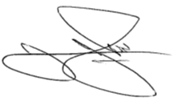 01/12/21
__________________ _______________________
Chief Executive Date

Appendix A: Public Consultation Portal

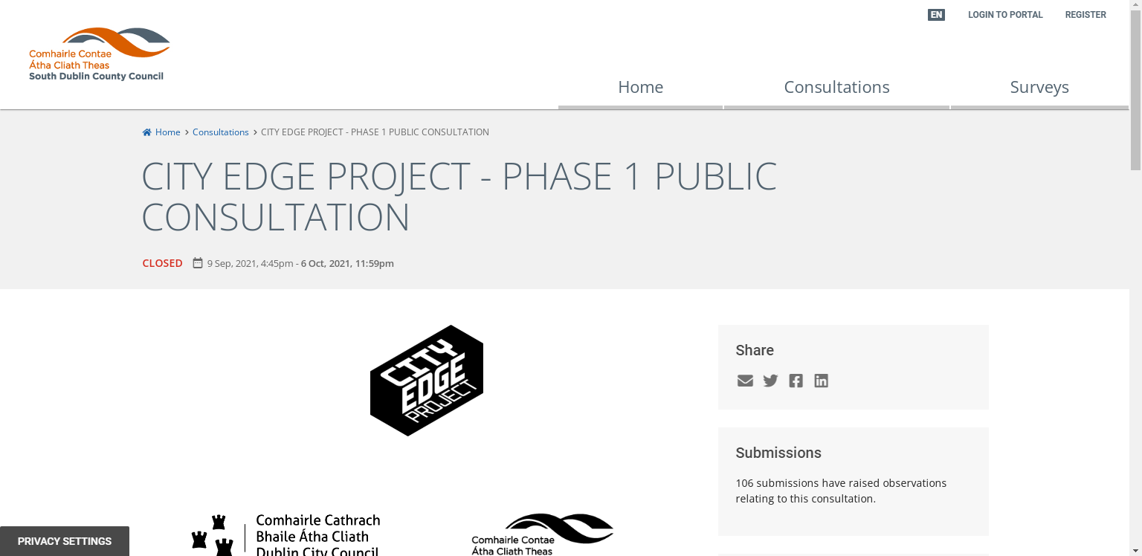

Appendix B: Newspaper Notices
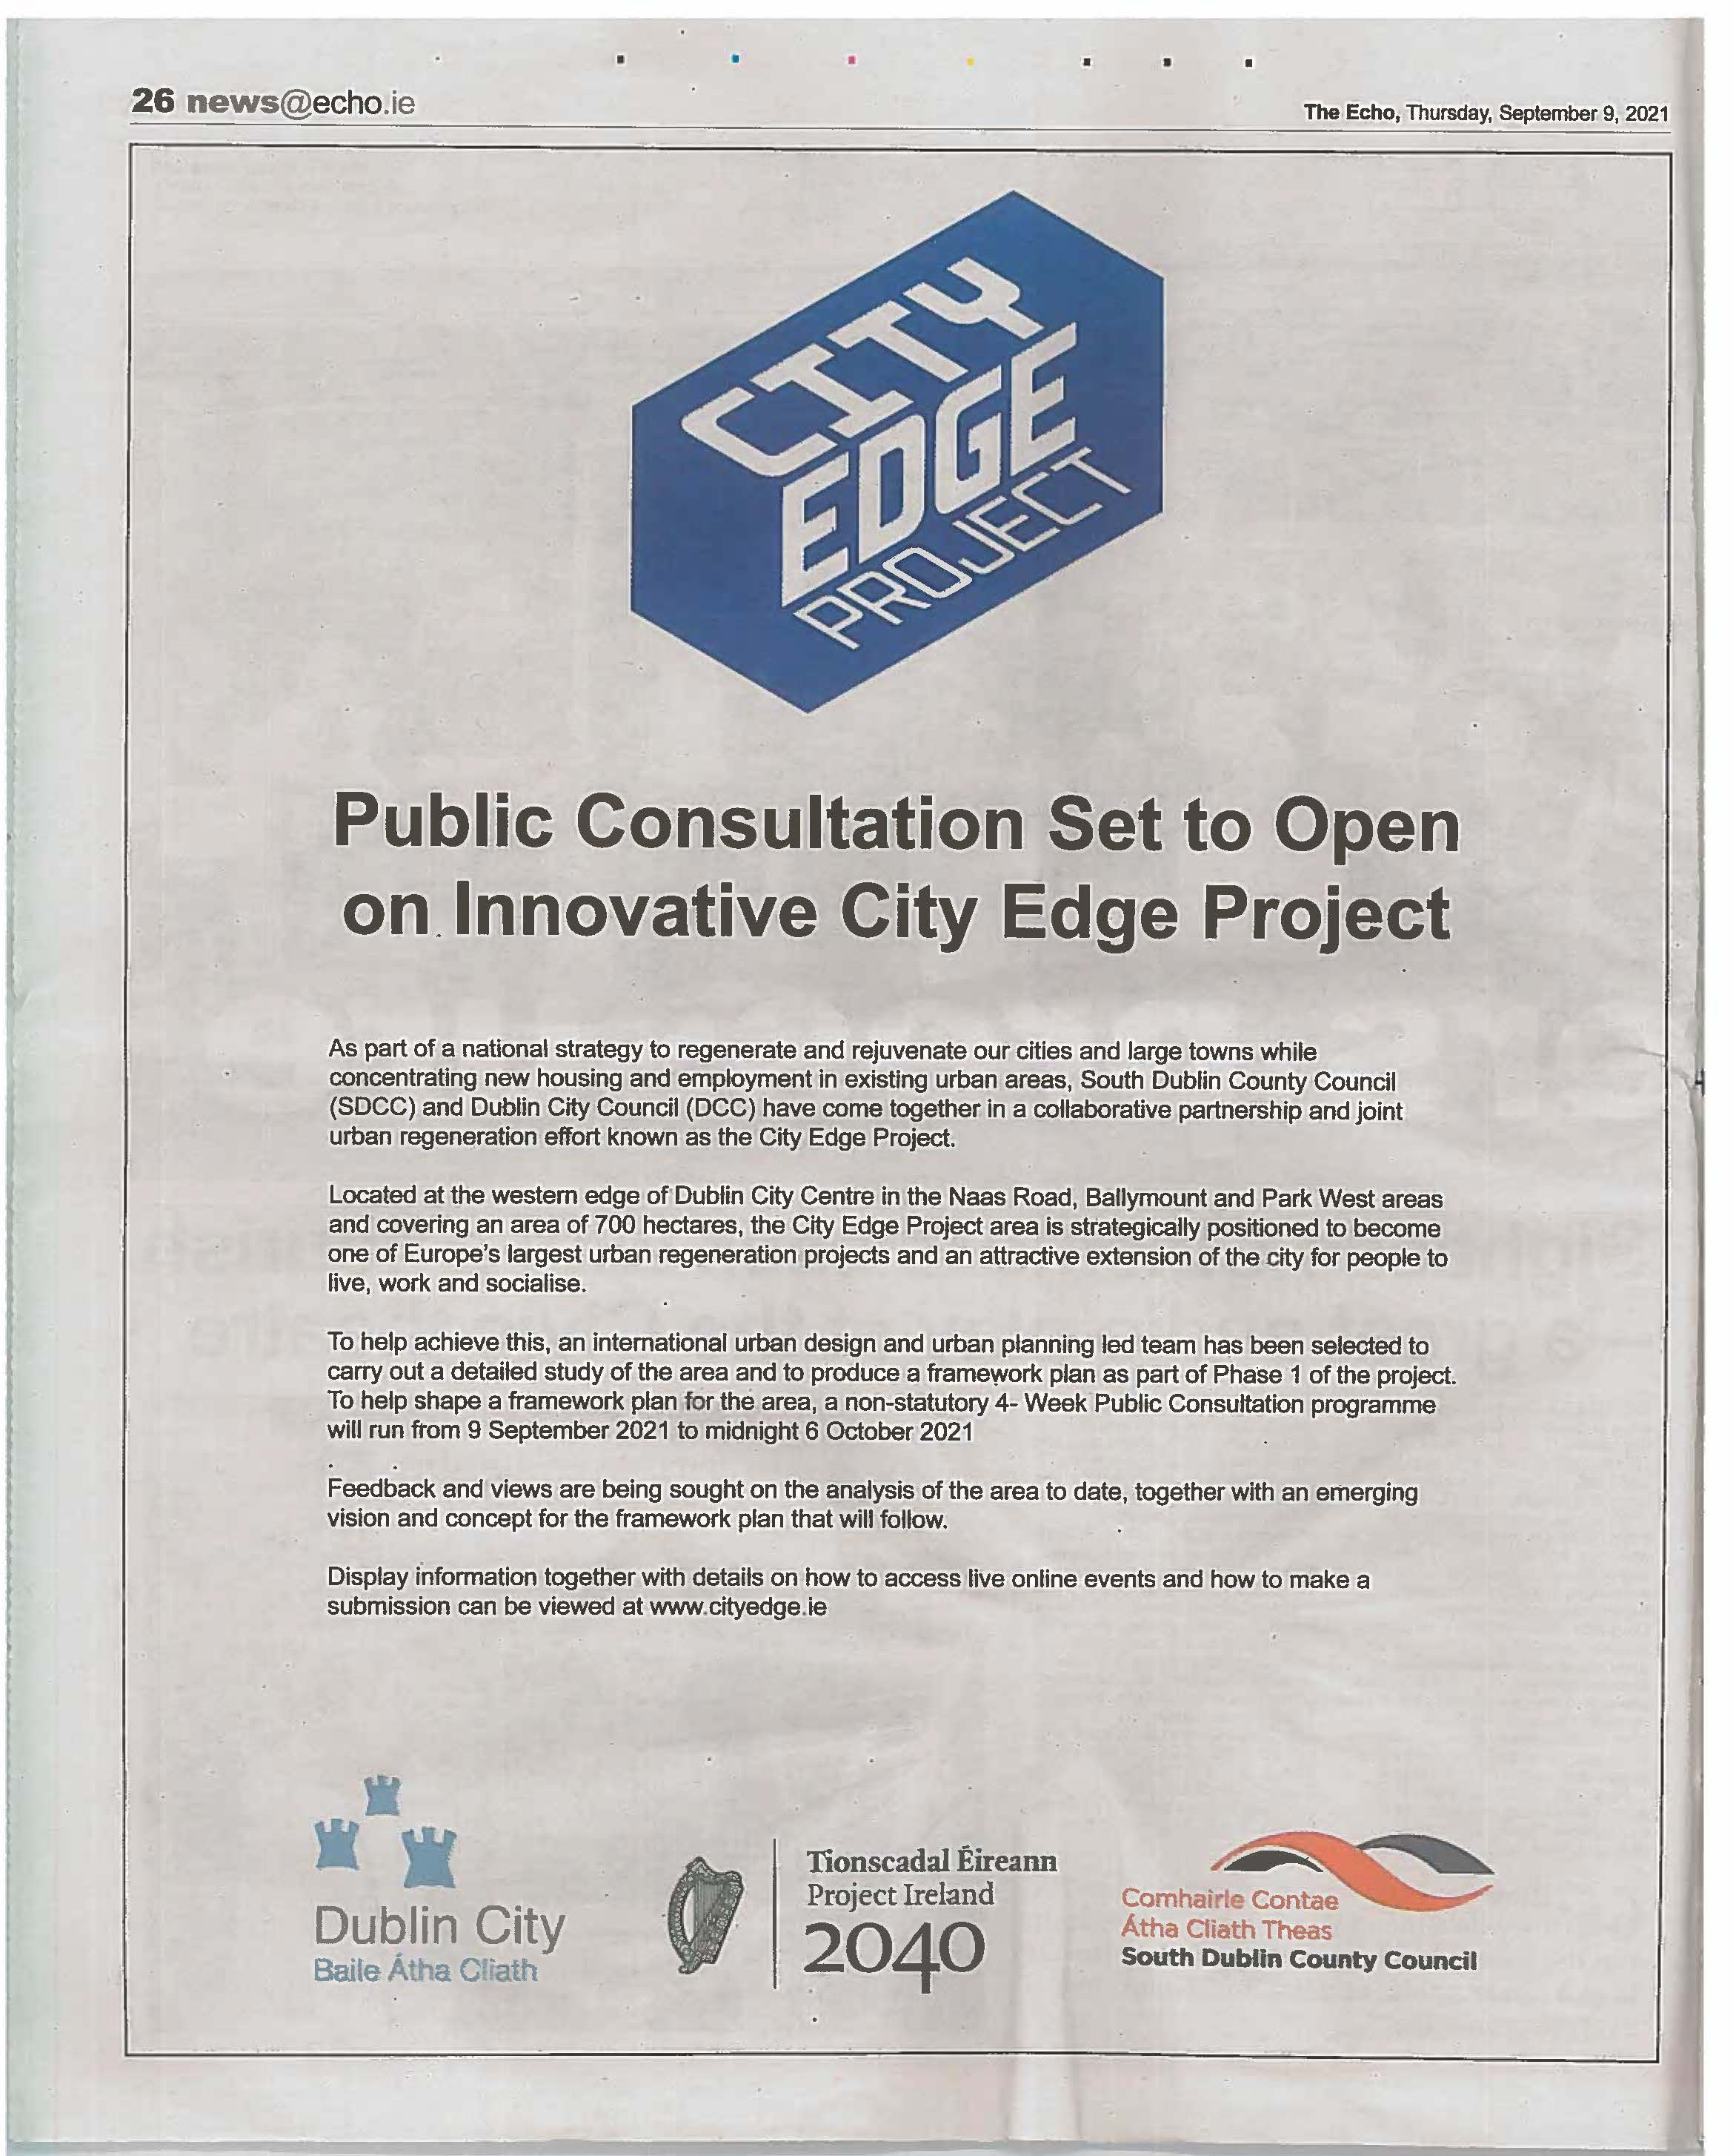
The Echo – Thursday 9th September 2021

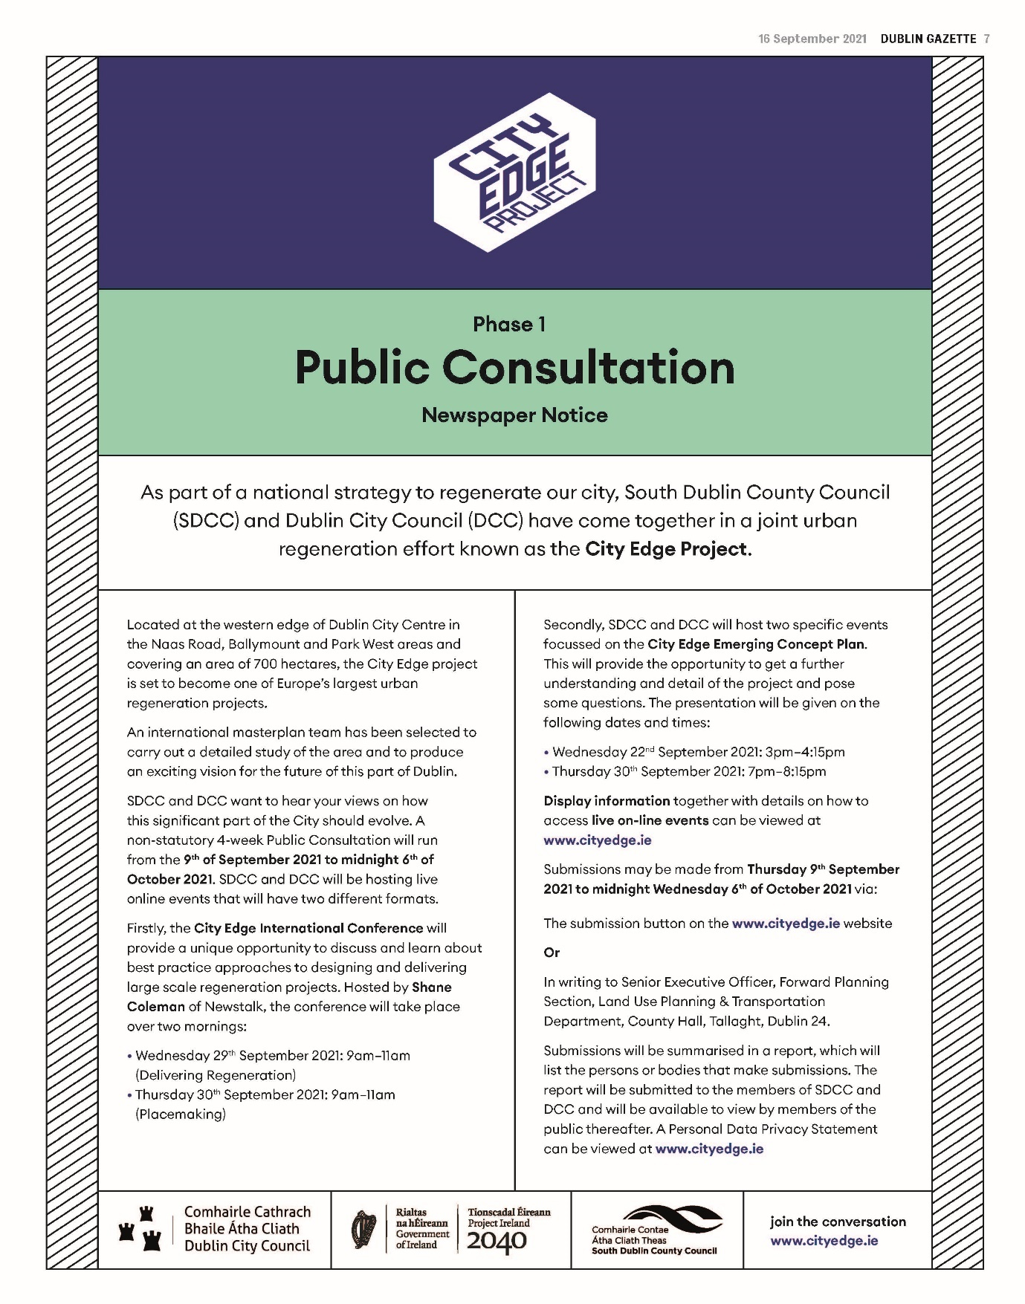
Dublin Gazette and People – Thursday 16th September 2021

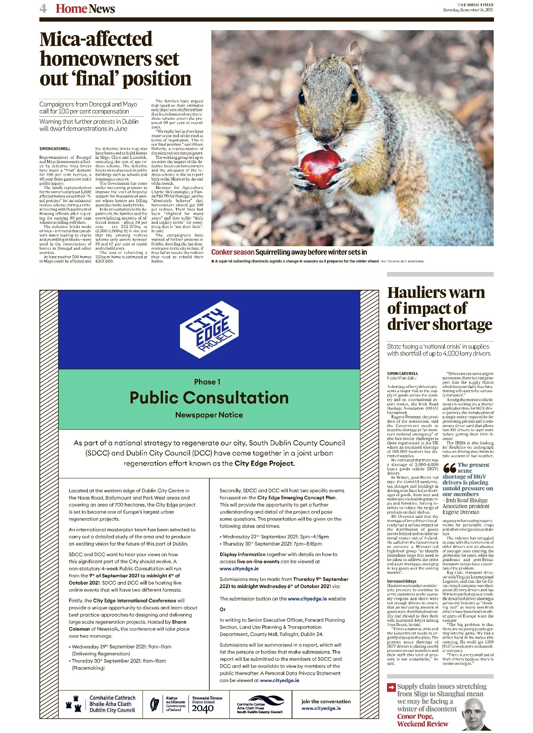
Irish Times – Saturday 18th September 2021

Appendix C: Public Consultation Launch Press Release, September 9th, 2021

CITY EDGE PROJECT

A MAJOR REGENERATION PROJECT FOR DUBLIN CITY

South Dublin County Council and Dublin City Council announce the
Launch of Phase 1 – Public Consultation and International Conference

South Dublin County Council (SDCC) and Dublin City Council (DCC) have announced the development of a major joint urban regeneration effort known as the City Edge Project. Located at the western edge of Dublin City Centre, this long-term, extensive redevelopment plan is part of a national strategy to regenerate Dublin city.

The City Edge Project is set to become one of Europe’s largest urban regeneration projects and an attractive extension of the city for people to live, work and socialise. The proposed development area extends to 700 hectares of land around the Naas Road, Ballymount and Park West area. This area is already a cornerstone of the Dublin economy with some 1,500 businesses employing 25,000 people, alongside well-established residential communities of 5,000 people. There are also significant areas of underutilised land and in the future, this part of the city could be further developed to accommodate up to 75,000 jobs and 40,000 homes.

An international masterplan team has been selected to carry out a detailed study of the area and to produce an exciting vision for the future of this part of Dublin. A significant part of the process is the Public Consultation period, whereby members of the public are invited to contribute to the process and help shape the future of the city.

To support this, a non-statutory 4- Week Public Consultation will run from the 9th of September 2021 to midnight 6th of October 2021. During that period, any member of the public can review the City Edge Emerging Concept Plan and make a submission through the website cityedge.ie. In addition, as part of this extensive consultation, SDCC and DCC will be hosting 2 live online forums which will provide the opportunity to gain further understanding of the project proposals and challenges. These live forums will provide the opportunity for people to pose questions. The live presentations will take place on the following dates and times:

• Wednesday 22nd September 2021: 3pm – 4:15pm
• Thursday 30th September 2021:7pm – 8:15pm

Display information together with details on how to access live on-line events and how to make a submission can be viewed at www.cityedge.ie
SDCC and DCC will also host the City Edge International Conference on September 29th and 30th. This live event series will provide a unique opportunity to discuss and learn about Best Global Practice approaches to designing and delivering large scale regeneration projects. Hosted by Newstalk’s Shane Coleman and running from 9am to 11am over 2 days, this is an online event open to the public and will feature a range of high profile national and international speakers from Dublin, London, Amsterdam, Copenhagen and Singapore, all of whom have been involved in significant and successful urban regeneration projects. They will share their experiences of designing and delivering complex regeneration projects and how the lessons from their projects could be applied to the City Edge speakers have been involved in include:

• Old Oak and Park Royal Development Corporation in London, which is supporting the delivery of 25,000 new homes and 40,000 new jobs around a new High Speed 2 station
• Gardens by the Bay is a significant new flagship park delivered by the state in Singapore and has become a key new destination
• Royal Docks in London, close to Canary Wharf, where the regeneration of these lands is underway and will support 25,000 new homes and 60,000 new jobs.
• Orestad in Copenhagen with a new population of 15,000 people in a mixed-use urban quarter based around a new metro
• Nordhavn in Copenhagen is progressing delivery of 40,000 new homes and 40,000 jobs around new public transport within an existing industrial area of the city.
• Sizeable state and private sector regeneration collaborations at IJburg Eastern Docklands and in Haven-Stad in Amsterdam
• Adamstown Strategic Development Zone in Dublin, the first plan of its kind in Ireland and that is supporting 7,000 new homes based on the principles of the Liveable City, and that is over halfway delivered

The City Edge Project represents a major development opportunity for Dublin City and to help shape and inform this work, SDCC and DCC want to hear people’s views on how this significant part of the city should evolve. The consultation programme is designed to provide ample opportunity for any member of the public to get involved and make a contribution to the project.

- 4- Week Public Consultation will run from the 9th of September 2021 to midnight 6th of October 2021 at www.cityedge.ie
- Public Presentations with live Q&A: Two live online forums will take place on Wednesday 22nd September 2021 at 3pm – 4:15pm and Thursday 30th September 2021 at 7pm – 8:15pm
- City Edge International Conference: The live online events take place on the mornings of September 29th and 30th, from 9am to 11am both days.
- Display information together with details on how to access the live on-line events and how to make a submission can be viewed at www.cityedge.ie

The following members of the City Edge steering committee are available for interview on request:

Mick Mulhern - Director of Planning and Transport South Dublin County Council
Mick is a qualified urban planner and designer and has worked in planning and regeneration for nearly 20 years. He recently returned to Dublin, having worked for the Mayor of London on significant regeneration schemes for 12 years and for the last 2 years has been working as the Director of Planning and Transport at South Dublin County Council where one of his key pieces of work is overseeing the City Edge Project.

Quote
The City Edge project has the potential to become one of the most transformational regeneration programmes ever progressed in Ireland. Today the area is a vibrant and important piece of Dublin but at over 700 hectares there is scope to use this land more intensely to support an expansion of the City and to provide space for up 75,000 jobs and 40,000 homes.

John O’Hara - City Planning Officer, Dublin City Council
John works closely with the Chief Executive, the Elected Members and external agencies in the management and delivery of strategic planning for the City, through the City Development Plan, Local Area Plans, and Strategic Development Zones (SDZ) schemes. John has considerable experience in both Ireland and the UK in urban regeneration. Recently John was responsible for the Docklands and Poolbeg SDZ Planning Schemes.

Quote
“The City Edge is an ambitious project that can deliver on the National Planning Frameworks objective to provide climate resilient compact urban growth. The delivery of this goal is contingent upon maximising the potential of existing and planned state of art public transport combined with a robust placemaking strategy focussed on the 15-minute city concept. The active collaboration all parties, public private, is required to achieve the scale of urban regeneration required”.

END

Appendix D: Press release 19th of September, announcing the opening of registration for live online events including the Online Public Presentations and City Edge International Conference.

PRESS RELEASE

19th September 2021

Registration is now open for City Edge Project live events,
hosted by South Dublin County Council and Dublin City Council

Strong public interest in one of Europe’s largest urban regeneration projects

Registration is now open on www.cityedge.ie for members of the public to join live online events to find out more about the ambitions of the City Edge Project, ask questions and have their say.

As part of its joint consultation programme, the four events to be hosted by South Dublin County Council (SDCC) and Dublin City Council (DCC) will be streamed live from www.cityedge.ie. Anyone interested in finding out more can register now for the live events at www.cityedge.ie.

A Presentation with Q&A is the first live event in the consultation programme, designed to provide ample opportunity for any member of the public to get involved and make a contribution to the project. The live programme culminates at the end of the month with the City Edge International Conference to be opened by the Minister for Housing, Local Government and Heritage, Daragh O’Brien and will include a range of international speakers sharing their experiences and lessons of regeneration projects from across Europe.

The details for all four live events are as follows:

Presentations with Q&A | City Edge International Conference
Wednesday, 22nd September at 3 pm  Thursday, 30th September at 7 pm | Wednesday, 29th September at 9 am  Thursday, 30th September at 9 am
Both events are just over an hour long and will feature a presentation and Q&A; attendees will have an opportunity to hear the details about what the project team are doing and what they’re trying to achieve. | These two-hour live events will provide members of the public with a unique opportunity to discuss and learn about best global practice approaches to designing and delivering large-scale regeneration projects.

In addition, a non-statutory 4-Week Public Consultation has been running from the 9th of September to midnight on the 6th of October for any member of the public to review the City Edge Emerging Concept Plan and make a submission at www.cityedge.ie.

To date, there has been great interest in the City Edge Project with over 20,000 views to the website from people looking to discover more about its vision for the future of the area at the western edge of Dublin City Centre; 700 hectares of land around the Naas Road, Ballymount and Park West area.

The City Edge Project is a long-term and extensive urban regeneration effort by SDCC and DCC of an area bigger than Dublin City centre. It will also form part of a national strategy to regenerate Dublin City. The area is already a cornerstone of the Dublin economy with some 1,500 businesses employing 25,000 people, alongside well-established residential communities of 5,000 people. This part of the city could be further developed to support an expansion of the City and provide space for up 75,000 jobs and 40,000 homes.

Mick Mulhern, City Edge steering committee member and Director of Planning and Transport at South Dublin County Council said:

“This is a significant regeneration project on a scale not seen before in Ireland and there has already been great interest on the website and in the public consultation process. This is an exciting opportunity to create an attractive extension of the City for people to live, work and socialise in.

“For the past number of months, we’ve been working with an international masterplan team looking at what is in the area now and trying to figure out how it could develop over the next 20 or 30 years, including the role of the State and the private sector in its redevelopment plan and achieving Zero Carbon for all development by 2050. This consultation programme is about showing people the work we’ve done and asking the public to contribute to the vision of how this important part of the City needs to be shaped for the future.”

ENDS

Appendix E: Press Release from 27th of September, announcing the speakers and details for the two-day City Edge International Conference as part of the project launch and public consultation events.

27th September 2021
South Dublin County Council and Dublin City Council host
public City Edge International Conference
Experts to speak about significant international regeneration projects,
to help shape the future of the western edge of Dublin City Centre
Keynote addresses from Housing Minister Darragh O’Brien
and Roger Madelin CBE, British Land, UK
Next week, South Dublin County Council (SDCC) and Dublin City Council (DCC) will host the City Edge International Conference on September Wednesday 29th and Thursday 30th. The live, online events, with Shane Coleman (Newstalk) as MC, will provide people with an interest in the City Edge Project with a unique opportunity to learn about Best Global Practice approaches to designing and delivering large scale regeneration projects, as well as more details about the vision for the project – one of Europe’s largest urban regeneration projects.
The City Edge Project is a long-term and extensive urban regeneration plan, jointly run by SDCC and DCC, of an area at the western edge of Dublin City Centre; 700 hectares of land encompassing the Naas Road, Ballymount and Park West locations. The area - bigger than Dublin City centre itself – is already a cornerstone of the Dublin economy with some 1,500 businesses employing 25,000 people, alongside well-established residential communities of 5,000 people. This part of the city could be further developed to support an attractive expansion of Dublin City and provide space for up 75,000 jobs and 40,000 homes.
The International Conference will be streamed live from www.cityedge.ie. Registration is now open on www.cityedge.ie for members of the public to join the event to find out more about the ambitions of the City Edge Project, ask questions and have their say.
The public event will be opened by the Minister for Housing, Local Government and Heritage, Darragh O’Brien. The line-up features a range of international and national speakers from Amsterdam, Copenhagen, Singapore, London and Dublin, all of whom have been involved in significant and successful urban regeneration projects. Over the two mornings, they will share their experiences of placemaking and regeneration in high-density cities and speak about the lessons from their projects that could be applied to the City Edge Project. The proposed line-up is as follows:
Wednesday, 29th September: 8:45 – 11 am (Delivering Regeneration on complex Brownfield land)
· Opening address from Darragh O'Brien, Minister for Housing, Local Government and Heritage
· Ton Schaap – Senior Urbanist, City of Amsterdam (speaking from the perspective of IJburg Eastern Docklands and Haven-Stad, Amsterdam)
· Arjan Klok – Chief urbanist for the Haven-Stad project at the Department of Spatial Planning and Sustainability, City of Amsterdam (speaking from the perspective of IJburg Eastern Docklands and Haven-Stad, Amsterdam)
· Paul Hogan – Chief Planner, Department of Housing, Local Government and Heritage (speaking from the perspective of Adamstown Strategic Development Zone, Dublin)
· Rita Justesen - Chief of Planning & Architecture, Copenhagen City & Port Development (speaking from the perspective of Orestad and Nordhavn in Copenhagen)
· Tony Reddy – Director, Reddy Architecture + Urbanism
· Mick Mulhern – Director of Land Use, Planning and Transportation, South Dublin County Council.
Thursday, 30th September: 8:45 – 11 am (Placemaking)
· Opening address from Roger Madelin CBE (who will also be a guest speaker) - Joint Head of Canada Water Development, British Land, UK
· Victoria Hills - Chief Executive, Royal Town Planning Institute, UK
· Gerard Maccreanor – Director, Maccreanor Lavington Architects Urbanists (speaking from the perspective of Royal Docks, London)
· Andrew Grant – Founding Director, Grant Associates (speaking from the perspective of Gardens by the Bay, Singapore)
· John O’Hara – City Planner, Dublin City Council.

Speaking ahead of his address on day one of the International Conference, Darragh O'Brien, Minister for Housing, Local Government and Heritage said:
“I welcome the work being undertaken by South Dublin County Council and Dublin City Council in their early engagement with the community and key stakeholders in developing a plan-led vision for the regeneration of the City Edge area of West Dublin. The development of brownfield land with good transport links for housing in our cities is a key part of delivering compact urban growth and increased housing supply. As well as having the potential to make a significant contribution to meeting our housing needs, this work will also ensure the provision of necessary economic, social and environmental infrastructure to support the development of well-balanced, sustainable communities.”
Roger Madelin CBE, Joint Head of Canada Water Development at British Land and former Director/CEO of Argent Group PLC, UK, is providing the opening address for day two of the International Conference. He said the time invested in this consultation phase is invaluable:
"The amazing opportunity presented with the City Edge Project could not come at a more important and urgent time. There will naturally be earnest voices eager to press on soonest to solve the housing crisis or to solve the climate crisis; there will also be voices of scepticism about any talk of doing things better, about genuine consultation and shared wider visioning.
"From my very lucky experiences of leading major projects in Birmingham, King’s Cross and now at Canada Water, time invested in listening to a wide audience, listening to the existing communities and business, learning from other cities, setting out a clear and unique vision and building a strong consensus is the essential foundation of success. After that, putting in place clear and strong policies to ‘guide, encourage, frame and enforce’ the delivery of change, will catalyse the much-needed results.”
Mick Mulhern, City Edge steering committee member and Director of Planning and Transport at South Dublin County Council said:
“This joint SDCC & DCC consultation programme is to provide ample opportunity for any member of the public to get involved, contribute, and help shape this potential and major regeneration project for this important part of the city for future generations. Similarly, our unique International Conference events are about showing the potential of the City Edge Project and inviting experts, who have done this elsewhere in the world, to input into the overall vision for the project. We want City Edge to be a place where people truly want to live, work and socialise and we want members of the public to be part of designing it, so that it meets their future needs in terms of housing, employment and transport, is best for the environment and addresses climate action.”
Also, on the evening of the 30th September members of the public can join a live online Presentation with Q&A and in just over an hour they will find out about the details of the project and what the project team is trying to achieve. Members of the public and stakeholders can also review the City Edge Emerging Concept Plan and have until midnight on the 6th of October to make a submission at www.cityedge.ie, as part of the non-statutory 4-Week Public Consultation for the project.
ENDS

Appendix F: Social Media Posts

Facebook Posts

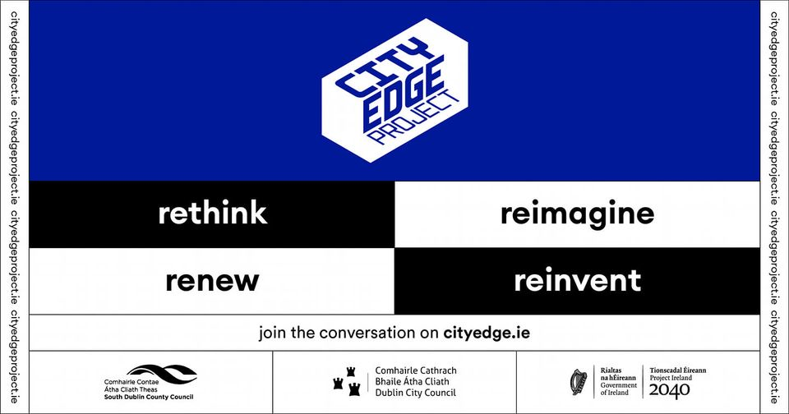
10th September
Unique in Ireland, the City Edge Project is a transformative initiative, re-imagining the Naas Road, Ballymount and Park West areas in Dublin. Creating a new urban space, it has the potential for 40,000 new homes and 75,000 jobs, making it one of the largest regeneration schemes in Europe. We want to hear what you think!
Visit https://cityedge.ie/ to find out more!

12th September
You can listen to Mick Mulhern, our Director of Land Use, Planning and Transportation, talk to The Hard Shoulder on Newstalk about #CityEdge and what it means for Dublin.
Find out more on the project here -》https://t.co/eYHwA6Cauu
NEWSTALK.COM
City Edge plan for south Dublin 'has potential for 40,000 homes' | Newstalk

21st September
You can register now for the #CityEdge emerging concept presentation taking place tomorrow at https://t.co/OtgCJqCh1J!
The Presentation and Q&A will provide the opportunity for people to gain further understanding of the project proposals and challenges as well as pose questions.

21st September
You can register now for the City Edge International Conference! https://cityedge.ie/register/
The City Edge International Conference will provide a unique opportunity to discuss and learn about best practice approaches to designing and delivering large scale regeneration projects. Hosted by Newstalk’s Shane Coleman there will be a range of national and international speakers from Dublin, London, Copenhagen, Amsterdam, Singapore and Rotterdam discussing their experiences and lessons from similar initiatives to the #CityEdge Project.

22nd September
The #CityEdge Presentation takes place today at 3pm and will provide an opportunity to get a further understanding and detail of this transformative new urban space with the potential for 40,000 new homes and 75,000 jobs.
You can register now on https://buff.ly/2XvsCIW!

25th September
Unique in Ireland, the City Edge Project is a transformative initiative, re-imagining the Naas Road, Ballymount and Park West areas in Dublin. Creating a new urban space, it has the potential for 40,000 new homes and 75,000 jobs, making it one of the largest regeneration schemes in Europe. We want to hear what you think!
Visit https://buff.ly/3k22EWi to find out more!

27th September
As part of a national strategy to regenerate our city, South Dublin County Council (SDCC) and Dublin City Council (DCC) have come together in a joint urban regeneration effort known as the City Edge Project.
Located at the western edge of Dublin City Centre in the Naas Road, Ballymount and Park West areas and covering an area of 700 hectares, the City Edge project is set to become one of Europe’s largest urban regeneration projects. SDCC and DCC want to hear your views on how this significant part of the City should evolve. A consultation is currently ongoing until midnight 6 October 2021.
Find out more here --> https://cityedge.ie/
Send us your thoughts here --> https://consult.sdublincoco.ie/.../city-edge-project...
Send us your thoughts here --> https://consult.sdublincoco.ie/.../city-edge-project...

29th September
Mick Mulhern, our Director of Land Use, Planning and Transportation, is coming up shortly on Newstalk FM to discuss the #CityEdge International Conference that is starting today.
More details here https://buff.ly/2XvsCIW
Watch along later here https://buff.ly/3uwCpep

2nd October
#CityEdge is a transformative reimagining of the Naas Road, Ballymount and Park West areas in Dublin. Creating a new urban space, it has the potential for 40,000 new homes, making it one of the largest regeneration schemes in Europe.
More info https://buff.ly/3k22EWi

Twitter Posts (Selection)

10th September
Unique in Ireland, the City Edge Project is a transformative initiative, re-imagining the Naas Road, Ballymount and Park West areas in Dublin. Creating a new urban space, it has the potential for 40,000 new homes and 75,000 jobs, making it one of the largest regeneration schemes in Europe. We want to hear what you think!
Visit https://cityedge.ie/ to find out more!

30th September
It was great having Minister @DarraghOBrienTD
with us yesterday for the #CityEdge International Conference! You can find out more about the project here http://cityedge.ie
Darragh O'Brien@DarraghOBrienTD
Delighted to join City Edge Intl Conference this morning. The City Edge Project jointly run by @DubCityCouncil & @sdublincoco is a long-term & extensive Urban Regeneration Plan of 700 hectares. Key to success is plan-led proposals with community engagement from outse

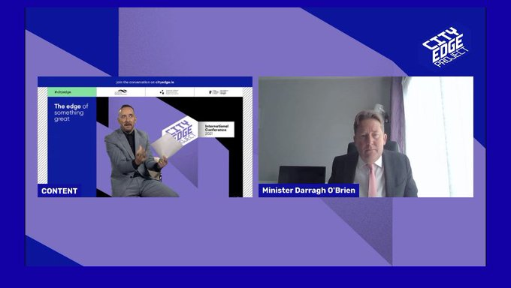

30th September
We have #Cityedge presentations with questions and answers coming up in about an hour! Check back into this link later to watch along

30th September
We’re underway with Day two of the #Cityedge International Conference

29th September
Mick Mulhern, our Director of Land Use, Planning and Transportation, speaking to @rtenews on the innovative #cityedge initiative this afternoon.
Day two of the international conference is coming up tomorrow at 9am at this link.
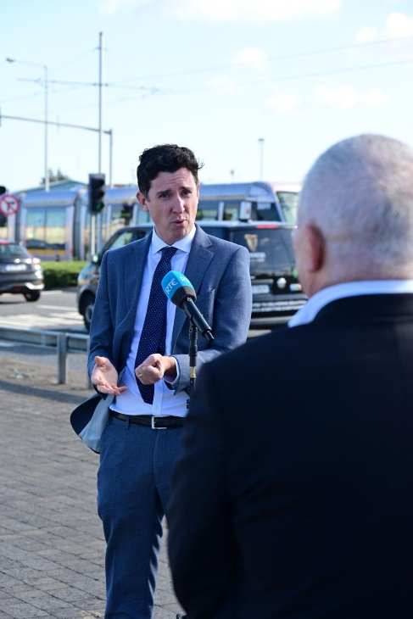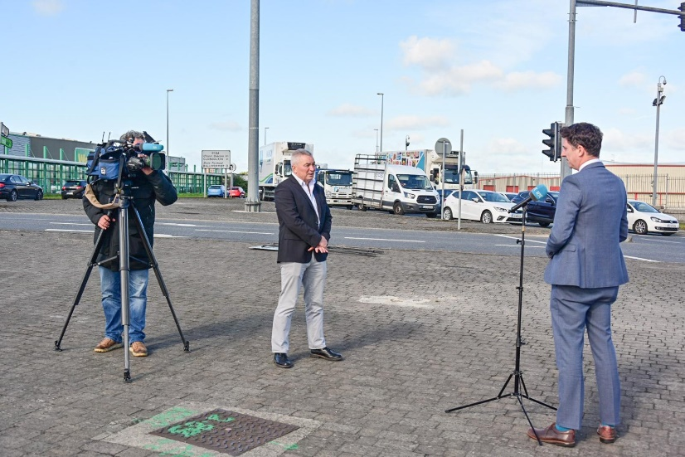

2nd October
#CityEdge is a transformative reimagining of the Naas Road, Ballymount and Park West areas in Dublin. Creating a new urban space, it has the potential for 40,000 new homes, making it one of the largest regeneration schemes in Europe.

Instagram Posts (Not Limited to)

29th September
Mick Mulhern, our Director of Land Use, Planning and Transportation, speaking to @rtenews on the innovative #cityedge initiative this afternoon.
Day two of the international conference is coming up tomorrow at 9am at this link.

21st September
You can register now for the #CityEdge emerging concept presentation taking place tomorrow at https://t.co/OtgCJqCh1J!
The Presentation and Q&A will provide the opportunity for people to gain further understanding of the project proposals and challenges as well as pose questions.

10th September
Unique in Ireland, the City Edge Project is a transformative initiative, re-imagining the Naas Road, Ballymount and Park West areas in Dublin. Creating a new urban space, it has the potential for 40,000 new homes and 75,000 jobs, making it one of the largest regeneration schemes in Europe. We want to hear what you think!
Visit https://cityedge.ie/ to find out more!

3rd October
#CityEdge is a transformative reimagining of the Naas Road, Ballymount and Park West areas in Dublin. Creating a new urban space, it has the potential for 40,000 new homes, making it one of the largest regeneration schemes in Europe.
More info https://buff.ly/3k22EWi

Appendix G: International Conference Evite

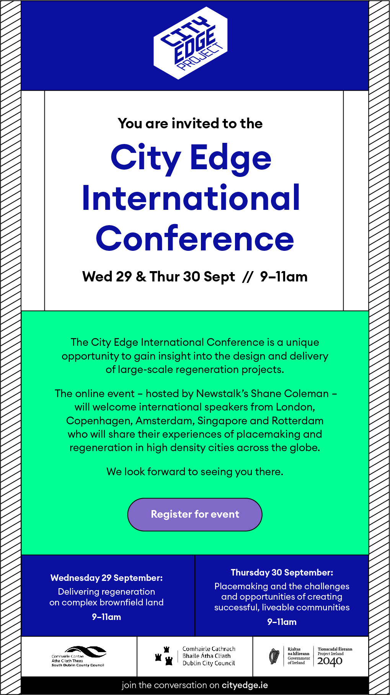

Appendix H: International Conference Evite Mailing List
Evites Mailing List
IPI - Irish Planing Insititue | Britvic Ireland
RTPII - Royal Town Planning Institute Ireland | M7 Capital
An Bord Pleanala
Eastern and Midland Regional Assembly
OPR -Office of Planning Regulator | UCC
 | TU Dublin
SCSI - Society of Chartered Surveyors Ireland | Queens Belfast
CIF - Construction Industry Federation | UCD
 | PPN SDCC
SDCC County Councillors/CE | PPN DCC
DCC County Councillors/CE
Landowners
Harris Lands | Waterways Ireland
Killeen Group Holdings | HSA
BOC Gases | Codema
Dranrebs Limited (Fox and Geese) | SEAI
Dairygold Site | EPA
AAI Walkinstown | TII
Quanta Capital | NTA
CIE | OPW
An Post | IDA
Development 8 | LDA
Corcom Properties
Development Ocht Ltd | Failte Ireland
Shorevale Investment Ltd | Enterprise Ireland
Amber Infrastructure / O'Flaherty Holdings (Hugh Blaney)
O'Flynn Construction Co. Unlimited Company
Crekav Trading GP Limited | Inland Fisheries
Goldenport Estate Ltd | Irish Water
Arcourt Limited | ESB
Harcourt Properties | Irish Rail
Thortons Recycling
John Burke
Fastnet Properties Ltd
Tenant + Ruttle Distribution Ltd
Nesta Offices

