South Dublin County Council Decade of Centenaries Programme 2021
South Dublin County Council’s Decade of Centenaries Programme 2021 explored and reflected on the impact of the pivotal events of 100 years ago at both a national and local level. The effect of the War of Independence, the Truce and the signing of the Anglo-Irish Treaty have been felt here, as elsewhere in the country, through the Civil War, and the past 100 years to today.
This year’s programme focused on local connections to the War of Independence, explored through cultural events, historical reflections, lectures and exhibitions. We reflected on life at the time in a broader context, including the social conditions experienced by local people during the revolutionary period, cultural life, the role of women during this time, and South Dublin County’s military heritage.
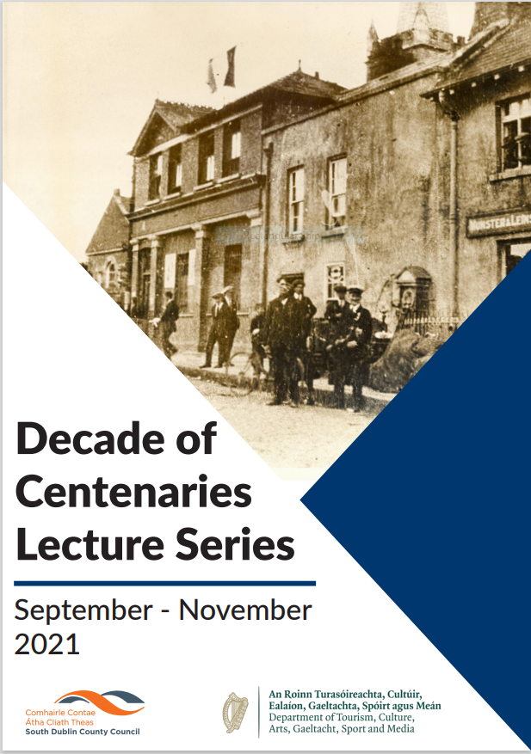
Lecture Series
Our lecture series for 2021 was hugely successful, hosting some of Ireland’s foremost historians. As all talks took place online, they drew large attendances from all over the world, as well as Ireland. The combined live attendance was 947 with many more watching recordings after the talks had taken place.
The Lecture Series for 2021 commenced in Spring when the following online talks took place:
• Tuesday 23rd March. The War of Independence: the South Dublin perspective (Cathy Scuffil) An introductory lecture on the War of Independence with a focus on the South Dublin County area.
• Thursday 20th April. We are Black and Tans: children during the Irish revolution (Liz Gillis). The story of the War of Independence has been told mainly from the perspective of adults, but children were as much a part of the story. How did the conflict affect them? They were witnesses, in some cases participants and sadly victims.
• Wednesday 12th May. What did you do in the War of Independence, Grandad? (Myles Dungan). Based on his new book Four Killings, Myles Dungan talked about the bloody narrative of his extended family during the revolutionary era and offered suggestions on how to research the activities of your own ancestors in that seminal conflict.
• Tuesday 25th May. Researching and Writing Your Family History (Dr. Sinéad McCoole) Following on from Myles Dungan’s talk this complementary talk aimed to help attendees to get started in researching and writing their own family history
These were followed by our Autumn/Winter Series:
• Saturday 4th September. From Truce to Treaty: de Valera’s 1921 (David McCullagh) This lecture explored Eamon de Valera’s leadership during the truce period and treaty negotiations, including an examination of his controversial refusal to go to London for negotiations with the British government in late 1921.
• Thursday 9th September. Nationalist Revolution in Ireland and Europe 1919-1923 (John Dorney) Between 1919 and 1923, Ireland experienced upheaval, revolution, partition and civil war. This experience was common to swathes of countries across Europe as the German, Austro-Hungarian and Russian empires collapsed in the wake of the First World War. This lecture aimed to put Ireland’s experience in its European context.
• Thursday 7th October. Seán Keating: Art, Politics and Building the Irish Nation (Eimear O’Connor) An exploration of the life and works of Rathfarnham-based artist Seán Keating during the period 1915-24, including his iconic depictions of the revolutionary period.
• Thursday 14th October. Sisters of the Revolutionaries: The Story of Margaret and Brigid Pearse (Therese and Mary Louise O’Donnell) This was a hybrid event with a small audience attending in person in Ballyroan Library, while it was also live-streamed. An evening of history and music with a lecture, interspersed with harp music and song, on the lives of the Pearse sisters and their formidable contribution to Irish educational, political and cultural life in the years following the execution of their brothers.
• Thursday 28th October. The Bureau of Military History: origins and overview of the collection (Commandant Daniel Ayiotis). A talk by Officer in Charge, the Military Archives, Commandant Daniel Ayiotis, on the origins and significance of the witness testimonies, providing first-hand accounts of the events of 1916-23, collected by the Bureau of Military History.
• Thursday 21st October. The War on Newspapers 1921-3 (Ian Kenneally) A talk on how newspapers influenced and were in turn influenced by the events of 1921-3.
• Thursday 4th November. The Rise and Fall of the Dáil Courts 1921-2 (John Dorney) During the War of Independence, across much of the country, the British system of justice was replaced entirely and largely peacefully, for a time, with Irish Republican Courts, before they were supressed by force. In this talk, John Dorney explored why, in the post-truce period, they did not become the basis for an Irish judicial system, removed entirely from its British predecessors.
• Thursday 11th November. Margaret Pearse and Revolutionary Women (Liz Gillis) During the period 1921-3, Margaret Pearse, bereaved mother of Padraig and Willie Pearse, committed herself to maintaining what she recognised as the republican legacies of her executed sons. This lecture explored the political activities of Margaret during the War of Independence and the Civil War.

Riots, Rifles and Rebels Book
This is a 110 page publication which will be delivered to all 8,000 5th class students in all primary schools across the county. The book will include chapters on various aspects of the 1913-23 period in Ireland, including the Lockout, the Great War, the 1916 Rising, the War of Independence and the Civil War. In articles written by South Dublin Libraries’ Local Studies staff as well as our Historian in Residence Liz Gillis, the story of the period will be told in a child friendly manner and will include the national story as well as a focus on what was happening in the South Dublin County area at the time.

Historian in Residence
Following an open competition, Liz Gillis was appointed Decade of Centenaries Historian in Residence for South Dublin County.
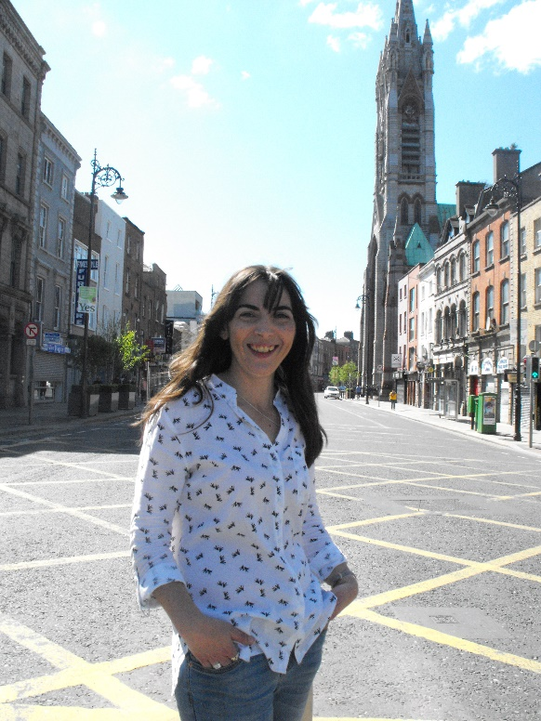
Liz has a degree in Modern Irish History and specialises in the Irish Revolutionary period. She is a lecturer at Champlain College Dublin and a researcher on The History Show on RTE Radio. She has also worked as a curator on the RTE 1916 Centenary Project, as a tour guide in Kilmainham Gaol, and as historical consultant on projects including the Custom House Visitor Centre and Hyatt Centric Liberties Hotel. She is the author of several books including Revolution in Dublin: A Photographic History 1916-1923, Women of the Irish Revolution, and May 25: Burning of the Custom House 1921. She was the recipient of the Dublin City Lord Mayor’s Award in 2018 for her contribution to history and was co-organiser of the online conference to mark the centenary of the burning of the Custom House in May 1921.
Liz believes in telling the national story from the local perspective and is passionate about getting people interested in history. As part of her residency, she is engaged in a number of projects and programmes:
• Research on the revolutionary period in South Dublin County.
• A series of public lectures, both online and in person, in library branches across South Dublin County, as well as talks for individual historical societies. Liz has delivered the following public talks:
- Monday 13th September. Zoom event to introduce Liz as our Historian in Residence, followed by a talk on the revolutionary period in South Dublin County.
- Tuesday 2nd November. North Clondalkin Library – What did the Women do anyway? Women and the Irish Revolution
- Thursday 18th November. Castletymon Library – The Irish War of Independence in Tallaght and Greenhills 1919-21
- Thursday 25th November. County Library, Tallaght – Love and Loss in the Irish Revolution
- Thursday 2nd December. Lucan Library - When will it ever end? 1921 a Year in Review and the War of Independence in Lucan.
- Tuesday 7th December. Clondalkin Library – The Revolution and Civil War in Clondalkin
- Thursday 9th December. Ballyroan Library – WT Cosgrave, Republican Councillor, Rebel and first President of the Executive of the Irish Free State
• Schools Webinars: Liz has delivered two webinars to schools across the county which have been very well received. On Thursday 21st October, she gave a talk to primary schools on “We are Black and Tans!”: Children and the Irish Revolution which was attended by 1200 children. On Tuesday 9th November, she gave a talk to secondary school students on Researching the Irish Revolution. This was aimed at transition year and 5th year students and offered advice on Leaving Cert History topics, and sources for primary information. 300 students attended, and a recording was made available to all secondary schools in the county. She is also delivering workshops to individual classes in schools, again all across the county.
• Assisting the Decade of Centenaries Artist in Residence in researching primary source material for her work.
• Research and script writing for South Dublin County Council’s ‘Revolutionary Trail’ app which will be delivered in 2022.
• Research and writing work for the ‘Riots, Rifles and Rebels’ book for primary schools which will be distributed to all primary schools in the county in December 2021.
Purchase of Archival Material
This funding allowed us to purchase new collections of stock related to the revolutionary period for school libraries across the county.
Local History Societies Grants
• Tallaght Historical Society were granted the sum of €1,000 for the production of an exhibition on the revolutionary period in Tallaght, which will be on permanent display at the Áon Scéal Irish Language and Cultural Café in Tallaght Village.
• Saggart Historical Interest Group were granted the sum of €3,000 for the publication of a book on the revolutionary period in the Saggart, Rathcoole and Newcastle areas.
Artist in Residence
Following an open competition, Eva Kelly was appointed the Decade of Centenaries Historian in Residence for South Dublin County. Eva is a Saggart based artist and illustrator represented by Lemonade Illustration Agency and a member of Illustrators Guild of Ireland. She studied Visual Communications at the National College of Art and Design and has a background in printmaking that informs her work. She has an MA in Visual Arts Education from the National College of Art and Design and MA in Illustration from the University of Hertfordshire. She teaches Illustration and Drawing. The idea of illustration as a visual essay is the focus of Eva’s work and through the residency she will document aspects of South Dublin life and culture, revealing aspects of and offering a new perspective in a visual form. In particular, her focus will be on the following themes.
• The Foundation of the State (1922)
• The experiences of women from South Dublin County during the revolutionary period and their changing role in society.
• An examination of specific personalities, events and themes from this period of significance to the history and culture of South Dublin County.

Taking inspiration from the above themes she will showcase the unique story of the history and characters of South Dublin County. Her work will be exhibited across the South Dublin Libraries branch network in early 2022. She is also currently working on the community engagement element of her residency, running workshops in schools and branch libraries in November and December 2021. Eva’s work can be followed on her blog at https://www.evakellyillustration.com/blog.

