RTFB ACM 14th December 2021
Libraries Report | Ballyroan Library November and December 2021 Highlights

Health Literacy Programme
This programme was funded by the Dormant Accounts Fund. There were three elements to the programme. Participants were invited to attend a six-week health and wellbeing course in the library, delivered in partnership with Dundrum College of Further Education throughout November and December. The programme aimed to facilitate older people to explore health and wellbeing topics and to increase awareness, knowledge, understanding and skills to support healthy choices. Participants also had the opportunity to attend a five-week Tai Chi in the Library course. The Chinese practice of Tai Chi is a gentle form of exercise that can help maintain strength, flexibility and balance for people of all ages and abilities. To provide a wider opportunity for engagement, online lectures were delivered by experts on topics including:
- How to develop and practice good health literacy
- How to stay active and connected in older age
- How to support the physical health and mental wellbeing of carers
- How to advocate for the health of a loved one
The final part of the project is the publication of a leaflet outlining the importance of health literacy and providing guidelines on how to access quality information and avoid misinformation. The leaflet was developed in collaboration with a health reporter and the National Adult Literacy Agency. Copies will shortly be available from all library branches.

Hellfire and Yonder Oral History and Folklore project
This programme was funded by Creative Ireland and took the form of six online workshops, which concluded in November. Renowned folklorist Michael Fortune taught participants how to collect and record oral history and folklore using modern technology. Participants learned how to use their smartphones, tablets and pcs along with accessible and free-to-use software to record and edit videos on various objects of research. Participants are in the final stages of editing their videos on subjects of local interest such as Massy’s Estate, Ticknock Hill and the Loreto Abbey and we hope to have a launch for the final output of the project in the New Year.
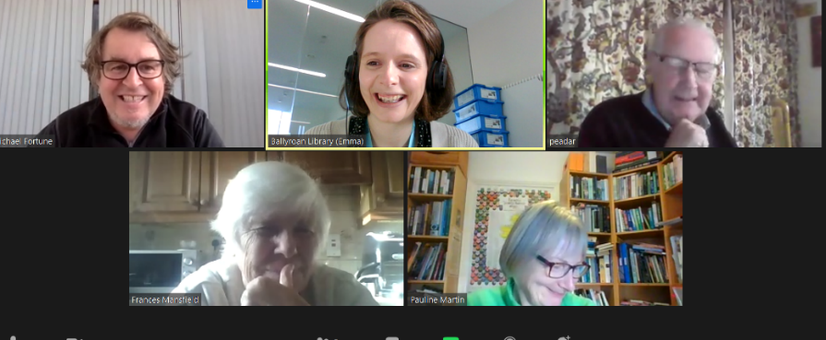

Christmas Craft Fair
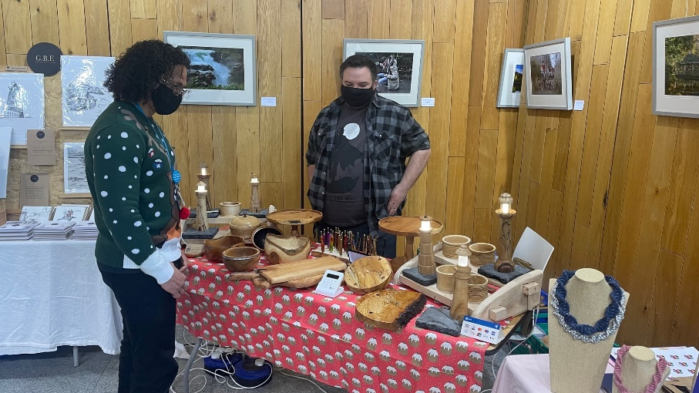
The Christmas Fair took place on Saturday 27th November and had 25 local craftspeople and small businesses taking part. It was very successful with over 1200 people through the doors on the day. Two events for children also took place as part of the fair – a magic show and Santa visits with 150 people attending across both events.

Sorry I’m Late, I’ve Got Kids! Parenting Programme Supported by the Dormant Accounts Fund.
- Thursday 18th November | Small Group Parenting Workshop with Trevor Higgins of Cloudsaway.ie
Psychologist and parenting coach Trevor Higgins gave tips and hosted an open Q and A with parents on how to best support their children.
- Wednesday 24th November | Talking Parenting with David Coleman
David Coleman is a practicing Clinical Psychologist and an Adjunct Associate Professor in the School of Psychology in UCD. This talk focused on practical tips for parents on how to help children and teenagers to deal with the stresses and pressures in their lives. This was a hybrid event with a small audience in the library while it was also live streamed.
- Tuesday 30th November | Parenting When Separated
Family Therapist Don Boardman of the South Dublin Partnership spoke on the topic of parenting when separated.

December Highlights
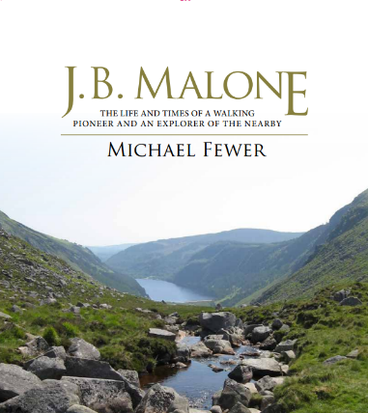
Wednesday 1st December | Book Launch: JB Malone by Michael Fewer
The latest local studies publication from South Dublin Libraries was launched by Mayor Peter Kavanagh. The book details the life and career of JB Malone who was a pioneer of way-marked trails and the most influential force in the development of hill-walking as a leisure activity in Ireland, particularly in the Dublin and Wicklow Mountains. The book is available to purchase and borrow from all branches of South Dublin Libraries and will shortly be available for download from our digital archive, Source.

Saturday 4th December | Family Time at Your Library
The Family Time at your Library events aim to support a family-focused approach to reading with children as part of the national Right to Read programme and to increase awareness of the benefits of reading and promote reading as a fun, recreational activity for children.
Winter Wonderland Storytime
Join us for a very special festive storytime for little ones.
Create your own Superhero!
Ever wanted to create your own Captain Marvel, Batman, T’Challa or Rocket? Are you ready for your mission? Put on your cape and get ready to create! Join Alan Nolan for this wonderful workshop as he talks about his favourite superheroes and shows you how to draw a super-powered animal and design your very own superhero!
Alan Nolan is the author and illustrator of Fintan's Fifteen, Conor's Caveman and the Sam Hannigan series for the O’Brien Press.

Wednesdays 8th and 15th December | Coderdojo
The popular regular coding club has moved online for the moment. CoderDojo is a global collaboration providing free and open learning to young people ages 7 - 17, especially in programming technology.

Thursday 9 December 2021 at 2:00pm | Book Illustration Workshop
Join our Decade of Centenaries Artist in Residence Eva Kelly to create a unique illustrated book inspired by natural objects. Learn how Eva uses these methods on her current project illustrating historical events and personalities as part of the South Dublin Libraries’ Decade of Centenaries project. Explore mark making techniques looking at colour and texture using inks, watercolour and pencils. This is a playful relaxed approach to image making and an introduction to handmade books. No experience necessary just a willingness to try new creative ideas!

Thursday 9th December 2021 at 7:00pm | The Life and Times of WT Cosgrave
WT Cosgrave, Republican Councillor, Rebel and first President of the Executive of the Irish Free State. Our Historian in Residence Liz Gillis along with Dublin City Council Historian in Residence Cathy Scuffil will discuss the life of WT Cosgrave from his early career as a member of Dublin Corporation to his role as leader of the Irish Free State. (Online event)

Wednesday 15th December at 12:30pm | Pennies from Heaven Christmas Show
Festive favourites at this lunchtime live music event.

Tuesday 21 December 2021 at 5pm | Get into the spirit of Christmas with these back-to-back events celebrating the life and works of Charles Dickens!
Charles Dickens and the Stories of Christmas Past
Having written arguably the most famous (secular) Christmas story of them all in A Christmas Carol, it is less well known that Dickens wrote many more Christmas stories. Dickens never failed to capture the public imagination and this talk from librarian Emma Edwards will explore his Christmas tales and his impact in popularising many Christmas customs and traditions.
Film Screening | The Man Who Invented Christmas
Join us for a Christmas movie night here in Ballyroan Library with a screening of the 2017 film The Man who Invented Christmas, starring Dan Stevens, Christopher Plummer and Jonathan Pryce. This film depicts Dickens (Stevens) receiving the inspiration for and writing his 1843 novella A Christmas Carol.

Wednesday 22nd December at 7:00pm| Cotton Club Quartet Christmas Crooners Show
An evening of fun and festive song with the Cotton Club Quartet. In the first eight weeks since we got back on the road, we have had 4132 visitors to the Mobile Library. On average we had 16.7 visitors at each of our 32 weekly public stops (which last about an hour each).

Exhibition

The Bremen Flight from Baldonnell

The exhibition is a visual one with rare photographs of the fliers and the plane - especially rare are the photos of the restored plane which now sits in Bremen airport. The exhibition is spread over five pullup panels and memorabilia.

Mobile library service

We made 112 home deliveries with our Library @Home service. This service came into its own during the lockdowns and continues to thrive. Visits are made on a 4 weekly basis to those who are cocooning or have health issues which prevent them from visiting the library.

In the first eight weeks since the mobile library service got back on the road, they have had 4132 visitors. On average we had 16.7 visitors at each of our 32 weekly public stops (which last about an hour each).

Arts Office

The Revival of Live Day

at Rathfarnham Church, Main Street, Rathfarnham

Friday, 17 December

The Revival of Live: Phase Two series continues to aim to animate local towns and districts so that communities can feel the invigorating benefits of live music, this time in a safe, indoor environment.
The concerts are curated and presented by Artscope’s Caroline Wynne in association with South Dublin County Council Arts Office and funded by the Department of Tourism, Culture, Arts, Gaeltacht, Sport and Media.
The aim of the Local Live Performance South Dublin County programme is to assist producers, promoters and venues in providing support for people in an industry which has suffered so much over the past few years. The funding obtained by Artscope will be used to support employment and wellbeing in the commercial arts and culture sectors through the provision of live performances by engaging the services of locally based professional artists, musicians, crew and other staff members involved in live performances.
For further information visit: Revival of Live - Artscope

