Appendices Draft Street improvement Management Guide
Local Transport Interventions to Improve Safety for all Road Users
25 Novemeber 2021
LUPT
South Dublin County Council

Index:
Appendix 1 WARRANTS FOR PEDESTRIAN CROSSING FACILITIES

Appendix 2 1988 Road Traffic (Bollards and Ramps) Regulations (S.I. No. 32 of 1988) and later part amended by (SI 291 of 1988)

Appendix 3 Age Friendly Parking

Appendix 4 Disability Access Legislation

Appendix 5: Section 38 Roads Act 1994

Appendix 6 Illustrations of Traffic Calming measures and
Pedestrian Improvements:

Appendix 1: WARRANTS FOR PEDESTRIAN CROSSING FACILITIES

SOUTH DUBLIN COUNTY COUNCIL
Roads (Traffic) Department

TRAFFIC STUDY GROUP – 2001
WARRANTS FOR PEDESTRIAN
CROSSING FACILITIES

JULY 2001

TRAFFIC MANAGEMENT/ETPU SECTION
SOUTH DUBLIN COUNTY COUNCIL
P.O. BOX 4122
COUNTY HALL
TALLAGHT
DUBLIN 24

TRAFFIC STUDY GROUP – 2001

WARRANTS FOR PEDESTRIAN CROSSING FACILITIES
1. Introduction
1.1 The Traffic Study Group has recommended that a number of locations be counted to determine whether there is a warrant for pedestrian crossing facilities at these locations.
1.2 The list of locations are given in Table 1 below.
1.3 This report has been produced by the Traffic Section of South Dublin County Council with the assistance of O’Connor Sutton Cronin & Associates. The report sets out the main selection criteria to be used in a warrant assessment for the provision of Pedestrian Crossing Signals.
1.4 The report is based on the relevant provision of the National Roads Authority’s publication in respect of warrants - RT 206 Warrants for Pedestrian Crossing Facilities

Table 1: Pedestrian Count Locations

P01 Whitehall Road West/Rockfield Avenue/Millgate
P02 Quarry Drive @ Whitehall Road West
P03 Anne Devlin Road/Ballyroan Road
P04 Marian Road (@ Church)
P05 Ballyroan Road/Marian Road
P06 Kimmage Road West (400m east of S.C.)
P07 Mountain Park/St. Dominics Road
P08 Monksfield Estate (@ Shops)
P09 Yellow Meadows Drive/Yellow Meadows Road
P10 Lucan/Newcastle Road (@ Superquinn)
P11 Knocklyon Road (@ Esso Station)
P12 Rathcoole Village
P13 Firhouse Road (@ Knocklyon Woods)
P14 Butterfield Avenue (@ Kilvere)
P15 Brittas Inn
P16 Ballyowen Shopping Centre
P17 Arthur Griffith Park
P18 Woodford Drive
P19 Limekiln Road (@ School)
P20 Firhouse Road @ Knocklyon Woods

2. Background and Methodology
2.1 As mentioned, the provision of Pedestrian Crossing Signals is dealt with in RT 206 Warrants for Pedestrian Crossing Facilities. The aim of warrants is to ensure that diverse situations, be they junctions, crossing points etc., be treated objectively and on an equal footing and to ensure an adequate but not excessive use is made of Traffic Control Devices.
2.2 There a number of types of pedestrian facilities in use:
• a Zebra crossing is one at which the pedestrian needs to establish right-of-way by placing a foot on the carriageway;
• a Conventional crossing is equipped with signal heads and drivers stop for red and proceed on green; and
• a Pelican crossing allows drivers to proceed on a flashing amber signal if no pedestrians are on the carriageway. This facility reduces the delay to traffic and have been in use from 1976 onwards.

2.3 A Zebra or Pelican crossing should only be installed when either a conflict warrant and/or accident warrant is met. The suitability of the location of the proposed crossing facility should also be examined.
2.4 While a warrant may be met, less restrictive measures should if possible be tried. One of the major difficulties presented to pedestrians is the width of the carriageway to be crossed. If the width can be reduced by building out a footpath locally or by providing a central refuge island then consideration should first be given to such measures.
2.5 As a general principle, it is recommended that zebra crossings be restricted to locations where the traffic speeds are low i.e. < 50 km/hr (<30 m.p.h.) and where the effective road width to be crossed is less than 11 metres.

Conflict Warrant
2.6 The conflict warrant is a measure of pedestrian and vehicle conflict. The particular facility i.e. no treatment, zebra crossing or pelican crossing which is appropriate for a location is obtained by considering a number of selection charts which plot the number of pedestrian per hour against the number vehicles/hour for a given road width and traffic speed.

2.7 The above sample chart is drawn for an effective road width of 6 metres and a traffic speed of less than 50 km/hr (30 m.p.h. approximately). A design formula is used in the development of these charts. The example shown is that a Pelican Crossing facility is required in a situation where a pedestrian volume of 925 pedestrians/hour has been recorded against a vehicular volume of 1175 vehicles/hour where the effective road width is 6 metres and the traffic speed is < 50km/hr.

2.8 Separate charts are drawn for the following situations:
• traffic speed < or > 50 km/hr
• effective road width 6m, 7m, 8m, 9m, 11m or 13m
• traffic direction 1-way or 2-way

2.9 The data required to make an assessment is as follows:

Road Width and Traffic Direction

• the appropriate road width is the distance pedestrians have to cross between footpath kerbs where no refuge islands exist. Where there is a refuge, the crossing on each side of the island is examined separately and one-way charts are used. Whichever side requires the higher degree of control is taken as the deciding warrant.

Traffic Speed

• this is the free-flowing speed of non-congested traffic. If this speed is not self-evident then
spot speeds should be recorded and the 85th percentile value taken.

Pedestrian and Vehicle Volumes

• pedestrian and vehicle volumes to be used in the relevant charts shall be the average of two
peak hours and must relate top the same period in each case.

2.10 In calculating pedestrian volumes the following procedure should be followed:

• pedestrians should be recorded over a 50 metre length of road either side of a crossing point
• where a location is within 50 metres of a junction then the count should be to the nearest
kerb line
• children of 12 years and less should be recorded separately from older persons where they
cross to or from school. The philosophy here is that high numbers of school children
crossing can be accommodated by a school warden as opposed to a pedestrian crossing
• the conflict warrant is not to be applied within 300 metres of an existing pedestrian crossing
or signalised intersection. The philosophy here is that more breaks occur in traffic close to
signals and this allows pedestrians to cross more easily. In these cases a higher vehicle/pedestrian conflict is required to justify a crossing facility.

2.11 In practice slightly lower volumes than those in the conflict warrant may be acceptable to
justify a facility in the following special circumstances:

• where there is a high percentage of shoppers with prams and young children
• where there is a high percentage of elderly or infirm persons

2.12 Also in practice, at seasonal locations such as resorts, crossing facilities may be justified
where warrant volumes are met for at least three months in the holiday season even
though they may not be met for the rest of the year.

Accident Warrant

2.13 An accident warrant for the provision of a crossing facility is met when each of the following
criteria is met:

• an adequate trial of less restrictive remedies has failed to reduce the accident frequency,
and
• three or more personal injury accidents , of a type susceptible to correction by the provision
of a pedestrian facility, have occurred in a five period, and
• pedestrian and vehicle volumes are not less than 75% of the volumes required to justify the
provision of a facility under the conflict warrant
Appendix 2:
1988 Road Traffic (Bollards and Ramps) ) Regulations (S.I. No. 32 of 1988) and later part amended by (SI 291 of 1988)
These Regulations allowed road authorities to construct ramps subject to quite stringent restrictions. Whilst these regulations were revoked by SI No. 332 of 2012, they provide useful guidance on when and where ramps should/should not be used. The main features were;

Ramps shall be provided in the following manner:—
(1) There shall be a distance of at least 20 metres and not
more than 200 metres between any two ramps on any
roadway.
(2) Where a road has a gradient of more than 10 degrees, a
ramp shall not be provided within 30 metres of the top of
the gradient and the distance between any two ramps on
the gradient shall not be greater than 70 metres.
(3) There shall be not less than two ramps on any roadway.
2. Where ramps are provided, they shall not be positioned—
( a ) so as to obstruct an entrance for vehicles
to premises or land adjoining the road,
( b ) on or within 30 metres of a pedestrian crossing,
( c ) at or within 30 metres of a location on a roadway
where a school warden operates,
( d ) on or within 30 metres of a bridge, tunnel,
culvert or other structure over which the
roadway passes,
( e ) under or within 30 metres of a structure over the
roadway any part of which is 6.5 metres or less above the roadway,
( f ) at or within 8 metres of a junction or a 45° bend with an inner kerb radius of less
than 50 metres.
( h ) within 30 metres of a railway level crossing.
3. A ramp shall not be provided unless it is within 5 metres of a street light.
4. Ramps shall not be provided on a roadway where the road concerned is—
( a ) a road in respect of which a speed limit exceeding 30 miles per hour applies,
( b ) a national road,
( c ) a dual carriageway, or
( d ) a road on which an omnibus service operates.
5. Each ramp shall—
( a ) be constructed of hot rolled asphalt,
( b ) extend across the width of the roadway between channels,
( c ) be 3.7 metres in length in the direction of the roadway,
( d ) have a maximum height at the centre above the road surface of 10 centimetres,
( e ) be properly secured so as to prevent movement, and
( f ) be painted with reflectorised white paint.

Appendix 3: Age Friendly Parking
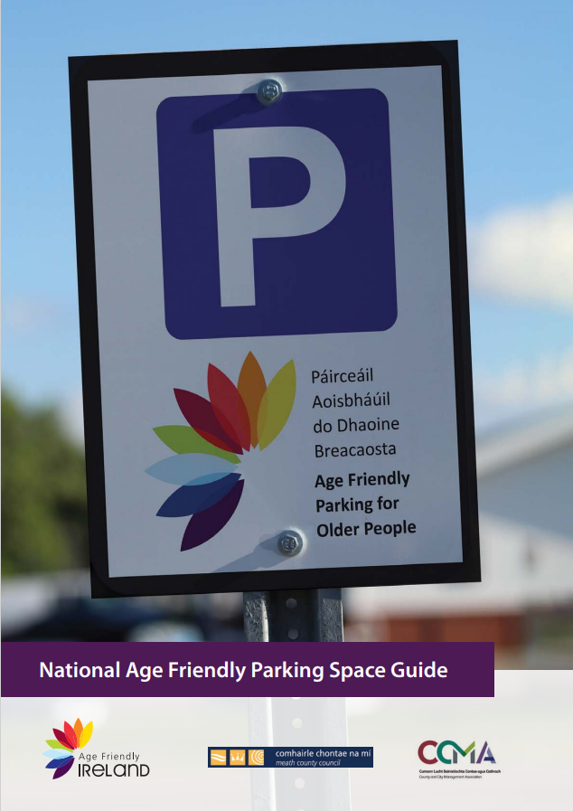
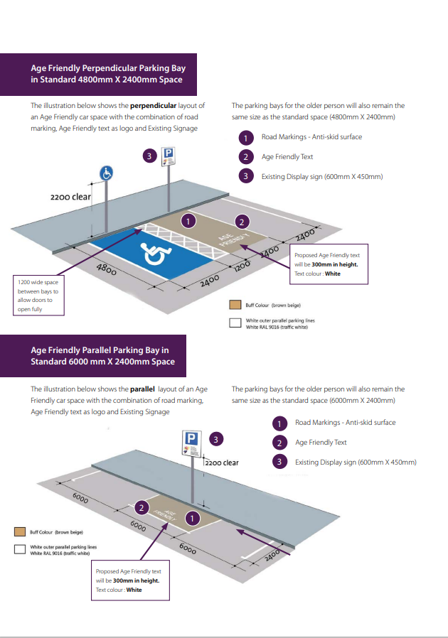
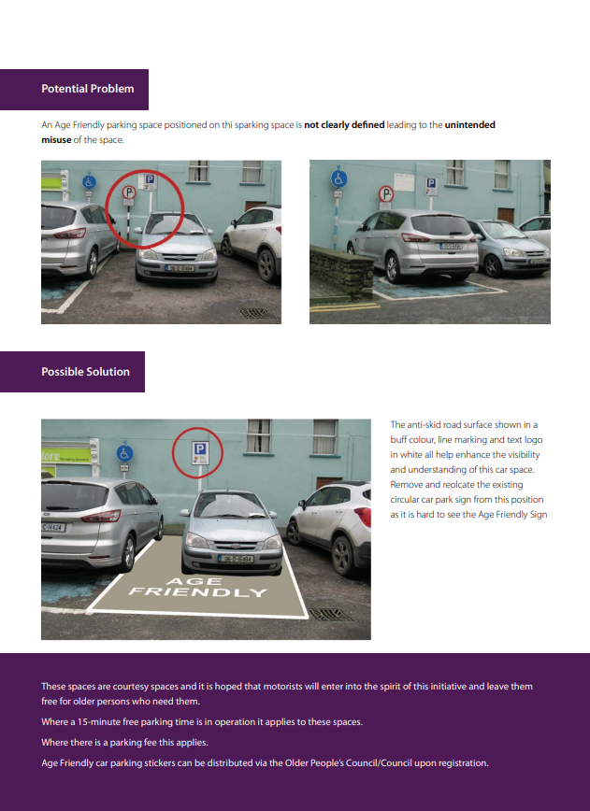

Appendix 4: Disability Access Legislation:
Disability Act 2005
26. (1) Where a service is provided by a public body, the head of the body shall—
(a) where practicable and appropriate, ensure that the provision of access to the service by persons with and persons without disabilities is integrated.

34.—A sectoral plan of the Minister for Transport (“the Minister”) shall contain information concerning—
(a) a programme of projected measures for the provision of access to persons with disabilities to passenger transport services for the general public provided by the Minister or by a public body in relation to which he or she performs functions or by a person or body licensed or regulated by the Minister,
(b) measures to be taken for the purpose of facilitating access by persons with disabilities to such services and the time within which such measures are to be taken,
(c) arrangements proposed to be put in place by the Minister and the Minister for the Environment, Heritage and Local Government to facilitate access to the vehicles providing the passenger transport services by such persons from a public road, and
(d) any other matter which the Minister considers appropriate.

Disability Access Certificate
Disability Access Certs, Building Control (Amendment) Regulations 2009

S.I. No. 351 of 2009
It is a requirement of Article 8 of these regulations that a certificate of compliance with respect to requirements under Part M of the Second Schedule of the Building Regulations (referred to as a Disability Access Certificate) shall be required in respect of all works or a building to which Part III of the Building Control Regulations 1997 applies (all buildings currently requiring a Fire Safety Certificate).
The regulations state that as and from 1 January 2010 no new building or no existing building in respect of which an extension or a material alteration has been made, shall be opened, operated or occupied unless a Disability Access Certificate (DAC) has been granted by the building control authority.
All architects/engineers and builders/developers involved in works to which these regulations apply (i.e. any works or building to which Part III of the Building Control Regulations 1997 apply, and which are intended to be opened, operated or occupied after 1 January 2010), should make themselves familiar with the requirements of these regulations.
An application for a Disability Access Certificate (DAC) shall be made to the building control authority on the prescribed form in related documents below. An application for a revised Disability Access Certificate can be found below.
The statutory fee for the making of a disability access certificate application, in accordance with Fifth Schedule to the Building Control Regulations 1997 to 2015, is €800 per building, or €500 per building where the application is made prior to commencement and coincides with an application for a fire safety certificate, where relevant.
An application for a dispensation from, or a relaxation of, any requirement of building regulations may be made under Section 4 of the Building Control Act 1990 on the prescribed form below.

Appendix 5: Section 38 Roads Act 1994
38.—(1) A road authority may, in the interest of the safety and convenience of road users, provide such traffic calming measures as they consider desirable in respect of public roads in their charge.
(2) A road authority may remove any traffic calming measures provided by them under this section.
(3) Before providing or removing traffic calming measures under this section of such class or classes as may be prescribed, a road authority shall—
(a) consult with the Commissioner;
(b) publish a notice in one or more newspapers circulating in the functional area of the authority—
(i) indicating that it is proposed to provide or remove the measures, and
(ii) stating that representations in relation to the proposal may be made in writing to the road authority before a specified date (which shall be not less than one month after the publication of the notice);
(c) consider any observations made by the Commissioner or any representations made pursuant to paragraph (b) (ii).
(4) The making of a decision to provide or remove traffic calming measures of a class prescribed under subsection (3) and the consideration of observations or representations under paragraph (c) of that subsection shall be reserved functions.
(5) Traffic calming measures shall not be provided or removed in respect of a national road without the prior consent of the National Roads Authority.
(6) The Minister may issue general guidelines to road authorities relating to traffic calming measures under this section and may amend or cancel any such guidelines and, where any such guidelines are, for the time being, in force, road authorities shall have regard to such guidelines when performing functions under this section.
(7) A traffic calming measure provided under this section shall be deemed to be a structure forming part of the public road concerned and necessary for the safety of road users.
(8) (a) A person who, without lawful authority, removes or damages or attempts to remove or damage a traffic calming measure provided under this section shall be guilty of an offence.
(b) An offence under this subsection may be prosecuted by the road authority in whose functional area the acts constituting the offence were done.
(9) In this section—
“provide” includes erect or place, maintain and (in the case of an instrument for giving signals by mechanical means) operate and cognate words shall be construed accordingly; and
“traffic calming measures” means measures which restrict or control the speed or movement of, or which prevent, restrict or control access to a public road or roads by, mechanically propelled vehicles (whether generally or of a particular class) and measures which facilitate the safe use of public roads by different classes of traffic (including pedestrians and cyclists) and includes the provision of traffic signs, road markings, bollards, posts, poles, chicanes, rumble areas, raised, lowered or modified road surfaces, ramps, speed cushions, speed tables or other similar works or devices, islands or central reservations, roundabouts, modified junctions, works to reduce or modify the width of the roadway and landscaping, planting or other similar works.

Appendix 6: Illustrations of Traffic Calming Measures and Pedestrian Improvements:
Crossings and Raised Tables
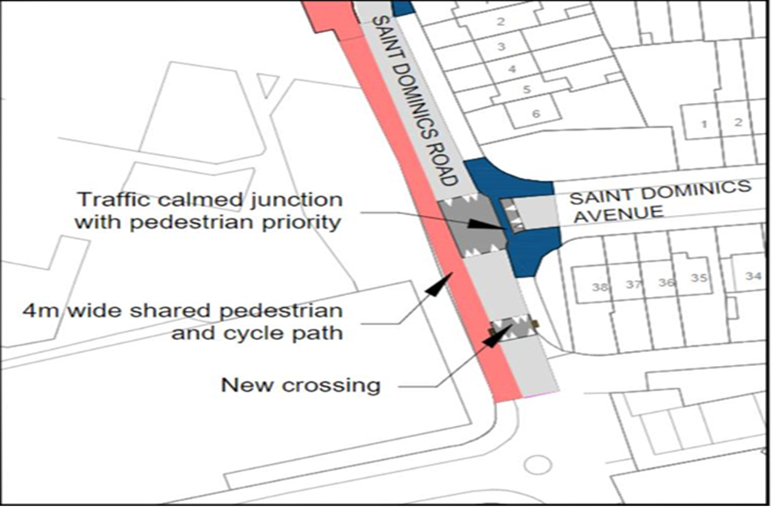

Shared Surfaces
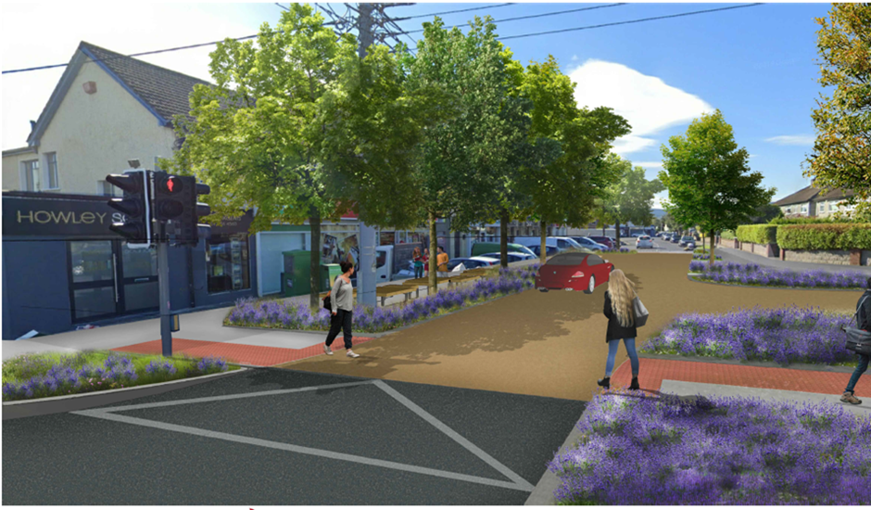

Pedestrian Crossing – Belisha Example
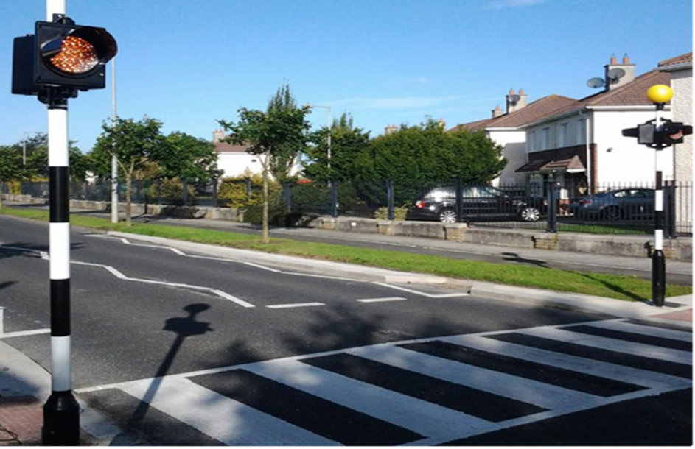

Horizontal Deflections
Build out Traffic Calming

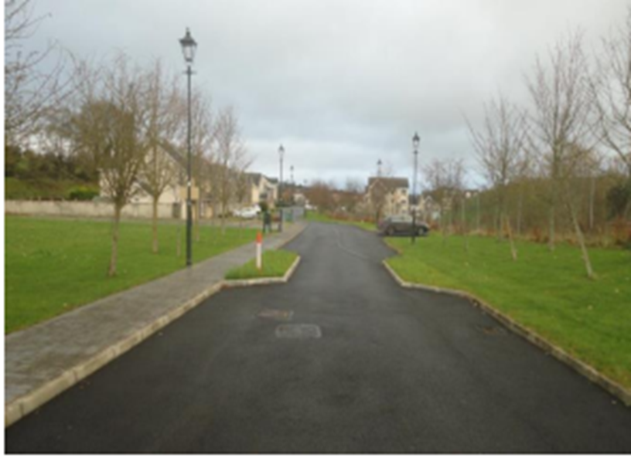

Build out - Engineering Drawing:
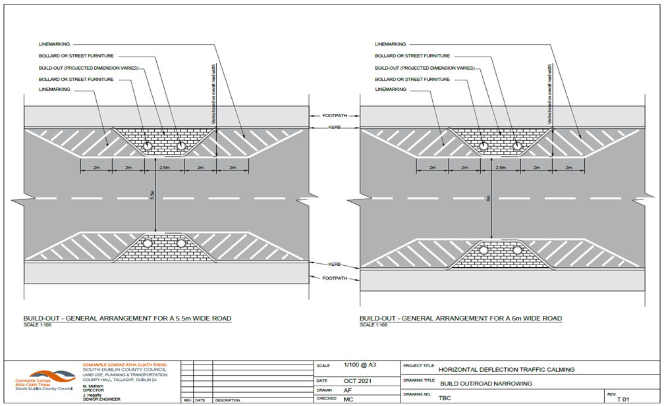
Centre Island – Adamstown
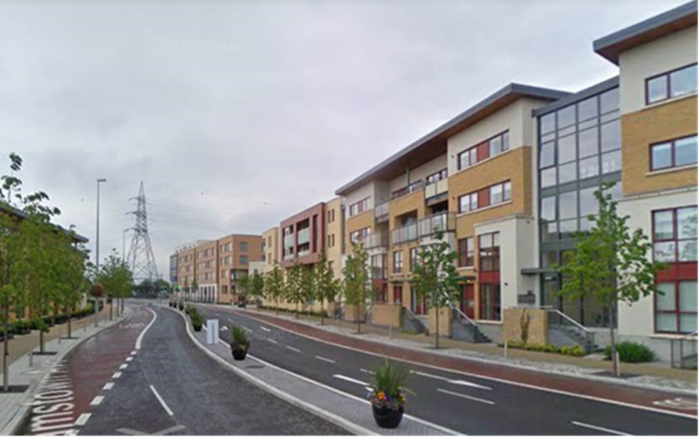

Vertical Deflections
Ramps – Example at Hunters Lane
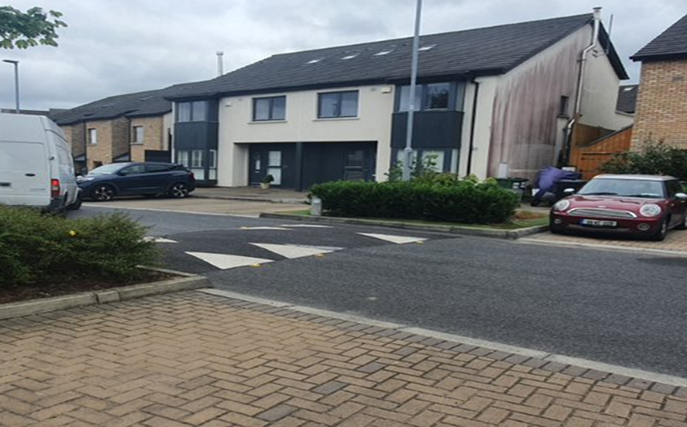
Enclosures
Tree Planting, Road Narrowing and Segregation – Proposed Example at Avonbeg
