

*draft Street Improvement management Guide*

LOCAL TRANSPORT INTERVENTIONS TO IMPROVE SAFETY FOR ALL USERS



November 25, 2021

Land Use Planning and Transportation

South Dublin County Council

**Index : Page 1**

**1.0 Introduction Page 2**

**2.0 Objectives of Street Improvement Management Guide Page 2**

**3.0 Historical Street Design through to the Current Approach Page 3**

**4.0 A New Approach to Traffic Calming Page 4**

**5.0 National and International Approaches to Traffic Calming Page 4**

**6.0 Design Manual for Urban Roads and Streets 2019 Page 6**

**7.0 Retrofit Traffic Calming Interventions Page 6**

**8.0 Vertical Deflection Interventions Page 7**

**9.0 Trial of Retrofit Traffic Calming Combinations Page 8**

**10.0 Slow Zones Page 8**

**11.0 Disability Access Page 8**

**12.0 Age Friendly Parking Page 9**

**13.0 Assessment Process for Traffic Calming Interventions Page 9**

**14.0 Consultation Process Page 11**

**15.0 Policy Recommendations Page 11**

**Appendices All Contained in other Attachment**

**Street Improvement Management Guide– Local Transport Interventions for all Road Users:**

**1.0 Introduction:**

The population of Dublin has risen by 9% in the last 10 years. CSO Figures 1.137million 2011to 1.242 million in 2021.

This means more people commuting to work, school, retail and social locations. The travel modes available are private car, public transport and active travel. The increasing vehicle traffic has led to several unwanted trends. These include congestion and longer journey times and speeding at some locations.

Recent Strategic Transport Policy such as the GDA Transport plan 2022 to 2035, the SDCC County Development Plan with our dedicated Sustainable Movement chapter are supporting the move away from the private car to more sustainable Travel alternatives. The increased active travel mode targets mean there will be more vulnerable users interacting with the vehicular traffic on our urban roads.

These trends of increasing vehicular traffic and increased vulnerable users drive the need for transport improvements that prioritise public transport, cycling and pedestrian facilities. There is a need to balance the needs of all road users and create a safe and pleasant environment for everyone.

This Street Improvement Management Guide seeks to examine best practice interventions that improve our methodology in traffic calming, improved selection of pedestrian crossing locations, improved facilities for vulnerable road users such as age friendly parking spaces and better access for the disabled.

**2.0 Objectives of the Street Improvement Management Guide**

This guidance document seeks to set out how SDCC will prioritise our expenditure to improve the local street network to better balance the needs of all road users but with an emphasis on promoting public transport and active travel initiatives in line with national policy on the reduction of Green House gases in the transport sector.

We set out the principals we will follow in the design of new transport networks and the preferred measures SDCC will adopt to make travel more sustainable, safer and cleaner in our county. Therefore, SDCC will concentrate on the design and delivery of schemes on the local street network that:

**1. Encourage walking, cycling and the use of public transport.**

**2. Improve permeability across the County**

**3. Improve safety at junctions for all road users**

**4. Introduce additional crossing points on our streets at key desire lines.**

**5. Reduce traffic speed to protect vulnerable road users through the use of traffic**

**calming works**

**4. Support universal travel access for vulnerable groups.**

**3.0 Historical Traffic Calming Guidance through to the Current Approach:**

In 1988, the Road Traffic (Bollards and Ramps) Regulations (S.I. No. 32 0f 1988) and later part amended by (S.I. 291 of 1998) were introduced. These allowed road authorities to construct ramps subject to quite stringent restrictions. Although revoked by 2012, they provide useful guidance on when and where ramps should/should not be used.

In 1994 the Roads Traffic Act was enacted. Under Section 38 of the 1994 Road Traffic Act a road authority may, in the interest of the safety and convenience of road users, provide such traffic calming measures as it is considered desirable in respect of public roads in its charge.

Public Transport Regulations Act 2009 enacted measures to enhance public bus services and included a Section 46 which provides clarity on which traffic calming measures come under the remit of section 38 of the Road Traffic Act 1994 as it states,

***‘the provision of traffic signed, road marking, bollards, posts, poles, chicanes, rumble areas, raised, lowered or modified road surfaces, ramps, speed cushions, speed tables or other similar works or devices, islands or central reservations, roundabouts, modified junctions, works to reduce or modify the width of the roadway and landscaping, planning or other similar works.’***

In mid-2003 a new manual the **‘Traffic Management Guidelines’** was jointly published by the Department of the Environment, the Department of Transport and The Dublin Transportation Office.

This is a very comprehensive manual deals with a whole range of issues including Road Safety, Consultation & Monitoring, Speed Management & Traffic Calming, Junction Design for various Road Users types (Pedestrians, Cyclists and Disabled People etc.), Public Transport and Parking.

In 2013, the Design manual for Urban Roads and Streets, (DMURS) was published. This gives guidance on how to incorporate a variety of traffic calming measures into the design of new roads and retrofitting into existing roads. Its emphasis is on horizontal control measures such as chicanes, tightening of junction radii and narrowing of the carriageway width. Also, it promotes distinction between different surface types to highlight pedestrian priority over vehicle priority. The DMURS document was further revised in 2019.

In 2014 the department issued a Circular on the control of Vehicle Speeds in Housing estates, which introduced an option to employ a 30kph speed limits category for Housing Estates and associated appropriate signage. These recommendations are incorporated into the 2015 Guidelines for Setting and Managing speed limits in Ireland, March 2015.

There is no longer the same consistency of approach by local authorities with regard to the provision of traffic calming. However, there has been a gradual movement to an over reliance on the speed ramps as a solution to all speed problems in residential estates.

**4.0 A New Approach to Traffic Calming:**

The modern approach to traffic speed control is based on an all-encompassing design of the entire built environment which psychologically sends the driver a message of the appropriate speed to drive in each environment. This design has a transport network that has vehicle, pedestrian and cycle elements with better active and public transport priority. With an increasing mix on our streets of walking, cycling and driving, along with new mobility options popping up on an almost daily basis, the traffic management approach will have to adapt. For many cities, so much focus is placed on separated facilities that are certainly the safest option for more vulnerable road users but getting separation on all streets is expensive and almost impossible.

There is however the problem of retrofitting existing neighbourhoods with these new design concepts. Studies have found that single or isolated interventions are often ineffective. A single type of traffic calming intervention on a single street will only affect driver speed locally and may indeed shift the problem to neighbouring streets. In retrofit situations, the introduction of several supporting interventions in combination has been found to work best. Traffic calming interventions should be made at neighbourhood scale and more than one measure should be combined for greater effect. For example, local pinch points could be combined with semi mature tree planting. This combined effect of a sense of enclosure and horizontal measures gives better results in traffic speed reduction.

**5.0 National and International Approaches to Traffic Calming:**

**Dutch Research:**

“The design of a Street and the larger network influences the speed at which people feel comfortable travelling along it. Traffic calming is everything planners and engineers do to reduce speed and/or volume on a given street or travel network. How the geometry, texture, friction, enclosure, street canopy and network design work together to influence how different modes use the space. Treatments like raised intersections, one-way features and added texture like cobblestone or pavers encourages travelling at slower speeds and a calmer environment that is more welcoming and safer for everyone using the space. Vehicle speed needs to be managed at a neighbourhood area level. Modifying speed behaviour cannot be approached one street at a time. For truly successful reductions of speed and/or volume, the entire network needs to be treated in a cohesive way.

**Core Principals of Traffic Design:**

* Traffic calming starts at network level.
* Work/design with the user in mind.
* Don’t design features against drivers: Use traffic psychology techniques to make them behave in the way you want them to.
* Width is everything: Wide streets enable faster travel speeds. If people find a space uncomfortable to drive in the first thing they do is slow down.
* A good street doesn’t need enforcement.
* No more than 6 minutes maximum at 30 km/hr limit to prevent driver frustration.

**(Nout Lennart, 2019)**

* The speed at which drivers travel is principally influenced by the characteristics of the street environment. If the design of a street creates the perception that it is safe to travel at higher speeds drivers will do so, even if this conflicts with the posted speed limit.
* The elimination of access and frontage along roads were often introduced to reduce risk, but it has served to encourage speeding.

**(Wicklow County Council, 2015)**

Integrated Design Approaches incorporate elements of urban design and landscaping that instinctively alter behaviour, thus reducing the necessity for more conventional measures (such as physical barriers and the road geometry) alone to manage behaviour. For example, drivers are more likely to maintain lower speeds over shorter distances than over longer ones. Therefore, block lengths kept to limits can naturally control speed.

**(DMURS 2019)**

UK Manual for Streets (2007) states that ‘most residential streets can successfully combine low to medium traffic movements with a pleasant residential setting, including on-street parking and the design of such streets from the outset should limit traffic speeds within the range of 30-50km/h, without the need to resort to the use of remedial measures such as speed ramps.’ The Manual goes on to ask whether ‘Does the design of residential streets strike the right balance between the different functions of the street’.

**(UK Manual for Streets, 2007)**

A Sustainable Transport Future - A New Transport Policy for Ireland 2009-2020 supports ‘ensuring that 30 km/h zones are designated in central urban areas which also continue to accommodate motorised traffic’.

**(Smarter Travel -2009)**

The Planning Guidelines- Manual for Local Area Plans (2013) details measures to ‘create or enhance a distinctive hierarchy of streets, spaces and landscapes within an integrated structure.’

**(The Planning Guidelines, 2013)**

Department issued a Circular on the control of Vehicle Speeds in Housing Estates. This Circular introduced an option to employ a 30 km/h speed limit category for Housing Estates and associated appropriate signage.

**(Guidelines for Setting and Managing Speed Limits in Ireland, 2015)**

**6.0 Design Manual for Urban Roads and Streets 2019:**

The Design Manual for Urban Roads and Streets adopts many of the researched Traffic Calming principles highlighted in the preceding section.

Better street design in urban areas will facilitate the implementation of policy on sustainable living by achieving a better balance between all modes of transport and road users. DMURS seeks to shift the street design principles away from just thinking about vehicle movements to a more Sustainable Approach involving all street users as illustrated in the following figure.

DMURS favours the concepts on the right-hand section of the figure below:

**CONVENTIONAL APPROACH DMURS APPROACH**

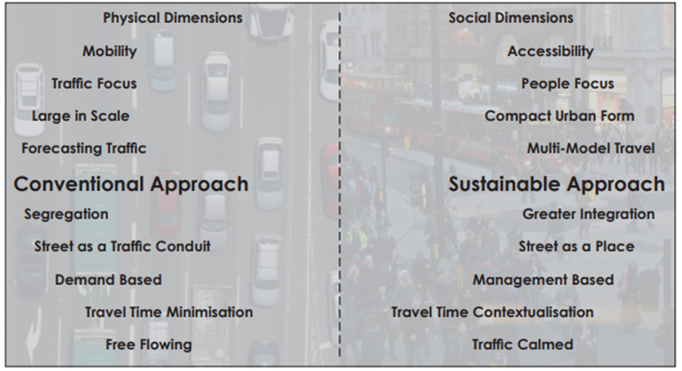

**7.0 Retrofit Traffic Calming Interventions:**

SDCC shall employ a range of measures in combination as retrofit Traffic Calming features. These can include the following which is not and exhaustive list of measures:

(See Appendix 6 Illustrations of Traffic Calming Measures and Pedestrian Improvements in the Appendix Document)

* Applying horizontal geometric measures:

(a) Build outs.

(b) Central islands or reservations.

(c) Carriageway width restrictions.

(d) Chicanes

(e) Tightening Junction Radii.

* Traffic Signal modal priority
* Change in colour with surface treatments.

1. Red or buff bound surfacing products.

* Change in texture.

1. Cobblestones and Pavers.
2. Rumble Strips.

* Introducing measures that provide enclosure such as large trees and street furniture.
* Introducing on-street parking.
* Vertical deflections such as ramps, bus cushions and raised tables.

**8.0 Vertical Deflection Interventions:**

The Traffic Management Guidelines emphasise that vertical deflections such as ramps, speed cushions and tables **should only be used as a last resort** and that all other measures should be considered first. Ramps and/or rumble strips do have unwelcome side effects such as additional noise, vehicle damage and possible personal injury. The Ambulance Service, generally, are not in favour of ramps and have concerns about the effect of ramps on people with spinal injuries travelling over ramps. The Fire Services are also concerned that ramps delay the response time of their fire tenders. Therefore, the choice and location of ramps as a traffic calming measure must be carefully considered.

Ramps shall only be used where speed limits are 50km/h. or 30km/h and on the following types of roads:

• Local Collector Roads

• Access Roads

**And they shall not be installed on:**

• National Roads

• Regional Road

• District Distributor Roads

• Homezones /Shared Surfaces

**9.0 Trial of Retrofit Traffic Calming Combinations:**

The Traffic Section recommends that a series of pilot study trials of retrofit Traffic Calming in combinations are conducted to assess the effectiveness of the various measures.

The best performing combination of measures shall be rolled out as the preferred interventions throughout the county.

**10.0 Slow Zones:**

The Slow Zone Sign, introduced in the Guidelines for Setting and Managing Speed Limits in Ireland (March 2015 Edition), is a sign to be used in housing estates where a 30 km/h speed limit is being applied. An example of its use is shown below:



**11.0 Disability Access:**

**Pedestrian Crossings:**

SDCC currently use a warrant policy dating back to 2001. (Appendix 1) There is some relaxation in standard warrant requirements for vulnerable users where:

* where there is a high percentage of shoppers with prams and young children
* where there is a high percentage of elderly or infirm persons.

The Disability Act 2005 says in 26. (1) where a service is provided by a Public body it shall ensure that where practicable and appropriate provision of access to the service by persons with disability is integrated.

The existing warrant process needs to be updated to reflect the increasing importance of access for the disabled.

I have done some research into what other Dublin LA’s are doing in this regard. They agree that no explicit guidance is available to guide them in the provision of pedestrian crossings where significant disabled users are present.

I propose to write to the DOT, the CCMA and the NTA to ask that a joint working group could be set up to develop the guidance for Pedestrian Crossings for disabled and vulnerable users.

**12.0 Age Friendly Parking:**

The Council is in the process of developing a policy on Age friendly parking. These parking spaces have a greater overall width and makes them easier to access. An example of an Age friendly parking space is shown below:

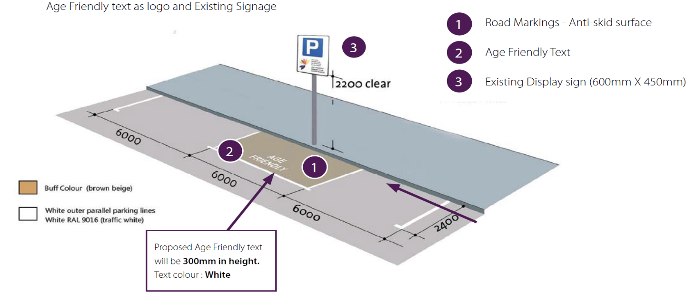

The proposed Age Friendly parking policy will decide the appropriate provision numbers in an urban setting and a consistent design footprint to be used in South Dublin.

**13.0 Assessment Process for Traffic Calming Interventions:**

Potential locations for Traffic Calming are generated by contacts from residents, elected members representations and the Traffic sections own site surveys.

SDCC propose to assess these requests for Traffic Calming in a more systematic way.

We propose a Prioritising and Scheme Selection System for traffic calming schemes on existing roads and estates which assesses the need in a quantifiable manner.

The assessment of proposed schemes shall be examined under the following headings:

• Average Speed of those exceeding the Speed Limit

• Percentage of vehicles exceeding the Speed Limit

• Available Street Width

• Accident History/Data

• Vulnerable Road Users

The assessment Table below gives a weighting to various important factors and gives a score for that particular location. Table 1 below shows a worked example of a site assessment. It incorporates more factors into the assessment like road geometry, the measured speeds of vehicles and vulnerable users.

The sites with highest scores will be prioritised first. Sites with less than the minimum score of 50 will not be considered for traffic calming.

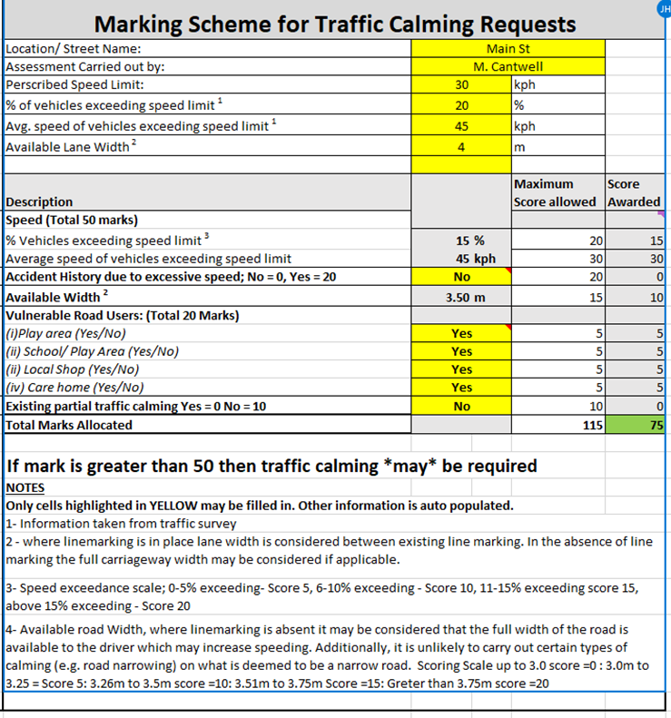

**Table 1 above is a snapshot of the Traffic Calming Assessment Marking Scheme to prioritise Traffic Calming Requests**

**14.0 Consultation Process:**

Depending on the scale of the intervention to be used, a new Street Improvement Scheme may incorporate a consultation process with the various interested stakeholders.

Works will be delivered under Section 38 of the Roads Act and so at a minimum would require a consultation process with those bodies prescribed in the Act (See section 38 in Appendix 5 of the Appendices Report.)

**15.0 Policy Recommendations:**

1. Informed by existing standards and practice across Ireland and Europe, it is proposed to adopt the following Street Management Objectives on our existing Road Network:

* Encourage walking, cycling and the use of public transport.
* Improve permeability across the County
* Improve safety at junctions for all road users
* Introduce additional crossing points on our streets at key desire lines.
* Reduce traffic speed to protect vulnerable road users through the use of
* Traffic calming works
* Support universal travel access for vulnerable groups.

1. South Dublin County Council’s Street Improvement Guide will only apply to Local Collector Roads and Access Roads with a Speed Limit of 50km/h or less that carry primarily residential, limited commercial and social traffic (schools etc) and may also have significant pedestrian and cyclist traffic. The Types of Interventions to be used to deliver the Objectives above are:

* Build Outs
* Central Reservations
* Ramps and Bus Cushions
* Reduction in vehicle road space.
* Enclosure /Tree Planting or on street parking where appropriate
* Shared Mode Road Space
* Colour or material changes to denote homezones
* Scoot Traffic Light Control to control traffic flows and speed
* Slow Zone designation in Housing estates
* Signalled Pedestrian crossings at Appropriate Locations
* Traffic Signal coordination to control Traffic Flows and Speed (SCOOT system)
* Better access for vulnerable road users such as Mobility Impaired and Age Friendly Parking Spaces

1. SDCC shall adopt Table 1 Marking Scheme for Traffic Calming Requests on existing roads and estates to assess the need and prioritise Traffic Calming schemes that SDCC shall carry out. manner. This marks each scheme in a quantifiable and consistent manner.
2. The Implementation of Traffic Calming measures will be at a network level to ensure consistent traffic speeds across the neighbourhood.
3. The Traffic Section recommends that a series of Pilot Study Trials of retrofit Traffic Calming in combinations are conducted to assess the effectiveness of the various measures. The best performing combination of measures shall be rolled out as the preferred interventions throughout the county.
4. SDCC are committed to use a wider range of appropriate traffic calming combination measures throughout the County. The possible range of traffic calming measures are illustrated in Appendix 6 of the Appendices Report.
5. In all proposed Traffic Calming schemes, a consultation process should take place with elected members (TMM), Residents and Resident Groups by, An Garda Síochána, Fire, Ambulance and Bus Services where relevant.
6. The Slow Zone Sign, introduced in the Guidelines for Setting and Managing Speed Limits in Ireland (March 2015 Edition), is a sign to be used in housing estates where a 30 km/h speed limit is being applied.
7. SDCC shall write to the Department of Transport, the CCMA and the NTA to get a workshop organised to update the warrant guidance to incorporate vulnerable users and key desire lines into the methodology for pedestrian crossing location selections.
8. SDCC is committed to developing an Age Friendly Parking Policy for the County.