COMHAIRLE CONTAE ÁTHA CLIATH THEAS

SOUTH DUBLIN COUNTY COUNCIL

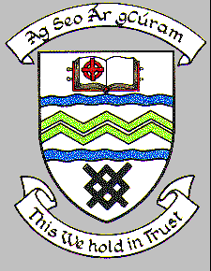

MEETING OF LUCAN PALMERSTOWN NORTH CLONDALKIN AREA COMMITTEE

TUESDAY 23rd NOVEMBER 2021

HEADED ITEM NO. 13

PROPOSED INITIATION OF PROCEDURE TO EXTINGUISH THE
PUBLIC RIGHT-OF-WAY

Laneway between nos. 46 & 48 Moorfield Avenue shown shaded red on the map below.

An application has been received from the residents of Moorfield Avenue to formally extinguish the public right-of-way in the laneway between 46 & 48 Moorfield Avenue, Clondalkin, Dublin 22.

It is proposed to affect the closure by erecting a gate to prevent anti-social behaviour. The Housing Department, Estate Management Section are willing to support the residents with funds in this regard. A petition from residents who agree has been submitted.

If the Committee agree, the procedure to extinguish the public right-of-way as above of this laneway will be initiated.
