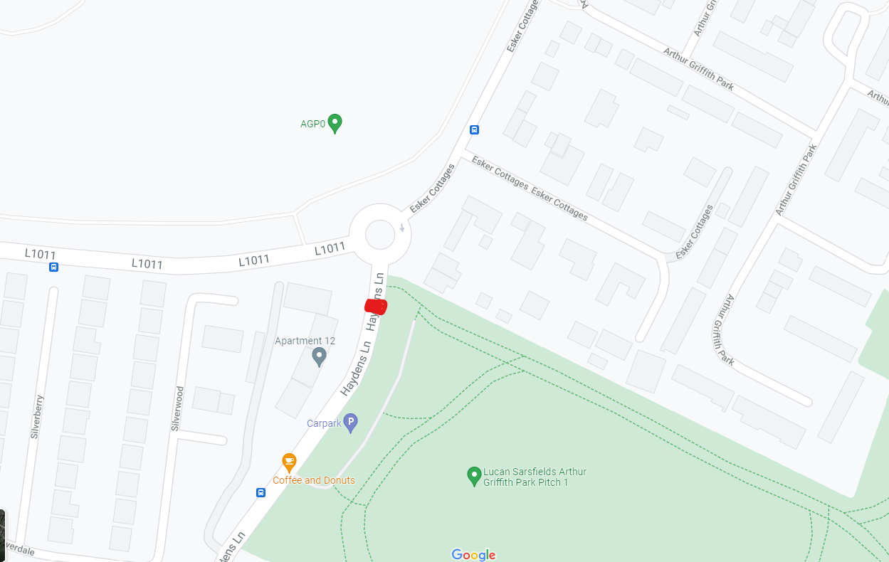
Proposed Signalised
Crossing

