**COMHAIRLE CONTAE ÁTHA CLIATH THEAS  
SOUTH DUBLIN COUNTY COUNCIL**



**MEETING OF LUCAN / PALMERSTOWN / NORTH CLONDALKIN AREA COMMITTEE**

**Tuesday, November 23, 2021**

**QUESTION NO.**

**QUESTION: Councillor P. Gogarty**

To ask the Manager for an update on progress to reduce noise and pollution on the boundary of Woodfarm Acres roads and Palmerstown village with the M50 following the raising of this matter over several years by a number of reps; and if a statement can be made on the the matter.

**REPLY:**

The following are the target values for undesirable high sound levels in the Noise Action Plan 2018-2023:

> 55 dB(A) Lnight

> 70 dB(A) Lday

The TII have a noise monitor located on the Old Lucan Road which would be indicative of noise at the roadside. The noise readings from this location are available online for the public.

The following noise readings are available for the last two and a half months

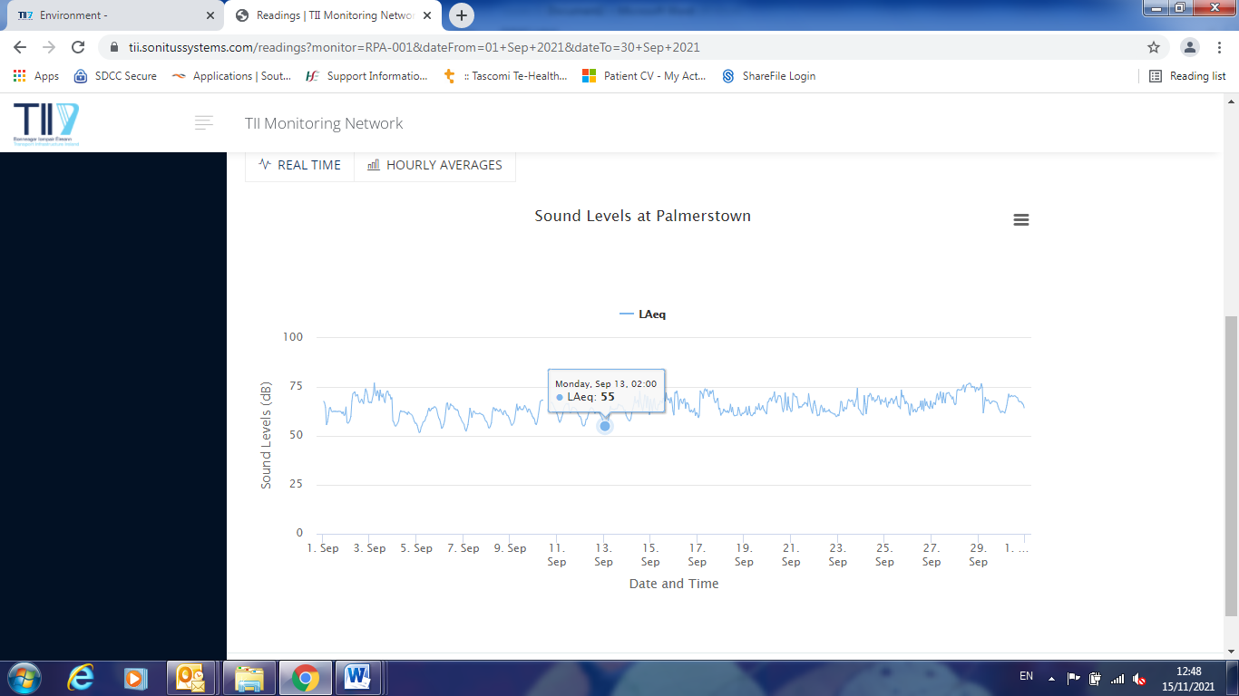

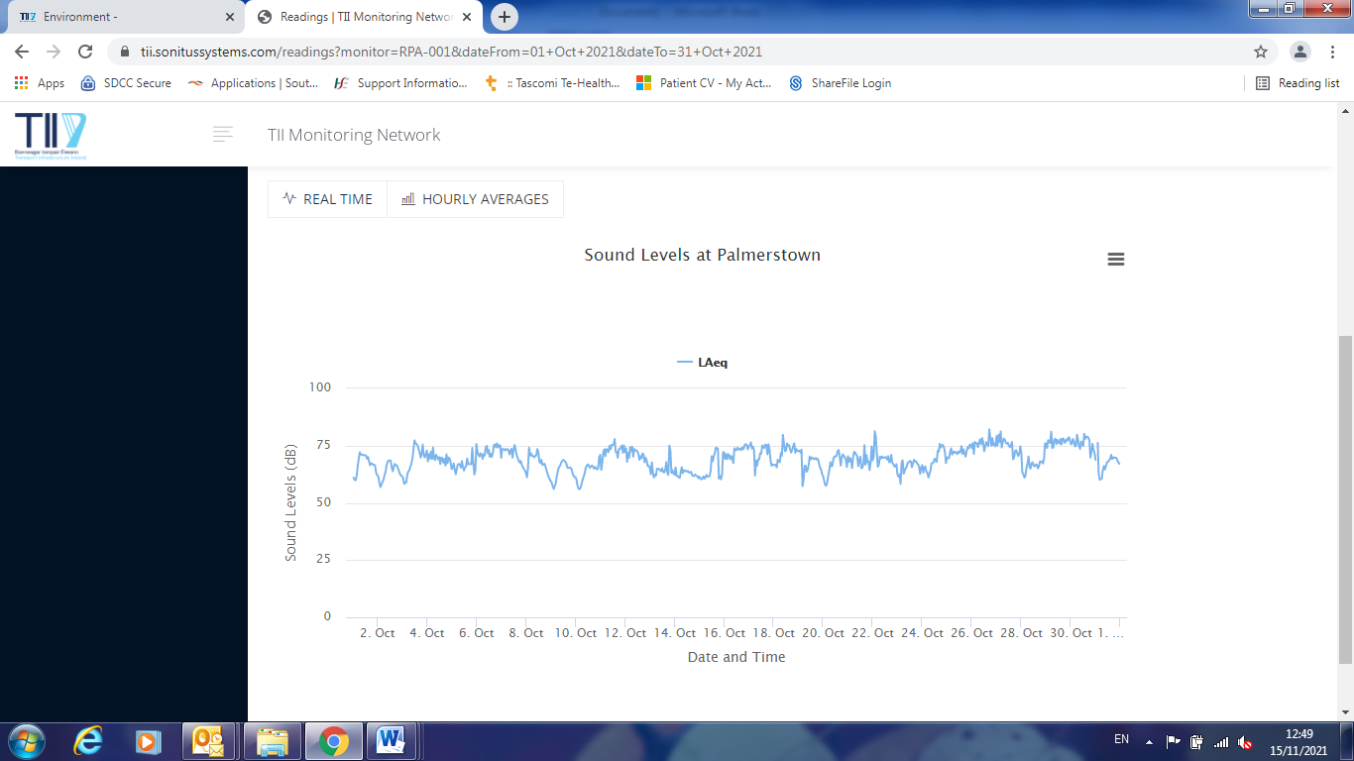

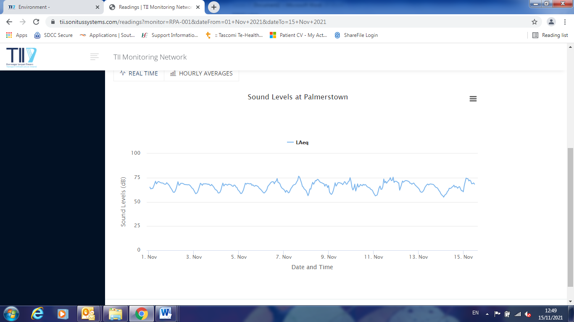

The 4th round of the European Directive on Noise Mapping is currently in its early stages.  This latest mapping exercise involves South Dublin County Council. The new round sees significant changes in the mapping exercise and major roads will be mapped in more detail.  As it currently stands, there are no specific legal noise limit values currently in place in Ireland regarding (environmental) road, rail and aircraft traffic noise. Local authorities currently only specify advisory levels. However, the WHO in 2019 lowered their threshold level of noise which they felt would negatively impact on people where the noise is consistent and on-going such as road traffic. As a result, the issue of noise pollution has been brought much more to the fore in mainstream planning for road infrastructure and location of dwellings close to major roads.  Noise is now accepted as being an invasive pollutant that can be harmful to some peoples’ health and wellbeing if occurring at such levels on a consistent basis.

Transport Infrastructure Ireland (TII) have responsibility for the erection of any noise barriers, the upgrade and maintenance of any existing barriers and all resurfacing of major roads including the M50.

The Environmental Health team have made representation to TII regarding noise levels along the N4 and M50 recently. There are noise barriers in place already along the M50 junction near Woodfarm Acres. Our latest response from the TII in October 2021 stated that they have raised the issue internally and would be in communication with us shortly. We await this response.