North Clondalkin Library: Overview of events

October & November have been very busy months in NCL.

We celebrated Children’s Book Festival (6 live school events), Red Line Book Festival (6 Live events incorporating Poetry, dance classes, Murder mystery night to a live music session with Dolcains Cellar) while continuing to offer our own regular events and twice daily class visits.

Highlights of the October:

* NOISE MUSIC INDUCTION: A collaboration between Music Generation and Contact studio. This saw 25 young music enthusiasts from across the county meet and upskill in NCL over a 4- day period -and use our newly developed Creative Studio.

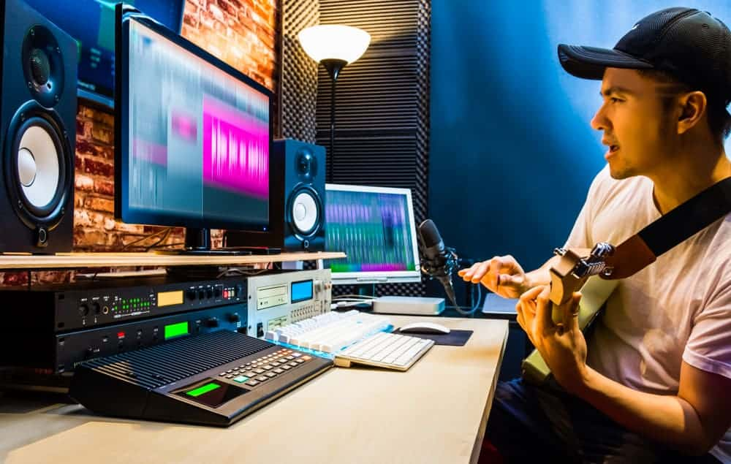

* Creative Campus Programme: This programme is a collaboration between Tallaght Community Arts, NCAD and SDPL and was initiated in October in NCL. Students from local secondary schools will begin working with graduate students from NCAD on an artistic project which will seek to promote positivity among them in the North Clondalkin area. Artistic forms will include Creative writing, photography amongst others -and will seek to use facilities available in the library-including 3D printer/Creative Studio etc. This programme will also run during the early part of 2022.

November is also a busy month in NCL.

* Science week – Saw 9 STEAM events taking place in NCL, mostly school events and all were well attended.
* **The Branch-wide parenting Programme**: saw 4 live events organized for NCL and one online event. Bookings have been very successful and in many instances, demand has outpaced availability.
* National Accessibility Week takes place the last week in November. We have lots of events taking place. This week will see the launch of our newly developed sensory garden on Tuesday 30th November. (DAF Funding) The ASD unit from St. Mary’s National school will attend the launch – and assist with some planting.

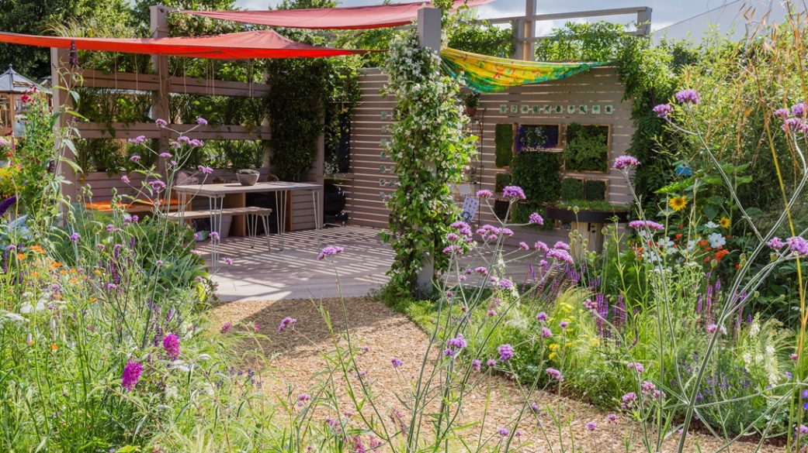

* The sensory garden ties in with our over-all plan to make NCL **an autism friendly library.** At present we host Sensory Saturday mornings, lamh story time sessions and have a programme of talks and workshops planned for December and early January. We have engaged with AsIAm and are seeking to get NCL autism accreditation -which will begin with staff training in December.

Lucan Highlights: November

1. Feel the Forces! science workshops for children with Autistic Spectrum Disorder. These workshops were held on Saturday 13th November for children with ASD and their carers/families. This was a very popular event. We had one at 10.30am and another at 11.30am. Each group had 10 children. They carried out fun experiments. There was lots of hands- on mixing of different colours and fizz bombs that delighted children and parents. All the other science events for children are fully booked. The Nutty scientist, The Really rubbish litter show, The Astronauts dinner and Discover Space generated great interest in the schools. Altogether we are hosting 16 classes in November for the Science events. One of the highlights was the python and chameleon in Daves live jungle. We had 2 very excited Primary classes here that morning and afterwards some curious adult patrons passing through the library got to hold Seamus the python and pet Phyllis the giant iguana. Science month in Lucan Library has been a memorable one.
2. Our Accessibility week at Lucan Library will be very special this year. We are setting up a consultation desk and making appointments available to people who want help with digital resources. Two staff will be available for one to on instruction on how to download the many resources we have to offer online. The idea is to release staff to spend time with people who need extra help and time especially older people. We also have The Magic table and projector on 1st and 2nd December and will invite adults with Intellectual disabilities from local services in their small groups or pods to enjoy this visual and auditory experience. They can sweep up leaves and collect fruit and pop it all into a virtual basket. That is just one of around 30 programmes available to use on the table. It is a real sensory treat.
3. The Becket for Beginners series  is now into its third week of a six week series on zoom. We are getting so much positive feedback on the quality of the course with the 35 participants who are reading Waiting for Godot and Happy Days. We had an email last week from one participant thanking us for making one of the more "difficult" writers so accessible . We are lucky to have an experienced facilitator who excels in adult education.