## COMHAIRLE CONTAE ATHA CLIATH THEAS

## SOUTH DUBLIN COUNTY COUNCIL

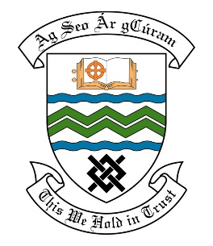

### MEETING OF THE LUCAN/ PALMERSTOWN/ NORTH CLONDALKIN AREA COMMITTEE MEETING

## 23rd November 2021

## HEADED ITEM NO. 12

**Deputations meeting – 21st October, 2021.**

**Hillcrest Residents Association**

**Deputation** **attendees** – Marie Murphy, Rita O’Brien & Bernie Raleigh.

**Elected Members** – Cllr. Joanna Tuffy, Cllr. Vicki Casserly, Cllr. William Joseph Carey, Cllr. Madeline Johansson, Cllr. Paul Gogarty & Cllr. Liona O’Toole.

**Council Officials** – Ankit Gour, Brian Carroll, Margaret Farrell, David Fennell, Olive Harrington, Tony O’Grady, Fionnuala Keane & John Hegarty.

Cllr. Joanna Tuffy presided.

**Items discussed**:

1. Installation of Pedestrian Crossing on Hillcrest Walk, adjacent to Tesco entrance/exit.
2. Speed limit signs at all entrances to estate, and Stop/Yield signs at all junctions within the estate.
3. Strategic placement of dog waste disposal bins through estate.
4. Removal of Tree Stumps from all grass verges.
5. Levelling of dangerously uneven footpaths throughout entire estate.
6. Commitments given at Deputation meeting.

**Commitments given**:

1. Will look at the provision of a bin near the Tesco Area. – David Fennell.
2. Will look at providing signage regarding dog fouling at Hillcrest Park. – David Fennell.
3. Start tree stump removal in November. – Olive Harrington.
4. Will carry out a survey to establish if a pedestrian crossing is needed. – John Hegarty.
5. Will look at the other entrance to the estate with the view of providing slow zone signs. – John Hegarty.
6. Will meet with group on site to review sites for Yield Signs. – John Hegarty.
7. Will include monies on the 2022 program. Area Engineer contact details will be sent to group for site meeting. – Tony O’Grady.
8. Will pass on details of location given to Irish Water. – Tony O’Grady.