## COMHAIRLE CONTAE ATHA CLIATH THEAS

## SOUTH DUBLIN COUNTY COUNCIL

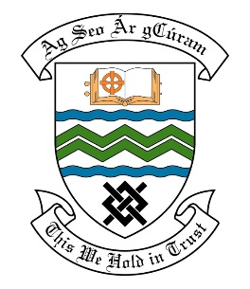

### MEETING OF THE RATHFARNHAM/TEMPLEOGUE/FIRHOUSE/BOHERNABREENA AREA COMMITTEE MEETING

## 9th November, 2021

## HEADED ITEM NO. 8

**Deputations meeting – 21st October @ 4pm.**

**Cherryfield Residents Association**

**Deputation** **attendees** – Clare Carberry, Audrey Bradley & Mary Lee.

**Elected Members** – Cllr. Pamela Kearns, Cllr. Alan Edge, Cllr. Yvonne Collins, Cllr. David McManus, Cllr. Carly Bailey & Cllr William Joseph Carey.

**Council Officials** – Ankit Gour, Brian Carroll, Margaret Farrell, Fionnuala Keane, Brendan Redmond, Leo Magee, Tony O’Grady, Eamon Harnett & Máire Ní Dhomhnaill.

Cllr. Alan Edge presided.

**Items discussed**:

1. Tree Planting.
2. Designated Biodiversity/Wildflower Area in Beechfield Park.
3. Footpath and road surface repairs.
4. Pavilion Building - Maintenance.
5. Cleaning of Laneways.
6. Commitments given.

**Commitments given**:

1. Will meet with group to identify planting areas before the end of November & develop a 5-year plan. - Máire Ní Dhomhnaill.
2. Will provide wildflower area maintenance or wildflower areas like the others in the county. Will put this on the program for 2022.
3. Will speak to the Area Engineer regarding grass verges covered in tarmac. Area Engineers contact details will be sent to the group to arrange a site meeting. Will include on 2022 works program. – Tony O’Grady.
4. Looking at replacing gutters early in the new year. - Eamon Harnett.
5. Will implement laneway cleaning program next year. Will inform the Councillors and Residents. – Leo Magee.