October Highlights:
Red Line Book Festival
Red Line Book Festival 2021 – The Roaring Twenties – the years after the Spanish flu.
This year was the 10th Anniversary of the Red Line Book Festival, the theme of this year’s festival was the roaring twenties. Reading groups across the county took part in the run up to festival by reading books penned or set in that period and this culminated in a discussion which took place in the Civic Theatre with broadcaster Rick O’Shea, Emily Hourican and Selina Guinness, the discussion was live streamed to book clubs across the county.
In total 69 in person and 15 online events took place across South Dublin County, venues included the Civic Theatre, Rua Red, Casement Aerodrome and all of the South Dublin Library network.
Highlights included:
Pure Magic - author Colin Tóibin in conversation with Kevin Power. (Civic Theatre) It was a great coup for the festival to secure one of Ireland’s top authors Colin Tóbin who generously agreed to take part in 2 events in the Civic Theatre.
Howdie Skelp – One of the worlds most renowned poets Paul Muldoon, based in Princeton University, closed the festival with an online reading from his new works projected onto the stage in the Civic theatre.
Between Two Hells, The Irish Civil War – author Diarmuid Ferriter in conversation with Richard Crowley. (Casement Aerodrome) A very interesting discussion on the research that Diarmuid completed for his latest book. This event was booked out and it was the festivals first visit to casement.
Professor Luke O’Neill in conversation with Dr Shubhangi Karmaker – Update on vaccines and therapies for COVID-19 (Civic Theatre). Luke O’Neill became a household name during the ongoing pandemic and this event featured a Q and A which allowed the audience to ask questions of the man himself.
Mind full – author and broadcaster Dermot Whelan in conversation with Fiona Brennan. Gatsby Night –a night of jazz with Cotton Club Quartet and singer Truly Divine. The audience were encouraged to dress for the occasion and many

Hellfire and Yonder: Oral History and Folklore Course with Michael Fortune
This online workshop series is being delivered by renowned folklorist Michael Fortune. Michael has helped people of all ages all over the country to record the past and tell their stories.
Oral history allows us to record the stories of the past in the words of those that lived it. Oral history can also be the medium through which stories pass down through generations. Michael will teach participants how to collect and record oral history and folklore over the course of these six workshops which are ongoing.
Supported by the Creative Ireland Programme South Dublin
Halloween and Mid-term events 26th – 30th October
Ballyroan Library had a great programme of in-branch events for Halloween including Slightly Spooky Storytime, Scary Science with STEM Studio, Baby Boo Music Workshops, Creepy Coderdojo and family Magic Show and Puppet Show. We also had a Haunted House event ongoing throughout the week, with over 300 children attending events.
Decade of Centenaries October events:
Thursday 7th October at 7:00pm
Seán Keating: Art, Politics and Building the Irish Nation
A talk with art historian Eimear O'Connor exploring the life and works of Rathfarnham-based artist Seán Keating during the period 1915-24, including his iconic depictions of the revolutionary period. 65 people attended this online talk.

Thursday 14th October at 7:00pm
Sisters of the Revolutionaries: The Story of Margaret and Mary Brigid Pearse with Teresa and Mary Louise O'Donnell
An evening of history and music about the lives of the Pearse sisters and their formidable contribution to Irish educational, political and cultural life in the years following the execution of their brothers. We had a small audience for this in person in the library, with 45 people also tuning in to the live stream on Zoom.

Schools Webinars with Historian in Residence
On Thursday 21st October, our Historian in Residence, Liz Gillis, spoke at a webinar for primary schools on the subject of ‘“We are Black and Tans”: Children and the Irish Revolution’. Over 1200 children from primary schools across the county attended this webinar.

Liz Gillis will also host a webinar for secondary schools on 4th November on ‘Researching the Irish Revolution’ which will offer tips on choosing and researching Leaving Cert History Topics.
November Highlights:
Health Literacy Series
A Six-week Health and Wellbeing Course for older people and for those with caring responsibilities for older people, which will take place each Monday in November.
The programme aims to facilitate older people to explore health and wellbeing topics and to increase awareness, knowledge, understanding and skills to support healthy choices.
The objectives are to:
- provide a structured opportunity for participants to share their experience, knowledge, understanding and skill in managing their health and wellbeing;
- raise awareness of inter-related areas of health and wellbeing (physical, emotional, mental, social, societal, spiritual);
- provide information about specific health topics and introduce participants to relevant resources, groups and supports;
- increase confidence and skill in managing personal health and wellbeing and in communicating with health service providers.

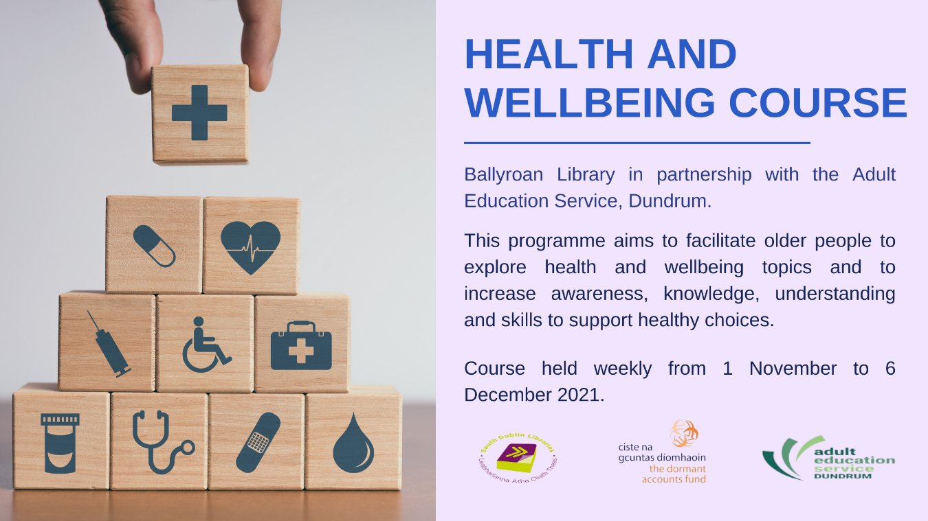

Tai Chi in the Library
The Chinese practice of Tai Chi is a gentle form of exercise that can help maintain strength, flexibility and balance for people of all ages and abilities. Join Tai Chi master Ross Cousens for some “meditation in motion” in a 5 week introductory course in the Library. Every Thursday in November.

Parenting Talks
All as part of the South Dublin Libraries Parenting Programme, supported by the Dormant Accounts Fund

Thursday 18th November at 7:00pm Trevor Higgins of Cloudsaway.ie
Local parenting coach Trevor Higgins will give tips and host an open Q and A with parents on how to best support their children.

Friday 19th November (3 shows) Anna Newell show entitled My Smile has fallen down
Production aimed at 5-7 year old children about processing their feelings.

Tuesday 30th November at 7:00pm Parenting When Separated
Don Boardman of the South Dublin Partnership will speak on the topic of parenting when separated

Wednesday 24th November at 7:00pm
Clinical Psychologist and broadcaster David Coleman will give a parenting talk as part of the programme. Title TBC.

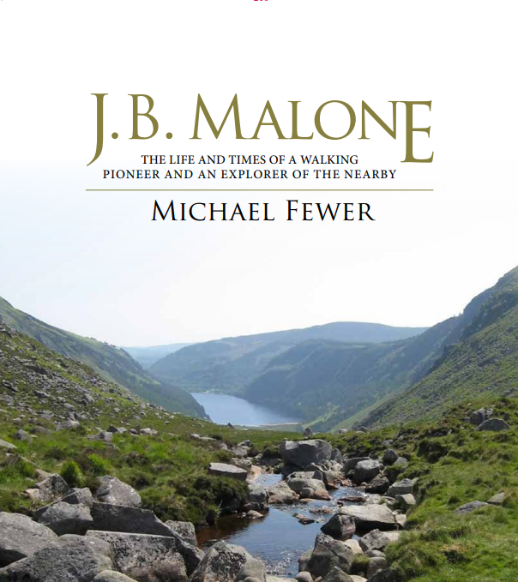

Book Launch: JB Malone: the life and times of a walking pioneer and explorer of the nearby
This new book by local author Michael Fewer will be launched by Mayor Peter Kavanagh on Wednesday 17th November at 7:00pm. The book details the life and career of JB Malone who was a pioneer of way-marked trails and the most influential force in the development of hill-walking as a leisure activity in Ireland, particularly in the Dublin and Wicklow Mountains.

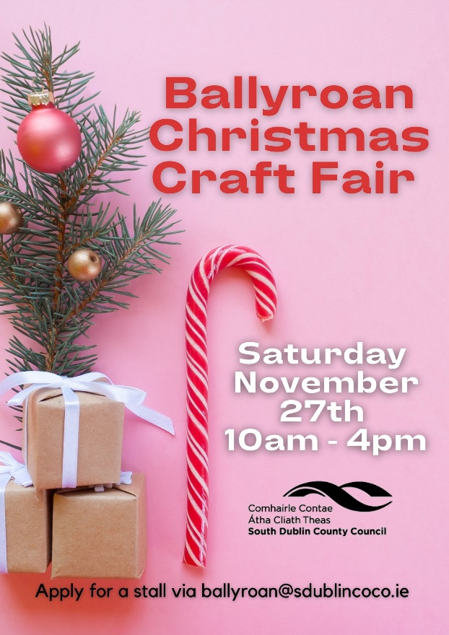
Christmas Craft Fair

We are delighted to announce that the Christmas Craft Fair will make a return to Ballyroan in 2021! On Saturday 27th November, you can expect a fun and festive day with live music outdoors, children’s entertainment, a visit from Santa himself, as well as lots of stalls from local craftspeople and food producers. Stalls are still available, please contact the library for further information.

Decade of Centenaries

Thursday 11th November at 7:00pm
Margaret Pearse and Revolutionary Women – a talk with Historian in Residence Liz Gillis (online event)

Regular events

Some of our regular programming will resume as in-person events in the library.

Thursday 4th November at 3:30pm
Junior Book Club

Saturdays at 10:00am
Children’s Chess Club

Fridays at 10:00am beginning 12th November
Parent and Toddler Group

Wednesdays 10th and 24th November at 6:00pm
Coderdojo coding club for children and teens

Monday 15th November
Philosophy Club for Children

Tuesdays at 6:00pm
Beginners Irish Class for Adults

