**Traffic Survey Report on Kennelsfort Road:**

**Survey Date: 22 June 2021:**

The following Motion was tabled at the Lucan/Palmerstown/North Clondalkin Area Committee Meeting on the 27 of April 2021:

**Mot (20) SubmittedBy:Councillor G. O'Connell Item ID: 70031**

**Date Submitted:13/04/2021 Owners:John Hegarty**

**“That the Chief Executive provide an update on progress in delivering on the proposed 3.5T restriction for the cell between the Oval and Kennelsfort Road as set out in the Manager's report below, and to indicate in the answer why it has taken so long to have the decision implemented.”**

The Traffic Department agreed to carry out a Traffic Survey as soon as practiclable to ascertain the number of HGV’s movements on Kennelsfort Road and to decide if any traffic interventions are required at this location. This report describes the survey that was carried out and analysis of the results of that survey and comes to a conclusion in respect of HGV movements this location.

**Kennelsfort Road Traffic Counts:**

An All Traffic Count survey was carried out for 24 hours on 22 of June 2021. The survey was carried out at the Bus Terminus on the Kennelsfort Road Upper as shown on the map below:

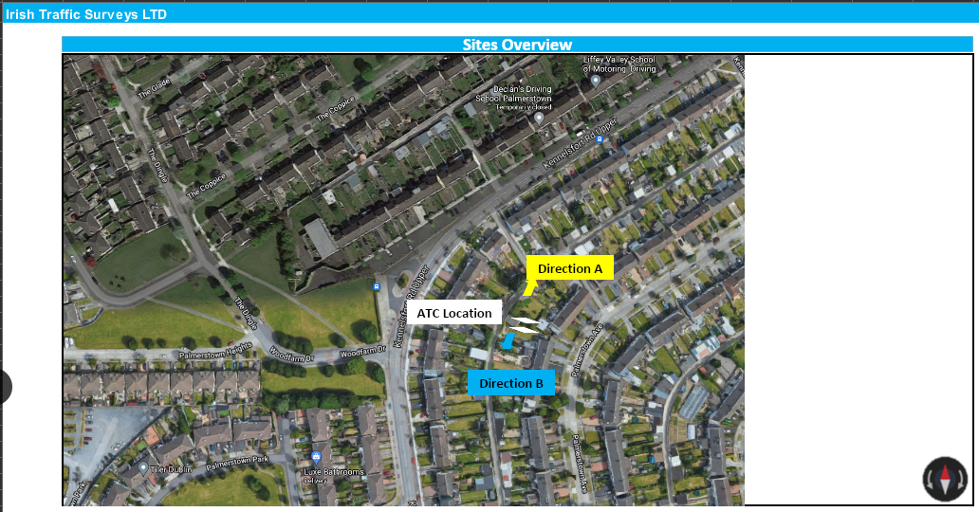

The following Table shows the total number vehicle movements surveyed at the Bus Terminus on Kennelsfort Road Upper:

The table of the Vehicle movements is set out below:

**Total Vehicles by Class:**

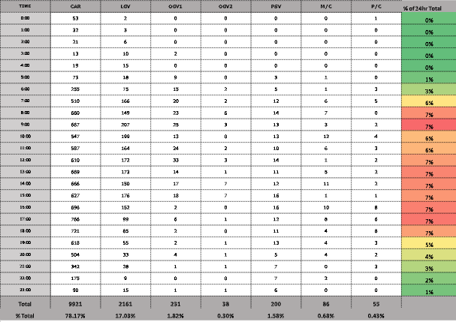

**Key showing the Categories and Vehicle Types:**

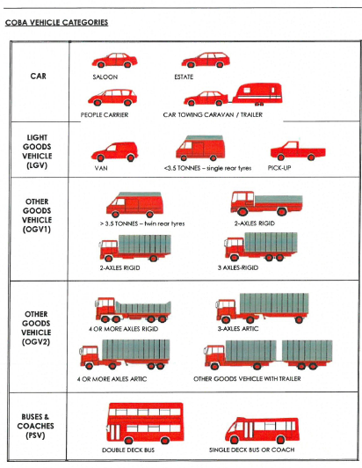

The table above shows that the percentage of OGV1 greater than 3.5 tonne and rigids up to 3 axles is 1.82%. and the percentage of OGV2 which is large HGV’s with 4 or more axles is 0.3%.

**Therefore, the total percentage of HGV’movements on Kennelsfort Road Upper is currently 2.12 %.**

A comparison with other roads in the county shows:

Greenhills Rd at the Airton Road Junction is 6.3% HGV’s.

Tower Rd, Clondalkin is 3.47% HGV’s.

Therefore, the HGV figure for Kennnelsfort Road is very low in comparison with other examples in the county.

A graphical representation of the HGV traffic in comparison to other traffic is demonstrated in the graph below:

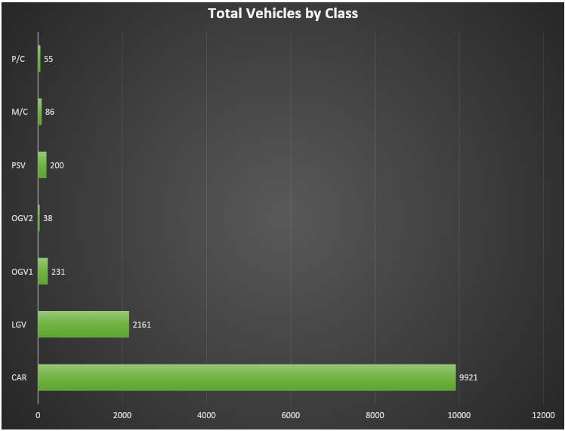

**Conclusion:** There are relatively low numbers of HGV movements on the Kennelsfort Road in comparison with other vehicle movements. The current percentage of HGV’s has been surveyed at 2.12%. The results of this survey are similar to a separate survey carried out in May 2016 and the report given to the members on Tuesday January 24, 2017 which was in response to a motion 14 Item ID: 52283. This report showed a total of 1.6% of the vehicles on Kennelsfort Road upper were Heavy Goods Vehicles. This demonstrates there has been little growth in HGV numbers over the last 5-year period.

**Further Survey Work to be carried out:**

The survey above was carried out when traffic numbers were returning to normal after the covid crisis. The traffic section is organising further surveys in September when the schools are open again and traffic numbers should have further normalised. More comprehensive surveys over several days will be carried out now as it is believed these will reflect the worst-case scenario at this location. The traffic section will revert with these figures when they are available.