Report on NCL: October/November Highlights:

OCTOBER EVENTS:

Children’s Book Festival:

Children’s Book festival saw 3 authors visiting NCL and engaging with classes from Local primary schools. Alan Nolan discussed his book furry friends; Tom Palmer engaged with over 90 children on his historical fiction books, while award winning Irish author Patricia Forde read from her latest book. In total 230 children had the opportunity to meet with an author during the festival.

](javascript:void(0))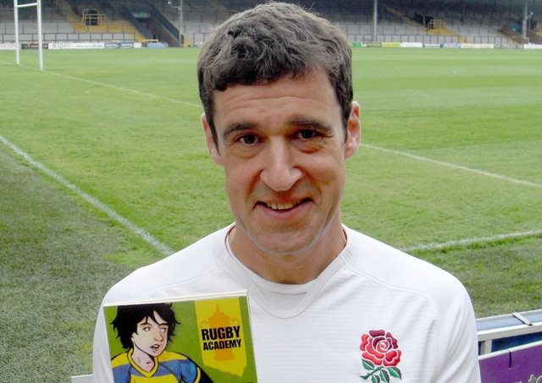

Red Line Book Festival:

In total, 6 events were hosted in NCL for Red Line Book Festival. Events ranged from nature poetry for adults and juniors, to an Open mic session with Dolcains Cellar, a live 1920s dance workshops along with a Great Gatsby murder mystery night. The Armagh Rhymers entertained 2 school groups with a bilingual session focussing on the Mummers tradition.

](https://www.bing.com/images/search?q=The%20Great%20Gatsby&view=detailv2&FORM=IQFRBA&id=639C06DE9685F2E5D139FE832D7096E8CFA0CE41&&expw=600&exph=600&mediaurl=https%3a%2f%2fth.bing.com%2fth%2fid%2fR.b644401270e7feb626ca87def7aa2cf2%3frik%3dQc6gz%252biWcC2D%252fg%26riu%3dhttp%253a%252f%252fwww.theatrealberta.com%252fwp-content%252fuploads%252f2018%252f11%252f2.gatsby.showcard.jpg%26ehk%3dleFckshF7uxU2nxepwxNny6oFEaYMwzLewKSSiFaC%252bM%253d%26risl%3d%26pid%3dImgRaw%26r%3d0&ccid=tkRAEnDn&ck=32BF19090A1FB0FA380A520F88A4B898&thid=OIP.tkRAEnDn_rYmyofe96os8gHaHa)[A picture containing microphone
](https://www.bing.com/images/search?q=Open%20Mic&view=detailv2&FORM=IQFRBA&id=0527F72906C4003FAACDB8D51C157A5CFB3FB610&&expw=1600&exph=1067&mediaurl=https%3a%2f%2ffortstjohn.com%2fwp-content%2fuploads%2f2015%2f02%2fopen-mic.jpg&cdnurl=https%3a%2f%2fth.bing.com%2fth%2fid%2fR.fe8e422fc7644b6a3a41b693e8d6d429%3frik%3dELY%252f%252b1x6FRzVuA%26pid%3dImgRaw%26r%3d0&ccid=%2fo5CL8dk&ck=2501DB96DF7F158080B007E9AA686934&thid=OIP._o5CL8dkS2o6QbaT6NbUKQHaE8)

](javascript:void(0))

Special events organised for October:

STEAM Saturdays: For children aged 8-12 years (2 Saturdays a month)

[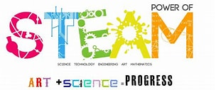](https://www.bing.com/images/search?q=steam+events+images&id=63AEEBA5D896010475C3C0AE500EB400FA54A7E9&FORM=IQFRBA)

Lamh at the library: Saturday 30th October Storytelling with Lamh sign language is taking place from 10.00am to 12.00pm all our welcome.

Lamh is for young children with developmental disabilities, Autism or a language delay who use Lamh, pictures or other communication systems.

[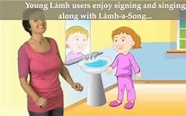](https://www.bing.com/images/search?q=lamh+images&id=9D92324EAF07BEEE8D936CBDA8F9109E2CB55A4A&FORM=IQFRBA)

NOVEMBER EVENTS:

Parenting Programme:

During the month of November, NCL will host 4 events as part of our County-wide Parenting programming:

Events will include

* Lamh Training session : A course for those interested in learning Lamh. It is suitable for complete beginners or people who use signs but never received formal training. Maximum participants 12. (Nov 18th & 25th)
* First Aid for Parents
* BullyProof Kids with Stella O’ Malley - A talk designed to give your children survival techniques.
* My Smile has fallen down – An interactive play for parents and children to help them cope with feelings of sadness.

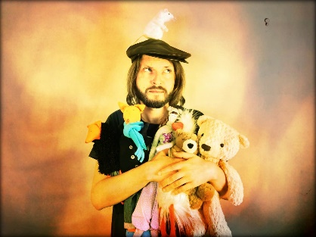

Season of Science November 2021

North Clondalkin Library

**Dave’s Jungle Reptile Show**

Wednesday 3rd Nov (NCL) 10.00am & 11.15am

Suit 1st-4th class. 1 Class per session. 45 mins – 1 hour

Join Dave and his reptiles.

Dave explains how the animals hunt, how they perceive the world, how they use their senses, eat and catch their prey. The students then have the unique experience of handling and touching a crocodile, tarantulas, scorpions, snakes and large lizards.

Contact: 0868596213 [davesjungle1@hotmail.com](mailto:davesjungle1@hotmail.com)

**Minecraft Coding Class with Ripcoder**

Wed 10th Nov (NCL)

Suit 4th – 6th Class. 1 class (c 25 kids) per session. 2 hours

Minecraft is a wonderful environment for learning code. Children who already love building in Minecraft, love the power that coding gives them. But also, Minecraft makes coding seem easy. When children write and run code in Minecraft the results are both immediate and very visual. This makes understanding abstract concepts seem concrete. Please not this is a coding class, not a Minecraft playing class.

Contact: Spain Hughes Ripcoder spainhughes@gmail.com

**Make an Astronaut’s Dinner with Anyone4Science**

Thur 18th (NCL 10 & 11.30

Suit 3rd – 6th class. 1 class per session. 1 hour

In this workshop the children learn about the space programme, the history of the international space station and about life on it. Food suitable for taking to space was very different to that eaten by most families at the time of the first space missions. The children all make a dinner suitable for astronauts including soup, fish, veg and potatoes and a tasty dessert.

Contact: Christine Campbell christine@anyone4science.com 087-6749608

**Discover Space with the Rediscovery Centre**

Thur 25th Nov (NCL)

Suit 3rd – 6th class. 1 class per session. 1.5 hours.

This fantastic workshop covers the topic of space, investigating the Universe, origins of the solar system, the planets and moons of our solar system and looking at space exploration. The workshop features a range of hands-on activities around the space theme, including investigating meteor impacts, exploring stored energy and making rockets.

Contact: Joanna [academy@rediscoverycentre.ie](mailto:academy@rediscoverycentre.ie) 01 8933801

**Lego Workshops with Bricks4Kidz**

Tue 23rd November (NCL) 10.00am & 11.15am

Suit 3rd – 6th Class. 1 class per session

A Bricks 4 Kidz Workshop takes learning out of the pages of the textbook and into an imaginative, 3-dimensional, hands-on learning experience! Use the LEGO® bricks your students already know and love to get them excited about learning. A Bricks 4 Kidz School Workshop is a fun-filled, engaging experience that kids will be talking about long after the fun and learning has en

**Report on Lucan: October/November Highlights:**

**OCTOBER EVENTS:**

**Children’s Book Festival:**

Lucan Library were delighted to host 5 events during October for Children Book Festival, some online.

Alan Nolan, author and illustrator, always entertaining, delivered a session online to a school;

Carol Ann Treacy gave a workshop via Google Hangouts;

Patricia Forde, author visit at the library for 2 separate class events;

and Young Adult writer Sue Divin spoke to students at a secondary school.

We also provided an online Clayotic workshop using Ireland’s only fastest drying clay. The theme was Dr Seuss’ The Cat in the Hat

](javascript:void(0))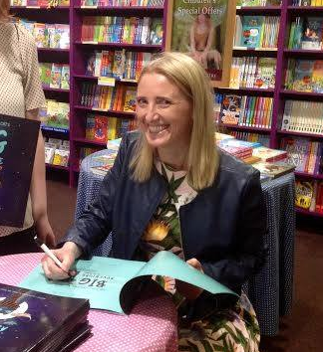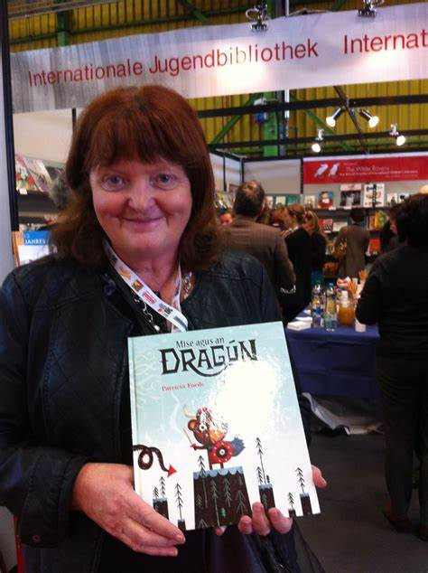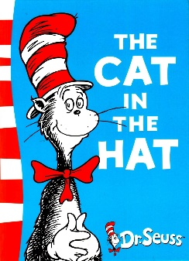

**Red Line Book Festival:**

Lucan Library hosted 3 events for Red Line Book Festival. These included one online event, one school event and one family event in-person at the library.

Michael Moylan of Irish History Live brought his dynamic history show to a local school.

A talk on Samuel Beckett drew a lot of attention, with scholar Terence Killeen giving an interesting account of his life and works.

Finally we had the Funbelieve Science Show for families. Due to space restrictions in light of Covid we could only host a small number of families but they all enjoyed this lively, educational event.

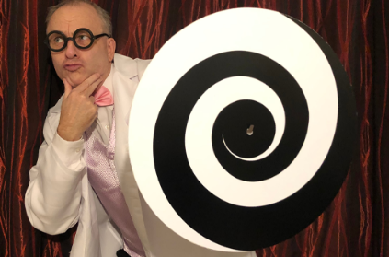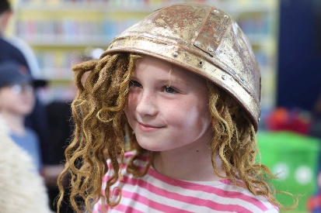

Special events organised for October:

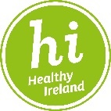**Healthy Ireland event: Mood Food by Paula Mee**. This highly informative online talk on which foods are best for our mental well-being as well as physical health was a great success with 50 people tuning in. This took place on 5th October.

Also on healthy eating, we promoted the **Healthy Eating for Parents and Teens** 6-week online cookery course which received a fantastic response,fully booked out. This started on Wed 20th Oct.

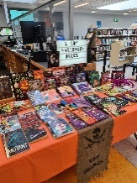**Halloween Activities** for children during mid-term break (all booked out):

Online Comic Art Workshop for Teenagers; online Clayotic Cat in the Hat workshop; online Creative Writing Workshop

In the library: Halloween Storytime for Under 6s; Halloween Yoga for under 6s; Wooden Heart – shadow puppet show with Garba Productions

Halloween LED Card kits –make your own light-up LED Halloween card.

Our library book clubs continue online– Mid-day Monday Book Club, first Monday of the month; Junior Book Club last Tuesday of the month; Lucan Library Book Club, last Wednesday of the month

**Art Competition for Social Inclusion Week in November (competition is open now). Winners work will be displayed during Social Inclusion week in our Exhibition space in Lucan library.**

**NOVEMBER EVENTS:**

**Season of Science November 2021 - Lucan Library**

**School Events:**

**Dave’s Jungle Reptile Show -** Thursday 4th Nov (Lucan) two shows for school.

**Make an Astronaut’s Dinner with Anyone4Science –** Tues 16 Nov two shows for school groups

**Discover Space with the Rediscovery Centre** - Monday 29th Nov – 2 sessions for school groups

**The Really Rubbish Litter Show with Scientific Sue** - Tuesday 30th Nov – 3 sessions for school groups

**Public Event, for children with ASD: Feel the Forces! A Science Show specially tailored for Children with an Austism Spectrum Disorder.** Saturday 13th November, 11.30am and 12.30pm. Book via Eventbrite.

**Samuel Beckett – Introduction to his life and works with Roslyn Hickey.** 6 week course, fully booked out.

**Parenting Programme**:

Lucan Library will host 2 events, part of County-wide Parenting programming:

* **Developing Resilience, Confidence and Social Skills in Children – a talk by psychotherapist Stella O’Malley**. 11th November, book via Eventbrite
* **Palmerstown Digital Hub: Same talk Stella O’Malley on 8th November**
* **Mother Tongues – Raising Bi-Lingual Children, a talk by Dr Francesca La Morgia**. 24th November, book via Eventbrite

**Poetry Workshops**: with renowned poet Nell Regan, Thursdays 18th and 25th November, 6.30pm to 8pm. Book via Eventbrite. Both workshops will be held in the library.

**Social Inclusion Week**:

Monday 15th November – **Self-care for the Carer** – learn some simple, calming head massage techniques with Barbara McAteer, book via Eventbrite

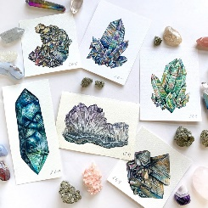Wednesday 17th November – **Crystal Art Painting** – a relaxing and mindful craft activity for adults with Margaret Goulding, book via Eventbrite

**National Accessibility Week**

Monday 22nd and Tuesday 23rd November – Lucan will borrow the “**Magic Table**” from NCL – this sensory device is perfect for helping people who have dementia or an intellectual disability. There are 6 pods booked for 6 one hourly afternoon sessions over both days.

During National Accessibility Week Lucan Library staff members Cathal and Aisling will be on hand to give **one-to-one assistance** with accessing South Dublin Libraries’ online resources as well as helping to answer other queries around using digital devices.  The focus will be to help people with DIGITAL ACCESS to library resources.

As our Christmas Craft Fair falls during Accessibility week, we are offering a space to a disability arts group, DoubleTAKE Supported Arts Studio, Rua Red.

***CHRISTMAS CRAFT FAIR IS IN PLANNING STAGE*** – expressions of interests from local crafts and arts invited. There will be music and a children’s event on the day. Saturday 27th November

**HISTORY AT LUCAN**

**Haunted Lucan exhibition** from 11th Oct to 1st November. Stories and strange tales from the big houses and environs of Lucan.

**28th October at 7pm on zoom- A decade of Centenaries talk**. The Bureau of Military History, origins and overviews of the collection with Commandant Daniel Ayiotis, Officer in charge.